Submitted by Group 3
Class: VIII A
MICROMOUSE
MAZE-SOLVING ROBOT
Technical Project Report

1. Project Overview
The Micromouse Maze-Solving Robot is an autonomous mobile robot designed to navigate a grid-based maze. An ESP32 microcontroller processes distance measurements from three VL53L0X time-of-flight sensors and feedback from the wheel encoders. It then controls two geared DC motors through a TB6612FNG dual H-bridge driver.
The planned maze is an 8 × 8 grid. The robot starts in the bottom-left cell facing north and targets the central 2 × 2 region. The navigation flowchart uses a right-hand priority: right, forward, left, and then the fallback action shown in the diagram.

2. Hardware Architecture
The ESP32 is the central controller. The front, left and right VL53L0X sensors detect nearby walls. Quadrature encoders report wheel movement, allowing the controller to estimate distance and turning. The TB6612FNG receives direction and PWM commands and drives the left and right N20 motors.
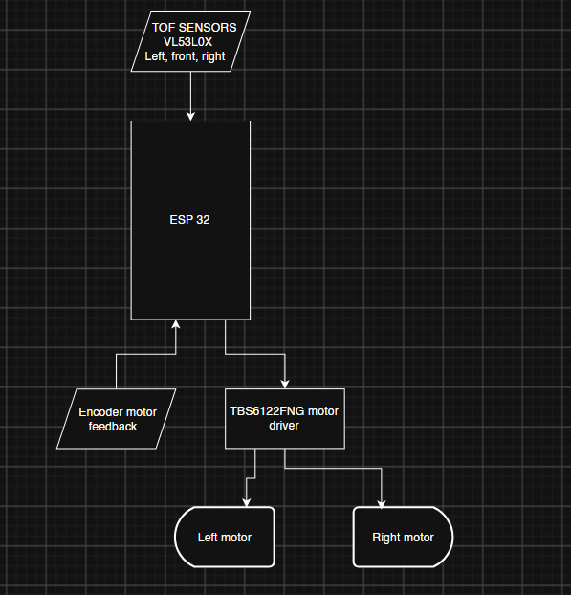
Figure 1. System block diagram.

2.1 Main Components
Component | Function
ESP32 development board | Runs the navigation logic and handles sensor, encoder and motor-driver signals.
3 × VL53L0X ToF sensors | Measure front, left and right distances for wall detection.
2 × N20 geared DC motors with encoders | Provide differential drive and wheel-motion feedback.
TB6612FNG motor driver | Controls the direction and speed of both motors.
2S Li-ion battery pack | Provides the robot's main electrical supply.
XL4015 and MP1584 buck converters | Provide separately regulated motor and 5 V logic rails.

2.2 Circuit Diagram
Figure 2 shows the supplied circuit schematic, including the ESP32 connections, ToF sensor bus, motor driver, encoder connections and battery-power section. The detailed views below make the main circuit sections easier to inspect.
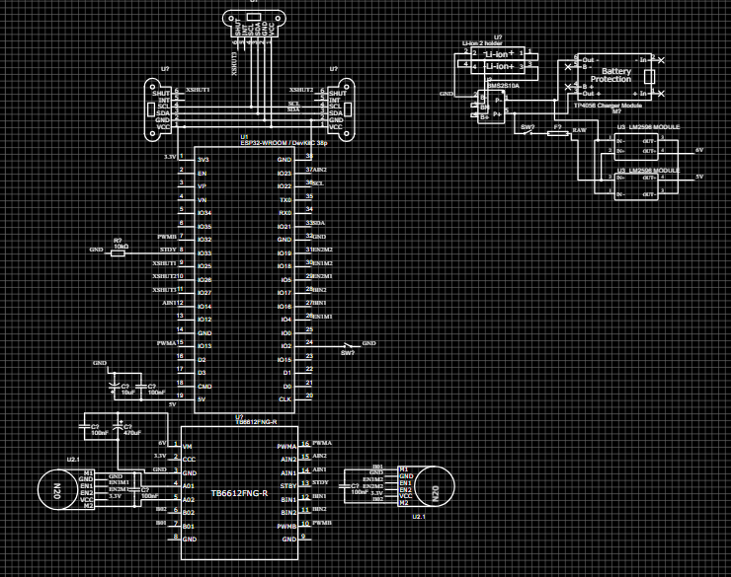
Figure 2. Overall circuit schematic supplied for the project.

2.3 Circuit Details
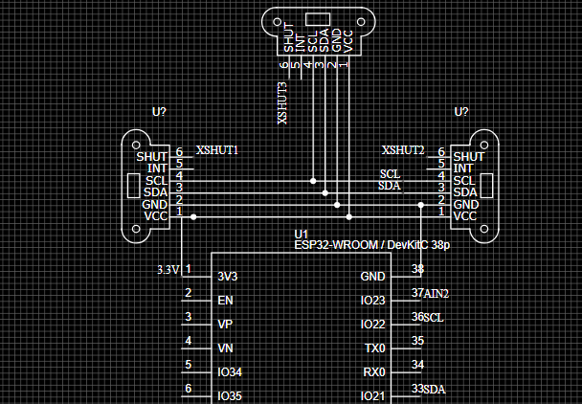
Figure 3. VL53L0X sensor connections and shared I²C bus.
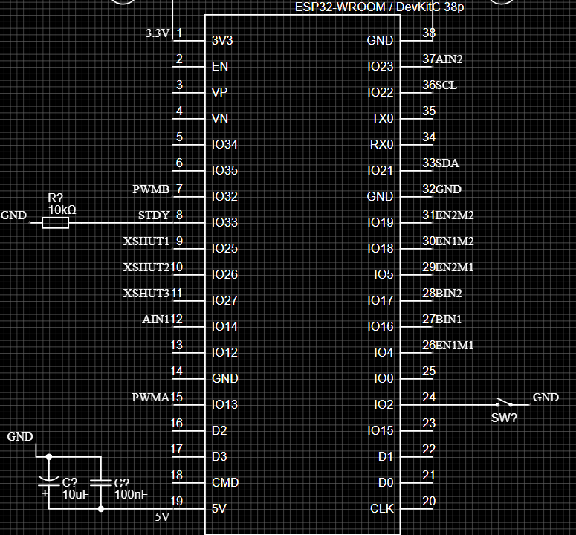
Figure 4. ESP32 pin assignments shown in the schematic.
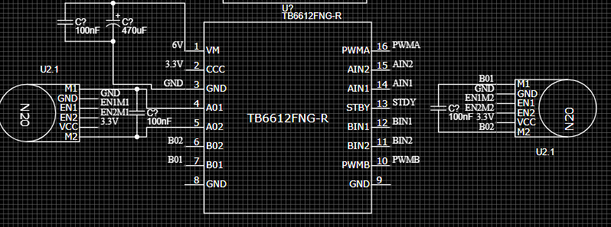
Figure 5. TB6612FNG motor-driver and motor connections.
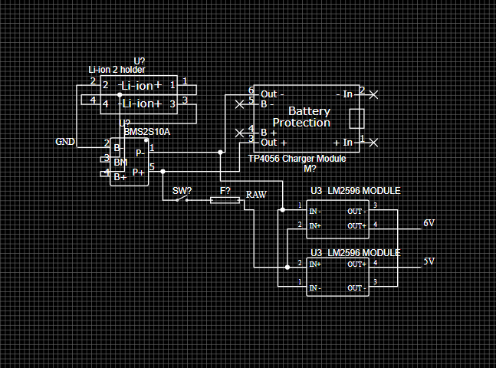
Figure 6. Battery, protection and converter section as drawn.

3. Navigation and Maze-Solving Method
After initialising the sensors, motor driver and encoder inputs, the robot waits for the start command. It repeatedly reads the three ToF sensors, updates its local maze map and evaluates the available directions.
- If the destination is reached, the robot stops.
- If the right path is clear, it turns right.
- Otherwise, if the front path is clear, it moves forward.
- Otherwise, if the left path is clear, it turns left.
- If no preferred direction is available, it follows the fallback branch in the flowchart.
This right-hand-priority method is simple to implement, but it does not guarantee a solution for every maze layout. The map must be updated consistently as new wall measurements are collected. The proposed code is live at
GitHub - devcodez674/micromouse · GitHub

3.1 Navigation Flowchart
The flowchart below represents the robot's initialisation sequence, sensor-reading cycle, destination check and directional decision process.
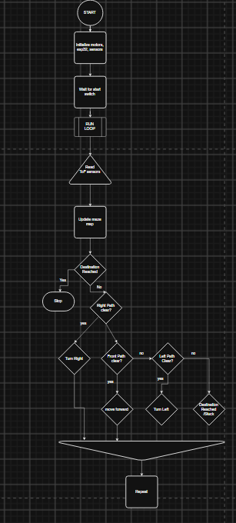
Figure 7. Maze-navigation flowchart.

4. Power Supply and Distribution
The robot uses a 2S Li-ion battery pack with a nominal voltage of 7.4 V and a fully charged voltage of 8.4 V. Two separate buck converters provide regulated motor and logic supplies.
- XL4015: supplies the TB6612FNG motor-driver VM input. Adjust its output to the motors' rated voltage (6 V only if the selected motors are rated for 6 V).
- MP1584: provides regulated 5 V to the ESP32 development board through its 5V/VIN input.
- The ESP32 board's onboard regulator provides 3.3 V for the microcontroller and compatible peripherals.
The battery, converters, ESP32 and motor driver share a common ground. The motor and logic supply rails are regulated separately to reduce motor-current disturbances on the controller supply.

4.1 Passive Components
Component | Quantity | Purpose
100 nF ceramic capacitor | 4 | Two for local rail decoupling and two across the motor terminals.
10 µF capacitor | 1 | Additional logic-rail decoupling.
470 µF capacitor | 1 | Bulk decoupling on the motor supply rail.
10 kΩ resistor | 1 | Pulls TB6612FNG STBY low during startup.
Each motor-terminal capacitor is connected directly across that motor's two terminals, not from a motor terminal to ground. The remaining capacitors provide local supply decoupling. The final PCB/module arrangement should be checked for existing capacitors before adding duplicates.

4.2 Charging and Battery Protection
The 2S battery pack requires a dedicated 2S Li-ion charger and suitable 2S protection circuitry. Charger voltage, cell configuration and protection ratings must match the battery pack.

5. Pin and Calibration Checks
- I²C: SDA GPIO21 and SCL GPIO22, as labelled in the schematic.
- ToF shutdown: XSHUT signals are assigned to GPIO25, GPIO26 and GPIO27.
- Motor-control signals and encoder GPIO assignments must be cross-checked against the final firmware and schematic.
- Assign unique I²C addresses to the three VL53L0X sensors during startup using their XSHUT pins.
- Calibrate encoder counts per wheel revolution, wheel diameter, wheelbase and maze-cell distance.
- Verify motor direction, sensor thresholds, turning accuracy and converter output voltages before a full maze run.

6. Conclusion
The design combines ToF-based wall detection, encoder feedback and differential-drive motor control in a compact autonomous robot. The block diagram, circuit schematic and navigation flowchart document the system architecture. Correcting the draft power section and completing sensor, motor and encoder calibration are necessary before the robot is ready for reliable operation.

