# logo

## O3 CRM MANAGEMENT PROJECT

OBJECTIVE

The objectives of the system are- ➢

* To reduce coding for create multiple CRM. ➢
* Reduced testing and debugging time for create a new CRM. ➢
* Increased accuracy and reliability. ➢
* Increased operational efficiency. ➢
* Data security.

###### This project is used by three types of users-

* Super Admin.
* Admin.
* Agent (Call Center Employee).

###### Super Admin

* Super Admin can create their multiple admin.

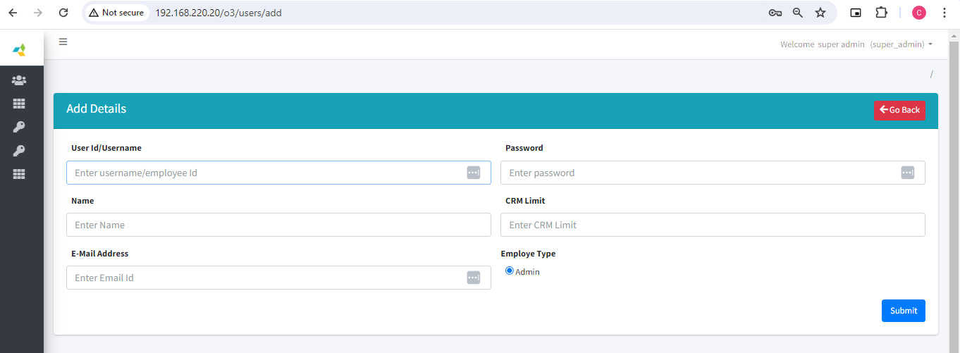

* Super Admin can delete admin edit there details and see the list of Admin list.
* Super Admin can Exports a CSV file of Admin List.

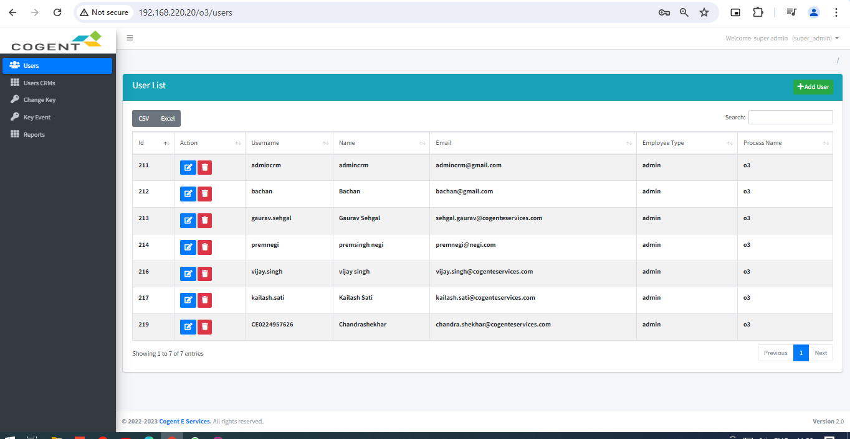

* Super Admin can also see CRM Users List ( Which CRM Created by Admin)
* Super Admin Export CSV file of Admin CRM List

### - CHANGE KEY -

* Once you proceed with **"change key"**, the system will generate a new key for your CRM and log you out. You need to log back in to the system and then proceed with the **"key event."** The **"key event"** may take some time to start, depending on the amount of existing data.
* Inserted Data in encrypted form (has Code) in database using key

### - Reports -

* Super Admin Fetched Reports Date wise of Admin CRM as Particular CRM
* Given Below Snapshot for Reports of Admin CRM

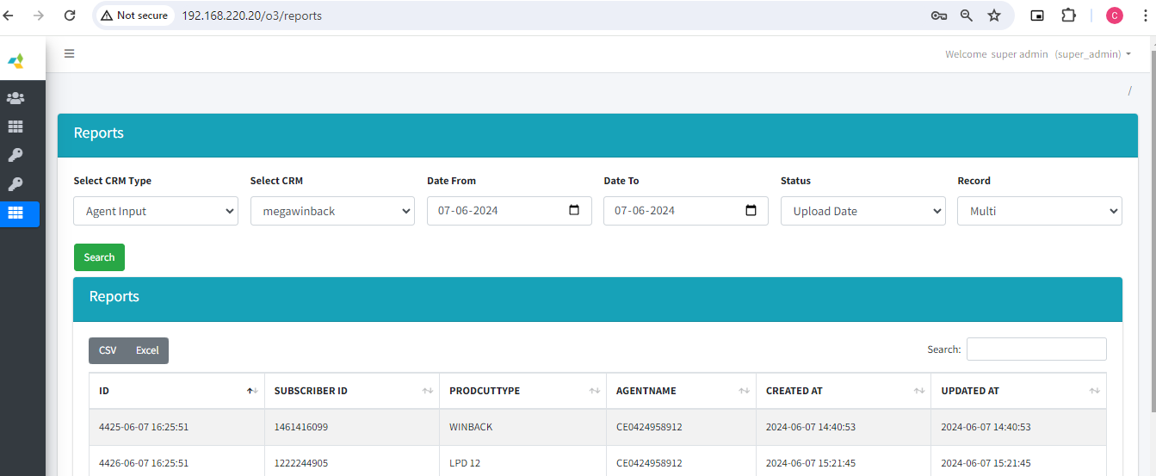

### - Admin -

* Admin Can Create multiple Agent and assign a Existing CRM.

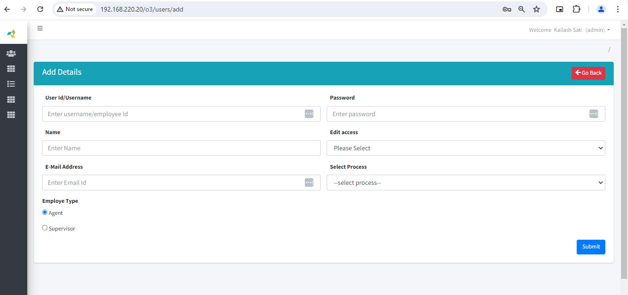

* Admin Can also edit , delete and update of existing agents.
* Here is Listing of Agents given below snapshot

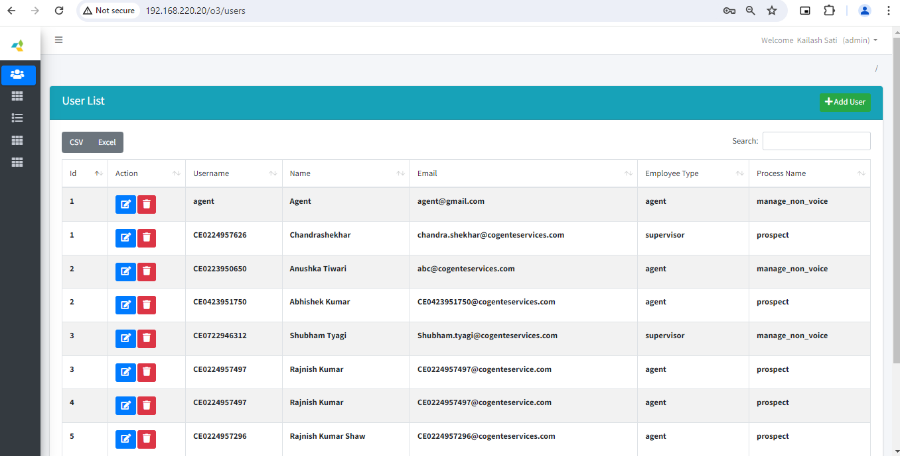

* Admin can see own CRM List and create a new CRM and Manage
* CRM have Two type : 1. Agent Input 2. Agent Data
* When Admin Create a CRM then database will be create for new crm and name as

Crm name. for example cgcrm_(prefix) demo_crm (crm name)) then database name will be

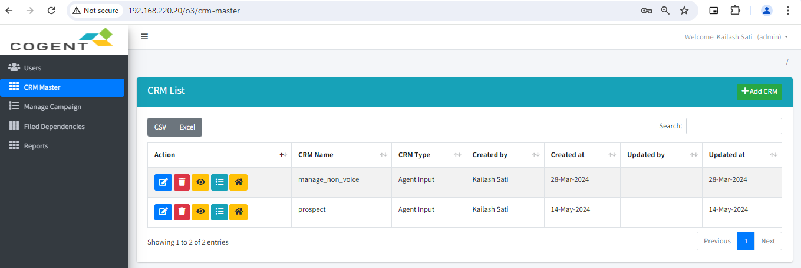

Manage Columns

### -: Manage Columns :-

* In Agent Input CRM have no excel sheet option for upload a excel sheet in database so

That admin can upload a data for ticket .