Final Project

### Nodes:

This shows that all hosts/devices were created successfully. This was done using the mininet command “node”, which lists all the nodes (hosts, switches, and the controller) in the current Mininet network.

### Links:

This shows that all the Links were successfully created, and the topology is correct. I did this using the “links: command which shows information about the links between switches and hosts in the emulated network.

### IP Addresses:

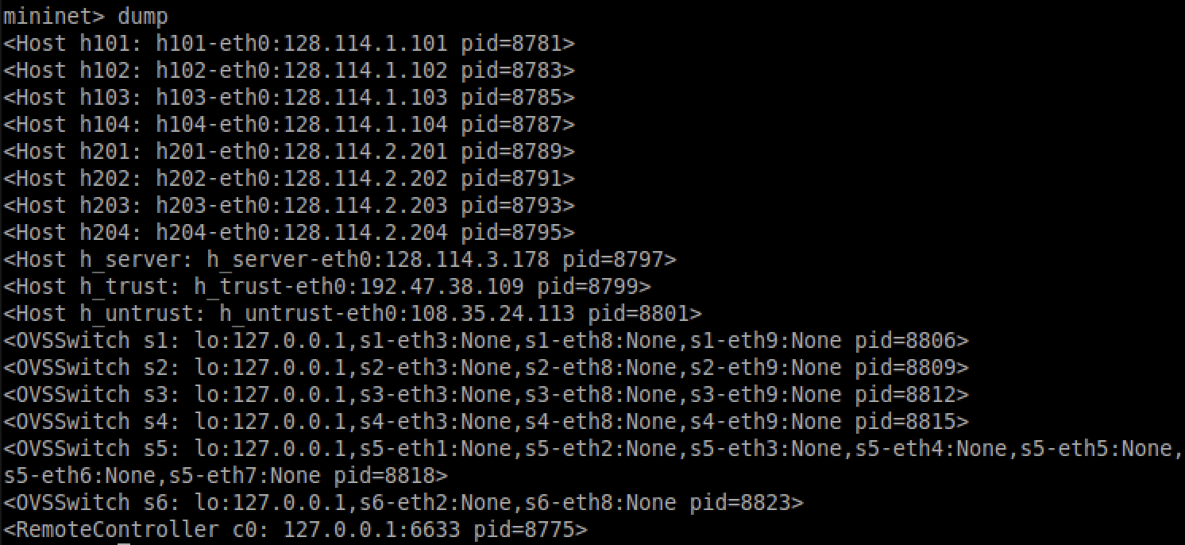

Using the command “dump” will show all the IP addresses, and pid assigned to each host. This listing hosts like h101, h102, and switches such as s1, $2, along with their corresponding IP addresses, interface connections, and process IDs. For instance, h101 is associated with IP 128.114.1.101 and switches s1, while s1 is linked with interfaces s1-eth3, s1-eth8, and s1-eth9. This detailed breakdown assists in visualizing the network topology.

### POX controller:

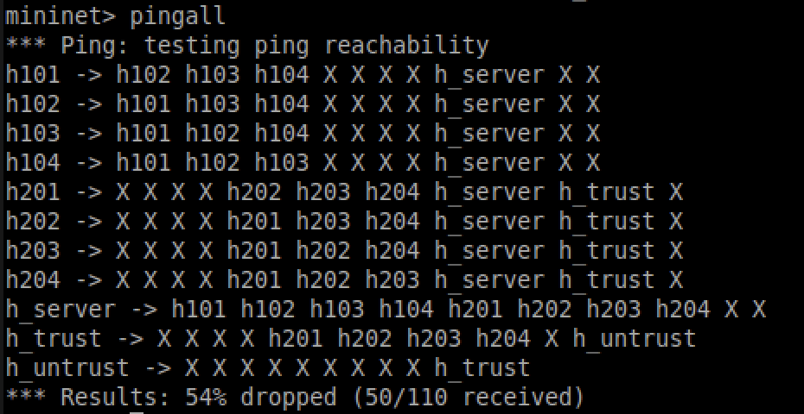

This shows that the untrusted host cannot send ICMP traffic to host 101-104 and 201-204. I found this using “pingall”, where pingall sends ICMP (Internet Control Message Protocol) traffic. It performs a ping test between all pairs of hosts in the network, and shows which hosts can communicate with each other. From this test we see that all hosts are able to communicate to at least one other host. The hosts 101-104 (floor 1) can only communicate with other hosts on floor 1 as well as the server. Hosts 201-204 (floor 2) can only communicate with other hosts on floor 2 as well as the server and the trusted server. The server is able to talk with all floors but not the trusted server and the untrusted server. The trusted host is able to communicate with the second floor and the untrusted host. However this is not supposed to happen, the trusted server should not be able to communicate with the second floor. I believe this is happening because of some wrong conditioning in my code. The untrusted host is able to communicate with no one except the trusted server. **All of this concludes** that all hosts are able to communicate, the untrusted host cannot send ICMP traffic to hosts 101-104 and hosts 201-204, however it can only send to the trusted host, trusted host cannot send traffic to 101-104 only to 201-204, and hosts 101-104 and hosts 201-204 are not able to communicate with each other.

### Special Tests:

In this section, I am just going to be running special tests that showcase which hosts can communicate with each other. I will be using the ping command (ex. h101 ping -c 3 h104). In the example command, host 101 will send packets to host 104, and it will show if the packets were received or not.

h101 ping -c 3 h201: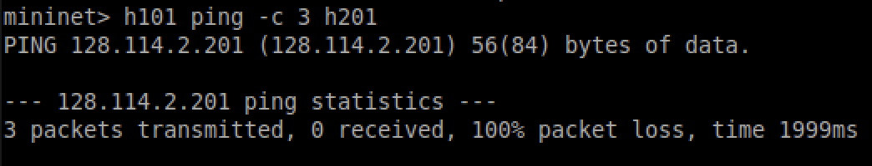

In this we are trying to communicate with host 201 which is the second floor, and from the results it shows that we cannot communicate with floor 2. This concludes that floor 1 will not be able to communicate with floor 2 which is what we want.

H_trust ping -c 3 h_server:

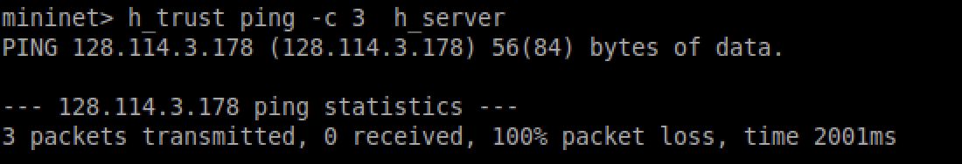

In this we are pinging the trusted server to communicate with the main server. The results show that they are not able to communicate with each other, since no packets were received which is what we want.

H101 ping -c 3 h_untrust:

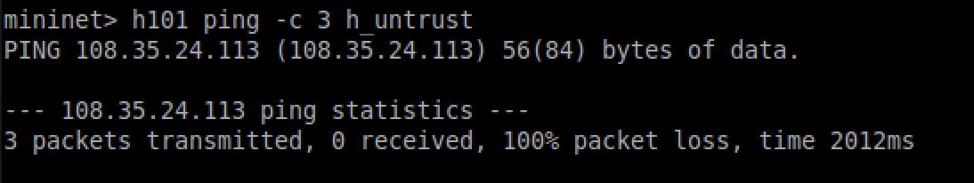

For this test we are going to ping the untrusted server from a host on floor 1. As we can see, they are not able to communicate with each other since no packets were received. This is what we want since we don't want a untrusted person to talk with our hosts on floor 1