Report prepared by Dev Dalal (1002228218) and Ujjwal Patel (1002228413).
Github: https://github.com/devdalal2002/Raft-and-2pc.git

Project Report: Two-Phase Commit (2PC) and Raft Consensus Implementations

1. Introduction
The goal of this project is to provide hands-on experience in implementing simplified versions of consensus algorithms: Two-Phase Commit (2PC) and Raft. Through this assignment, we aim to understand how 2PC achieves distributed commit and how Raft achieves fault-tolerant consensus by handling leader election, maintaining log consistency, and managing distributed state transitions.
The implementations use gRPC for communication between nodes/processes and Docker for containerization to ensure isolated deployment and networked communication among nodes.

2. Why are Consensus Algorithms Needed?
In distributed systems, replicating changes across processes requires ensuring all processes apply changes in the same order despite failures such as crashes or network issues. Simple replication strategies that wait for all replicas may lose availability or consistency.
Consensus algorithms enable distributed systems to achieve agreement on a sequence of state changes with high availability and fault tolerance, ensuring consistency and progress even under failures.

3. Two-Phase Commit (2PC) implemented by Ujjwal Patel
3.1 Overview
2PC is a consensus protocol that manages atomic transactions across distributed processes by coordinating commit or abort decisions. It designates one node as the coordinator and others as participants.

3.2 Details
The protocol consists of two phases:
Voting Phase:
- The coordinator sends a vote-request message to all participants.
- Participants reply with a vote-commit or vote-abort message indicating readiness to commit or abort the transaction.
Decision Phase:
- The coordinator collects votes and decides:
- If all participants vote commit, the coordinator sends a global-commit message.
- If any participant votes abort, the coordinator sends a global-abort message.
- Participants act on the final decision, committing or aborting the transaction accordingly.
Our implementation uses gRPC-defined RPC methods for vote-request, vote-commit, vote-abort, global-commit, and global-abort messages. Each RPC logs messages on client and server sides indicating message flow for debugging and transparency.
Each node runs as a Docker container with intra-node gRPC communication between voting and decision phases.
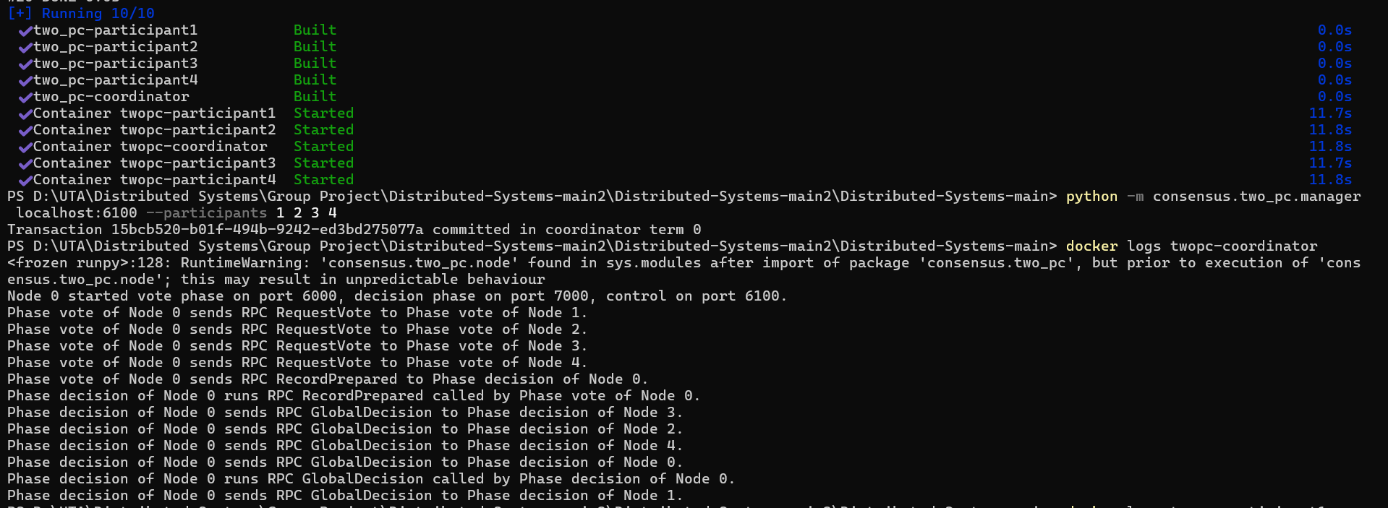

4. Raft Consensus Algorithm implemented by Dev Dalal
4.1 Overview
Raft enables distributed consensus via leader election and log replication. A server is either a leader or follower, or a candidate during elections. The leader manages log replication and regularly sends heartbeat messages to maintain authority.

4.2 Details
4.2.1 Leader Election
- Each follower starts with a randomized election timeout in range [1.5, 3.0] seconds.
- If no heartbeat is received within the election timeout, the follower becomes a candidate, increments its term, votes for itself, and sends RequestVote RPCs to other nodes.
- If the candidate receives a majority of votes, it becomes leader and starts sending heartbeat AppendEntries RPCs every 1 second.
- If another candidate wins or no majority is reached, it reverts to follower and awaits heartbeats.
This randomized election timeout reduces split votes and ensures only one leader is elected.

4.2.2 Log Replication
- The leader accepts client requests, appends them to its log with an incrementing index and term.
- It forwards the log entries to followers in AppendEntries RPCs (heartbeat).
- Once a majority acknowledges replication, the leader commits the entry and applies the state.
- Followers apply committed entries to keep logs consistent.
- Client requests sent to followers are forwarded to the current leader.
RPCs log messages on client and server sides indicating their invocation.

4.3 Implementation Details
The Raft node implementation uses Python threading for election and heartbeat loops, gRPC for RPC handling, and a simple randomized election timeout mechanism. Nodes start as followers and follow the described state transitions.

5. Assignment Summary
- Implemented voting and decision phases of 2PC via gRPC with proper message logging.
- Containerized each node using Docker, enabling communication with at least 5 nodes.
- Implemented Raft leader election with heartbeat timeout (1 second) and randomized election timeout (1.5 - 3 seconds).
- Managed follower, candidate, leader states with proper transitions, vote counting and leadership establishment.
- Built log replication mechanisms forwarding client requests and ensuring consistency.
- Created automated Raft test cases for leader election, heartbeat stability, log replication, client forwarding, and leader failover.

6. Tests
Test Case 1: Leader Election
Purpose
Verify that the Raft cluster successfully elects a single leader when initialized.
Implementation
- Setup: Initialize a 5-node cluster with no pre-designated leader
- Steps: Start all nodes, wait up to 10 seconds for election, verify exactly one leader exists
- Success Criteria: One node elected as leader, four nodes remain followers
Validation
This test validates Raft's safety property (no split-brain), liveness property (cluster makes progress), and the election timeout mechanism. When the cluster starts, randomized election timeouts ensure one node becomes a candidate first, requests votes, and achieves majority consensus (3/5 votes) to become leader.
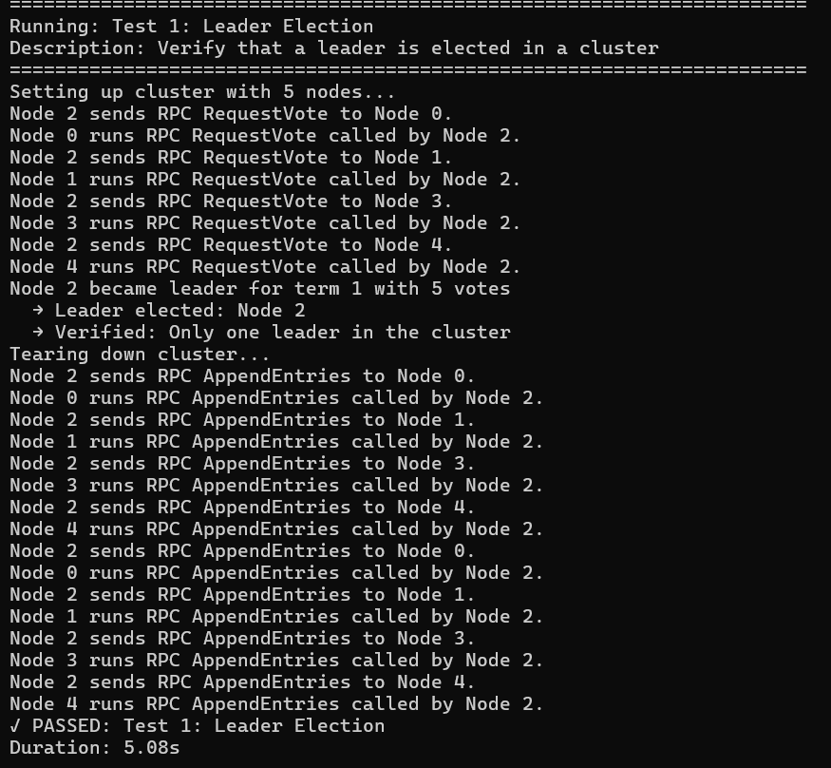

Test Case 2: Leader Failover
Purpose
Verify the cluster recovers from leader failure by electing a new leader, ensuring continuous availability.
Implementation
- Setup: 5-node cluster with established leader
- Steps: Identify current leader, stop the leader node, wait for new election (up to 15 seconds)
- Success Criteria: New leader elected with different ID and higher term number
Validation
Validates fault tolerance and failure detection. When the leader fails, followers detect missing heartbeats after ~150-300ms. The first follower whose election timeout expires becomes a candidate and achieves majority votes (3/4 remaining nodes) to become the new leader, demonstrating high availability.
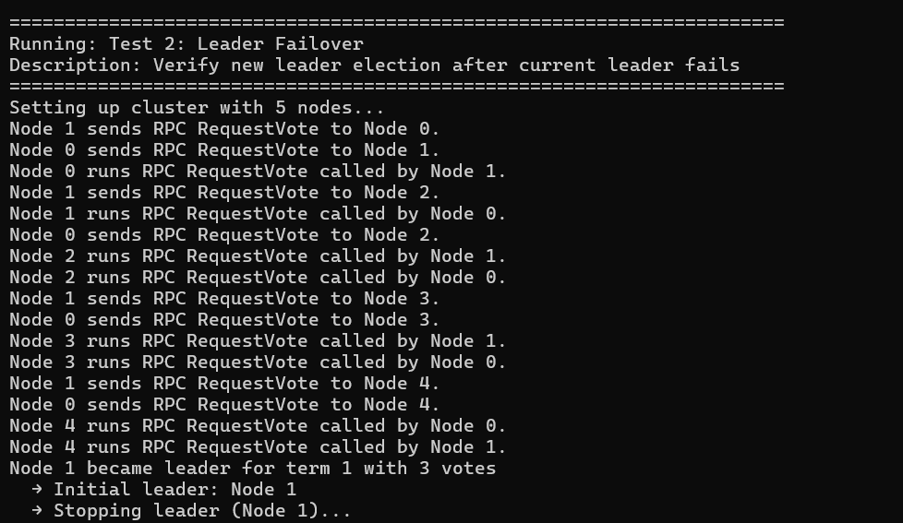
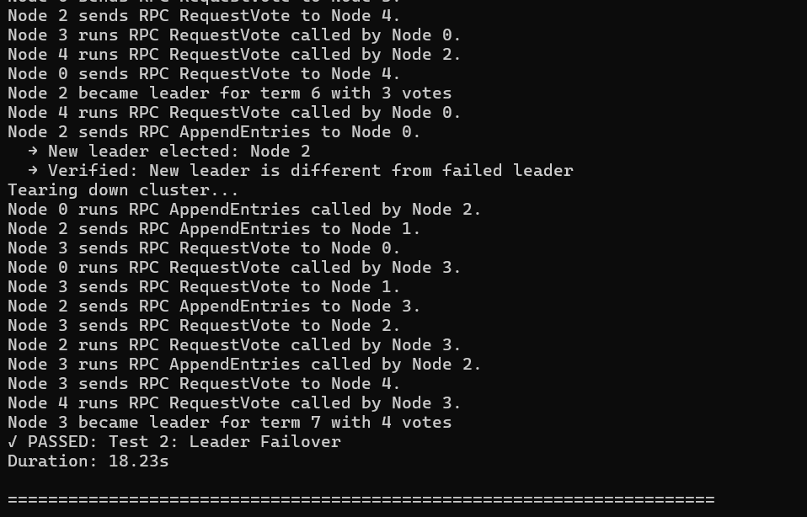

Test Case 3: Log Replication and Consistency
Purpose
Verify commands are correctly replicated across all nodes, maintaining strong consistency.
Implementation
- Setup: 3-node cluster with elected leader
- Steps: Send 5 sequential commands to leader ("set x 1", "set y 2", "set z 3", "delete x", "set w 4"), wait 2 seconds for replication
- Success Criteria: All nodes have identical state machine contents in the same order
Validation
Validates log replication, consistency, and ordering. For each command, the leader appends it to its log, sends AppendEntries RPCs to followers, waits for majority acknowledgment (2/3), commits the entry, and applies it to the state machine. All nodes converge to identical logs.
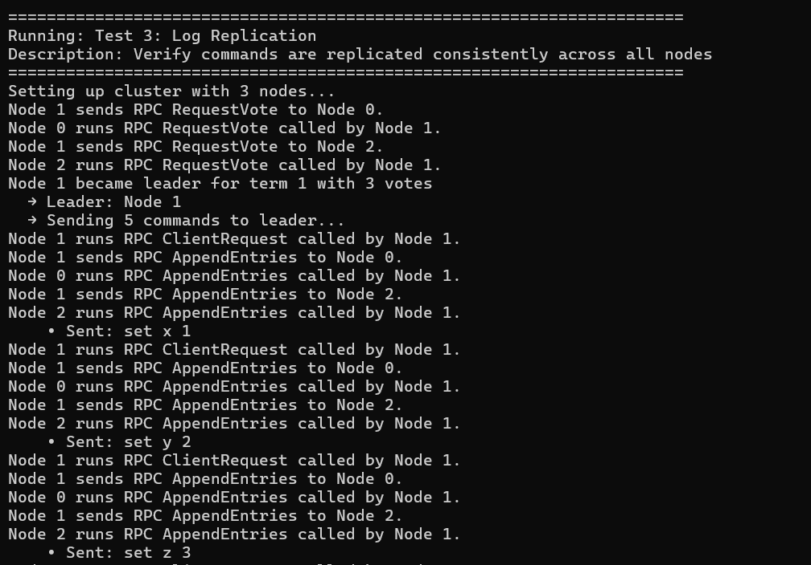
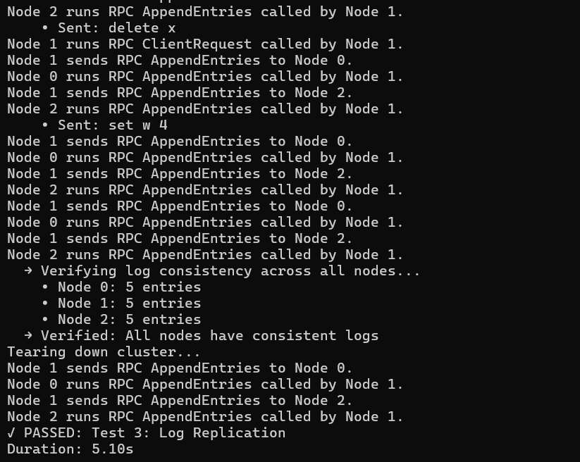

Test Case 4: Client Request Forwarding
Purpose
Verify client requests sent to follower nodes are correctly forwarded to the leader.
Implementation
- Setup: 3-node cluster with elected leader
- Steps: Send command to a follower node (not leader), wait for forwarding and replication
- Success Criteria: Follower accepts request, forwards to leader, command replicates to all nodes
Validation
Validates request forwarding and location transparency. When a follower receives a client request, it identifies the current leader (from heartbeats) and forwards the request. The leader processes it normally, and success is returned to the client through the follower.
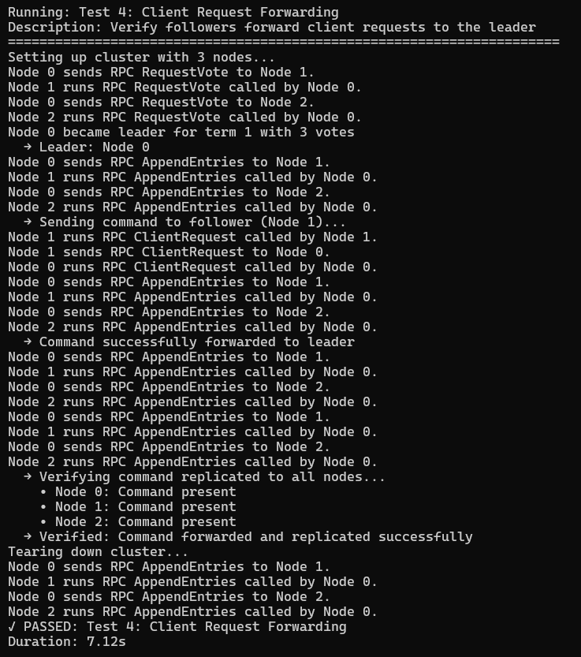

Test Case 5: Network Partition and Recovery
Purpose
Verify the cluster maintains consistency during network partitions and prevents split-brain scenarios.
Implementation
- Setup: 5-node cluster with elected leader
- Steps: Send initial command, verify replication to all nodes, stop 1 non-leader node, send command during partition, verify majority consensus
- Success Criteria: Initial command replicates to all 5 nodes; after stopping 1 node, remaining 4 nodes can still process commands with 3-node majority
Validation
Validates partition tolerance and split-brain prevention through majority-based consensus. With 4 active nodes, the leader maintains a majority (3/4) and can commit new entries. Raft's majority requirement ensures at most one partition can elect a leader, prioritizing consistency over availability (CP in CAP theorem).
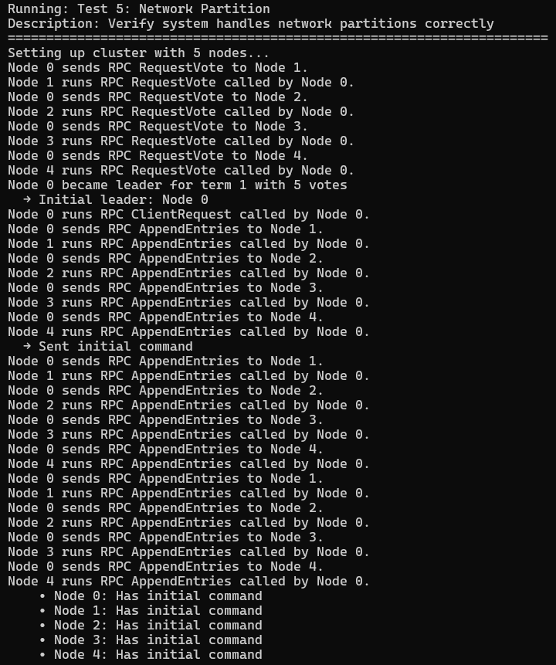
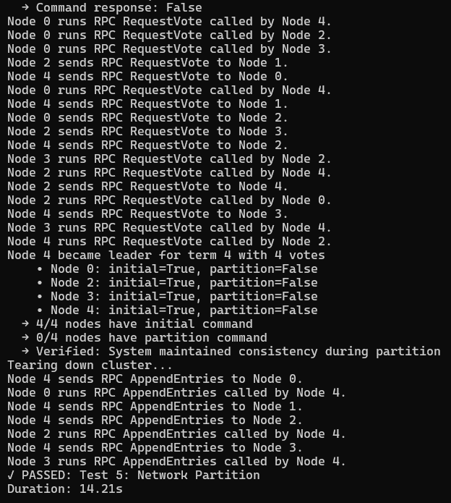
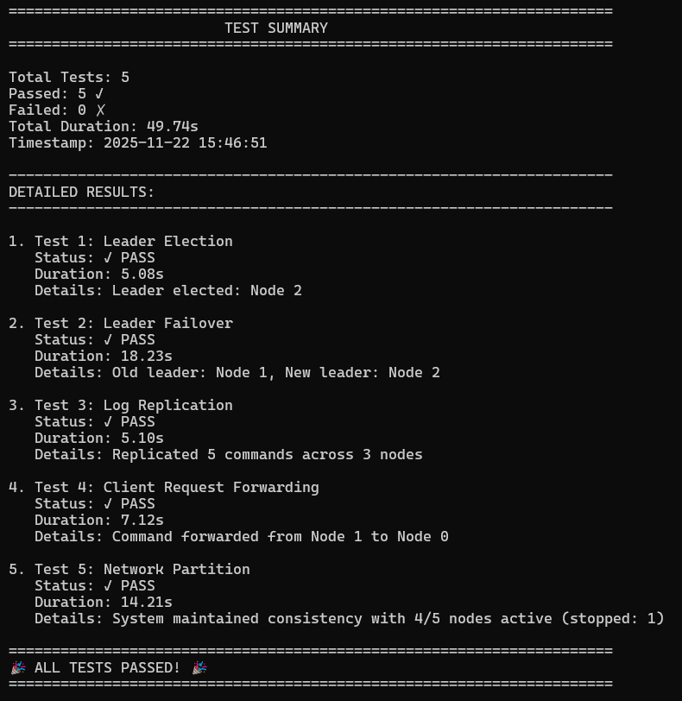

7. References
1. Consensus Algorithms and Distributed Systems literature
2. gRPC and Docker official documentation
3. Raft: In Search of an Understandable Consensus Algorithm, Diego Ongaro and John Ousterhout

