Files we have (will be used later):
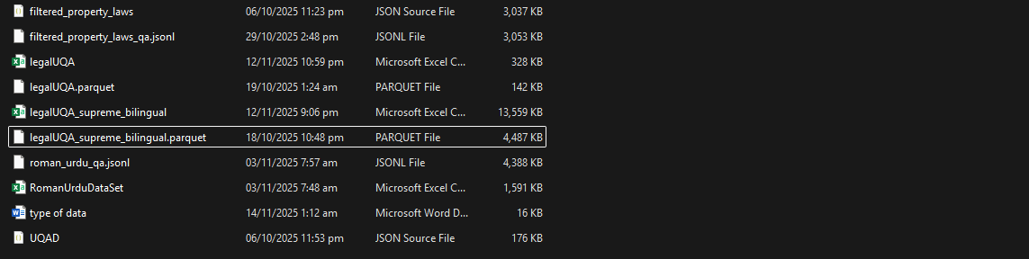
- Original file
- Instruction style banany ki koshish ki thi recheck karna thik hai k sai karny ki zrorat hai
- Legal urdu and English questions answers
- Supreme courts ki judgments ka instruction style banaya hai zabardasti recheck karna
- Ignore roman urdu filhal
- Uqad ye general urdu k question answers hain inko bhi dekhna
GOAL: We have to refine tune our model with more correct data and more epoch
Masla: Hamary pass jo original sources se data uthaya hai usme kisi bhi file main columns or rows nahi hain simple text para hua hai or kafi irrelevant chizain bhi hain, usko hamne filter out karna hai or single file main leke ana hai. Yani k jo different sources se data uthaya hai usko akatha kar k aik file main dalna hai likin usse pehly har file k ander esy columns banany hain jo sab datasets main common ho sakain. Jab common hojayen gi tab hi single file bany gi.
Your task: Ab tumne ye karna hai k kisi bhi AI model se ye pocho k ye rola hai or iska solution kesy banain ham? Matlab mujhe ni smjh aa rhi k ye chiz possible bhi hai k ni or agar to ni hai to koi strong bases pe answer nikalwao kahin se k q nai possible.
or agar possible hai to is hisab se data nikalna hai tamam files main se
How much should we add data from each file?
- Property-law & Q/A + Supreme Court judgement Q/A → 70–80%
- Legal UQAD (filtered) → 10–15%
- General UQAD (filtered) → 10–15%
- Roman urdu bhi end main dekh lena
Final Result:
Aik single csv file chahiye jisme sab files ka data para ho or atleast 5 se 7 columns hon or rows jitni zyada hon utna acha hai.
Us k baad we will use this file to check with sir mansoor and then re-train the model.

