NUnit Successful Tests:

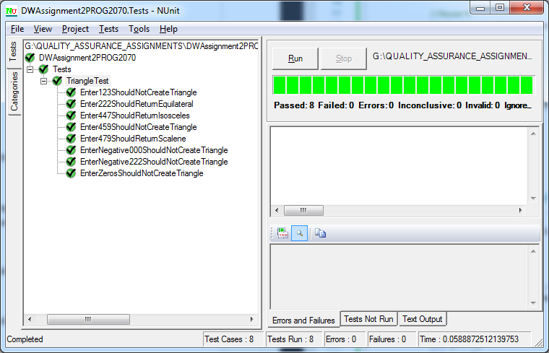

Test 1: Enter Zeros Should Not Create Triangle  
I selected zeros for the input because a triangle cannot be created with no side lengths.

Test 2: Enter 1,2,3 Should Not Create TriangleI selected 1, 2 and 3 for this test because a person uneducated in triangle geometry would probably believe this is a valid input. It is not valid because of the triangle inequality theorem which states: the sum of two sides of the triangle must be greater than the other side.

Test 3: Enter 2,2,2 Should Return Equilateral  
I selected 2, 2 and 2 for this test because when the three sides of a valid triangle are equal it is an equilateral triangle.

Test 4: Enter 4,4,7 Should Return Isosceles  
I selected 4,4 and 7 for this test because when only two sides of a valid triangle are equal it is an isosceles triangle.

Test 5: Enter 4,7,9 Should Return Scalene  
I selected 4,7 and 9 for this test because when a triangle is valid and each side is a different size, it is a scalene triangle.

Test 6: Enter 4,5,9 Should Not Create Triangle  
I selected 4,5 and 9 for this test because once again, if someone is uneducated in triangle geometry they might believe this is a valid triangle. However, 4 + 5 is not greater than 9 and therefore it fails the triangle inequality theorem.

Test 7: Enter negative 2, 2, 2 Should Not Create Triangle  
I selected -2, -2 and -2 for this test because negative values cannot create a triangle.

Test 8: Enter negative 0,0,0 Should Not Create Triangle  
I selected -0,-0 and -0 for this test because it is an odd input considering zero cannot be negative. This test makes sure the program can handle this odd input.