NASA Midterm Update

Deval Manish Deliwala

Under Daniel R. Hart.

Ultimate Goal: A full parameterized simulation of EDMR/NZFMR for 4H-SiC from first principles.

Full Internship Objectives:
- Deriving the 16x16 Spin Hamiltonian for 4H-Silicon Carbide, accounting for Zeeman, Hyperfine, Zero-Field Splitting, and Exchange Interaction Terms.
- Solve eigenvalues for each Hamiltonian combination. Generate Energy vs. B field(s) for every singlet-triplet eigenvector and plot where degeneracies occur.
- Solve the Stochastic Liouville Equation (SLE) for the complete Spin Hamiltonian
- Use the SLE model as a functional to fit against EDMR spectra.

Quick Summary:
Every objective has been completed except for 4, which should be completed within a week. The full 16x16 Spin Hamiltonian (along with every sub-combination of Zeeman, Hyperfine, ZFS, and Exchange Hamiltonians) was generated programmatically with Python in the coupled electron - nuclear zeeman basis, completing Objective 1. A script for calculating the eigenvalues and performing spectral decomposition back into the coupled basis and was used to build eigenenergy simulation plots, completing Objective 2. The Stochastic Lioville Equation,
$$\frac{∂ρ}{∂t}=-\frac{i}{ℏ}[H,ρ]-\frac{k}{2}\{Λ,ρ\}+pΓ.$$

was calculated at steady-state for the full Spin Hamiltonian, completing Objective 3. It returns the 16x16 density matrix $ρ(B)$ describing the full spin-ensemble for a given B field. Taking the trace, $\text{Tr}(Λ_{S}ρ(B))$ with the singlet projector $Λ_{S}$ gives the singlet-population within the 4H-SiC chip as a function of B. Because the singlet-population is proportional to the measured spin current from EDMR/NZFMR,
$$\text{Tr}(Λ_{S}ρ(B))∝I(\text{nA})$$

we have a model for plotting the EDMR spectra by sweeping over B. This is the start of Objective 4.

Objective 1 — Deriving the 16x16 Spin Hamiltonian for 4H-SiC

This objective is split into two parts:
- Deriving Silicon Carbide’s Spin Hamiltonian mathematically.
- Programatically solving the Spin Hamiltonian for a symbolic matrix functional.

A complete description for Part 1 and Part 2 can be found on my website. It goes through every step of the process.

~Weeks 1-2

$$H={\overset{̂}{H}}_{Z}+{\overset{̂}{H}}_{HF}+{\overset{̂}{H}}_{ZFS}+{\overset{̂}{H}}_{EX}$$

4H-SiC’s (believed) primary electrically-active defect is the Silicon Vacancy $V_{Si}^{-}$, which is a 2-electron (spin-1/2) + 2-nuclei (spin-1/2) system. Hence, the full Hamiltonian has $2^{4}=16$ basis states, for a 16x16 matrix. I choose the coupled-electron + nuclear zeeman basis:

$$B=\{|s,m⟩⊗|m_{I_{1}}⟩|m_{I_{2}}⟩\}$$
where
- $|s,m⟩$ is the coupled-state between both electrons.
- $|m_{I_{1/2}}⟩∈\{|↑⟩,|↓⟩\}$ are the two-nuclei in the spin-up/spin-down zeeman basis.

I mathematically calculated the action of ${\overset{̂}{H}}_{Z},{\overset{̂}{H}}_{HF},{\overset{̂}{H}}_{ZFS},\text{and}{\overset{̂}{H}}_{EX}$ on each state, summed them together to get the full action of $H$ on every basis state. This is covered fully in Part 1. Then I programmed it all in Python symbolically using SymPy and NumPy in Part 2.

Result:
A full parameterizable 16x16 Spin Hamiltonian that serves as the foundation for everything that follows. One can input any value for the Zeeman, Hyperfine, ZFS, and Exchange constants:
$$θ=\{A_{a1},A_{a2},A_{b1},A_{b2},g_{e},g_{n1},g_{n2},μ_{B},μ_{n},B,D_{1},D_{2},J\}$$

and out comes the exact 16x16 Spin Hamiltonian for that theoretical system.

Objective 2 — Performing Eigenenergy Simulations

A complete description for this objective can be found here. It covers all the methodology, code, algorithms employed to generate the eigenspectra(s).

~ Week 3
This objective is fairly straightforward:
- For each B, calculate the Spin Hamiltonian.
- Call LAPACK geev to solve the eigenvalues and eigenvectors.
- Convert eigenvectors to linear combination of coupled-electron and nuclear-zeeman basis states via spectral decomposition.
- Employ Hungarian (Kuhn-Munkres) algorithm to assign basis vectors as B is swept over.
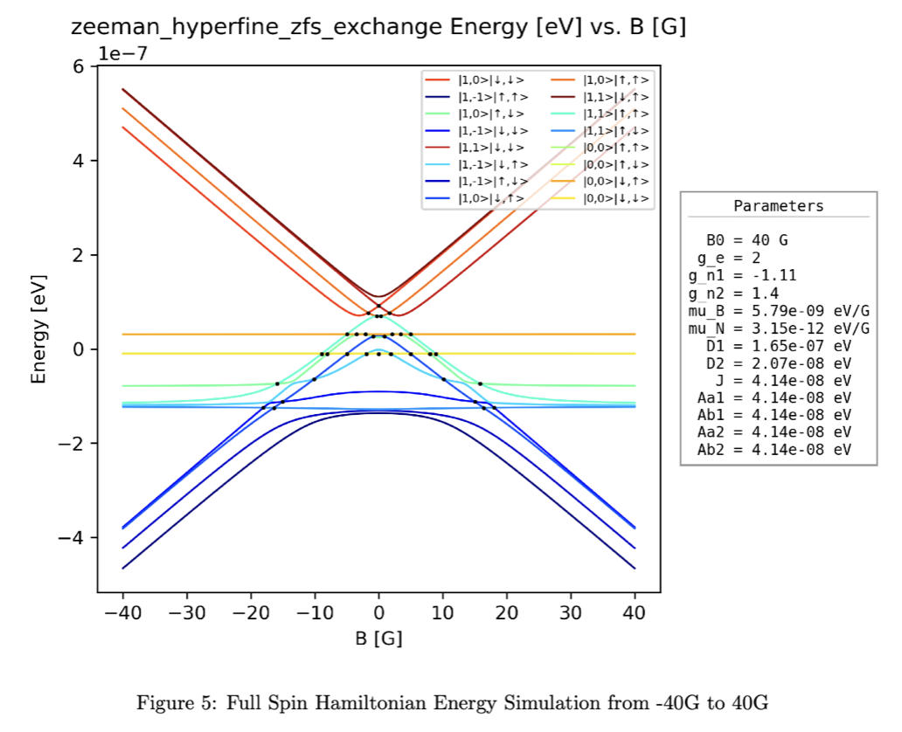
- Plot eigenspectra over B.

Shown above is the calculated Eigenspectra simulation for the full Spin Hamiltonian. Previous dissertations using MATLAB were only capable of performing the Zeeman + Hyperfine 16x16 eigensimulation. My script allows any combination of the four Spin Hamiltonian terms. Plots are shown here for more Hamiltonian combination simulations.

Objective 3 — Solving the Stochastic Liouville Equation

This objective involves solving

for the previously calculated 16x16 Spin Hamiltonian to get an expression for the density matrix $ρ(B)$ as a function of B. A complete description of how this was accomplished is shown here.
~Weeks 4-5
We simplify the above problem into Sylvester Form via
$$Aρ+ρA^{†}+g=0$$
where
$$A=-\frac{i}{ℏ}H-\frac{1}{2}(k_{S}+k_{D})Λ_{S}-\frac{1}{2}k_{D}Λ_{T},g=-\frac{1}{16}pΓ.$$
An exact solution for $ρ$ is known,
$$ρ=∫_{0}^{∞}e^{-iAt}ge^{iA^{†}t}dt.$$
However, numerical implementations rely on matrix operations. Hence, we vectorize the above Sylvester equation into a linear system of 256 equations:

$$(I⊗A+A^{†}⊗I)vec(ρ)=-vec(g).$$

where $(I⊗A+A^{†}⊗I)∈C^{256×256}$ is a 256x256 matrix. This equation can be solved with any dense solver. I use NumPy’s np.linalg.solve routine with Fortran column-major ordering. Afterwards I un-vectorize the 256x1 column vector back into a 16x16 numerical matrix.
$$0=-\frac{i}{ℏ}[H,ρ]-\frac{k}{2}\{Λ,ρ\}+pΓ.$$

Therefore, from solving the above equation for any B value, we get $ρ(B)$, the density matrix describing the full spin-ensemble at that B value. If we repeat this calculation over every B from say, -100G to 100G (like in EDMR), we would know a complete description of the state of 4H-SiC at every moment.
Note* This is a numerical solve, solving $ρ(B)$ symbolically from the SLE is near-impossible, as it easily includes millions of symbolic expressions. We still get a complete description though.

Objective 4 — Simulating EDMR and Fitting

This objective is half-complete. Simulating EDMR is finished, but fitting to determine the correct Hyperfine + ZFS + Exchange constants is difficult and ongoing. I will cover what I have done so far.
~ Weeks 6 - ongoing
We now have an expression for $ρ(B)$, capable of determining the density matrix for all B. Taking the trace with the singlet projector, $Tr(Λ_{S}ρ(B))$, gives us the singlet population as a function of B. Because the singlet-population is directly proportional to current (as only singlets can undergo recombination), our model of EDMR and NZFMR can be described via

$$I(nA)=ATr(Λ_{S}ρ(B))+I_{0}.$$

$A\text{and}I_{0}$ are proportionality constants to be determined from fitting. However, this has been done in past dissertations. What hasn’t been done is a full resonance-to-resonance EDMR model. This adds a rotating-wave approximation (RWA) term of $hω$ along with the lock-in modulation, both of which are difficult to simulate. I did this though, and have a full EDMR/NZFMR model given by the equation above with the modified Hamiltonian — and hence density matrix — after solving the Stochastic Lioville Equation.
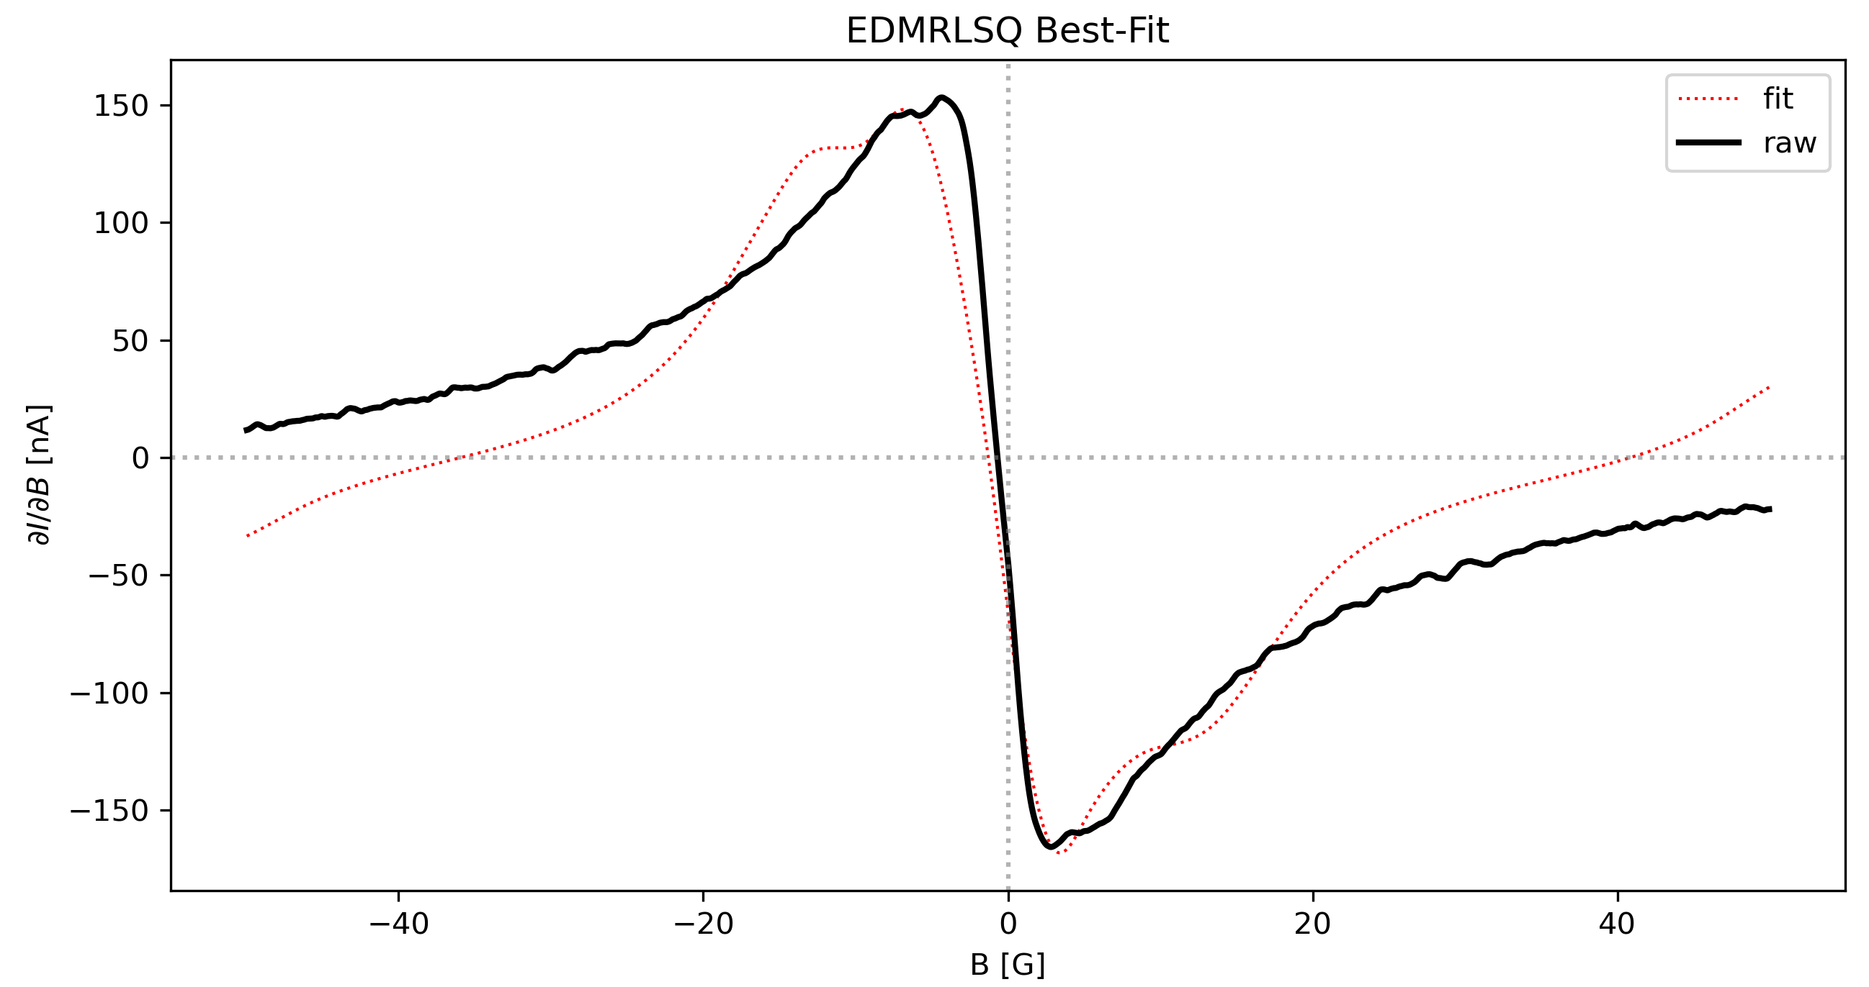
All that is left, is to generate an optimal fitting against real EDMR data, with the same experimental parameters (Bias voltage, Modulation Amplitude, and the Hamiltonian parameters). This is where I am now. An example least-squares fitting of just the central zero-field from an EDMR simulation is shown below. This will be improved upon by an MCMC fit afterwards.

