|  |  |
| --- | --- |
|  |  |

Faculty of Technology and Engineering

## U & P U. Patel Department of Computer Engineering

Date: 11 / 3 / 2022

## Practical List

|  |  |  |  |  |  |
| --- | --- | --- | --- | --- | --- |
| Academic Year | : | 2021-22 | Semester | : | 4 |
| Course code | : | CE259 | Course name | : | Programming in Python |

**Note: Practical List is for Students. We need to cover concept require to implement respective practical**

* ***AIM:***

You are given n words. Some words may repeat. For each word, output its number of occurrences. The output order should correspond with the input order of appearance of the word. See the sample input/output for clarification.

# * CODE & OUTPUT:

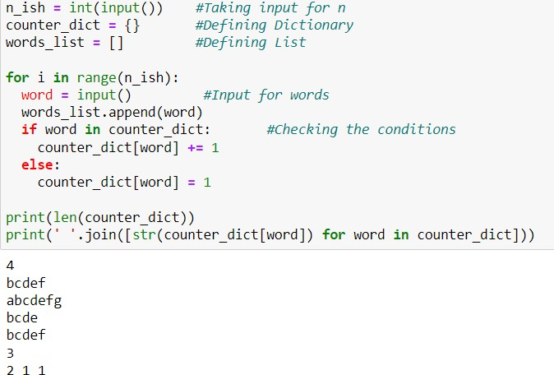

***Software used:*** Anaconda

# * CONCLUSION:

[Python Dictionary](https://www.geeksforgeeks.org/python-dictionary/) is like a map that is used to store data in the form of a key:value pair. Python provides various in-built functions to deal with dictionaries.

Lists are just like dynamically sized arrays, declared in other languages (vector in C++ and ArrayList in Java). Lists need not be homogeneous always which makes it the most powerful tool in [Python](https://www.geeksforgeeks.org/python-programming-language/). A single list may contain DataTypes like Integers, Strings, as well as Objects. Lists are mutable, and hence, they can be altered even after their creation.