|  |  |
| --- | --- |
|  |  |

Faculty of Technology and Engineering

# U & P U. Patel Department of Computer Engineering

# Practical List

|  |  |  |  |  |  |
| --- | --- | --- | --- | --- | --- |
| Academic Year | : | 2021-22 | Semester | : | 4 |
| Course code | : | CE259 | Course name | : | Programming in Python |

**Note: Practical List is for Students. We need to cover concept require to implement respective practical**

* ***AIM:***

You are given a string and your task is to swap cases. In other words, convert all lowercase letters to uppercase letters and vice versa.

Sample Input: HackerRank.com presents "Pythonist 2". Sample Output: hACKERrANK.COM PRESENTS "pYTHONIST 2".

* ***CODE & OUTPUT:***

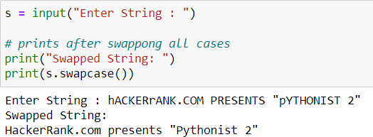

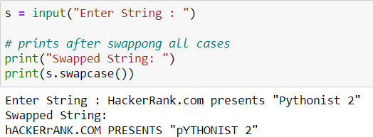

* ***CONCLUSION:***

I have learnt how to use function of swapping the case of the String.

The string swapcase() method converts all uppercase characters to lowercase and vice versa of the given string, and returns it.

## Syntax:

string_name.swapcase()

Here string_name is the string whose cases are to be swapped.

## Parameter:

The swapcase() method does not takes any parameter.

## Return value:

The swapcase() method returns a string with all the case s changed.