|  |  |
| --- | --- |
|  |  |

Faculty of Technology and Engineering

## U & P U. Patel Department of Computer Engineering

Date: 15 / 03 / 2022

## Practical List

|  |  |  |  |  |  |
| --- | --- | --- | --- | --- | --- |
| Academic Year | : | 2021-22 | Semester | : | 4 |
| Course code | : | CE259 | Course name | : | Programming in Python |

**Note: Practical List is for Students. We need to cover concept require to implement respective practical**

# * AIM:

Write a Program in Python to implement a Stack Data Structure using Class and Objects, with push, pop, and traversal method.

# * CODE & OUTPUT:

# Aim: Write a Program in Python to implement a Stack Data Structure using Class and Objects,

# With push, pop, and traversal method. # Stack implementation in python

# Creating a stack def create stack():

stack = [] return stack

# Creating an empty stack def check_empty(stack):

return len(stack) == 0

# Adding items into the stack def push(stack, item):

stack.append(item) print("pushed item: " + item)

# Removing an element from the stack

def pop(stack):

if (check_empty(stack)): return "stack is empty"

return stack.pop()

stack = create_stack() push(stack, str(1)) push(stack, str(2)) push(stack, str(3)) push(stack, str(4))

print("popped item: " + pop(stack))

print("stack after popping an element: " + str(stack))

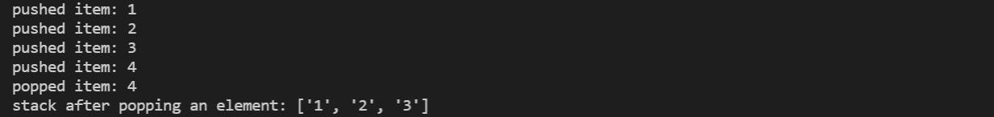

***Software used:*** VS CODE

# * CONCLUSION:

A stack is a linear data structure that stores items in a Last-In/First-Out (LIFO) or First-In/Last-Out (FILO) manner. In stack, a new element is added at one end and an element is removed from that end only. The insert and delete operations are often called push and pop.