Department of Computer Technology
Vision Statement of the Department.
To be a preferred hub for nurturing computer engineering aspirants through innovative, ethical, value-based technical education, impactful research, and industry collaboration, to become successful professionals contributing for the betterment of society.
Mission Statement of the Department.
To nurture computer engineering professionals by offering Dynamic learning environment that encourages problem-solving using emerging technology, National Education Policy aligned evidence-based technical education, fostering ,innovation, research, and industry–institute collaboration & Holistic, ethical and sustainable development for lifelong success.

Session 2026-2027

Vision:Dream of where you want. | Mission: Means to achieve Vision

Program Educational Objectives of the program (PEO): (broad statements that describe the professional and career accomplishments)
PEO1 | Preparation | P: Preparation | Pep-CL abbreviation
PEO2 | Core Competence | E: Environment  (Learning Environment) | pronounce as Pep-si-lL  easy to recall
PEO3 | Breadth | P: Professionalism | pronounce as Pep-si-lL  easy to recall
PEO4 | Professionalism | C: Core Competence | pronounce as Pep-si-lL  easy to recall
PEO5 | Learning Environment | L: Breadth (Learning in diverse areas) | pronounce as Pep-si-lL  easy to recall

Program Outcomes (PO): (statements that describe what a student should be able to do and know by the end of a program)

Keywords of POs:
Engineering knowledge,Problem analysis, Design/development of solutions,Conduct Investigations of Complex Problems, Engineering Tool Usage, The Engineer and The World,Ethics, Individual and Collaborative Team work,Communication, Project Management and Finance, Life-Long Learning

PSO Keywords: Cutting edge technologies, Research

“I am an engineer, and I know how to apply engineering knowledge to investigate, analyse and design solutions to complex problems using tools for entire world following all ethics in a collaborative way with proper management skills throughout my life.” to contribute to the development of cutting-edge technologies and Research.

Integrity: I will adhere to the Laboratory Code of Conduct and ethics in its entirety.

Name and Signature of Student and Date
(Signature and Date in Handwritten)

Department of Computer Technology
Vision Statement of the Department.
To be a preferred hub for nurturing computer engineering aspirants through innovative, ethical, value-based technical education, impactful research, and industry collaboration, to become successful professionals contributing for the betterment of society.
Mission Statement of the Department.
To nurture computer engineering professionals by offering Dynamic learning environment that encourages problem-solving using emerging technology, National Education Policy aligned evidence-based technical education, fostering ,innovation, research, and industry–institute collaboration & Holistic, ethical and sustainable development for lifelong success.

Session | 2026-27 (ODD) |  | Course Name | Web Technology Lab
Semester | 3 |  | Course Code | 23CT1301
Roll No | 50 |  | Name of Student | Devashish Dhote
Practical Number |  | 4 - A
Course Outcome |  | - Understand various internet technologies.  - Design the web pages using HTML and CSS.  - Implement the XML technology to store the data.  - Develop the interactive web pages using JavaScript.
Aim |  | To explore the basics of JavaScript and its role in web development.
Problem Definition |  | Build a registration form (name, email, password, phone  number) and write JavaScript to validate all fields on submit, displaying inline error  messages
Theory  (100 words) |  | JavaScript is a programming language used to create dynamic content for websites. It is a lightweight, cross-platform, and single-threaded programming language. It's an interpreted language that executes code line by line, providing more flexibility.  - Client Side: On the client side, JavaScript works along with HTML and CSS. HTML adds structure to a web page, CSS styles it, and JavaScript brings it to life by allowing users to interact with elements on the page, such as actions on clicking buttons, filling out forms, and showing animations. JavaScript on the client side is directly executed in the user's browser.  - Server Side: On the Server side (on Web Servers), JavaScript is used to access databases, file handling, and security features to send  responses, to browsers.

Department of Computer Technology
Procedure and Execution (100 Words) | Step for Implementation:  - Open a text editor (VS Code, Notepad, Sublime, etc.).  - Create a file named practical4a.html.  - Write the standard HTML structure (<!DOCTYPE html>, <html>, <head>, <body>).  - Add input fields and a button to capture user data.  - Insert a <script> block with JavaScript functions to read inputs, validate them, and update page content dynamically using the DOM.  - Save the file and run it in a browser.  - Test by clicking the button and checking console output for validation results.
Procedure and Execution (100 Words) | Code:  <!DOCTYPE html>  <html>  <head>  <title>Form Validation</title>  <script>  function submitForm(e) {  e.preventDefault();  let uname = document.getElementById("uname").value.trim();  let uage = document.getElementById("uage").value;  let uemail = document.getElementById("uemail").value;  let upass = document.getElementById("upass").value;  let uphone = document.getElementById("uphone").value;  if (uname === "") {  alert("Name required");  return;  }  if (uage < 16 || uage > 60) {  alert("Age must be 16-60");  return;  }  if (!/^[^@]+@[^@]+\.[a-z]{2,}$/i.test(uemail)) {  alert("Invalid email");  return;

Vision Statement of the Department.
To be a preferred hub for nurturing computer engineering aspirants through innovative, ethical, value-based technical education, impactful research, and industry collaboration, to become successful professionals contributing for the betterment of society.
Mission Statement of the Department.
To nurture computer engineering professionals by offering Dynamic learning environment that encourages problem-solving using emerging technology, National Education Policy aligned evidence-based technical education, fostering ,innovation, research, and industry–institute collaboration & Holistic, ethical and sustainable development for lifelong success.

Department of Computer Technology
Vision Statement of the Department.
To be a preferred hub for nurturing computer engineering aspirants through innovative, ethical, value-based technical education, impactful research, and industry collaboration, to become successful professionals contributing for the betterment of society.
Mission Statement of the Department.
To nurture computer engineering professionals by offering Dynamic learning environment that encourages problem-solving using emerging technology, National Education Policy aligned evidence-based technical education, fostering ,innovation, research, and industry–institute collaboration & Holistic, ethical and sustainable development for lifelong success.
}
if (upass.length < 6) {
alert("Password too short");
return;
}
if (!/^[0-9]{10}$/.test(uphone)) {
alert("Phone must be 10 digits");
return;
}

alert("Form submitted successfully!");
}
</script>
</head>
<body>
<h3>Registration</h3>
<form onsubmit="submitForm(event)">
<input id="uname" placeholder="Name"><br>
<input id="uage" type="number" placeholder="Age"><br>
<input id="uemail" type="email" placeholder="Email"><br>
<input id="upass" type="password" placeholder="Password"><br>
<input id="uphone" placeholder="Phone"><br>
<button type="submit">Submit</button>
</form>
</body>
</html>

Department of Computer Technology
Output:

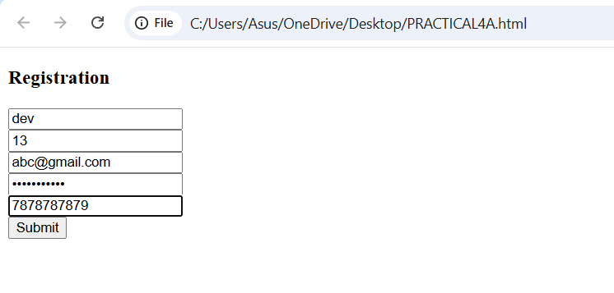
Output Analysis | Initial State: The browser displays multiple input boxes for different information.  - On Button Click (Valid Input): It takes the input entered in the fields and validates them. If all input are valid it displays a “Successfully submitted” message as shown in picture 2.  - On Button Click (Empty Input or Invalid input): If the field is left empty or the input provided is not in a valid format it displays an error as shown in picture 1.

Vision Statement of the Department.
To be a preferred hub for nurturing computer engineering aspirants through innovative, ethical, value-based technical education, impactful research, and industry collaboration, to become successful professionals contributing for the betterment of society.
Mission Statement of the Department.
To nurture computer engineering professionals by offering Dynamic learning environment that encourages problem-solving using emerging technology, National Education Policy aligned evidence-based technical education, fostering ,innovation, research, and industry–institute collaboration & Holistic, ethical and sustainable development for lifelong success.

Department of Computer Technology
Vision Statement of the Department.
To be a preferred hub for nurturing computer engineering aspirants through innovative, ethical, value-based technical education, impactful research, and industry collaboration, to become successful professionals contributing for the betterment of society.
Mission Statement of the Department.
To nurture computer engineering professionals by offering Dynamic learning environment that encourages problem-solving using emerging technology, National Education Policy aligned evidence-based technical education, fostering ,innovation, research, and industry–institute collaboration & Holistic, ethical and sustainable development for lifelong success.
Link of student Github profile where lab assignment has been uploaded | https://github.com/devdhote20
Conclusion | The experiment successfully demonstrated client-side form validation using JavaScript. It verified user inputs, displayed appropriate alerts for errors, and ensured smooth submission when all conditions were met — showing how JavaScript enhances interactivity and reliability in web forms..
Plag Report (Similarity index < 12%) | 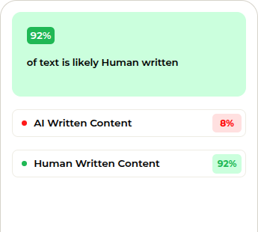
Date | 11/08/2026

