To be a preferred hub for nurturing computer engineering aspirants through innovative, ethical, value-based technical education, impactful research, and industry collaboration, to become successful professionals contributing for the betterment of society.
Mission Statement of the Department.
To nurture computer engineering professionals by offering Dynamic learning environment that encourages problem-solving using emerging technology, National Education Policy aligned evidence-based technical education, fostering ,innovation, research, and industry–institute collaboration & Holistic, ethical and sustainable development for lifelong success.

Session 2026-2027

Vision:Dream of where you want. | Mission: Means to achieve Vision

Program Educational Objectives of the program (PEO): (broad statements that describe the professional and career accomplishments)
PEO1 | Preparation | P: Preparation | Pep-CL abbreviation pronounce as Pep-si-lL easy to recall
PEO2 | Core Competence | E: Environment  (Learning Environment) | Pep-CL abbreviation pronounce as Pep-si-lL easy to recall
PEO3 | Breadth | P: Professionalism | Pep-CL abbreviation pronounce as Pep-si-lL easy to recall
PEO4 | Professionalism | C: Core Competence | Pep-CL abbreviation pronounce as Pep-si-lL easy to recall
PEO5 | Learning  Environment | L: Breadth (Learning in diverse areas) | Pep-CL abbreviation pronounce as Pep-si-lL easy to recall

Program Outcomes (PO): (statements that describe what a student should be able to do and know by the end of a program)
Keywords of POs:
Engineering knowledge,Problem analysis, Design/development of solutions,Conduct Investigations of Complex Problems, Engineering Tool Usage, The Engineer and The World,Ethics, Individual and Collaborative Team work,Communication, Project Management and Finance, Life-Long Learning

PSO Keywords: Cutting edge technologies, Research

“I am an engineer, and I know how to apply engineering knowledge to investigate, analyse and design solutions to complex problems using tools for entire world following all ethics in a collaborative way with proper management skills throughout my life.” to contribute to the development of cutting-edge technologies and Research.

Integrity: I will adhere to the Laboratory Code of Conduct and ethics in its entirety.

Name and Signature of Student and Date

(Signature and Date in Handwritten)

Name: Devashish Dhote
Date: 15/09/2026

To be a preferred hub for nurturing computer engineering aspirants through innovative, ethical, value-based technical education, impactful research, and industry collaboration, to become successful professionals contributing for the betterment of society.
Mission Statement of the Department.
To nurture computer engineering professionals by offering Dynamic learning environment that encourages problem-solving using emerging technology, National Education Policy aligned evidence-based technical education, fostering ,innovation, research, and industry–institute collaboration & Holistic, ethical and sustainable development for lifelong success.

Session | 2024-25 (ODD) | Course Name | Web Technology Lab
Semester | 3 | Course Code | 23CT1301
Roll No | 50 | Name of Student | Devashish Sharad Dhote

Practical Number | 2
Course Outcome | - Understand various internet technologies.  - Design the web pages using HTML and CSS.  - Implement the XML technology to store the data.  - Develop the interactive web pages using JavaScript.
Aim | Build a To-Do List web app where users can add,  delete, and mark tasks as complete, using vanilla JavaScript DOM methods only.
Problem Definition | Build a To-Do List web application using HTML, CSS and Vanilla JavaScript. The application should allow the user to enter a new task and add it to the task list. Each task must have a Complete button to mark the task as completed and a Delete button to remove it from the list. JavaScript DOM methods such as getElementById(), createElement(), textContent, appendChild(), addEventListener(), remove() and classList.toggle() should be used to dynamically create and manipulate the page elements. No external frameworks or libraries should be used.
Theory  (100 words) | The Document Object Model (DOM) is a programming interface that represents an HTML page as a tree of elements. JavaScript uses the DOM to read, modify, create and remove webpage elements dynamically. In this practical, getElementById() is used to find HTML elements, while .value reads user input. createElement() creates new elements and textContent adds text to them. appendChild() inserts the elements into the webpage. addEventListener() handles user actions such as button clicks. The remove() method deletes elements from the DOM. classList.toggle() adds or removes a CSS class to mark a task as completed.
Procedure and Execution  (100 Words) | Step for Implementation:  - Create a folder named TodoList in Visual Studio Code.  - Create two files: index.html and script.js.  - Design the basic To-Do List structure using HTML.  - Add an input box, Add Task button and empty task list.  - Link script.js with index.html.  - Use getElementById() to access the required HTML elements.  - Read the entered task using .value.  - Validate the input and display an alert for an empty task.  - Use createElement() and textContent to create a task.  - Use appendChild() to display it.  - Create Complete and Delete buttons dynamically.  - Use classList.toggle() to mark tasks complete and remove() to delete them.
To be a preferred hub for nurturing computer engineering aspirants through innovative, ethical, value-based technical education, impactful research, and industry collaboration, to become successful professionals contributing for the betterment of society.
Mission Statement of the Department.
To nurture computer engineering professionals by offering Dynamic learning environment that encourages problem-solving using emerging technology, National Education Policy aligned evidence-based technical education, fostering ,innovation, research, and industry–institute collaboration & Holistic, ethical and sustainable development for lifelong success.
Code:
Index.html
<!DOCTYPE html>
<html lang="en">
<head>
<meta charset="UTF-8">
<title>My To-Do List</title>
<link rel="stylesheet" href="style.css">
</head>
<body>
<h1>My To-Do List</h1>

<input type="text" id="taskInput" placeholder="Enter a task">
<button id="addBtn">Add Task</button>

<ul id="taskList"></ul>

<script src="script.js"></script>
</body>
</html>

style.css
body {
font-family: Arial, sans-serif;
text-align: center;
margin-top: 50px;
}

input {
padding: 8px;
width: 200px;
}

button {
padding: 8px 12px;
margin-left: 5px;
cursor: pointer;
}

li {
list-style: none;
margin: 10px 0;
}

.completed {
text-decoration: line-through;
color: gray;
}

script.js
const taskInput = document.getElementById("taskInput");
const addBtn = document.getElementById("addBtn");
const taskList = document.getElementById("taskList");

addBtn.addEventListener("click", function() {
const taskText = taskInput.value.trim();
if (taskText === "") return;

const li = document.createElement("li");
li.textContent = taskText;

const completeBtn = document.createElement("button");
completeBtn.textContent = "Complete";
completeBtn.style.backgroundColor = "green";
completeBtn.style.color = "white";
completeBtn.onclick = function() {
li.classList.toggle("completed");
};

const deleteBtn = document.createElement("button");
deleteBtn.textContent = "Delete";
deleteBtn.style.backgroundColor = "red";
deleteBtn.style.color = "white";
deleteBtn.onclick = function() {
taskList.removeChild(li);
};

li.appendChild(completeBtn);
li.appendChild(deleteBtn);
taskList.appendChild(li);
taskInput.value = "";
});

Output:

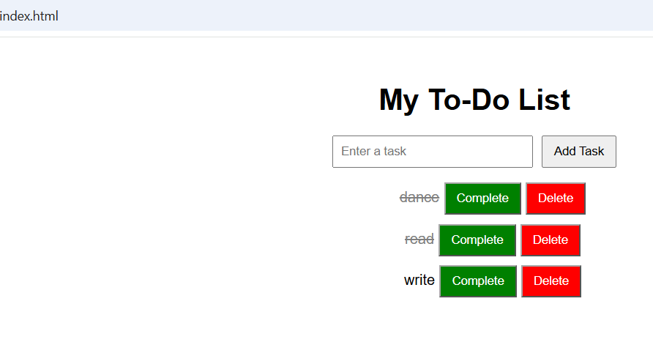
Output Analysis | The To-Do List application was successfully executed in the browser. A new task can be entered and added dynamically to the list. The Complete button marks a task as completed by applying the completed CSS class, which displays the task with a line-through effect. Clicking Complete again restores the normal appearance. The Delete button removes the selected task from the DOM. The input box is automatically cleared after adding a task. Thus, the required DOM manipulation operations are working correctly.
Link of student Github profile where lab assignment has been uploaded | https://github.com/devdhote20
Conclusion | Thus, the registration form was successfully developed using HTML, CSS and JavaScript. JavaScript was used to validate the input fields using conditional statements, loops and form validation. The program successfully displayed appropriate error messages for invalid inputs and showed “Registration Successful!” when all the entered details were valid.
Plag Report (Similarity index < 12%) | Not generated / not supplied
Date | 15/09/2026

