Department of Computer Technology
Vision Statement of the Department.
To be a preferred hub for nurturing computer engineering aspirants through innovative, ethical, value-based technical education, impactful research, and industry collaboration, to become successful professionals contributing for the betterment of society.
Mission Statement of the Department.
To nurture computer engineering professionals by offering Dynamic learning environment that encourages problem-solving using emerging technology, National Education Policy aligned evidence-based technical education, fostering ,innovation, research, and industry–institute collaboration & Holistic, ethical and sustainable development for lifelong success.

Session 2026-2027

Vision:Dream of where you want. | Mission: Means to achieve Vision

Program Educational Objectives of the program (PEO): (broad statements that describe the professional and career accomplishments)
PEO1 | Preparation | P: Preparation | Pep-CL abbreviation
PEO2 | Core Competence | E: Environment (Learning Environment) | pronounce as Pep-si-lL easy to recall
PEO3 | Breadth | P: Professionalism | pronounce as Pep-si-lL easy to recall
PEO4 | Professionalism | C: Core Competence | pronounce as Pep-si-lL easy to recall
PEO5 | Learning Environment | L: Breadth (Learning in diverse areas) | pronounce as Pep-si-lL easy to recall

Program Outcomes (PO): (statements that describe what a student should be able to do and know by the end of a program)

Keywords of POs:
Engineering knowledge,Problem analysis, Design/development of solutions,Conduct Investigations of Complex Problems, Engineering Tool Usage, The Engineer and The World,Ethics, Individual and Collaborative Team work,Communication, Project Management and Finance, Life-Long Learning

PSO Keywords: Cutting edge technologies, Research

“I am an engineer, and I know how to apply engineering knowledge to investigate, analyse and design solutions to complex problems using tools for entire world following all ethics in a collaborative way with proper management skills throughout my life.” to contribute to the development of cutting-edge technologies and Research.

Integrity: I will adhere to the Laboratory Code of Conduct and ethics in its entirety.

Name and Signature of Student and Date
(Signature and Date in Handwritten)

Department of Computer Technology
Vision Statement of the Department.
To be a preferred hub for nurturing computer engineering aspirants through innovative, ethical, value-based technical education, impactful research, and industry collaboration, to become successful professionals contributing for the betterment of society.
Mission Statement of the Department.
To nurture computer engineering professionals by offering Dynamic learning environment that encourages problem-solving using emerging technology, National Education Policy aligned evidence-based technical education, fostering ,innovation, research, and industry–institute collaboration & Holistic, ethical and sustainable development for lifelong success.

Session | 2024-25 (ODD) |  | Course Name | Web Technology Lab
Semester | 3 |  | Course Code | 23CT1301
Roll No | 50 |  | Name of Student | Devashish Sharad Dhote
Practical Number |  | 7
Course Outcome |  | - Understand various internet technologies.  - Design the web pages using HTML and CSS.  - Implement the XML technology to store the data.  - Develop the interactive web pages using JavaScript.
Aim |  | JavaScript — Asynchronous Programming (Fetch/Promises)
Problem Definition |  | Build a small Weather App or Movie-Search App that fetches data from ONE public API using fetch()/async-await and renders it dynamically.
Theory  (100 words) |  | Asynchronous JavaScript enables web applications to request external data without freezing the browser's execution thread. Modern applications rely on the fetch() API paired with async/await syntax, providing a clean, synchronous-looking structure to resolve asynchronous Promise objects. When a user triggers a query—such as searching for a movie title—an HTTP GET request is dispatched to a public REST API endpoint. Once the server delivers the JSON payload, the application parses the response and dynamically updates the Document Object Model (DOM).  This decouples the interface from server data, enabling real-time content rendering without requiring full page reloads.
Procedure and Execution (100 Words) |  | - Structure the HTML interface with an input field, search button, and an empty results container.  - Select these DOM elements in JavaScript and attach a click event listener to the search button.  - When triggered, the async function captures the search query and briefly displays a loading state.  - An HTTP GET request is dispatched to the public API using await fetch().  - The script halts execution until the server responds, checking for HTTP errors before parsing the payload via await

Department of Computer Technology
Vision Statement of the Department.
To be a preferred hub for nurturing computer engineering aspirants through innovative, ethical, value-based technical education, impactful research, and industry collaboration, to become successful professionals contributing for the betterment of society.
Mission Statement of the Department.
To nurture computer engineering professionals by offering Dynamic learning environment that encourages problem-solving using emerging technology, National Education Policy aligned evidence-based technical education, fostering ,innovation, research, and industry–institute collaboration & Holistic, ethical and sustainable development for lifelong success.
response.json().
- Using map(), the JSON array is transformed into HTML strings and injected into the DOM via innerHTML, while try...catch catches network failures.
CODE: | HTML:  <!DOCTYPE html>  <html>  <head>  <title>Weather App</title>  <link rel="stylesheet" href="style.css">  </head>  <body>  <h1>Weather App</h1>  <input type="text" id="cityInput"  placeholder="Enter city name">  <button id="searchButton"> Search  </button>  <div id="weatherResult"></div>  <script src="script.js"></script>  </body>  </html>  JS:  let cityInput = document.getElementById("cityInput"); let searchButton =  document.getElementById("searchButton"); let weatherResult = document.getElementById("weatherResult");  searchButton.addEventListener("click", function()  {  let city =

Department of Computer Technology
Vision Statement of the Department.
To be a preferred hub for nurturing computer engineering aspirants through innovative, ethical, value-based technical education, impactful research, and industry collaboration, to become successful professionals contributing for the betterment of society.
Mission Statement of the Department.
To nurture computer engineering professionals by offering Dynamic learning environment that encourages problem-solving using emerging technology, National Education Policy aligned evidence-based technical education, fostering ,innovation, research, and industry–institute collaboration & Holistic, ethical and sustainable development for lifelong success.
cityInput.value.trim(); if(city == "")
{
weatherResult.innerHTML = "<p>Please enter a city.</p>"; return;
}
getWeather(city);
});
async function getWeather(city)
{
weatherResult.innerHTML = "<p>Loading...</p>";
try
{
let geoUrl =
"https://geocoding-api.open-meteo.com/v1/search?name="
+ encodeURIComponent(city)
+ "&count=1";
let geoResponse = await fetch(geoUrl);
if(!geoResponse.ok)
{
throw new Error("Geocoding request failed");
}
let geoData =
await geoResponse.json(); if(!geoData.results)
{
weatherResult.innerHTML = "<p>City not found.</p>";

Department of Computer Technology
Vision Statement of the Department.
To be a preferred hub for nurturing computer engineering aspirants through innovative, ethical, value-based technical education, impactful research, and industry collaboration, to become successful professionals contributing for the betterment of society.
Mission Statement of the Department.
To nurture computer engineering professionals by offering Dynamic learning environment that encourages problem-solving using emerging technology, National Education Policy aligned evidence-based technical education, fostering ,innovation, research, and industry–institute collaboration & Holistic, ethical and sustainable development for lifelong success.
return;
}
let location = geoData.results[0]; let latitude = location.latitude; let longitude = location.longitude; let weatherUrl =
"https://api.open-meteo.com/v1/forecast"
+ "?latitude=" + latitude
+ "&longitude=" + longitude
+
"&current=temperature_2m,relative_humidity_2m,weather_code,win d_speed_10m";
let weatherResponse = await fetch(weatherUrl); if(!weatherResponse.ok)
{
throw new Error("Weather request failed");
}
let weatherData =

Department of Computer Technology
Vision Statement of the Department.
To be a preferred hub for nurturing computer engineering aspirants through innovative, ethical, value-based technical education, impactful research, and industry collaboration, to become successful professionals contributing for the betterment of society.
Mission Statement of the Department.
To nurture computer engineering professionals by offering Dynamic learning environment that encourages problem-solving using emerging technology, National Education Policy aligned evidence-based technical education, fostering ,innovation, research, and industry–institute collaboration & Holistic, ethical and sustainable development for lifelong success.
await weatherResponse.json(); let current = weatherData.current;
let temperature = current.temperature_2m; let humidity =
current.relative_humidity_2m; let windSpeed = current.wind_speed_10m;
let weatherCode = current.weather_code; weatherResult.innerHTML = "<h2>" + location.name + "</h2>" + "<p>Country: "
+ location.country + "</p>" + "<p>Temperature: "
+ temperature + " °C</p>" + "<p>Humidity: "
+ humidity + " %</p>" + "<p>Wind Speed: "
+ windSpeed + " km/h</p>" +

Department of Computer Technology
Vision Statement of the Department.
To be a preferred hub for nurturing computer engineering aspirants through innovative, ethical, value-based technical education, impactful research, and industry collaboration, to become successful professionals contributing for the betterment of society.
Mission Statement of the Department.
To nurture computer engineering professionals by offering Dynamic learning environment that encourages problem-solving using emerging technology, National Education Policy aligned evidence-based technical education, fostering ,innovation, research, and industry–institute collaboration & Holistic, ethical and sustainable development for lifelong success.
"<p>Weather Code: "
+ weatherCode + "</p>";
}
catch(error)
{
weatherResult.innerHTML =
"<p>Unable to fetch weather data.</p>"; console.log(error);
}
}
Output Analysis | The browser displays a dynamically updated weather report showing the requested city's name and country as a heading, followed by a list of current weather metrics: Temperature (in °C), Humidity (in %), Wind Speed (in km/h), and a numeric Weather Code. It also displays status messages like "Loading...", "Please enter a city.", or "City not found." based on user interaction.  

Department of Computer Technology
Vision Statement of the Department.
To be a preferred hub for nurturing computer engineering aspirants through innovative, ethical, value-based technical education, impactful research, and industry collaboration, to become successful professionals contributing for the betterment of society.
Mission Statement of the Department.
To nurture computer engineering professionals by offering Dynamic learning environment that encourages problem-solving using emerging technology, National Education Policy aligned evidence-based technical education, fostering ,innovation, research, and industry–institute collaboration & Holistic, ethical and sustainable development for lifelong success.
Link of student Github profile where lab assignment has been uploaded | https://github.com/devdhote20
Conclusion | This JavaScript code effectively demonstrates the core principles of asynchronous API integration and DOM manipulation. By chaining two separate API calls—first to resolve location coordinates and second to fetch the meteorological data—it successfully builds a functional, dynamic weather widget. While it serves as a solid foundation, implementing security best practices for DOM insertion, mapping raw API codes to user-friendly text, and enhancing input validation would elevate it from a basic script to a robust, production-ready application.
Plag Report (Similarity index < 12%) | 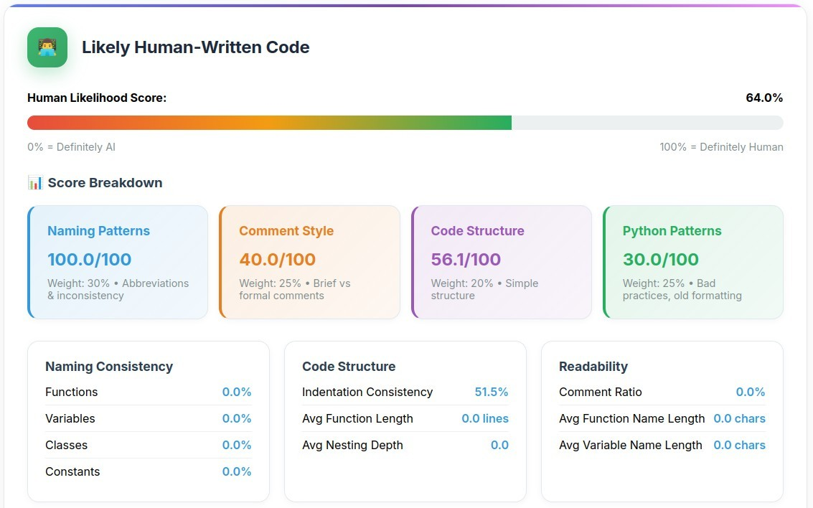
Date | 06/10/2026

