To be a preferred hub for nurturing computer engineering aspirants through innovative, ethical, value-based technical education, impactful research, and industry collaboration, to become successful professionals contributing for the betterment of society.
Mission Statement of the Department.
To nurture computer engineering professionals by offering Dynamic learning environment that encourages problem-solving using emerging technology, National Education Policy aligned evidence-based technical education, fostering ,innovation, research, and industry–institute collaboration & Holistic, ethical and sustainable development for lifelong success.

Session 2026-2027

Vision:Dream of where you want. | Mission: Means to achieve Vision

Program Educational Objectives of the program (PEO): (broad statements that describe the professional and career accomplishments)
PEO1 | Preparation | P: Preparation | Pep-CL abbreviation pronounce as Pep-si-lL easy to recall
PEO2 | Core Competence | E: Environment  (Learning Environment) | Pep-CL abbreviation pronounce as Pep-si-lL easy to recall
PEO3 | Breadth | P: Professionalism | Pep-CL abbreviation pronounce as Pep-si-lL easy to recall
PEO4 | Professionalism | C: Core Competence | Pep-CL abbreviation pronounce as Pep-si-lL easy to recall
PEO5 | Learning  Environment | L: Breadth (Learning in diverse areas) | Pep-CL abbreviation pronounce as Pep-si-lL easy to recall

Program Outcomes (PO): (statements that describe what a student should be able to do and know by the end of a program)
Keywords of POs:
Engineering knowledge,Problem analysis, Design/development of solutions,Conduct Investigations of Complex Problems, Engineering Tool Usage, The Engineer and The World,Ethics, Individual and Collaborative Team work,Communication, Project Management and Finance, Life-Long Learning

PSO Keywords: Cutting edge technologies, Research

“I am an engineer, and I know how to apply engineering knowledge to investigate, analyse and design solutions to complex problems using tools for entire world following all ethics in a collaborative way with proper management skills throughout my life.” to contribute to the development of cutting-edge technologies and Research.

Integrity: I will adhere to the Laboratory Code of Conduct and ethics in its entirety.

Name and Signature of Student and Date

(Signature and Date in Handwritten)

Name: Devashish Sharad Dhote
Date: 28/07/2026

To be a preferred hub for nurturing computer engineering aspirants through innovative, ethical, value-based technical education, impactful research, and industry collaboration, to become successful professionals contributing for the betterment of society.
Mission Statement of the Department.
To nurture computer engineering professionals by offering Dynamic learning environment that encourages problem-solving using emerging technology, National Education Policy aligned evidence-based technical education, fostering ,innovation, research, and industry–institute collaboration & Holistic, ethical and sustainable development for lifelong success.

Session | 2024-25 (ODD) | Course Name | Web Technology Lab
Semester | 3 | Course Code | 23CT1301
Roll No | 50 | Name of Student | Devashish Sharad Dhote

Practical Number | 3
Course Outcome | - Understand various internet technologies.  - Design the web pages using HTML and CSS.  - Implement the XML technology to store the data.  - Develop the interactive web pages using JavaScript.
Aim | To create and demonstrate the use of inline, internal, and external CSS for designing and styling a student registration form.
Problem Definition | To apply the three CSS styling approaches in a single HTML page and observe how inline, internal and externally linked styles can be used to control the appearance and alignment of a student registration form.
Theory  (100 words) | CSS (Cascading Style Sheets) is used to control the appearance and layout of HTML webpages. It can modify properties such as background color, text alignment, font style, size, and spacing. CSS can be applied in three ways: inline CSS is written directly inside an HTML element, internal CSS is placed within the <style> section of an HTML document, and external CSS is stored in a separate stylesheet and linked to the HTML file.
Procedure and Execution  (100 Words) | Step for Implementation:  1. Create an HTML file containing the student registration form.  2. Add an external CSS file and connect it to the HTML document using the <link> element.  3. Use internal CSS within the <style> tag to define suitable page styles.  4. Apply inline CSS directly to selected HTML elements to change their appearance.  5. Add the required registration fields along with Submit and Reset buttons.  6. Save both the HTML and CSS files and open the HTML file in a web browser.  7. Observe the effect of inline, internal, and external CSS on the webpage and verify the final layout.
To be a preferred hub for nurturing computer engineering aspirants through innovative, ethical, value-based technical education, impactful research, and industry collaboration, to become successful professionals contributing for the betterment of society.
Mission Statement of the Department.
To nurture computer engineering professionals by offering Dynamic learning environment that encourages problem-solving using emerging technology, National Education Policy aligned evidence-based technical education, fostering, innovation, research, and industry–institute collaboration & Holistic, ethical and sustainable development for lifelong success.
Code:
<!DOCTYPE html>
<html>
<head>
<title>Student Registration Form</title>
<style>
label1 {
text-align: center;
}

h2 {
font-size: 50px;
}
h2 {
text-align: center;
}
h2 {
text-shadow: 2px 2px 5px black;
}
h2 {
color: green;
}
label1 {
font-size: 20px;
}
label2 {
font-size: 20px;
}
label3 {
font-size: 20px;
}
label4 {
font-size: 20px;
}
label5 {
font-size: 20px;
}

form {
width: 1000px;
margin: 40px auto;
padding: 30px;
background: rgba(255,255,255,0.8);
border-radius: 15px;
box-shadow: 0 0 15px black;
text-align: center;
}

</style>
</head>
<body>
<form>

<h2>Student Registraion Form</h2>

<label>First Name:</label><br>
<input type="text" id="fname"><br><br>

<labe2>Last Name:</label2><br>
<input type="text" id="lname"><br><br>

<label3>Email:</label3><br>
<input type="email" id="email"><br><br>

<label4>Password:</label4><br>
<input type="password" id="password"><br><br>

<label5>Phone Number:</label5><br>
<input type="text" id="phone"><br><br>

</form>
<button type="Register">Register</button>

</body>
</html>

Output:
A Student Registration Form is displayed with a centered layout. The heading “Student Registration Form” appears in green, centered, with a large font size and a shadow effect. The form contains First Name, Last Name, Email, Password, and Phone Number fields. A Register button is displayed below the form.

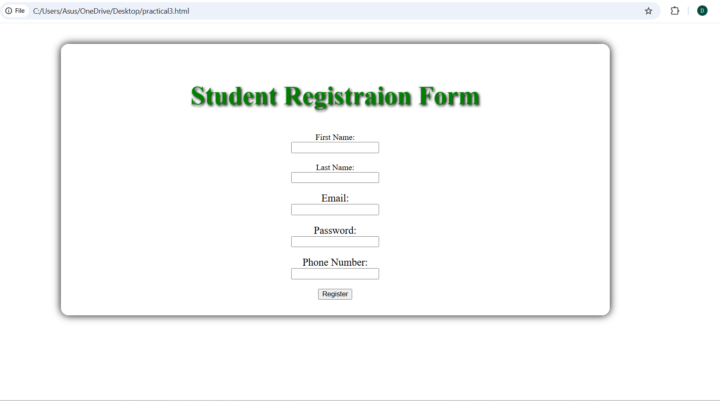
Output Analysis | The output demonstrates all three CSS methods. The inline style directly changes the heading, the internal stylesheet changes the body background and form alignment, and the external stylesheet is referenced through style.css. No CSS rules for style.css were supplied with the given code, so only the effects explicitly defined in the HTML can be verified from the provided implementation.
Link of student Github profile where lab assignment has been uploaded | https://github.com/devdhote20
Conclusion | The Student Registration Form was implemented using inline, internal and external CSS references. The practical demonstrated how CSS can be applied at different levels to control the appearance and layout of an HTML page.
Plag Report (Similarity index < 12%) | Not generated / not supplied
Date | 28/07/2026

