**Swasthik S Nettar**

**4NI19IS102**

**A SECTION**

**CI/CD PIPELINE**

Continuous integration (CI) and continuous delivery (CD), also known as CI/CD, embodies a culture, operating principles, and a set of practices that application development teams use to deliver code changes more frequently and reliably.

CI/CD allows organizations to ship software quickly and efficiently. CI/CD facilitates an effective process for getting products to market faster than ever before, continuously delivering code into production, and ensuring an ongoing flow of new features and bug fixes via the most efficient delivery method.

CI is a modern software development practice in which incremental code changes are made frequently and reliably. Automated build-and-test steps triggered by CI ensure that code changes being merged into the repository are reliable. The code is then delivered quickly and seamlessly as a part of the CD process. In the software world, the CI/CD pipeline refers to the automation that enables incremental code changes from developers’ desktops to be delivered quickly and reliably to production.

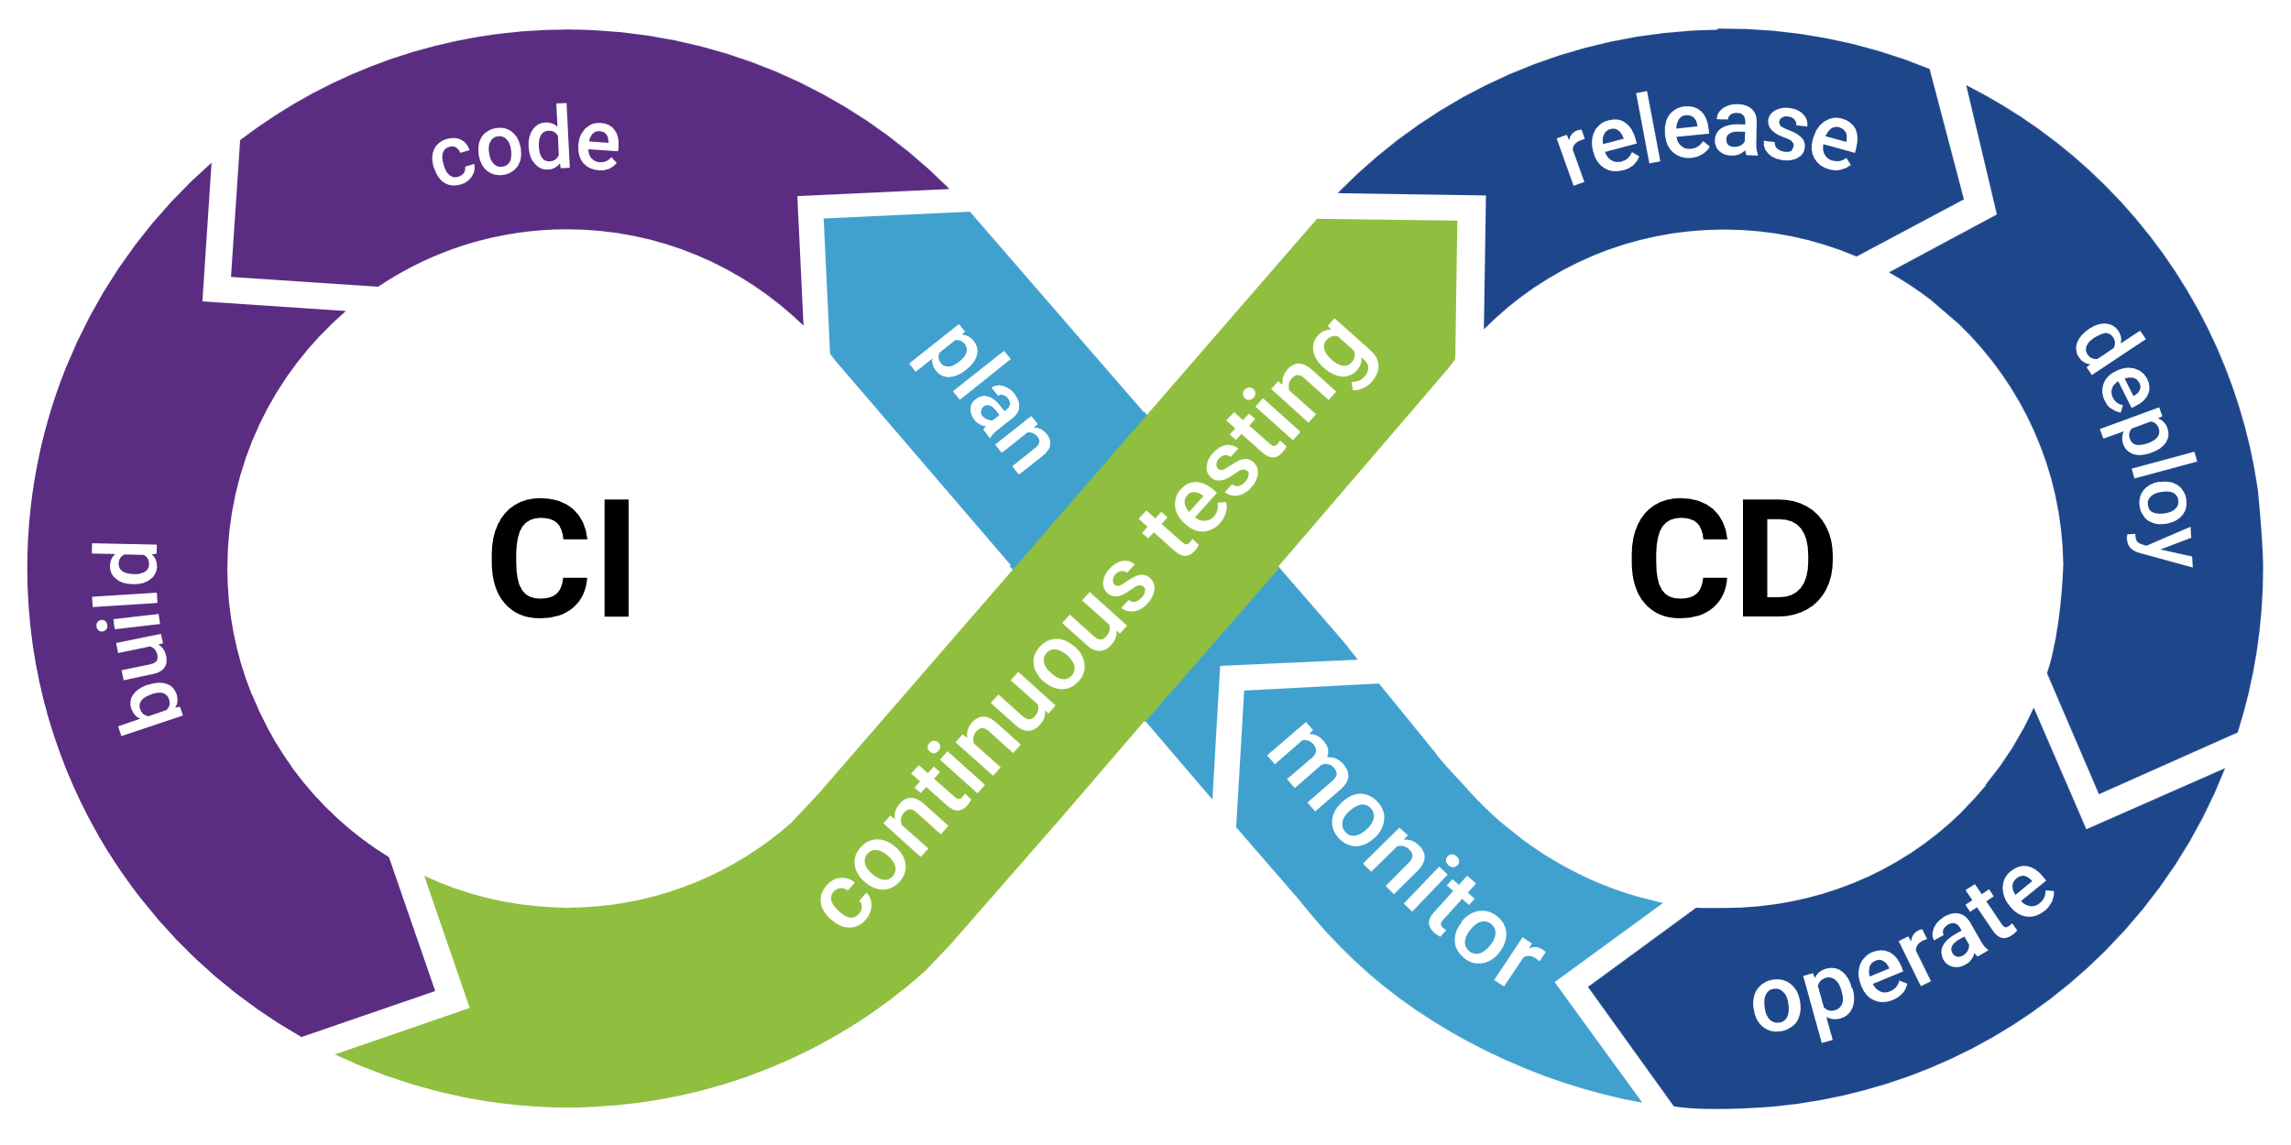

**How is CI/CD related to DevOps?**

DevOps is a set of practices and tools designed to increase an organization’s ability to deliver applications and services faster than traditional software development processes. The increased speed of DevOps helps an organization serve its customers more successfully and be more competitive in the market.

Continuous integration (CI) helps developers merge their code changes back to a shared branch. In continuous delivery, every stage—from the merger of code changes to the delivery of production-ready builds—involves test automation and code release automation. At the end of that process, the operations team is able to deploy an app to production quickly and easily.

The final stage of a mature CI/CD pipeline is continuous deployment. As an extension of continuous delivery, which automates the release of a production-ready build to a code repository, continuous deployment automates releasing an app to production.

**USES OF CI/CD**

CI/CD automates the process of integrating, releasing, and deploying software while removing traditional roadblocks.

CI/CD enables you to:

* **Ship software quickly and efficiently**
* **Increase productivity**
* **Reduce risk on delivery**
* **Incorporate user feedback faster**
* **Standardize processes**

**CI/CD TOOLS**

1. **Jenkins**

Jenkins is an automation server built to create a CI/CD environment for almost any combination of languages and repositories.

1. **CircleCI**

CircleCI is a CI/CD automation platform built with an emphasis on speed.

And many more….