**DevOps Assignment -1**

**CI/CD PIPELINE**

CI/CD (Continuous Integration / Continuous Deployment) is a software development practice that aims to make the software development process more efficient by automating the build, test, and deployment stages.

CI/CD allows organizations to ship software quickly and efficiently. CI/CD facilitates an effective process for getting products to market faster than ever before, continuously delivering code into production, and ensuring an ongoing flow of new features and bug fixes via the most efficient delivery method.

In a CI/CD workflow, developers commit their code changes to a version control system (such as Git) and the changes are automatically built, tested, and deployed to production. This allows for faster and more frequent software releases, as the team does not have to manually build and deploy the code each time a change is made.

CI/CD pipelines also help ensure that code changes do not introduce new bugs or regressions, as the automated build and test stages can catch issues before they are deployed to production.

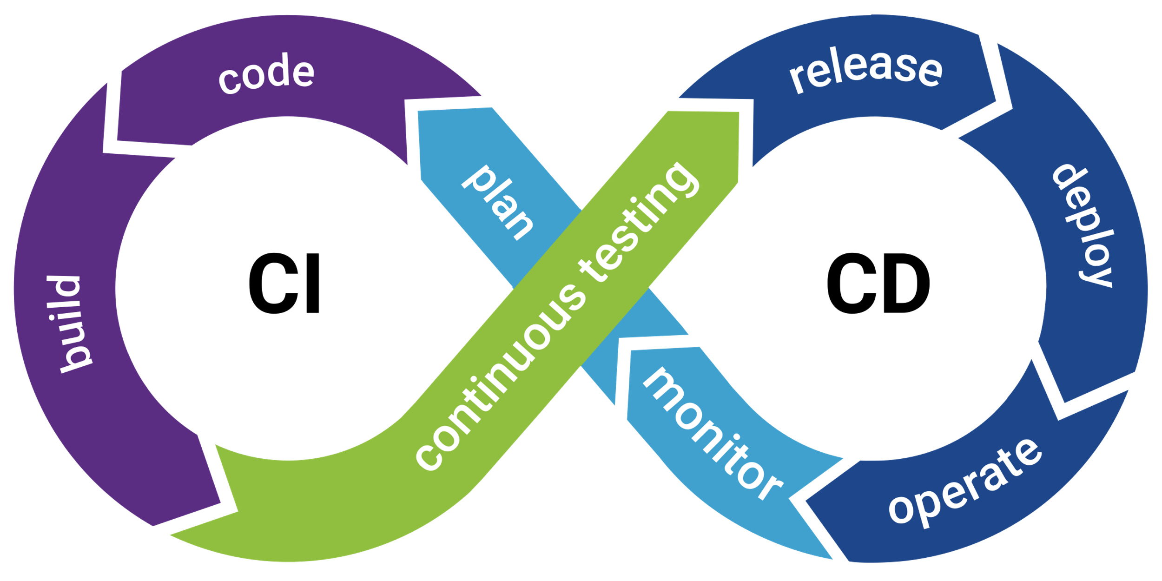

**How is CI/CD related to DevOps?**

DevOps is a set of practices and tools designed to increase an organization’s ability to deliver applications and services faster than traditional software development processes. The increased speed of DevOps helps an organization serve its customers more successfully and be more competitive in the market.

Continuous integration (CI) helps developers merge their code changes back to a shared branch. In continuous delivery, every stage—from the merger of code changes to the delivery of production-ready builds—involves test automation and code release automation. At the end of that process, the operations team is able to deploy an app to production quickly and easily.

The final stage of a mature CI/CD pipeline is continuous deployment. As an extension of continuous delivery, which automates the release of a production-ready build to a code repository, continuous deployment automates releasing an app to production.

**What are the uses of CI/CD ?**

The use of CI/CD helps teams deliver high-quality software faster and more reliably. CI/CD enables you to:

* **Ship software quickly and efficiently**
* **Increase productivity**
* **Reduce risk on delivery**
* **Incorporate user feedback faster**
* **Standardize processes**

**What are the CI/CD Tools Available?**

There are many tools available that can help teams implement a CI/CD workflow. Some common tools include:

1. Jenkins: An open-source automation server that can be used to automate tasks related to building, testing, and deploying software.
2. Travis CI: A cloud-based continuous integration service that can be used to build, test, and deploy software projects hosted on GitHub.
3. CircleCI: A cloud-based continuous integration and delivery platform that can automate the build, test, and deployment process for various languages and platforms.
4. GitLab CI/CD: A built-in continuous integration, delivery, and deployment tool that is part of the GitLab platform.

These tools can be configured to automatically build, test, and deploy code changes whenever a commit is made to the version control repository. They can also be configured to run tests and perform other tasks as part of the build process, such as linting the code or generating code coverage reports.

Overall, the use of CI/CD tools can help teams automate and streamline the software development process, allowing them to deliver high-quality software faster and more reliably.

**How CI/CD Pipeline works?**

Here is an example that illustrates the basic flow of a CI/CD pipeline:

1. Developer commits code changes to version control repository (e.g. Git).
2. CI/CD server (e.g. Jenkins) detects the code commit and triggers a build.
3. The CI/CD server retrieves the code from the version control repository and runs any necessary build tasks (e.g. compiling the code).
4. The CI/CD server runs automated tests to validate the code changes.
5. If the build and tests are successful, the CI/CD server deploys the code to a staging environment.
6. The code is manually reviewed and tested in the staging environment.
7. If the code passes review and testing, it is deployed to production.

This is just one example of a CI/CD pipeline, and there are many variations and additional steps that can be included depending on the specific needs of the project. The exact flow of a CI/CD pipeline will vary depending on the tools and processes that are used.