# After logging out from the app, the page does not refresh to the Landing page or Home page

**Environment -** https://buggy.justtestit.org/

**Steps**

1. Login to https://buggy.justtestit.org/ using a valid username and password
2. Navigate to the profile page
3. Click the Logout button

**Actual Results**

The user can log out but the profile page is not redirected to the landing page. It will keep staying on the same page (profile page) even after the user logs out. Please refer the attached image.

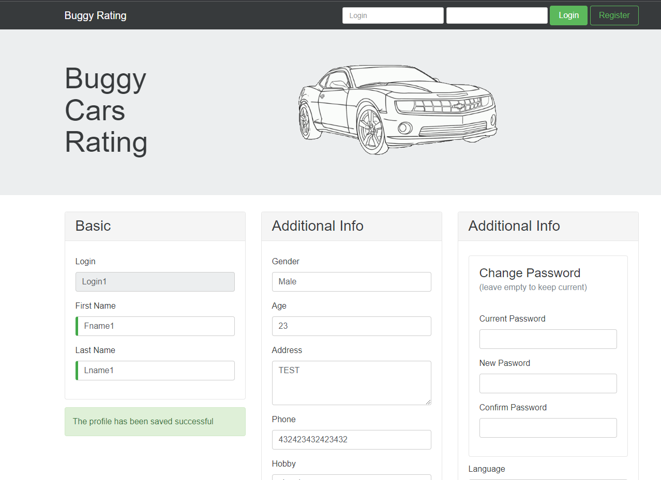

**Expected Results**

The system and the landing page or home page should be visible when the user is logged out.

**Priority - High**

# Cannot logout if a user is on the overall page

**Environment -** https://buggy.justtestit.org/

**Steps**

1. Log into https://buggy.justtestit.org/ using a valid username and password
2. Navigate to the Overall Rating page (Please refer to S-01)s
3. Press the logout button 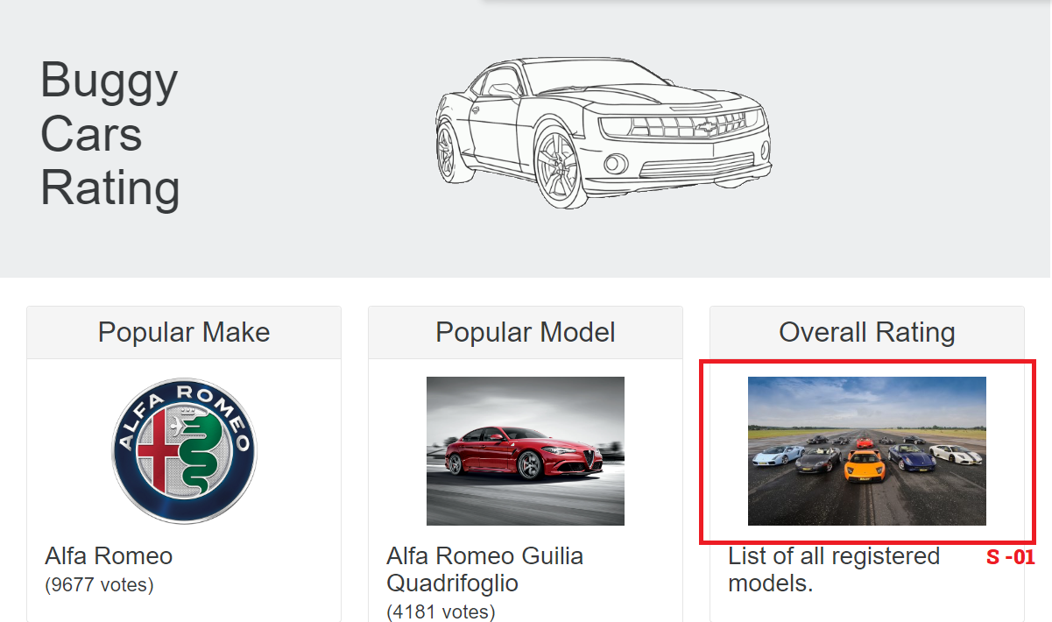

**Actual Results**

The user is not able to log out from the system when they press the logout button. The issue remains even when the page is refreshed.

**Expected results**

The user should be able to logout from the system

**Priority - High**

# Error Messages are not properly defined in Profile > Additional information column

**Environment -** <https://buggy.justtestit.org/>

**Steps**

1. Login to https://buggy.justtestit.org/ using a valid username and password
2. Navigate to the profile page
3. Add invalid data to the Gender and Age fields
4. Press the save button

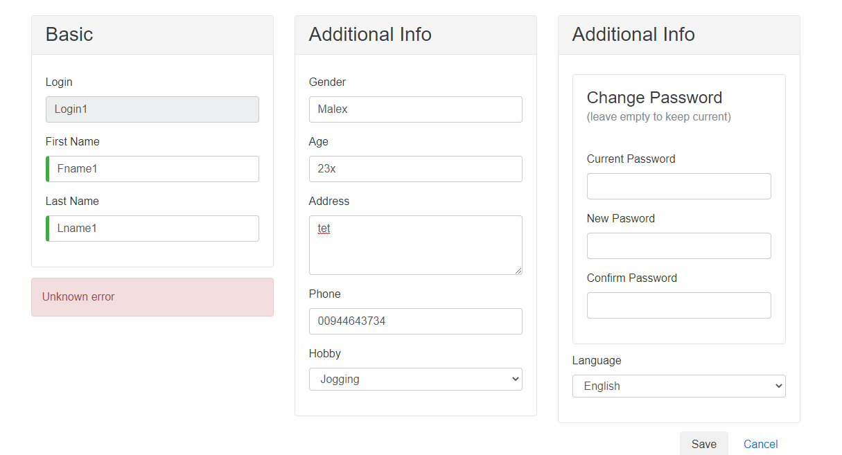

**Actual Results**

An error message displays in red and the user cannot identify what the error is.

**Expected results**

Error messages should be clear and informative

**Priority - Medium**