Introduction
The human T-cell leukemia virus type 1 (HTLV-1) is a neglected oncogenic retrovirus that primarily affects marginalized and isolated populations. After several decades of chronic infection, the virus is directly responsible for an aggressive form of T-cell lymphoma (ATLL, Adult T-cell Leukemia/Lymphoma) and several autoimmune disorders, particularly HTLV-1-associated myelopathy/tropical spastic paraparesis (HAM/TSP). (1) Moreover, even seemingly asymptomatic carriers (ACs) face a significantly higher risk of death from indirect complications. (2) (3) Although transmission has been controlled in some developed regions, HTLV-1 remains disattended across most of the global south. (4) (5) On top of that, HTLV-1 predominantly impacts rural populations with low genetic admixture and limited access to healthcare. (6) (7) (8) (9)
Efforts to identify high-risk ACs have centered on three key determinants: viral, host, and environmental factors. Among viral factors, the current HTLV-1 classification (e.g., Cosmopolitan [a–d], Japanese, West African) is based on LTR and env regions diversity, which aligns with geographical distribution but lacks clear ties to disease outcomes. Functional genomic differences are still controversial, with Tax A (Transcontinental) trending to high incidence of HAM/TSP, worse survival likelihood among ATLL cases and low cytotoxic activity compared to Tax B (Japanese). (10) (11) (12) (13) Clinically, proviral load and oligoclonality remain the most widely adopted viral prognostic markers, while emerging evidence suggests defective proviruses may contribute to immune evasion in ATLL progression. (14) (15) However, most findings have primarily been validated in Japanese cohorts, limiting their generalizability.
Host factors appear to play a central role in determining why only a small proportion (less than 10%) of ACs eventually develop ATLL or HAM/TSP. Early epidemiological observations—such as familial clustering and the disproportionate prevalence of HTLV-1-related diseases in specific ethnic populations—strongly suggest a genetic component influencing disease susceptibility. (16) (17) (18) Further supporting this, a recent meta-analysis identified specific human leukocyte antigen (HLA) alleles associated with either protection against HTLV-1 infection or modulation of disease progression. (19) Additionally, genomic and transcriptomic studies showed distinct age- and population-based differences (Western vs. Japanese cohorts), underscoring how host-pathogen interactions and genetic background influence HTLV-1-related disease susceptibility and severity. (20) (21)
Environmental factors, such as Strongyloides coinfection, have been linked to ATLL progression, although the underlying mechanisms remain unclear. South America (SA) has a high prevalence of both HTLV-1 and Strongyloides. Specifically, Peru is of particular interest due to its highest ATLL incidence and its Indigenous ancestry, which is the largest in the SA region. (22) (23) However, comprehensive genomic studies on HTLV-1-infected individuals in Peru remain limited. Our study aims to characterize the virological, immunological, and host genetic diversity of HTLV-1 infection using a high-throughput approach in Peruvian patients.

Methods

Population study and HTLV-1 confirmation
After obtaining informed consent, blood samples were collected from participants in the prospective HTLV-1 cohort at the Instituto de Medicina Tropical Alexander von Humboldt (Universidad Peruana Cayetano Heredia, Lima, Peru). The study was approved by the Ethics Committees of Universidad Peruana Cayetano Heredia, Miyazaki University, and Kagoshima University. All participants had previously been screened for HTLV-1 and confirmed positive by both enzyme-linked immunosorbent assay (ELISA) and PCR-based testing. DNA was extracted from peripheral blood mononuclear cells (PBMCs) using the Ficoll gradient technique. DNA concentration and purity were assessed using NanoDrop spectrophotometry, with samples meeting A260/A280 ratios of >1.8 considered suitable for sequencing.

NGS sequencing
Next-Generation Sequencing (NGS) Library preparation was performed using [kit name], following manufacturer’s protocol. Sequencing was conducted on Illumina Hiseq3000 with [read length] paired-end reads and an average depth of [X] per sample. Raw reads were first analyzed for quality and adapter removal using Fastp, then consensus HTLV-1 sequences were obtained using BWA MEM + IVAR and J02029.1 as reference sequence, with -t 0.8 and quality parameter pileup 20 in Samstool.
After targeted enriched NGS, sequence reads were trimmed, mapped, processed, and assembled with Fastp, BWA-MEM, Samtools, and IVAR, using J02029.1 as reference. Sequences with low-quality, duplicates or with < 60% pairwise identity were excluded. Filtered and curated HTLV-1 complete genomes were retrieved from NCBI (Accessed by January, 2024). MSA was performed by MAFFT using L-NS-i approach. Samples with less than 6000bp or pairwise identity less than 60% were excluded. (IRID011_S130, IRID038_S122, IRID040_S124, IRID067_S233) n=4. After MAFFT alignment. A three-partitions model was selected using ModelFinder and PartitionFinder. SRA and consensus sequences are available under the xxx Bioproject in NCBI (Accession Number). All the pipelines included in the present paper are published in a GitHub repository. (https://github.com/deve105/htlv_paper_2025)
ML consensus tree was obtained using RXAML after reaching coalescence with more than 5000 bootstraps. Cluster analysis and diversity were explored using ML, Bayesian, DAPC and Kmeans. Bayesian phylodynamic and phylogeographic analyses were performed using BEAST v2.7. For the ML consensus tree, identical sequences were excluded. Sequences were trimmed at 22 nucleotides in the 5’LTR and 13 in the 3’LTR.

Recombination analyses
Recombination was initially evaluated using the phi-test followed by a exploratory screening using RDP, GENECONV, Bootscan, MaxChi, SisCan and 3Seq and LARD, implemented in RDP4.5. Potential recombination was suspected when at least four methods showed a Bonferroni-corrected P-value threshold of 0.05(or smaller). Sequences with potential recombination signal were evaluated with GARD, implemented in Hyphy, and excluded from the final data set.

Integration Site Analysis

HLA Analysis
Following reads extraction from the chromosome 6, coverage and quality score analyses were performed for all HLA regions. High-resolution HLA typing was carried out using OptiType (2-field resolution for HLA-I) and HLA-LA (3-field resolution for HLA-I/II). Allotypes failing quality thresholds (score <0.8 or average coverage <20) were discarded. Results from both bioinformatics tools were pairwise compared, and considering the average coverage for HLA-II, only HLA-I was considered to further analysis. The concordances and Cohen’s Kappa between HLA-LA and Optitype were 93%, 85%, and 100% for HLA-A, HLA-B, and HLA-C, respectively. The HLA-LA pipeline was selected for further analyses.Hardy-Weinberg Equilibrium (HWE) was tested for each locus using the exact test implemented on the pegas package with 1000 replicates with a significance threshold of α=0.05. Pairwise FST was estimated using Weir & Cockerham’s (1984) method with 10,000 bootstrap replicates implemented on the package hierfstat. Significant differentiation was inferred when 95% CIs excluded zero. HLA class I allele frequencies were calculated after reduction to 2-field resolution using the reduceHlaCalls function from the package midasHLA. Frequencies for the Peruvian population were obtained using the function getHlaFrequencies and compared to the USA National Marrow Donor Program (NMDP) populations that were retrieved from Allele Frequency Net Database (http://www.allelefrequencies.net/). Evolutionary divergence of the human leucocyte antigen class I (HLA-I) genes was evaluated using the Grantham distance at HLA-A, HLA-B, and HLA-C. Grantham distance takes into account composition, polarity, and volume.

Results

Clinical and epidemiological features
A total of 67 patients with confirmed HTLV-1 infection were included in the study, comprising 10 HAM/TSP patients and 57 asymptomatic carriers (ACs). The lifetime Strongyloides infection rate was 56.7% overall and more frequent among males. No association was found between Strongyloides infection and HTLV-1-related complications. Demographic and epidemiological characteristics are detailed in Table 1. During the 5-year follow-up, the progression rate to ATL among ACs was 5.3% (3 cases). Notably, the 5-year mortality rate was 15%, although 12% of patients were lost to follow-up during COVID-19 pandemic. [*Proviral load data should be included in this paragraph*]

HTLV-1 genomics and phylogenomics features
A total of 71 DNA samples—corresponding to 67 patients (including 4 serial samples)—were analyzed. The median HTLV-1 genome coverage in the Peruvian cohort was 158x (IQR: 23-218); (Supplementary Figure 1). After excluding 4 samples with less than 5x coverage, the final dataset comprised 63 cases (Supplementary Figure 2). Among these, 3 cases (4.8%) harbored type II defective viruses (5’LTR-deleted; Figure 1A). Notably, 2 out of 3 ATL cases and 1 AC exhibited these deletions. No type I defective viruses were detected in this cohort. . The mean Oligoclonality Index (OCI) for the entire cohort was 0.21 (95% CI: 0.17–0.26). Five out of 57 samples showed an OCI greater than 0.5. Importantly, all cases that developed ATLL had an OCI greater than 0.6. No significant differences in OCI were observed regarding Strongyloides status (p-value = 0.63). The OCI was 0.91 (95% CI: 0.903–0.908) for ATLL, 0.14 (95% CI: 0.093–0.182) for HAM/TSP, and 0.19 (95% CI: 0.156–0.225) for ACs (Figure 1B). [*Correlation between PVL and IS abundance, and PVL with OCI, Additional reanalysis is pending*]
A total of 63 complete HTLV-1 genomes from Peru and 320 curated HTLV-1 genomes retrieved from NCBI were included (112 Brazilian, 1 Chilean, and 207 from other regions). After recombination screening using RDP4, SimPlot, and Bootscan, three sequences showed consistent recombination signals in at least 3 algorithms (KF797883, KY007245, KY007246), all of Brazilian origin, and were excluded from further phylogenetic analysis. Traditional genomic classification of the 63 Peruvian HTLV-1 isolates revealed that 61 (96.8%) belonged to the Cosmopolitan/Transcontinental (1a) subtype, while 2 (3.2%) were classified as African subtype (Black Peruvian). Particularly, both African subtype cases originated from the coastal region of Peru, were of mestizo ethnicity, and one individual presented with HAM/TSP. This distribution confirms the predominance of the Cosmopolitan subtype in the Andean region, with rare African subtype cases possibly representing more recent viral introductions.
The maximum likelihood consensus tree is presented in Figure 2. The majority of South American samples clustered within the Transcontinental (subtype 1a) clade, primarily in the Andean-Amazonian subgroup. However, 6 Peruvian cases (9.5%) fell outside the Andean-Amazonian subgroup, clustering instead with samples of worldwide origin, including isolates from Native Americans in Canada, Brazil, and Iran. A minority of Brazilian sequences (3.6%) clustered within the Japanese, potentially related to Japanese-descendant cases. Interestingly, one Peruvian sample (IRID034) showed direct phylogenetic relationship to the common Transcontinental ancestor, while two Peruvian isolates (IRID003 and IRID074) clustered separately from the Cosmopolitan subtype, showing closer genetic proximity to African subtypes. Interestingly, most HTLV-1-related complications were observed in sequences from Transcontinental subtype viruses, with no HAM/TSP cases observed within the Japanese clade among publicly available complete HTLV-1 genomes.
The unsupervised cluster analyses using the discriminant analysis of principal components consistently confirmed the existence of a well-defined clade in SA. [Pending to write]
Bayesian Analysis: The only calibration available was the assumption of contemporaneous sequences of African origin introduced during the early 1600. The structured coalescent analysis revealed an ancient origin of the SA clade. The divergence time estimation was 7409 (CI 5064 - 9020) YBP. (FIGURE 3)[Pending to have a good reference-time]

HLA-I diversity in the Peruvian HTLV-1 cohort
The Peruvian HTLV-1 cohort exhibited distinct HLA-I allele distributions, with A02:01 being the most frequent allele at the HLA-A locus (44%), followed by A24:02 (17%) and A68:01 (7%). The HLA-B locus showed equal frequencies for B35:01 and B35:05 (12% each), with B48:01 at 11%, while the HLA-C locus was dominated by C04:01 (29%), followed by C01:02 (18%) and C*07:02 (13%). Comparative analyses with the NMDP database and a Japanese HTLV-1 cohort revealed population-specific variations, with HLA-A and HLA-C conforming to Hardy-Weinberg equilibrium (p=0.06 and p=0.33, respectively), but HLA-B showing significant deviation (p=0.01), likely reflecting its well-documented role in balancing selection or cohort-specific demographic factors. Complete allele frequencies are detailed in Supplementary Table 1. The Peruvian and Japanese cohorts showed significant moderate genetic differentiation (mean FST = 0.047, 95% CI [0.023, 0.072]), consistent with population-specific HLA allele frequency distributions. No differences were observed in the outcome, proviral load, or OCI with respect to HLA subtype at either the nucleotide or amino acid level. Then, we aimed to explore HLA evolutionary divergence between Japanese and Peruvian HTLV-1 cases using an independent cohort from Miyazaki, considering that alleles diversity peptide-binding strongly affects immune response. Peruvian samples showed a reduced HLA global divergence but driven mainly by HLA-A. These differences may contribute to distinct patterns of HTLV-1 susceptibility or disease progression in the Peruvian population. Fewer dominant alleles may constrain immune responses to HTLV-1.
Suplementary Figure 1: NGS average coverage of HLA locus from the Peruvian HTLV-1 cohort and the Miyazaki-Japan HTLV-1 cohort.
Figure 4: Haplotype frequency for HLA-I alleles greater than 5% in the Peruvian HTLV-1 cohort compared to a) relevant populations from the NMDP database and b) the Miyazaki-Japan HTLV-1 cohort.

Genomic mutations in the HTLV-1 cohort.

Bibliography
1. Bangham CRM. HTLV-1 persistence and the oncogenesis of adult T cell leukemia/lymphoma. Blood [Internet]. 2023 Feb 17;blood.2022019332. Available from: https://ashpublications.org/blood/article/doi/10.1182/blood.2022019332/494602/HTLV-1-persistence-and-the-oncogenesis-of-adult-T
2. Schierhout G, McGregor S, Gessain A, Einsiedel L, Martinello M, Kaldor J. Association between HTLV-1 infection and adverse health outcomes: A systematic review and meta-analysis of epidemiological studies. The Lancet Infectious Diseases [Internet]. 2020;20(1):133–43. Available from: http://dx.doi.org/10.1016/S1473-3099(19)30402-5
3. Valcarcel B, Ampuero GS, Cruz-Ku G de la, Enriquez DJ, Malpica L. Outcomes of HTLV-1 Carriers with Diffuse Large B-Cell Lymphoma: A Single-Center Retrospective Matched Cohort Study. Clinical Lymphoma, Myeloma & Leukemia. 2022 Apr;22(4):251–9.
4. Nishijima T, Shimada S, Noda H, Miyake K. Towards the elimination of HTLV-1 infection in japan. The Lancet Infectious Diseases [Internet]. 2019 Jan 1;19(1):15–6. Available from: https://www.sciencedirect.com/science/article/pii/S1473309918307357
5. Martin F, Tagaya Y, Gallo R. Time to eradicate HTLV-1: An open letter to WHO. The Lancet [Internet]. 2018 May 12;391(10133):1893–4. Available from: https://www.sciencedirect.com/science/article/pii/S0140673618309747
6. Van Tienen C, De Silva TI, Alcantara LCJ, Onyango CO, Jarju S, Gonçalves N, et al. Molecular Epidemiology of Endemic Human T-Lymphotropic Virus Type 1 in a Rural Community in Guinea-Bissau. Kashanchi F, editor. PLoS Neglected Tropical Diseases [Internet]. 2012 Jun 12;6(6):e1690. Available from: https://dx.plos.org/10.1371/journal.pntd.0001690
7. Djuicy DD, Mouinga-Ondémé A, Cassar O, Ramassamy JL, Mamimandjiami AI, Bikangui R, et al. Risk factors for HTLV-1 infection in Central Africa: A rural population-based survey in Gabon. PLoS Neglected Tropical Diseases [Internet]. 2018 Oct 12;12(10):e0006832. Available from: https://pmc.ncbi.nlm.nih.gov/articles/PMC6200283/
8. Einsiedel L, Pham H, Talukder MR, Taylor K, Wilson K, Kaldor J, et al. Very high prevalence of infection with the human T cell leukaemia virus type 1c in remote Australian Aboriginal communities: Results of a large cross-sectional community survey. Matsuoka M, editor. PLOS Neglected Tropical Diseases [Internet]. 2021 Dec 8;15(12):e0009915. Available from: https://dx.plos.org/10.1371/journal.pntd.0009915
9. Ita F, Mayer EF, Verdonck K, Gonzalez E, Clark D, Gotuzzo E. Human t-lymphotropic virus type 1 infection is frequent in rural communities of the southern andes of peru. International Journal of Infectious Diseases. 2014;19(1):46–52.
10. Sakihama S, Morichika K, Saito R, Miyara M, Miyagi T, Hayashi M, et al. Genetic profile of adult t-cell leukemia/lymphoma in okinawa: Association with prognosis, ethnicity, and HTLV-1 strains. Cancer Science [Internet]. 2021 Mar;112(3):1300–9. Available from: https://www.ncbi.nlm.nih.gov/pmc/articles/PMC7935801/
11. Sakihama S, Saito M, Kuba-Miyara M, Tomoyose T, Taira N, Miyagi T, et al. Human t-cell leukemia virus type i Tax genotype analysis in okinawa, the southernmost and remotest islands of japan: Different distributions compared with mainland japan and the potential value for the prognosis of aggressive adult t-cell leukemia/lymphoma. Leukemia Research [Internet]. 2017 Oct 1;61:18–24. Available from: https://www.sciencedirect.com/science/article/pii/S0145212617304873
12. Sugata K, Takatori M, Reda O, Tan BJY, Tokunaga M, Sato T, et al. Effect of viral antigen mismatch on antiviral t-cell response and immunotherapeutic efficacy against adult t-cell leukemia/lymphoma. The Journal of Infectious Diseases [Internet]. 2025 Mar 15;231(3):816–21. Available from: https://doi.org/10.1093/infdis/jiae457
13. Furukawa Y, Yamashita M, Usuku K, Izumo S, Nakagawa M, Osame M. Phylogenetic subgroups of human t cell lymphotropic virus (HTLV) type i in the tax gene and their association with different risks for HTLV-iassociated myelopathy/tropical spastic paraparesis. The Journal of Infectious Diseases [Internet]. 2000 Nov 1;182(5):1343–9. Available from: https://doi.org/10.1086/315897
14. Katsuya H, Islam S, Tan BJY, Ito J, Miyazato P, Matsuo M, et al. The Nature of the HTLV-1 Provirus in Naturally Infected Individuals Analyzed by the Viral DNA-Capture-Seq Approach. Cell Reports [Internet]. 2019 Oct;29(3):724–735.e4. Available from: https://linkinghub.elsevier.com/retrieve/pii/S2211124719311933
15. Estrada-Grossmann JM, Alarcon-Braga E, Salazar-Valdivia F, Silvana-Jauregui A, Acurio K, Pacheco-Barrios N, et al. Risk factors for malignant progression to adult-t-cell leukemia/lymphoma in HTLV-1 carriers: A systematic review of cohort and case-control StudiesRisk factors for ATL in HTLV-1 carriers: review. Clinical Lymphoma Myeloma and Leukemia [Internet]. 2025 Apr 19; Available from: https://www.sciencedirect.com/science/article/pii/S2152265025001442
16. Iwanaga M, Watanabe T, Utsunomiya A, Okayama A, Uchimaru K, Koh KR, et al. Human t-cell leukemia virus type i (HTLV-1) proviral load and disease progression in asymptomatic HTLV-1 carriers: A nationwide prospective study in japan. Blood [Internet]. 2010 Aug 26;116(8):1211–9. Available from: https://doi.org/10.1182/blood-2009-12-257410
17. Alvarez C, Gotuzzo E, Vandamme AM, Verdonck K. Family aggregation of human t-lymphotropic virus 1-associated diseases: A systematic review. Frontiers in Microbiology [Internet]. 2016 Oct 28;7. Available from: https://www.frontiersin.orghttps://www.frontiersin.org/journals/microbiology/articles/10.3389/fmicb.2016.01674/full
18. Adams SV, Newcomb PA, Shustov AR. Racial patterns of peripheral t-cell lymphoma incidence and survival in the united states. Journal of Clinical Oncology [Internet]. 2016 Mar 20;34(9):963–71. Available from: https://ascopubs.org/doi/10.1200/JCO.2015.63.5540
19. Mardi S, Rashidian M, Bastan F, Molaverdi G, Mozhgani SH. The role of human leukocyte antigen in HTLV-1 infection and progression to ATLL and HAM/TSP: a systematic review and meta-analysis. Virology Journal. 2025 Jan 20;22(1):13.
20. Myers CS, Williams E, Cornejo CB, Pongas G, Toomey NL, Sanches JA, et al. Distinctive genomic features of human T-lymphotropic virus type 1-related adult T-cell leukemia-lymphoma in Western populations. Haematologica [Internet]. 2024 Aug 8;109(12):4021–39. Available from: https://haematologica.org/article/view/haematol.2024.285233
21. Luchtel RA, Zhao Y, Aggarwal RK, Pradhan K, Maqbool SB. ETS1 is a novel transcriptional regulator of adult T-cell leukemia/lymphoma of North American descent. Blood Advances. 2022 Oct 25;6(20):5613–24.
22. Homburger JR, Moreno-Estrada A, Gignoux CR, Nelson D, Sanchez E, Ortiz-Tello P, et al. Genomic Insights into the Ancestry and Demographic History of South America. PLoS genetics. 2015 Dec;11(12):e1005602.
23. Malpica L, Idrobo H, Pavlovsky A, Miranda ECM, Castro D, Beltran B, et al. Epidemiology, clinical features, and outcomes of peripheral t-cell lymphoma in latin america: An international, retrospective, cohort study. The Lancet Haematology [Internet]. 2025 Apr 1;12(4):e258–68. Available from: https://www.thelancet.com/journals/lanhae/article/PIIS2352-3026(25)00011-0/abstract

Variable | OverallN = 64 (100.0%)¹ | Strongyloides (-)N = 26 (40.6%)¹ | Strongyloides (+)N = 38 (59.4%)¹ | p-value²
Sex |  |  |  | 0.13
Female | 35 (56%) | 17 (68%) | 18 (49%)
Male | 27 (44%) | 8 (32%) | 19 (51%)
Age(years) | 49 (39, 54) | 49 (38, 54) | 50 (39, 54) | 0.8
Birthplace |  |  |  | 0.4
Amazonian region | 2 (3.6%) | 0 (0%) | 2 (6.1%)
Andean region | 22 (39%) | 8 (35%) | 14 (42%)
Coastal region | 32 (57%) | 15 (65%) | 17 (52%)
Disease outcome |  |  |  | <0.001
Asymptomatic carriers | 51 (80%) | 15 (58%) | 36 (95%)
ATLL | 3 (4.7%) | 2 (7.7%) | 1 (2.6%)
HAM/TSP | 10 (16%) | 9 (35%) | 1 (2.6%)
5-year mortality rate |  |  |  | 0.5
Alive | 50 (85%) | 19 (79%) | 31 (89%)
Death | 9 (15%) | 5 (21%) | 4 (11%)
¹n (%); Median (Q1, Q3)
²Pearson's Chi-squared test; Wilcoxon rank sum test; Fisher's exact test
Table 1. Demographic and epidemiological features of the HTLV-1 Peruvian Cohort
Figure 1. Whole HTLV-1 coverage
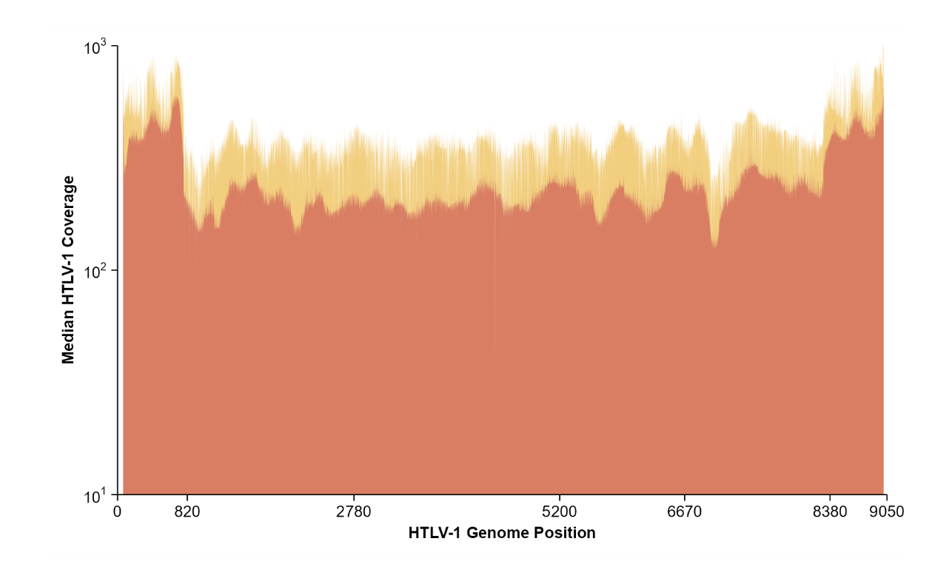
Figure 1B. Defective type II HTLV-1 virus in the Peruvian cohort.
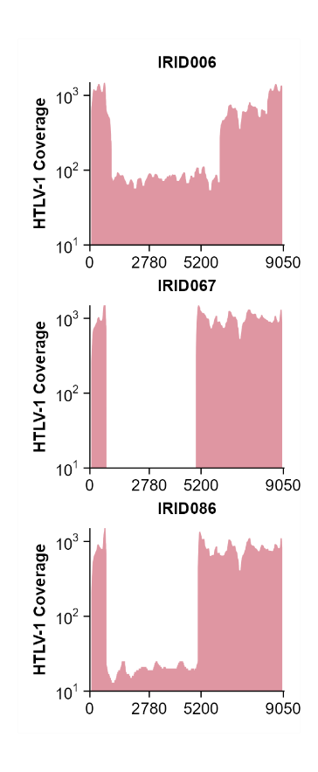
Figure 1C. Oligoclonatily Index (Gini’s Index) by disease outcome at the end of the cohort.
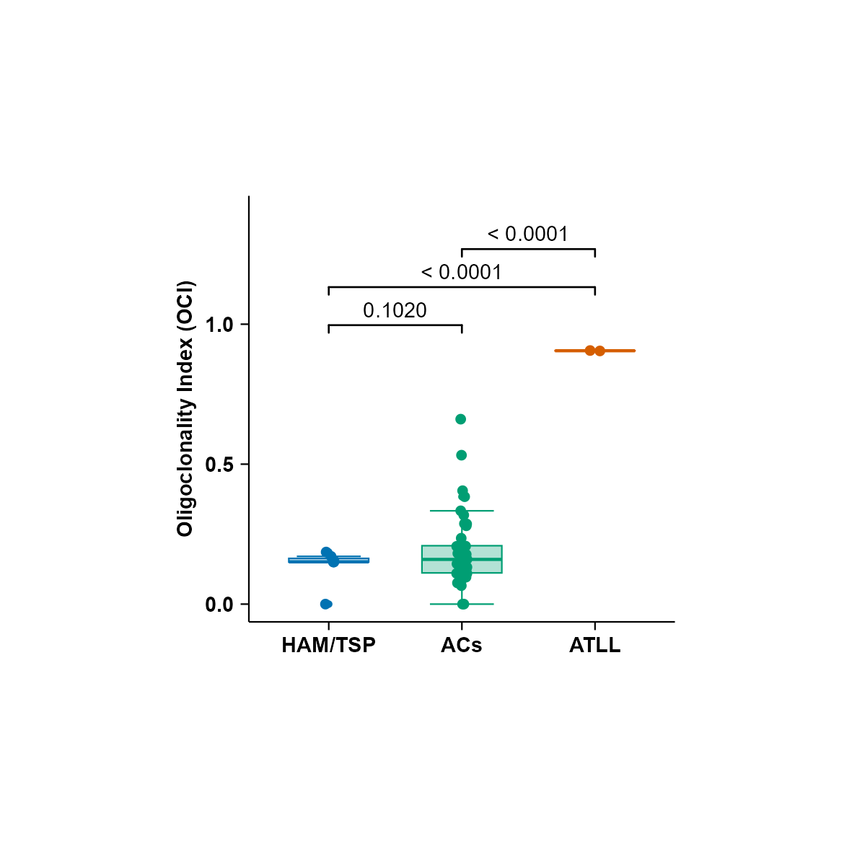

Figure 1D.
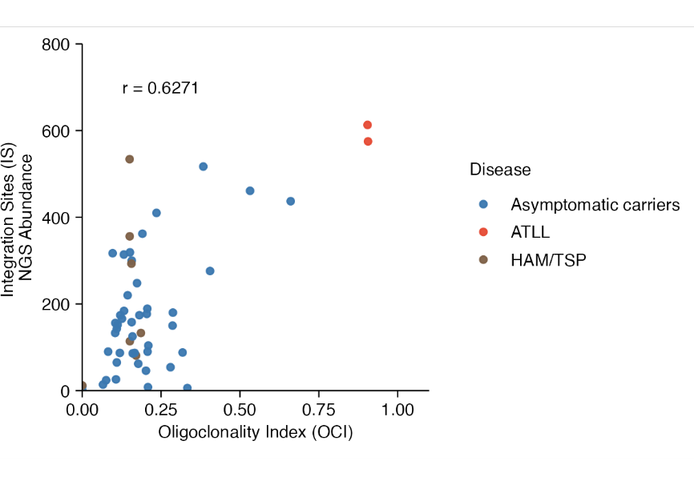

Figure 2. ML Tree
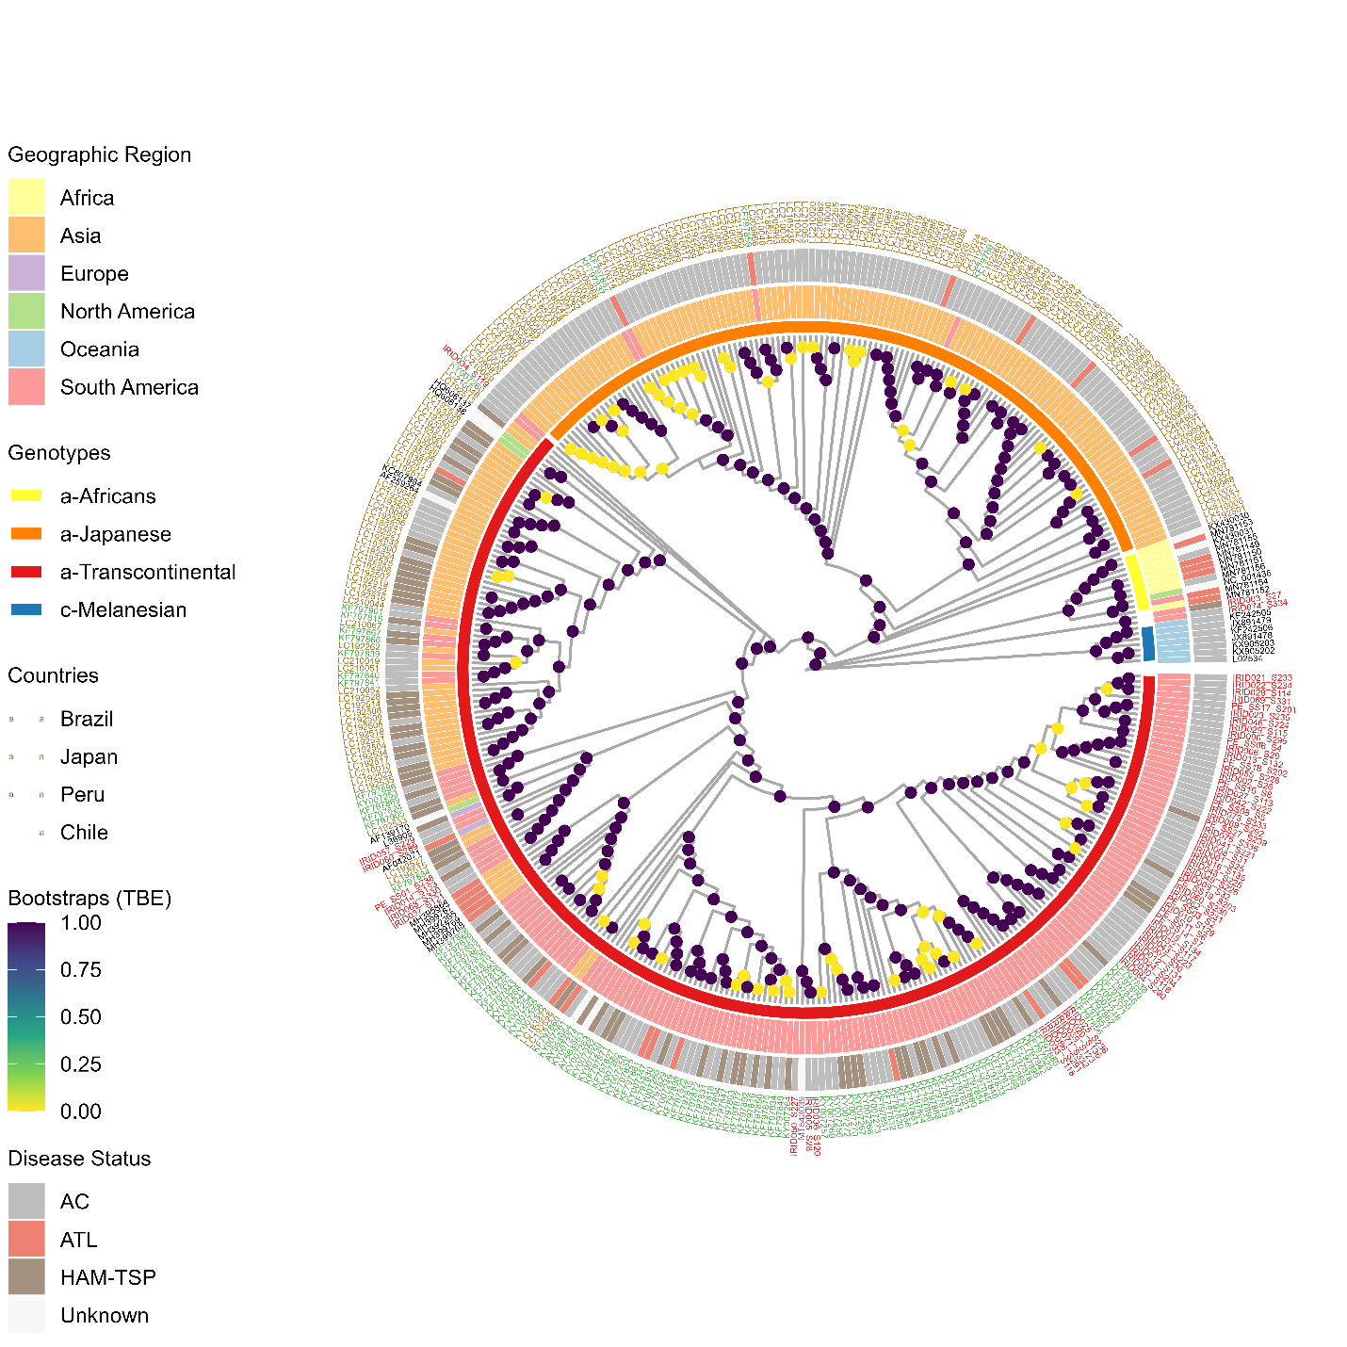

Figure 4. HLA analysis of the Peruvian Cohort
