Variable | Strongyloides (-)  N = 29 (43.3%)¹ | Strongyloides (+)  N = 38 (56.7%)¹ | p-value² | Total¹
Sex |  |  | 0.039
Female | 21 (72) | 18 (47) |  | 39 (58)
Male | 8 (28) | 20 (53) |  | 28 (42)
Age (years) | 49.5 (38.5, 55.0) | 49.5 (39.0, 54.0) | >0.9 | 49.5 (39.0, 54.0)
Birthplace |  |  | 0.4
Amazonian region | 0 (0) | 2 (6.1) |  | 2 (3.6)
Andean region | 8 (35) | 14 (42) |  | 22 (39)
Coastal region | 15 (65) | 17 (52) |  | 32 (57)
Proviral Load (PVL,%) | 3.3 (1.1, 6.4) | 5.0 (3.2, 6.9) | 0.11 | 4.5 (2.5, 6.9)
PVL-Risk (≥4%) |  |  | 0.10
High-Risk | 14 (48) | 26 (68) |  | 40 (60)
Low-Risk | 15 (52) | 12 (32) |  | 27 (40)
Oligoclonality Index (OCI) | 0.2 (0.1, 0.2) | 0.2 (0.1, 0.2) | 0.9 | 0.2 (0.1, 0.2)
7-year disease outcome |  |  | <0.001
Asymptomatic carriers | 18 (62) | 36 (95) |  | 54 (81)
ATLL | 2 (6.9) | 1 (2.6) |  | 3 (4.5)
HAM/TSP | 9 (31) | 1 (2.6) |  | 10 (15)
7-year vital status |  |  | 0.5
Alive | 19 (79) | 31 (89) |  | 50 (85)
Death | 5 (21) | 4 (11) |  | 9 (15)
¹n (%); Median (Q1, Q3)
²Pearson's Chi-squared test; Wilcoxon rank sum test; Fisher's exact test; Wilcoxon rank sum exact test
Table 1. Demographic and Clinical Characteristics of HTLV-1-Infected Individuals by LSI Status

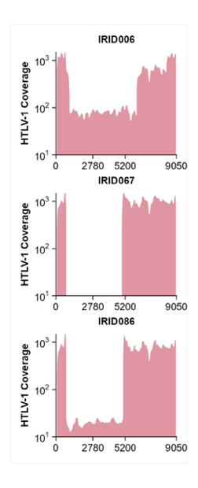
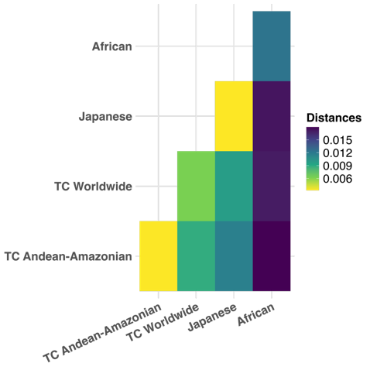
A
B
C

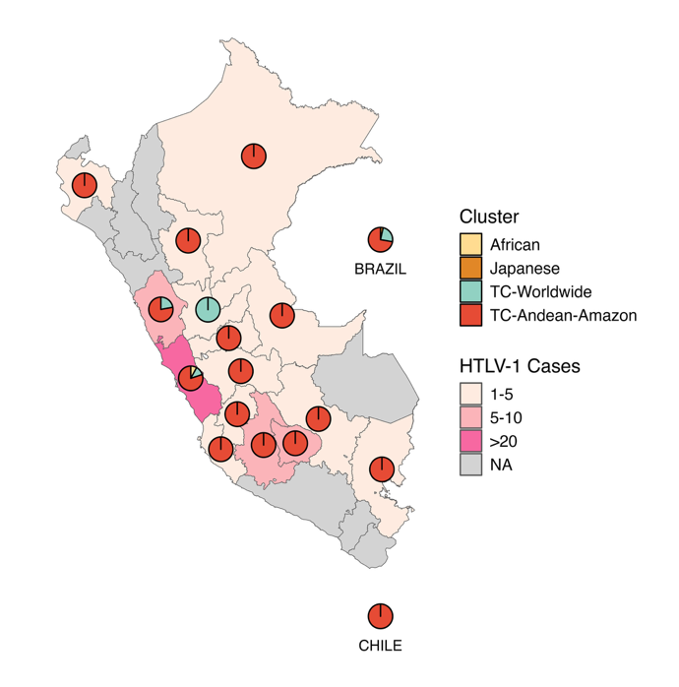
D
E
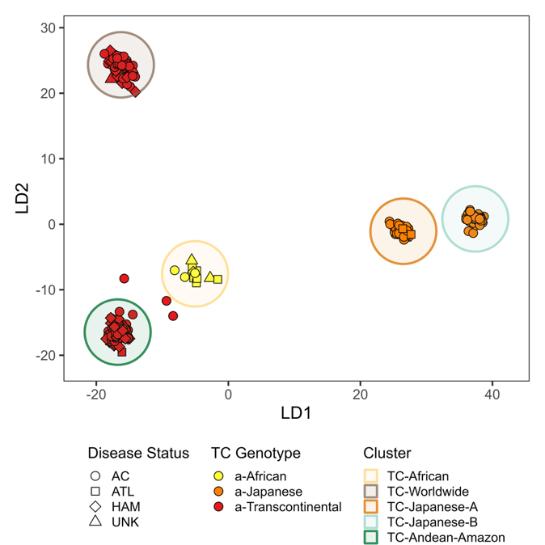

Figure 1. HTLV-1 genomics features of the Peruvian cohort
A) Identification of defective Type II viruses within the cohort, characterized by a reduction of at least 10% in total HTLV-1 genome coverage. These findings highlight significant genomic deletions or alterations that may impact viral functionality. B) Correlation analysis between Proviral Load (PVL) and Oligoclonality Index (OCI), evaluated using Spearman's rho. The black line represents the linear regression fit, illustrating the relationship between clonal expansion and viral load. C) Nucleotide distances between clusters within the Cosmopolitan clade, calculated using the K80 evolutionary nucleotide model. This analysis provides insights into genetic divergence and variability across HTLV-1 samples. D) Unsupervised clustering performed using dudiPCA, revealing distinct subgroups within the Transcontinental genotype (red). The Andean Amazon cluster is highlighted with a dark green circle, showcasing unique genetic characteristics specific to this region. E) Geographic representation of HTLV-1 clusters identified across South American samples, illustrating spatial patterns and diversity of viral genotypes within the continent.
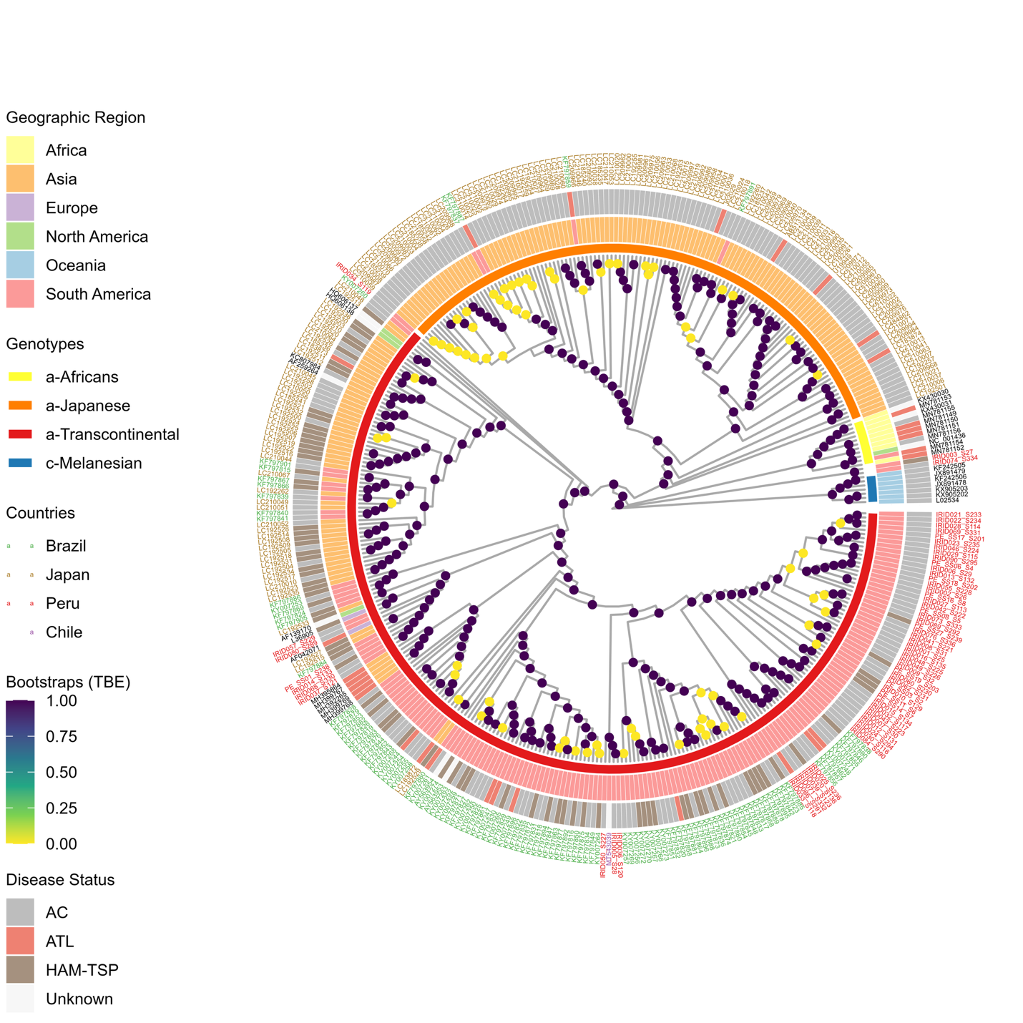
Figure 2. Genome-wide HTLV-1 global phylogenomic
A consensus phylogenetic tree was generated using RAxML, incorporating Transfer Bootstrap Expectation (TBE) support values. The tree reached coalescence after 5000 bootstrap iterations, ensuring robust and reliable support for the inferred evolutionary relationships. This tree provides insights into the genetic diversity and clustering patterns of HTLV-1 samples within the cohort.
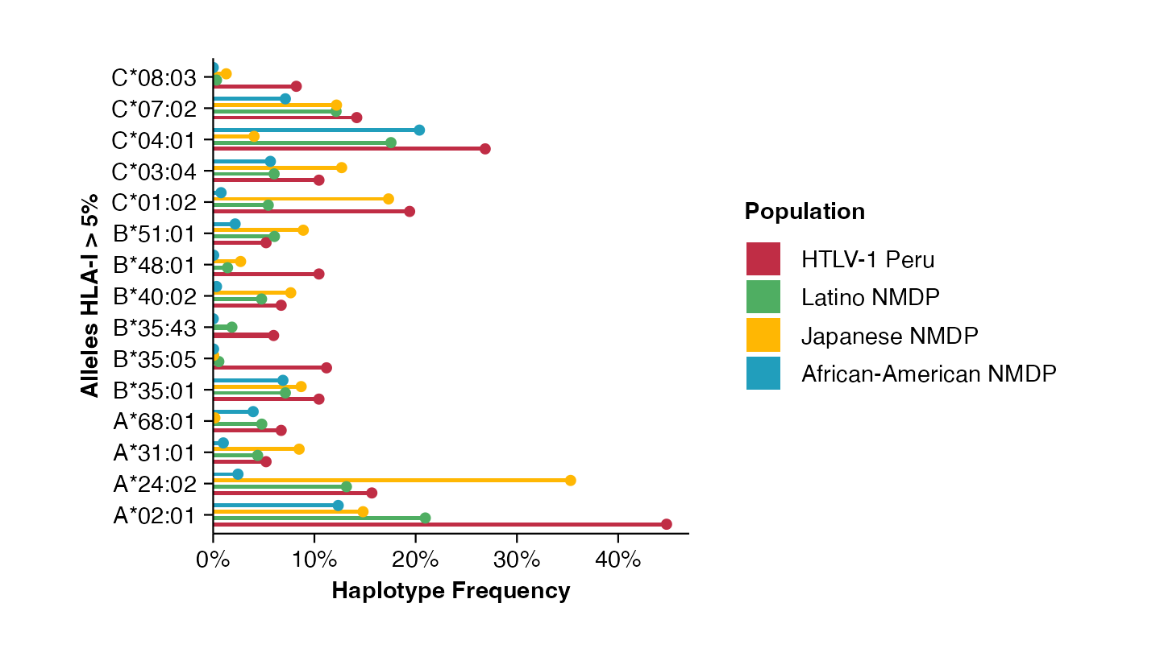

Figure 3. HLA-I diversity between HTLV-1 infected people from Japan and Peru.
Allele frequencies for HLA class I alleles with a prevalence greater than 5% are shown, derived using two independent algorithms: HLA-LA and Optitype compared to different worldwide populations from the NMDP database.

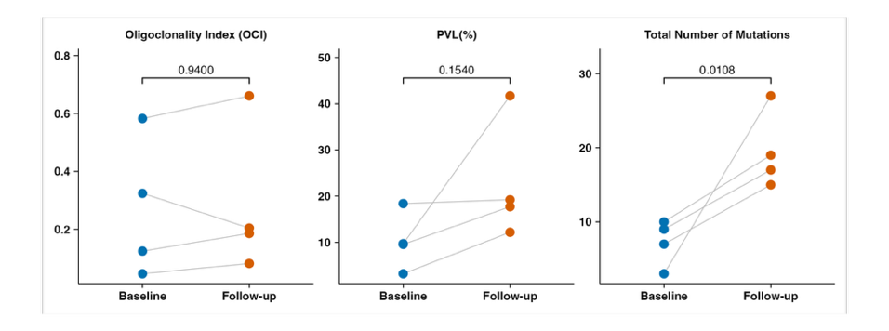
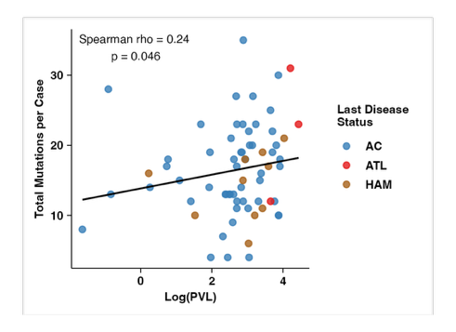
C
A

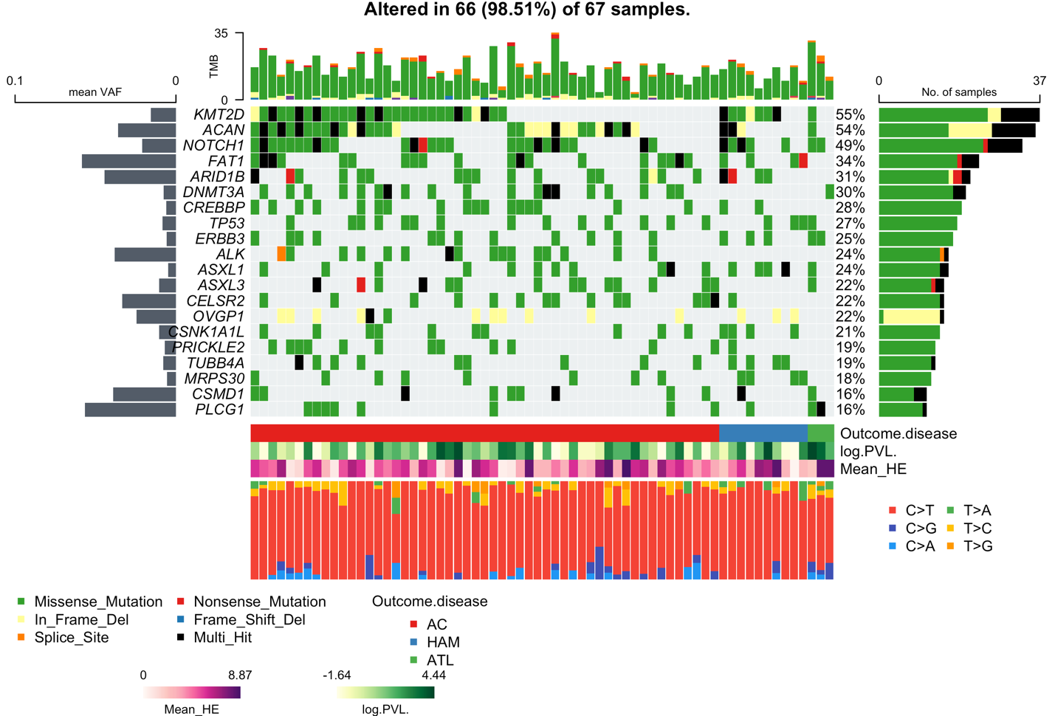
B

C

D

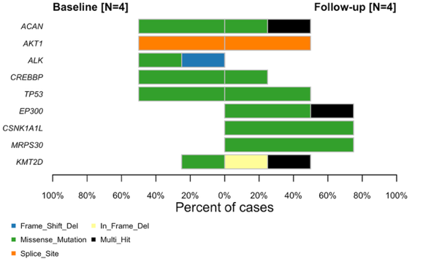
E

Figure 4. Clonal Hematopoiesis in HTLV-1-Infected Individuals
A) Oncoplot displaying somatic mutations with a variant allele frequency (VAF) of at least 0.5%, excluding putative germline SNPs. B) Correlation plot illustrating the relationship between the total number of mutations per sample and proviral load (PVL). C) Time-series evaluation of four representative samples, showing variations in OCI, PVL, and the number of mutations across multiple evaluations. D) Oncobarplot comparing baseline and follow-up mutations, highlighting dynamic changes in mutational profiles over time.

