## Common

* given two polygon A, B finds *intersection points* ( cyan )
* results is two broken geoms on ips
  + each *edge* (line, arc) is tagged with an "**inside**" attribute that is true if the edge is included into other polygon or overlaps other polygon edges

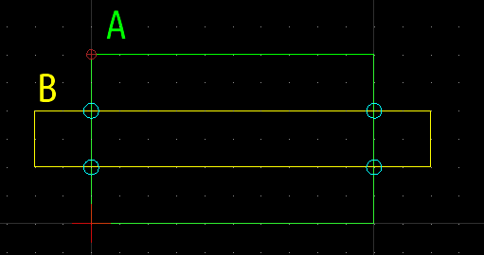

## Intersection

* start from an intersection point until all are visited
  + walk on inside edges until all ips are visited or the start ip are reached

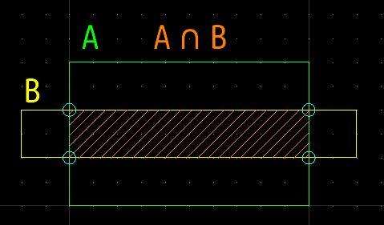

## Union

* start from an intersection point walk on NOT inside edges until the same intersection point reached

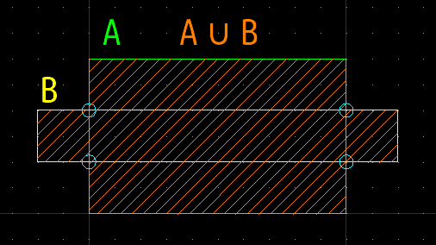

## Difference

* start from an intersection point until all are visited
  + walk on NOT inside edges until another intersection point reached
  + walk toward starting ip travelling inside edges

