Data Analytics Capstone
Accuracy and Fairness Trade-offs in Machine Learning Credit Default Prediction:
A Threshold-Level Governance Study for Retail Lenders

Final Report
Mrityunjay Ravi Iyer
Walsh College
QM640: Data Analytics Capstone
[Mentor Name]
Fall 2026 Term
October 13, 2026

Table of Contents
Abstract 4
Introduction 5
Background and Context 5
Business Problem Statement 6
Technical Problem Statement 6
Purpose and Research Questions 7
Scope 9
Literature Review 9
Machine Learning in Credit Scoring 9
Fairness Definitions and Impossibility 10
Fairness in Credit 11
Mitigation Methods 11
Regulatory Context 12
Gaps and Justification of the Approach 12
Data and Research Methodology 13
Data Source and Ethics 13
Variables and Data Dictionary 13
Cleaning and Sampling Design 15
Exploratory Data Analysis 17
Algorithms and Technical Justification 20
Evaluation Metrics 21
Statistical Methods 21
Analytical Workflows 22
Results 27
RQ1: Predictive Performance 27
RQ2: Outcome Disparity 29
RQ3: Fairness at a Simulated Cut-off 30
RQ4: Mitigation Trade-offs 34
Reproducibility Across Machines 36
Analysis and Discussion 37
Technical Interpretation 37
Business Implications 38
Synthesis Against the Hypotheses 39
Implementation 41
Practical Deployment as a Validation Artefact 41
Algorithmic Steps 41
Human and Machine Requirements for Reproducibility 42
Limitations and Next Steps 42
References 45
Appendix A 50
Appendix B 51
Appendix C 52
Appendix D 53

Abstract
Retail lenders deploy machine learning default models that outrank logistic scorecards on accuracy but seldom report how the resulting decisions differ by demographic group or what it costs to narrow the difference. This study audits three default-prediction models on the UCI Default of Credit Card Clients dataset (30,000 Taiwanese cardholders, 22.1% default) under a stratified five-fold design that keeps model fitting, policy calibration, and evaluation on disjoint data. Four questions are answered. Gradient boosting reaches an area under the ROC curve of 0.784 against 0.755 for logistic regression, a paired difference of 0.029 (95% CI 0.026 to 0.033, DeLong z = 15.7, p < .001). Men default 3.4 points more often than women (z = 6.92, p < .001), a gap that halves after adjustment for credit limit and age. At a simulated 75% retention cut-off the model trained without sex wrongly flags creditworthy men 2.8 points more often than creditworthy women (95% CI 1.8 to 3.8, p < .001). That gap passes a ±0.05 benchmark by equivalence test and fails a ±0.02 benchmark. Disparate impact stands at 0.946. Including sex as an input widens the gap by 1.0 point. Reweighing the training data is non-inferior on AUC but closes the gap only when the model can see sex. Per-sex thresholds close it to 0.4 points at a bad-rate cost of 0.03 points. The audit is delivered as a reproducible pipeline and a threshold-level decision table for model validation. An age-band disparity of 6.8 points, found along the way, is the larger unaddressed risk.
Keywords: credit scoring, algorithmic fairness, disparate impact, equal opportunity, gradient boosting, model validation, threshold adjustment, reweighing

Introduction

Background and Context
The credit decisions I review for Indian banks and non-banking financial companies (NBFCs) are now produced, in most new retail programmes, by gradient-boosted tree models. Logistic scorecards are now the exception in new builds. Ensemble methods have improved on logistic regression in most published benchmarks, although the gain varies by dataset: Lessmann et al. (2015) compared 41 classifiers on eight credit datasets and found boosted and bagged trees ahead on the area under the receiver operating characteristic curve (AUC) in most cases. What is less often measured is whether the model treats groups of borrowers differently and by how much. In my experience that question gets a policy answer, usually that sex and marital status were excluded from the feature set. It does not get a number. Excluding the protected attribute does not establish that the resulting decisions are free of group-level differences, because other features can carry the same information (Kamiran & Calders, 2012).
Regulatory attention to fairness in financial AI has increased, although the obligations depend on jurisdiction and instrument. The Reserve Bank of India (RBI) FREE-AI Committee report of 13 August 2025 sets out seven guiding principles and 26 recommendations, among them disclosure of AI-driven credit assessments and fairness provisions proposed for the Digital Lending Directions (Reserve Bank of India, 2025). Those provisions stay advisory until the RBI adopts them. The European Union's Artificial Intelligence Act lists credit scoring of natural persons as a high-risk use in Annex III (European Parliament & Council of the European Union, 2024). It does not apply in India and serves here as a point of comparison. In the United States the problem has been measured. Fuster et al. (2022) found that machine learning in mortgage underwriting raised accuracy but widened the dispersion of predicted default across racial groups. Bartlett et al. (2022) found algorithmic lenders charging Latinx and African-American borrowers higher rates.
This study places the trade-off in a threshold-level decision table using the measures validation teams already read: retention rate, default rate among retained customers, AUC, and the fairness gap at each cut-off. My position, developed in the AI strategy coursework of this programme, is that fairness in a deployed model is decided by configuration choices, the threshold and the sample weights above all, and that no governance document changes the outcome. This capstone tests that position on a public dataset with stated statistical power.

Business Problem Statement
A retail lender's model validation unit signs a default model into production on the strength of its AUC and Kolmogorov–Smirnov (KS) statistic, and attests to fairness by confirming that protected attributes are absent from the inputs. The chief risk officer who owns that sign-off cannot answer, in numbers, three questions a supervisor or a board risk committee may put. How differently do the model's decisions fall on men and women at the operating cut-off? Did excluding sex from the inputs change that? What would the lender give up, in accuracy or in bad debt, to narrow the gap? Without those numbers the fairness attestation describes a process and says nothing about outcomes. If the model is later challenged, the lender has no decision record to show. What is missing, in business terms, is a validation artefact that expresses the fairness trade-off in the units a credit policy committee already uses and that can be regenerated on demand from the lender's own scores.

Technical Problem Statement
The technical problem is a supervised binary classification task with an attached fairness audit, evaluated so that no estimate is contaminated by the data that produced the model or the policy. The dependent variable is DEFAULT, a missed payment in the month after a six-month observation window, coded 1 or 0. Twenty-three cardholder attributes plus four engineered features (Table 2) are the independent variables. Two derived decision variables, FLAG (simulated referral) and RETAIN (simulated favourable decision), carry the audit. Because the dataset records outcomes for customers who already held credit, the setting is a retrospective portfolio-retention simulation. A threshold applied to it simulates whom a lender would have retained or referred, and nothing about whom it would have approved. Three estimation problems follow. First, model comparison with a pre-specified paired contrast on correlated AUCs. Second, group-level inference on proportions (default rates, false-decline rates, retention rates) with intervals, equivalence tests against stated benchmarks, and paired inference for before-and-after comparisons on the same individuals. Third, a policy-calibration problem in which cut-offs, per-group thresholds, and training weights must be set on data disjoint from both the training rows and the evaluation rows.

Purpose and Research Questions
Four aims follow, one per research question. Each question, its hypotheses, and the variables involved are set out below and summarised in Table 1.

Research Question 1 (RQ1): Predictive Performance
How do logistic regression, random forest (Breiman, 2001), and gradient boosting (Chen & Guestrin, 2016) compare in predicting next-month default, measured by AUC with a 95% confidence interval (CI), and is the AUC improvement of the pre-specified gradient boosting model over the logistic baseline statistically significant under the DeLong et al. (1988) test?
H1₀: AUC_{GB} = AUC_{LR}. H1₁: AUC_{GB} > AUC_{LR}. Gradient boosting against logistic regression is the single pre-specified contrast. Random forest is a secondary benchmark.

Research Question 2 (RQ2): Outcome Disparity
Do observed default rates differ by sex and by age band, and how large are the differences before and after adjustment for credit limit and age?
H2₀: p_{male} = p_{female}. H2₁: p_{male} ≠ p_{female}. For age bands, H2b₀ is independence of default and age band. A difference of 0.03 is the planned minimum meaningful difference used for power and sits outside the hypothesis.

Research Question 3 (RQ3): Fairness at a Simulated Cut-off
At a simulated cut-off that retains 75% of existing cardholders, how do favourable-selection rates and false-decline rates differ by sex, and how do those differences compare with two predefined research benchmarks, a disparate impact ratio of at least 0.80 and a false-decline rate gap within ±0.05?
H3₀: FDR_{male} = FDR_{female}, where FDR is the false-decline rate, the share of non-defaulters flagged. H3₁: FDR_{male} ≠ FDR_{female}. Equivalence tests carry the benchmark comparison. The model audited is trained without SEX, EDUCATION, and MARRIAGE, the configuration lenders deploy under unawareness.

Research Question 4 (RQ4): Mitigation Trade-offs
How do training-data reweighing (Kamiran & Calders, 2012) and group-specific threshold adjustment (Hardt et al., 2016) change the false-decline rate gap and the simulated portfolio outcomes, and what predictive-performance or decision-quality cost arises under each?
For reweighing, H4₀: AUC_{RW} ≤ AUC_{base} − 0.01 and H4₁: AUC_{RW} > AUC_{base} − 0.01, a one-sided non-inferiority test on paired AUCs. For threshold adjustment the AUC is unchanged by construction, so the cost is measured at the decision level as the change in the default rate among retained cardholders at a common retention rate, with a paired bootstrap interval.
Table 1
Research Questions, Hypotheses, and Variables
RQ | Null hypothesis | Dependent variable(s) | Independent variable(s) | Primary test
RQ1 | AUC of gradient boosting equals AUC of logistic regression | DEFAULT (held-out score ranking) | 23 attributes and 4 engineered features | DeLong paired AUC test, one-sided
RQ2 | Default rate equal by sex; default independent of age band | DEFAULT | SEX; AGE_BAND; AGE and log LIMIT_BAL as covariates | Two-proportion z; chi-square; logistic regression
RQ3 | False-decline rate equal by sex at 75% retention | FLAG, RETAIN by group (false-decline rate, retention rate) | SEX | Two-proportion z; TOST equivalence; bootstrap
RQ4 | Reweighed AUC inferior to baseline by more than 0.01; decision-level costs zero | AUC; false-decline gap; default rate among retained | Mitigation configuration | DeLong non-inferiority; paired bootstrap
Note. AUC = area under the receiver operating characteristic curve. TOST = two one-sided tests.

Scope
In scope are one public dataset of 30,000 cardholders, three model families, one primary protected attribute (sex) and one secondary attribute (age band), and two mitigation methods. Two fairness measures serve as tests, the disparate impact ratio on RETAIN and the false-decline rate gap, with the true-positive rate gap and equalized odds reported alongside. A trade-off table across simulated retention rates and a Shapley additive explanations (SHAP) decomposition by sex (Lundberg & Lee, 2017) complete the scope. Out of scope are neural network classifiers, whose interpretability cost on tabular high-stakes decisions is not repaid by their accuracy gain (Rudin, 2019), synthetic data, in-processing mitigation, calibration-based fairness criteria, causal inference, profit optimisation, reject inference, and deployment.

Literature Review
Five strands make up the literature: the accuracy case for machine learning in credit scoring, the formal definitions of group fairness and the impossibility results that constrain them, empirical fairness studies in credit, mitigation methods, and the regulatory frame. I review each for what it establishes and where it stops, and close with the gap this study addresses.

Machine Learning in Credit Scoring
Credit scoring has used statistical classifiers since the 1960s, with logistic regression dominant because its coefficients can be read, challenged, and regulated (Hand & Henley, 1997). Lessmann et al. (2015), updating Baesens and colleagues' 2003 comparison, ran 41 classifiers on eight datasets and found heterogeneous ensembles and boosted trees ahead of logistic regression in most settings, with gains of a few AUC points. Friedman (2001) supplied the gradient boosting machine the modern implementations descend from, and Chen and Guestrin (2016) the XGBoost system used here, which postdates the Lessmann benchmark. Breiman's (2001) random forest remains the standard bagged comparator. Khandani et al. (2010) showed at a large United States bank that tree-based models on transaction and bureau data forecast delinquency well enough to cut losses by 6% to 25% under simulated credit-line management, and Berg et al. (2020) showed that even ten digital-footprint variables reach an AUC comparable to a bureau score. Two conclusions carry into this study. The accuracy gain from ensembles is real but modest, one to three AUC points, so a fairness intervention that costs a full point gives back a large share of what the ensemble bought. The gain also depends on the decision rule attached to the score, a point Khandani and colleagues stressed, and it is the reason this study works at the threshold level. Rudin (2019) argues that for high-stakes decisions the interpretability cost of black-box models is paid in a currency regulators control. On that argument the logistic baseline stays in as the comparator a validation unit can read line by line.

Fairness Definitions and Impossibility
Formal fairness definitions outnumber what any one audit can satisfy. Dwork et al. (2012) framed individual fairness as treating similar people similarly. Group definitions followed: demographic parity (equal selection rates), equalized odds and equal opportunity (equal error rates across groups, with equal opportunity restricted to the favourable outcome) in Hardt et al. (2016), and calibration within groups. Verma and Rubin (2018) catalogued twenty such definitions and showed that most cannot hold together. Kleinberg et al. (2017) and Chouldechova (2017) proved the constraint that matters most here. When base rates differ between groups, a classifier cannot be calibrated within each group and have equal false-positive and false-negative rates at the same time, except in degenerate cases. So a lender must choose which criterion to govern to, and the choice depends on whose error matters. Feldman et al. (2015) expressed the four-fifths rule from United States employment-selection guidelines (Uniform Guidelines on Employee Selection Procedures, 1978) as a disparate impact ratio and showed how to certify and repair it. Barocas et al. (2019) and Mehrabi et al. (2021) survey the field and document the failure of fairness through unawareness: removing the protected attribute does not remove disparity when other features carry the same information. This study takes equal opportunity, read from the borrower's side as the false-decline rate, as the primary criterion, with the disparate impact ratio second. Kozodoi et al. (2022) found separation-type criteria the most practical for scorecards, and a wrongly declined creditworthy customer is the harm a conduct regulator asks about.

Fairness in Credit
Empirical credit studies have measured the trade-off that the definitions predict. Fuster et al. (2022) found, on United States mortgage data, that replacing logistic regression with machine learning raised predictive accuracy but spread the predicted default rates further apart across racial groups. Accuracy improved for some groups far more than for others. Bartlett et al. (2022) found that algorithmic lenders charged Latinx and African-American borrowers higher rates even where rejection rates were similar. Kozodoi et al. (2022) applied several fairness criteria to seven credit datasets, found that most could be met at a low profit cost, and identified separation as the practical criterion. Corbett-Davies and Goel (2018) argued that threshold rules, with a single threshold or group-specific thresholds, are where the fairness choice is made in practice. They also argued that the costs of fairness constraints should be measured against the decision maker's objective. Most papers assert those costs. None of these papers reports the result as a credit committee reads it, with approval or retention rate, bad rate, and AUC at each candidate cut-off and the fairness gap alongside. None separates the calibration of the cut-off from its evaluation.

Mitigation Methods
Mitigation methods are grouped by where they act. Pre-processing changes the training data: Kamiran and Calders (2012) reweigh each row by the ratio of the expected to the observed joint frequency of its group and outcome, so that group and outcome become independent in the weighted training set. In-processing changes the learning objective, for instance through adversarial debiasing, and is out of scope here. Post-processing changes the decision rule: Hardt et al. (2016) showed that any classifier can be made to satisfy equal opportunity or equalized odds by choosing group-specific thresholds, possibly randomised, on a held-out set, and Fairlearn implements that construction (Bird et al., 2020). Their costs fall in different places. Reweighing retrains the model and can change the ranking, so its cost is read from the AUC. Threshold adjustment leaves the scores intact, so its cost appears in the decision-level outcome, here the default rate among retained cardholders. It carries a governance cost too, because the protected attribute is needed at decision time, and in some jurisdictions that is disparate treatment. The literature states, but rarely quantifies on a single dataset, that reweighing on an attribute the model does not see can only act through proxies. This study tests that directly.

Regulatory Context
The RBI FREE-AI Committee report (Reserve Bank of India, 2025) recommends, among 26 items, that regulated entities disclose AI-driven credit assessments and adopt board-level AI governance with fairness provisions, and it proposes amendments to the Digital Lending Directions. Until adopted, the recommendations are advisory. The EU Artificial Intelligence Act (European Parliament & Council of the European Union, 2024) classifies creditworthiness assessment of natural persons as high risk and attaches logging, human oversight, and conformity obligations. The four-fifths rule originated in the 1978 Uniform Guidelines on Employee Selection Procedures and has no statutory standing in Indian credit regulation. This study treats 0.80 and ±0.05 as research benchmarks for that reason, and no compliance claim rests on them.

Gaps and Justification of the Approach
Four gaps follow from the review. First, the empirical credit studies report group differences in model outputs. They stop short of the decision-level trade-off at a lender's operating point in the units a credit policy uses. Second, most fairness evaluations set thresholds and post-processors on the same data they then report performance on, which overstates the result. Hardt et al. (2016) themselves set thresholds on held-out data, but applied studies seldom separate calibration from evaluation. Third, the comparative cost of pre-processing and post-processing on one dataset, measured with paired inference, is rarely reported. Whether reweighing depends on the model seeing the attribute is stated in the literature and, as far as I can find, never measured. Fourth, the regulatory texts now ask for numbers that the validation literature does not yet routinely supply. Each gap gets an answer here: a trade-off table across retention rates, a three-way split within each fold that separates fitting, calibration, and evaluation, paired bootstrap inference for every before-and-after comparison, and a decision record a validation unit can regenerate.

Data and Research Methodology

Data Source and Ethics
The study uses dataset 350, Default of Credit Card Clients, from the UCI Machine Learning Repository, derived from Yeh and Lien (2009) and donated to the repository in January 2016. It describes 30,000 cardholders of a Taiwanese card issuer observed from April to September 2005, and the target records a missed payment in October 2005. It is available at https://archive.ics.uci.edu/dataset/350/default+of+credit+card+clients under the persistent identifier https://doi.org/10.24432/C55S3H, and the repository's recommended citation is Yeh (2009). A single Excel workbook holds the 30,000 rows and 25 columns, with no missing values, under a Creative Commons Attribution 4.0 licence. The download script in the repository fetches the file, verifies its SHA-256 checksum (c76095b2…9e44), and checks the documented structure: 30,000 by 25, 6,636 defaults, 11,888 male and 18,112 female cardholders.
The file contains no names, account numbers, addresses, or dates of birth, and the identifier is a sequential index with no link to the issuer's systems. Released for secondary analysis under an open licence, the data were used as published, and no re-identification or linkage was attempted. SEX holds two administrative categories recorded by the issuer in 2005 and does not describe the range of gender identities. Sex and marital status are used only to measure disparity, never as inputs to the audited model. A measured disparity is evidence of a group-level difference in simulated decisions. It is not a finding of unlawful discrimination, which depends on law, intent, and business justification this study does not examine. Passing the two benchmarks establishes no regulatory compliance in any jurisdiction.

Variables and Data Dictionary
Table 2 defines every variable in the file, the four engineered features, and the two simulated decision variables. Monetary variables are in New Taiwan dollars (NT$). Where the repository documentation is silent, the table records my interpretation as an assumption and names the sensitivity run that tests it.
Table 2
Data Dictionary
Variable | Type | Meaning | Units or coding | Role
ID | Integer | Row identifier | 1 to 30,000 | Keys out-of-fold predictions; not a feature
LIMIT_BAL | Numeric, continuous | Credit limit including supplementary cards | NT$, 10,000 to 1,000,000 | Independent; candidate proxy for sex
SEX | Categorical, nominal | Sex as recorded by the issuer | 1 = male, 2 = female | Protected attribute (RQ2 to RQ4); excluded from the unaware model
EDUCATION | Categorical, ordinal | Highest education attained | 1 = graduate school, 2 = university, 3 = high school, 4 = other; 0, 5, 6 undocumented, kept as one level (sensitivity B) | Independent; excluded from the unaware model
MARRIAGE | Categorical, nominal | Marital status | 1 = married, 2 = single, 3 = other; 0 undocumented, kept as a level (sensitivity B) | Independent; excluded from the unaware model
AGE | Numeric, discrete | Age at observation | Years, 21 to 79 | Independent; source of AGE_BAND
PAY_0, PAY_2 to PAY_6 | Categorical, ordinal (6) | Repayment status, September back to April 2005 | 1 to 9 = months of delay; −1 = paid in full; −2 and 0 undocumented, read as no consumption and revolving use (sensitivity A) | Independent; strongest expected predictors
BILL_AMT1 to BILL_AMT6 | Numeric, continuous (6) | Statement balance, September back to April | NT$; negative values are credit balances | Independent
PAY_AMT1 to PAY_AMT6 | Numeric, continuous (6) | Amount paid, September back to April | NT$, non-negative | Independent
DEFAULT | Binary | Missed payment in October 2005 | 1 = default, 0 = no default | Dependent variable
AGE_BAND (derived) | Categorical, ordinal | Age in four bands | < 30, 30 to 39, 40 to 49, ≥ 50 | Secondary protected attribute
UTILISATION (derived) | Numeric, continuous | Latest balance over credit limit | BILL_AMT1 / LIMIT_BAL; negative and > 1 retained | Independent, engineered
PAY_RATIO (derived) | Numeric, continuous | Latest payment over prior balance | PAY_AMT1 / BILL_AMT2, capped at 1; 1 where BILL_AMT2 ≤ 0 | Independent, engineered
MAX_DELAY (derived) | Numeric, discrete | Worst repayment code in six months | Code −2 to 9; not a duration | Independent, engineered
FLAG (decision) | Binary | Simulated referral: score above cut-off | 1 = flagged, 0 = not | Numerator of the false-decline rate
RETAIN (decision) | Binary | Simulated favourable decision | 1 − FLAG | Basis of the disparate impact ratio
Note. NT$ = New Taiwan dollars. The unaware model is trained with SEX, EDUCATION, and MARRIAGE removed; an aware model including them is trained for comparison.

Cleaning and Sampling Design
Three coding issues were handled before modelling. EDUCATION holds undocumented values 0, 5, and 6 in 345 rows and MARRIAGE an undocumented 0 in 54 rows. Both were kept as a distinct level so the assumption stays visible, and sensitivity B merges them into the documented other category. The repayment-status fields hold −2 and 0, which the repository does not define. I read them as no consumption and revolving use, and sensitivity A collapses both into one non-delinquent code. No value is missing and the identifier is unique, so no row was dropped. Monetary variables are right-skewed (Table 3) and were transformed by a sign-preserving log for the logistic model only, with the transform fitted inside each training fold. Tree models received the raw values.
The sampling design is stratified five-fold cross-validation (CV) keyed on ID and stratified on sex by outcome, so each held-out fold holds 6,000 cardholders. Inside each outer training set of 24,000, 19,200 rows form the fit partition, on which models are trained and tuned by inner three-fold CV. The other 4,800 form the calibration partition, where isotonic recalibration, the retention cut-off, the per-sex thresholds, and the reweighing weights are set. Each held-out fold is scored once and never used to choose anything. Every cardholder receives one prediction and one decision from a configuration that did not see them, and the evaluation pool is the full 30,000. Figure 1 shows the pipeline. Every random process uses the seed 640.
Figure 1
Solution Pipeline From Data Acquisition to Decision Table
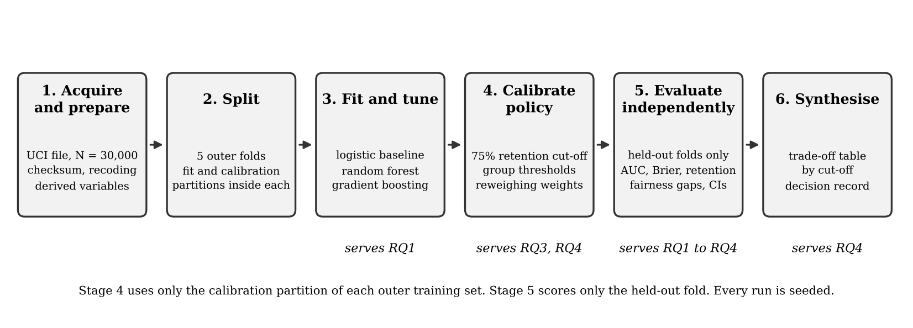
Note. Stages 1 and 2 run once. Stage 3 answers RQ1, stage 4 sets cut-offs and weights for RQ3 and RQ4, stage 5 produces every reported estimate on held-out folds, and stage 6 assembles the trade-off table.
The sample-size plan from the synopsis is reproduced in Appendix B. Its binding requirement was 14,587 cardholders for a 95% CI half-width of 0.01 on an AUC of 0.78 (Hanley & McNeil, 1982). The pre-specified paired contrast needed 4,470 at a correlation of 0.70 (Fleiss et al., 2003, for the two-proportion calculations and DeLong et al., 1988, for the paired AUC variance). At 30,000, the evaluation pool is 2.06 times the requirement. The observed paired-AUC correlation between XGBoost and logistic regression was 0.85, above the 0.70 planning assumption, so the design was conservatively powered.

Exploratory Data Analysis
Univariate summaries of the numeric variables are in Table 3. Credit limit is right-skewed with a median of NT$140,000, and age has a median of 34 with a long right tail to 79. The monthly payment amounts are the most skewed variables in the file (skewness 10 to 30), and they are the reason the logistic pipeline carries a log transform. The six repayment-status codes have medians of 0 and 75th percentiles of 0, so most cardholders were current in every month and the signal lies in the minority with positive codes. Of the categorical variables, 60.4% of cardholders are female, 46.8% hold a university degree and 35.3% a graduate degree, and 53.2% are single. Default prevalence is 22.1%.
Table 3
Univariate Summary of Numeric Variables (N = 30,000)
Variable | Mean | SD | Min | Median | Max | Skew
LIMIT_BAL (NT$) | 167,484 | 129,748 | 10,000 | 140,000 | 1,000,000 | 0.99
AGE (years) | 35.5 | 9.2 | 21 | 34 | 79 | 0.73
PAY_0 (code) | −0.02 | 1.12 | −2 | 0 | 8 | 0.73
PAY_6 (code) | −0.29 | 1.15 | −2 | 0 | 8 | 0.95
BILL_AMT1 (NT$) | 51,223 | 73,636 | −165,580 | 22,382 | 964,511 | 2.66
BILL_AMT6 (NT$) | 38,872 | 59,554 | −339,603 | 17,071 | 961,664 | 2.85
PAY_AMT1 (NT$) | 5,664 | 16,563 | 0 | 2,100 | 873,552 | 14.67
PAY_AMT6 (NT$) | 5,216 | 17,777 | 0 | 1,500 | 528,666 | 10.64
UTILISATION | 0.42 | 0.41 | −0.62 | 0.31 | 6.46 | 0.82
PAY_RATIO | 0.40 | 0.44 | 0.00 | 0.10 | 1.00 | 0.56
MAX_DELAY (code) | 0.44 | 1.35 | −2 | 0 | 8 | 0.69
Note. Intermediate months (PAY_2 to PAY_5, BILL_AMT2 to BILL_AMT5, PAY_AMT2 to PAY_AMT5) lie between the September and April values shown and are in the repository table eda_summary_numeric.csv.
Bivariate analysis (Figure 2) shows where the outcome varies. Men default at 24.2% and women at 20.8%. By age band it is lowest at 30 to 39 (20.3%) and highest at 50 and over (25.3%), a U shape with no monotone trend. The September repayment code separates the outcome more sharply than any other field: cardholders coded 0 or below default at 13% to 17%, those one month late at 34%, and those two or more months late at 50% to 78%. Defaulters have a median credit limit of NT$90,000 against NT$150,000 for non-defaulters and a median utilisation of 0.49 against 0.27. Men have a lower median credit limit than women, NT$130,000 against NT$150,000, and higher median utilisation, 0.41 against 0.25 (Figure 3). Through those two fields a model that never sees sex can still tell men from women.
Figure 2
Default Rate by Sex, Age Band, and September Repayment Code
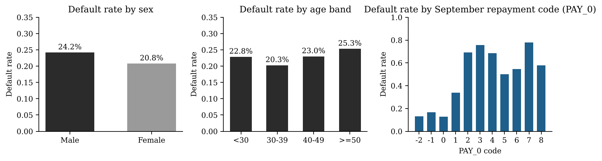
Note. Repayment code 1 to 8 denotes months of delay; −2, −1, and 0 denote no consumption, paid in full, and revolving use respectively (the first and last are interpretations; see Table 2).
Figure 3
Distributions of Credit Limit and Utilisation by Outcome
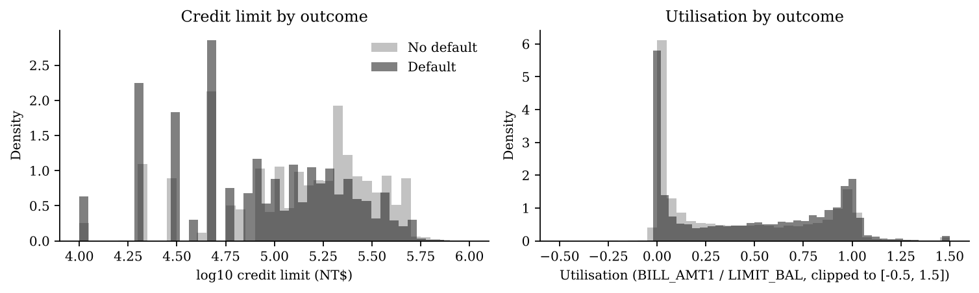
Note. Credit limit on a log10 scale. Utilisation clipped to [−0.5, 1.5] for display; values outside the range are retained in modelling.
Multivariate structure was examined with Spearman correlations among the predictors and the outcome (Figure 4). Among the predictors, the six repayment codes are strongly correlated with one another (0.5 to 0.8), as are the six bill amounts (above 0.8), so the engineered MAX_DELAY summarises the first block and UTILISATION the second against the credit limit. With the outcome, MAX_DELAY has the largest correlation (0.32), followed by PAY_0 (0.29) and the earlier repayment codes in declining order (0.22 to 0.14), while credit limit (−0.17), the latest payment amount (−0.16), and the payment ratio (−0.13) are protective. Age is uncorrelated with the outcome (0.005) although the band pattern is U-shaped, so RQ2 uses age band and not age. Figure 5 shows the credit-limit difference by sex that the SHAP analysis later identifies as the third-largest carrier of the fairness gap.
Figure 4
Spearman Correlation Among Predictors and the Outcome
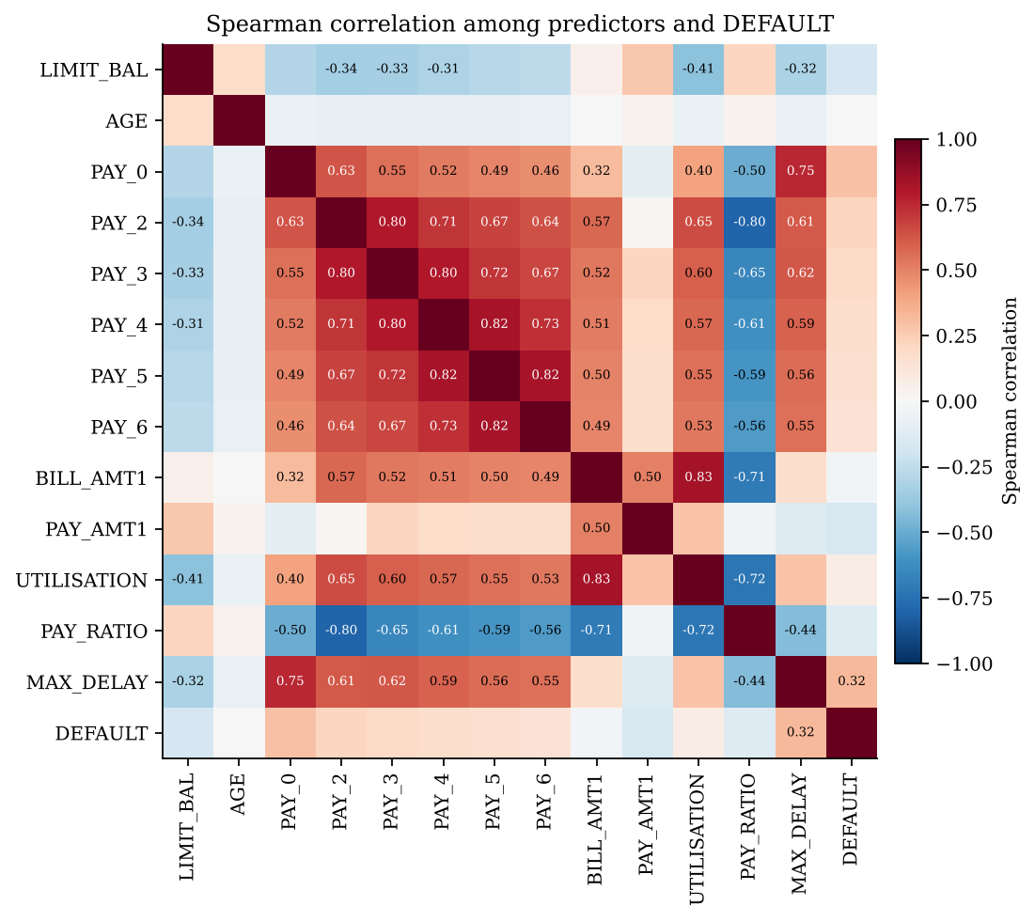
Note. Cells with absolute correlation of at least 0.30 are annotated.
Figure 5
Credit Limit by Sex
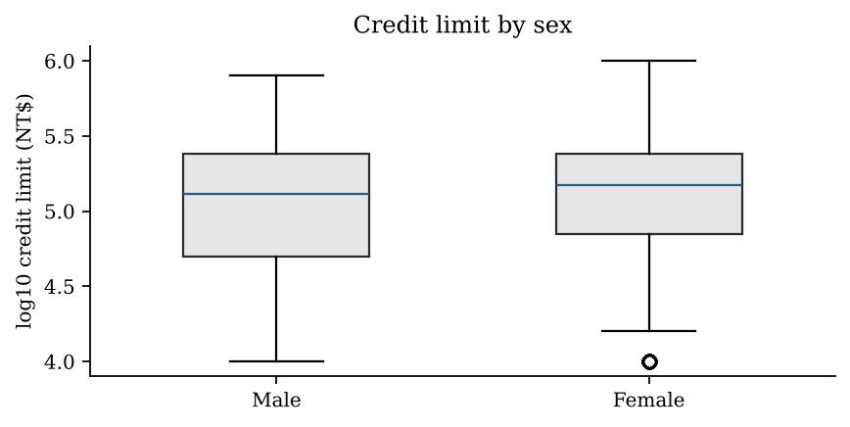
Note. Boxes show the interquartile range of log10 credit limit; the line is the median.

Algorithms and Technical Justification
Three supervised classifiers were trained on identical fit partitions and scored on identical held-out folds. Logistic regression with L2 regularisation, standardised numeric inputs, and one-hot encoded categories is the baseline, because it is the model most Indian lenders still hold in production and the one a validation unit can read line by line. Its regularisation strength was chosen by inner three-fold grid search over four values. Random forest (Breiman, 2001) with 500 trees, a minimum leaf size of 20, and balanced subsample class weights is the bagged comparator. XGBoost (Chen & Guestrin, 2016) is the challenger, with learning rate, depth, number of trees, subsampling, column sampling, minimum child weight, and L2 penalty chosen by a 12-candidate randomised search under inner three-fold CV on the fit partition, so no held-out row influences a tuning choice. The selected values per fold are in Appendix C. Class imbalance (22% positives) was handled by class weighting, which can distort probability calibration, so every model's raw probabilities were recalibrated by isotonic regression fitted on the calibration partition and the Brier score is reported before and after. Lessmann et al. (2015) showed that these three families bracket the achievable range on credit data. The pre-specified contrast is XGBoost against logistic regression, fixed in the synopsis, so the significance test is never applied to whichever model happens to score highest.

Evaluation Metrics
Classification metrics are defined from the confusion matrix of true positives (TP), false positives (FP), true negatives (TN), and false negatives (FN), where a positive is a predicted default, so FLAG = 1 is the positive prediction and RETAIN = 1 − FLAG.
$Precision = \frac{TP}{TP + FP}, TPR = \frac{TP}{TP + FN}, FDR = FPR = \frac{FP}{FP + TN}$ (1)
$F_{1} = \frac{2 × Precision × TPR}{Precision + TPR}$ (2)
$AUC = \frac{1}{n_{D} n_{N}} Σ_{i, j} I_{ij}$ (3)
$Brier = \frac{1}{N}\sum_{i = 1}^{N}{{\left({p̂}_{i} − y_{i}\right)}^{2}}$ (4)
In Equation 1 the false-decline rate (FDR) is the false-positive rate read from the borrower's side, the share of non-defaulters who are flagged. In Equation 3, I_{ij} equals 1 when defaulter i scores above non-defaulter j and 0 otherwise, so the AUC is the probability that a random defaulter outranks a random non-defaulter, and it does not depend on the cut-off. KS is max |TPR(t) − FPR(t)| over thresholds t, and the Brier score (Equation 4) measures calibration. The fairness measures compare the two sex groups g. The favourable-selection rate is RETAIN_{g} = (TN_{g} + FN_{g})/n_{g}, and the disparate impact ratio is DI = min(RETAIN_{g})/max(RETAIN_{g}), with the four-fifths benchmark met when DI ≥ 0.80 (Feldman et al., 2015). The false-decline gap FDR_{male} − FDR_{female} is the equal opportunity difference of Hardt et al. (2016) once the favourable outcome is taken as non-default. The true-positive gap is TPR_{male} − TPR_{female}, and the equalized odds difference is the larger of the two absolute gaps. The default rate among retained cardholders, total FN over total RETAIN, is the simulated portfolio outcome at each cut-off.

Statistical Methods
Each research question carries a formal test, an effect size with a 95% interval, an assumption check, and a decision at α = .05, and the full register of 30 tests is in Appendix D. AUC intervals and the paired contrast use the DeLong et al. (1988) method in the fast form of Sun and Xu (2014). Secondary contrasts are Holm-adjusted (Holm, 1979). A Nadeau and Bengio (2003) corrected paired t-test across the five folds is reported as a check on the pooled contrast, since fold-level AUCs share training rows. Calibration is examined by Hosmer–Lemeshow decile test (Hosmer et al., 2013) and reliability plot. Proportions are compared by two-proportion z tests with pooled standard errors and Newcombe intervals, with Cohen's (1988) h as the effect size. Independence of default and age band is tested by chi-square with Cramér's V and a bootstrap interval, followed by Holm-adjusted pairwise tests. Logistic regression, with variance inflation factors reported, estimates the adjusted sex effect. Where the research claim is that a gap lies within a tolerance, the two one-sided tests procedure (Schuirmann, 1987) is applied at the stated margin. A confidence interval inside a band is a reading. An equivalence test is a decision. Fairness measures carry 1,000-draw stratified bootstrap intervals. Within a sex-by-outcome stratum the resampled flag count is exactly binomial, so the bootstrap is exact. Comparisons between configurations on the same individuals use a paired stratified bootstrap of the difference. Reweighing is tested for non-inferiority of the paired AUC at a margin of 0.01, and threshold adjustment is tested by McNemar's test on decision flips. Statistical reporting follows APA conventions.

Analytical Workflows
Figures 6 to 9 give the step-by-step workflow for each research question. Each step maps onto a script in the repository (Appendix A): data preparation and fold assignment in prepare.py, model fitting and calibration in train.py, cut-offs, thresholds, and weights in policy.py, metrics and inference in evaluate.py, and one analysis script per question.
Figure 6
Workflow for RQ1, Predictive Performance
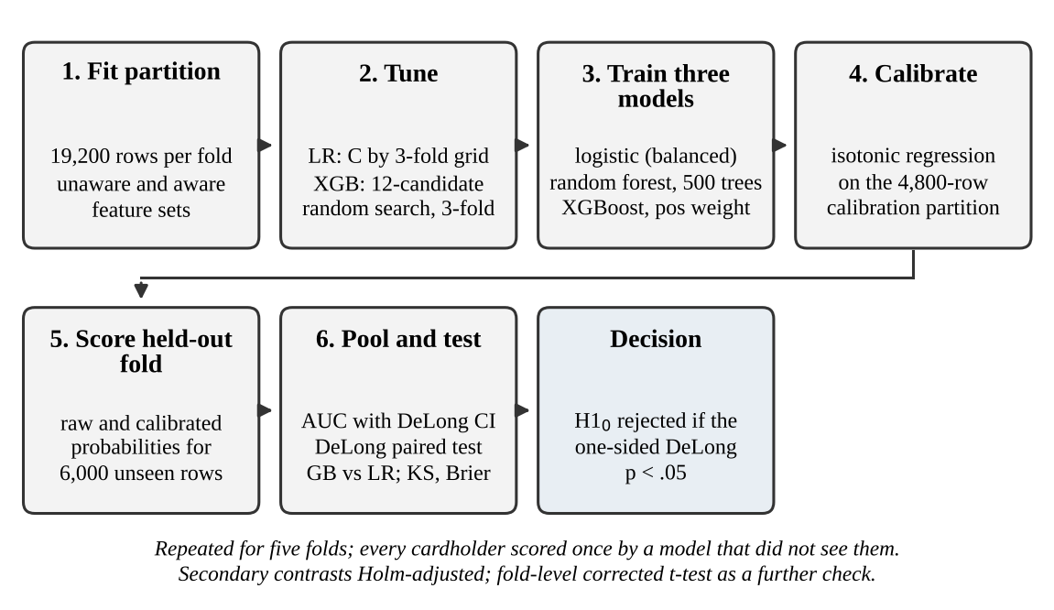
Note. LR = logistic regression; XGB = XGBoost; GB = gradient boosting; CI = confidence interval; KS = Kolmogorov–Smirnov statistic.
For RQ1 the algorithmic components run in order. Folds and partitions are assigned by stratified sampling. The logistic penalty and seven XGBoost hyperparameters are tuned by inner CV on the fit partition, the three models are trained on that partition, and their probabilities are recalibrated by isotonic regression on the calibration partition. The held-out fold is scored, the five held-out folds are pooled into one evaluation set of 30,000, and the pre-specified paired DeLong contrast is run with the secondary contrasts Holm-adjusted. This sequence runs twice, once for the unaware feature set and once for the aware set.
Figure 7
Workflow for RQ2, Outcome Disparity
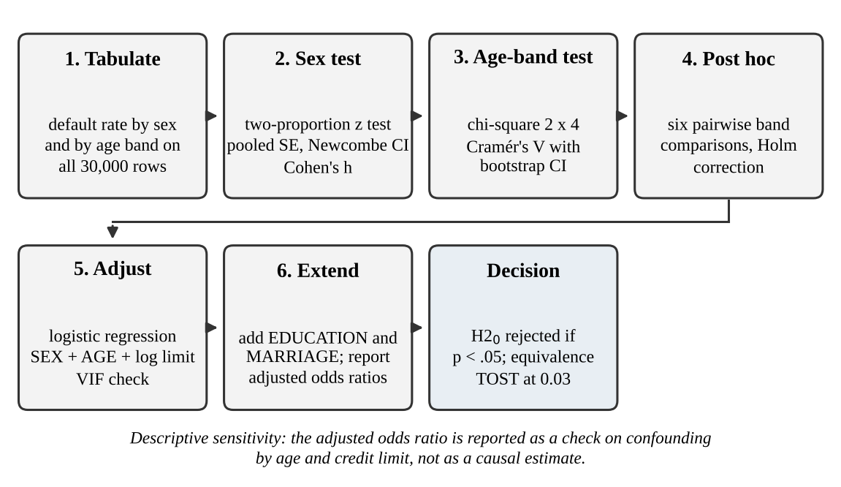
Note. SE = standard error; VIF = variance inflation factor; TOST = two one-sided tests.
RQ2 needs no model. Default rates are tabulated by sex and by age band on the full file. The sex difference gets the two-proportion test with a Newcombe interval and Cohen's h, and the age bands get the chi-square test with Cramér's V, a bootstrap interval, and six Holm-adjusted pairwise comparisons. A logistic regression of DEFAULT on sex, age, and log credit limit, with a collinearity check, gives the adjusted sex effect, and an extended regression adds education and marital status. An equivalence test at a margin of 0.03 asks whether the sex gap is small enough to be immaterial by the planning threshold.
Figure 8
Workflow for RQ3, Fairness at a Simulated Cut-off
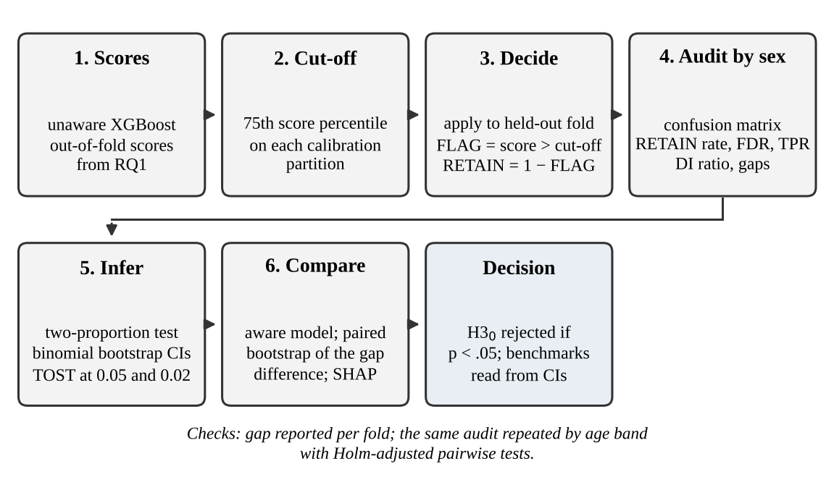
Note. FDR = false-decline rate; TPR = true-positive rate; DI = disparate impact ratio; SHAP = Shapley additive explanations.
RQ3 takes the unaware XGBoost scores from RQ1. In each fold the 75th percentile of the calibration partition's scores becomes the cut-off, which is applied to the held-out fold to produce FLAG and RETAIN. Pooled decisions are audited by sex through confusion matrices, from which the retention rate, false-decline rate, true-positive rate, disparate impact ratio, and gaps follow. Inference uses the two-proportion test on the false-decline rate, binomial bootstrap intervals on every measure, and equivalence tests at margins of 0.05 and 0.02. The audit is repeated for the aware model and the paired bootstrap of the gap difference tests whether unawareness changed anything. SHAP attributions by sex, computed on fold 0, list the candidate carriers of the gap, and the audit is repeated by age band.
Figure 9
Workflow for RQ4, Mitigation Trade-offs
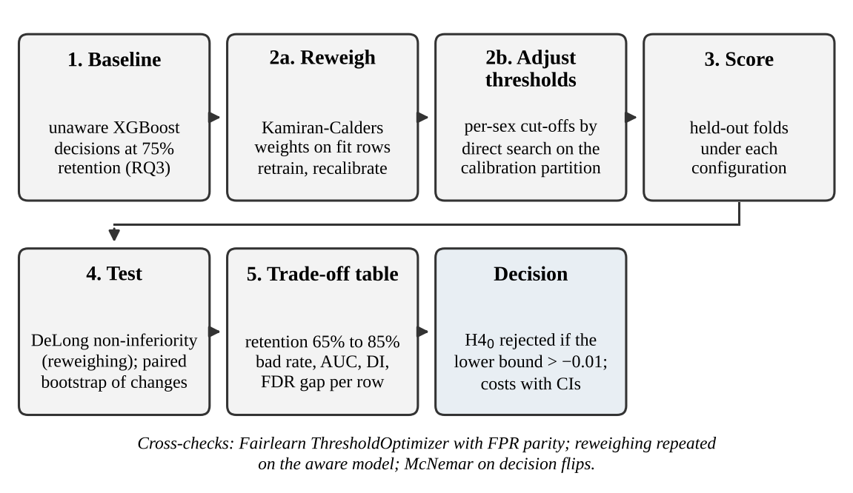
Note. Reweighing and threshold adjustment are applied separately to the RQ3 baseline and judged on different measures.
RQ4 applies two mitigations to the RQ3 baseline. Reweighing computes Kamiran–Calders weights on each fold's fit partition, retrains XGBoost with the tuned hyperparameters and those weights, recalibrates the cut-off, and scores the held-out fold, after which the paired DeLong non-inferiority test and the fairness audit follow. Threshold adjustment keeps the scores and searches the calibration partition for the pair of per-sex thresholds that equalises the false-decline rates while holding overall retention at 75%, then applies them to the held-out fold. Fairlearn's ThresholdOptimizer is run as a cross-check. A trade-off table repeats the audit at retention rates of 65% to 85% for the unmitigated and both mitigated configurations, and the paired bootstrap tests every change in gap, disparate impact, and default rate among retained cardholders. Reweighing is also applied to the aware model to test whether its effect depends on the model seeing the attribute.

Results
All results are computed on the pooled held-out predictions and decisions of the 30,000 cardholders. Unless stated, the feature set is the unaware set. Effect sizes carry 95% intervals and every hypothesis decision is at α = .05. Appendix D lists the 30 tests with their statistics, assumptions, and decisions.

RQ1: Predictive Performance
Table 4 reports the discrimination and calibration of the three models. XGBoost reached an AUC of .784, 95% CI [.778, .791], and random forest .784 [.777, .790], against logistic regression at .755 [.748, .762]. The pre-specified paired contrast gave a difference of .029 in favour of XGBoost, 95% CI [.026, .033], DeLong z = 15.66, one-sided p < .001, with a paired-AUC correlation of .85. H1₀ was rejected. The secondary contrasts, Holm-adjusted, found random forest ahead of logistic regression by .029 [.025, .033], z = 14.38, p < .001, and no difference between XGBoost and random forest, .0004 [−.0012, .0020], z = 0.50, p = .62. The fold-level Nadeau–Bengio corrected t-test agreed, t(4) = 9.85, one-sided p < .001, with the XGBoost advantage over logistic regression lying between .024 and .032 in every fold (Table 5). Adding the three demographic fields raised the XGBoost AUC by .0015 to .786 [.779, .792] and the logistic AUC by .0018. Those fields carry almost nothing the repayment and balance history does not. KS was .43 for both ensembles and .40 for logistic regression. Before recalibration the Brier scores were .179 for XGBoost and .166 for random forest, the former inflated by the class-weighting. After isotonic recalibration both were .135 against .143 for logistic regression. The Hosmer–Lemeshow test on the recalibrated XGBoost probabilities rejected at χ²(8) = 19.02, p = .015, with the largest decile deviation between observed and mean predicted default rates at 1.3 percentage points. At N = 30,000 the test is sensitive to deviations of that size, and the reliability plot (Figure 10) lies on the diagonal across all ten deciles. At this sample size and power .80 the minimum detectable AUC difference was .005. F1 at the 75% retention cut-off was .544 for XGBoost and .516 for logistic regression.
Table 4
Model Performance on Pooled Held-Out Folds (N = 30,000)
Feature set | Model | AUC [95% CI] | KS | Brier, raw | Brier, calibrated | F1 at cut-off
Unaware | Logistic regression | .755 [.748, .762] | .399 | .196 | .143 | .516
Unaware | Random forest | .784 [.777, .790] | .430 | .166 | .135 | .545
Unaware | XGBoost | .784 [.778, .791] | .428 | .179 | .135 | .544
Aware | Logistic regression | .756 [.750, .763] | .398 | .195 | .143 | .517
Aware | Random forest | .784 [.778, .791] | .429 | .165 | .134 | .546
Aware | XGBoost | .786 [.779, .792] | .428 | .179 | .134 | .544
Note. AUC intervals by DeLong et al. (1988). The cut-off for F1 retains 75% of cardholders and is set on each fold's calibration partition. Calibrated Brier scores use isotonic regression fitted on the calibration partition.
Table 5
Pre-specified and Secondary AUC Contrasts, Unaware Feature Set
Contrast | AUC difference [95% CI] | z | p (Holm) | Paired correlation | Decision
XGBoost vs logistic (pre-specified, one-sided) | .029 [.026, .033] | 15.66 | < .001 | .85 | Reject H1₀
Random forest vs logistic (secondary) | .029 [.025, .033] | 14.38 | < .001 | .83 | Reject
XGBoost vs random forest (secondary) | .0004 [−.0012, .0020] | 0.50 | .62 | .97 | Retain
XGBoost vs logistic, fold-level corrected t-test | .029 [.021, .038] | t(4) = 9.85 | < .001 |  | Reject
Note. Holm adjustment applies to the three secondary two-sided contrasts. The fold-level test uses the Nadeau and Bengio (2003) variance correction for overlapping training sets.
Figure 10
ROC Curves and Reliability by Decile, Unaware Feature Set
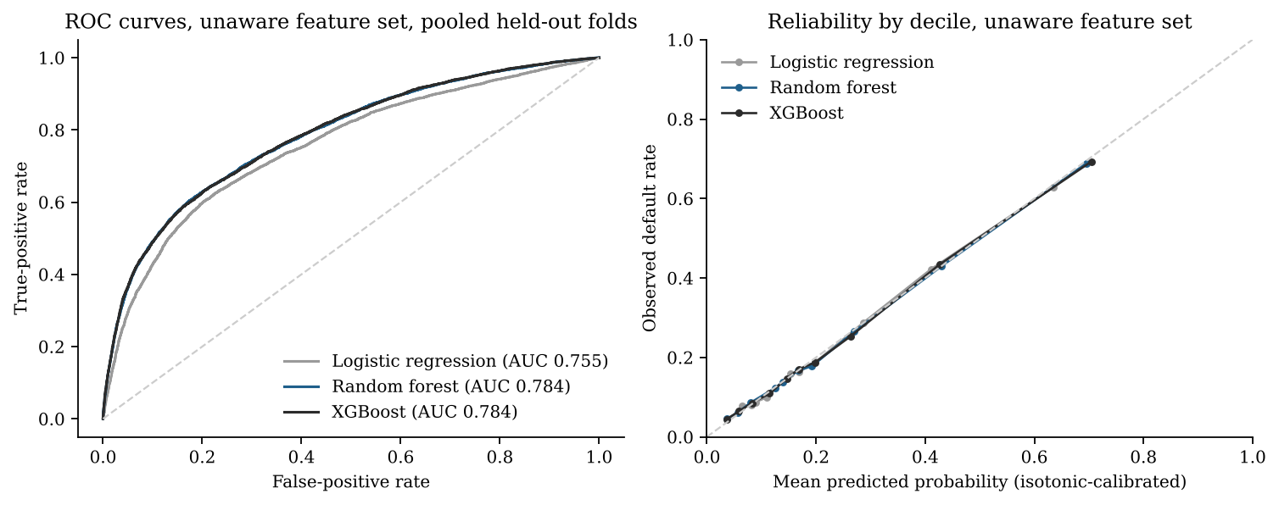
Note. Reliability uses isotonic-calibrated probabilities. Curves are computed on the pooled held-out folds.

RQ2: Outcome Disparity
Men defaulted at 24.17% (2,873 of 11,888) and women at 20.78% (3,763 of 18,112). The difference of 3.39 percentage points, Newcombe 95% CI [2.42, 4.36], was significant, z = 6.92, p < .001. H2₀ was rejected. Cohen's h was .08, a small effect, and the minimum detectable difference at this sample size was 1.4 points. An equivalence test at the planning margin of 0.03 did not find the gap within the margin (upper one-sided p = .79), so the difference is material by the threshold set in the synopsis. Across age bands (Table 6) the default rate was 22.8% under 30, 20.3% at 30 to 39, 23.0% at 40 to 49, and 25.3% at 50 and over. The chi-square test rejected independence, χ²(3) = 44.11, p < .001, with Cramér's V = .038, bootstrap 95% CI [.027, .050], a negligible effect by Cohen's benchmark (w < .10). Five of the six Holm-adjusted pairwise comparisons were significant, the exception being under-30 against 40 to 49 (difference −0.1 points, p = .85). The largest was 30 to 39 against 50 and over, −5.0 points [−6.9, −3.3], p < .001.
Adjustment reduced but did not remove the sex difference. Unadjusted, the odds ratio for male was 1.22, 95% CI [1.15, 1.28]. Controlling for age and log credit limit, the adjusted odds ratio was 1.12 [1.06, 1.18], Wald z = 3.88, p < .001, and the average marginal difference in predicted default fell from 3.39 to 1.88 points. Credit limit was the dominant covariate (odds ratio 0.64 per log unit [0.63, 0.66]) and age a weak positive one (1.009 per year [1.006, 1.012]), and variance inflation factors were at most 1.03. Adding education and marital status left the male odds ratio at 1.14 [1.07, 1.20], z = 4.39, p < .001. Men have a lower median credit limit than women (NT$130,000 against NT$150,000), so roughly half of the raw sex gap in default is accounted for by the limits the issuer had set before the observation window. These are descriptive adjustments. I do not read them causally, because the limit-setting process that produced them is unobserved.
Table 6
Default Rate by Sex and Age Band With Tests
Group | n | Default rate [95% CI] | Comparison | Difference [95% CI] | Test statistic | p
Male | 11,888 | 24.17% [23.40, 24.94] | Male − female | 3.39 [2.42, 4.36] | z = 6.92 | < .001
Female | 18,112 | 20.78% [20.19, 21.37] | Cohen's h | .08
Under 30 | 9,618 | 22.84% [22.00, 23.68] | Independence of DEFAULT and AGE_BAND | Cramér's V = .038 [.027, .050] | χ²(3) = 44.11 | < .001
30 to 39 | 11,238 | 20.25% [19.51, 21.00] | 30 to 39 vs 50 and over (Holm) | −5.05 [−6.88, −3.27] | z = −5.74 | < .001
40 to 49 | 6,464 | 22.97% [21.95, 24.00] | Under 30 vs 40 to 49 (Holm) | −0.13 [−1.46, 1.19] | z = −0.19 | .85
50 and over | 2,680 | 25.30% [23.65, 26.94] | Adjusted male odds ratio | 1.12 [1.06, 1.18] | z = 3.88 | < .001
Note. Differences in percentage points. The adjusted odds ratio controls for AGE and log LIMIT_BAL. Full pairwise results are in the repository table rq2_age_band_posthoc_holm.csv.

RQ3: Fairness at a Simulated Cut-off
At the cut-off that retained 74.8% of cardholders, the unaware XGBoost model retained 72.3% of men and 76.4% of women, a disparate impact ratio of .946, bootstrap 95% CI [.934, .958], above the .80 benchmark (Table 7). Among cardholders who went on to pay, 17.55% of men and 14.76% of women were flagged: a false-decline gap of 2.79 percentage points, Newcombe 95% CI [1.82, 3.77], z = 5.68, p < .001. H3₀ was rejected. In all five folds the gap was positive, ranging from 1.97 to 4.33 points with a standard deviation of 0.96. The equivalence test at the ±0.05 benchmark rejected non-equivalence (upper one-sided p < .001), so the gap is within the benchmark by test as well as by interval, whereas the equivalence test at ±0.02 did not (p = .94). Among defaulters, 59.6% of men and 57.2% of women were flagged. That true-positive gap of 2.37 points [−0.03, 4.75], z = 1.94, p = .053, did not reach significance. Among retained cardholders the default rate was 13.5% for men and 11.6% for women, 12.4% overall. Figure 11 shows the three measures with intervals for the four configurations audited.
Table 7
Fairness Audit at 75% Simulated Retention, by Configuration
Configuration | Retention, male / female | DI ratio [95% CI] | FDR, male / female | FDR gap [95% CI] | z, p | TPR gap [95% CI]
XGBoost, unaware (primary) | .723 / .764 | .946 [.934, .958] | .176 / .148 | .028 [.018, .038] | 5.68, < .001 | .024 [.000, .050]
XGBoost, aware | .715 / .768 | .931 [.919, .942] | .183 / .145 | .038 [.028, .048] | 7.77, < .001 | .041 [.018, .065]
Logistic, unaware | .727 / .766 | .949 [.937, .961] | .179 / .156 | .023 [.014, .034] | 4.55, < .001 | .038 [.013, .061]
Random forest, unaware | .724 / .763 | .949 [.938, .961] | .174 / .149 | .025 [.016, .035] | 5.16, < .001 | .021 [−.002, .045]
Note. DI = disparate impact ratio on RETAIN. FDR = false-decline rate among non-defaulters. TPR = true-positive rate among defaulters. Intervals are 1,000-draw stratified bootstrap percentiles. Cut-offs set per fold on the calibration partition.
Figure 11
Fairness Measures With 95% Intervals for Four Model Configurations
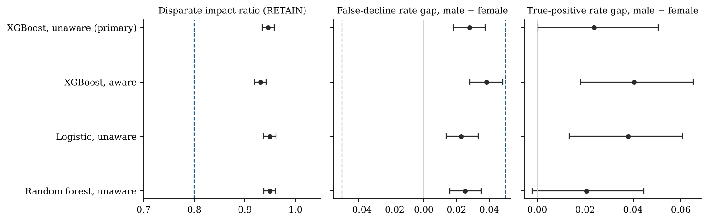
Note. Dashed lines mark the .80 benchmark for the DI ratio and the ±.05 benchmark for the false-decline gap.
Including sex, education, and marital status as inputs widened the gap. The aware XGBoost model's false-decline gap was 3.82 points [2.83, 4.84]. The paired stratified bootstrap of the difference between the two models' gaps on the same individuals gave 1.03 points, 95% CI [0.66, 1.40], bootstrap p < .001. Excluding the attributes narrowed the gap by about one point. It did not remove it. Table 8 holds the per-sex confusion matrices behind every figure in this section. The SHAP decomposition on fold 0 (Figure 12) placed MAX_DELAY (mean |SHAP| .44), PAY_0 (.32), LIMIT_BAL (.14), UTILISATION (.14), and BILL_AMT1 (.13) as the five largest contributors overall. Three of them raised male risk relative to female risk on average: MAX_DELAY by .029 log-odds, LIMIT_BAL by .022, and PAY_0 by .017. Two of them, MAX_DELAY and PAY_0, reflect worse repayment histories among men in the file. LIMIT_BAL reflects the lower credit limits the issuer had assigned to men, the proxy mechanism the EDA anticipated. SHAP values on one fold are candidates for investigation, and I would not read them as proof that a feature acts as a proxy.
Table 8
Per-Sex Confusion Matrices at 75% Retention, Unaware and Aware XGBoost
Configuration | Sex | n | TP | FP | FN | TN | Retain rate | FDR | TPR | Default rate, retained
Unaware | Male | 11,888 | 1,711 | 1,582 | 1,162 | 7,433 | .723 | .176 | .596 | .135
Unaware | Female | 18,112 | 2,152 | 2,118 | 1,611 | 12,231 | .764 | .148 | .572 | .116
Aware | Male | 11,888 | 1,741 | 1,648 | 1,132 | 7,367 | .715 | .183 | .606 | .133
Aware | Female | 18,112 | 2,128 | 2,075 | 1,635 | 12,274 | .768 | .145 | .566 | .118
Note. A positive prediction is FLAG = 1. TP = flagged defaulters; FP = flagged non-defaulters (false declines); FN = retained defaulters; TN = retained non-defaulters.
Figure 12
SHAP Attributions by Sex, Unaware XGBoost, Fold 0 Held-Out Rows
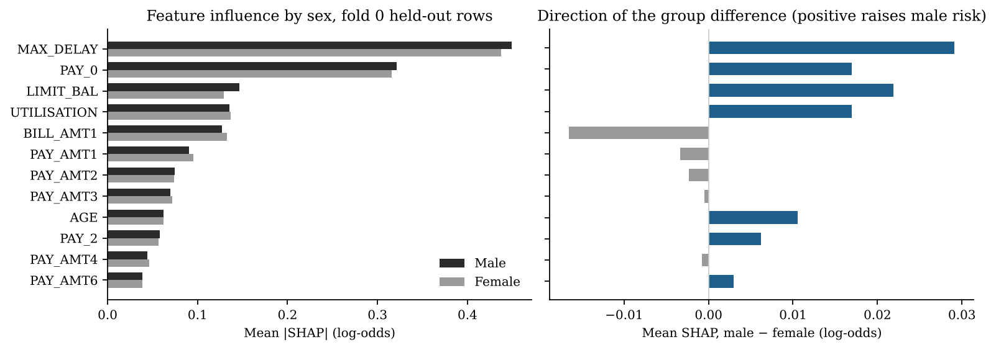
Note. Left: mean absolute attribution by sex. Right: difference in mean attribution, male minus female; positive values raise male predicted risk relative to female.
The same audit by age band (Table 9) found larger differences than by sex. The false-decline rate was 14.1% for cardholders aged 30 to 39 and 20.9% for those 50 and over, a gap of 6.80 points, 95% CI [4.92, 8.76], z = 7.63, Holm-adjusted p < .001. That gap exceeds the ±0.05 benchmark the sex comparison met. Five of the six pairwise band comparisons were significant after Holm correction. Between the 50-and-over band and the 30-to-39 band the disparate impact ratio was .88, above .80. Age band was a secondary attribute in the design, so the age result is reported as a supporting finding and the answer to RQ3 stays with sex. It is, though, the larger disparity in this portfolio.
Table 9
Fairness Audit by Age Band at 75% Retention, Unaware XGBoost
Age band | n | Retention rate | FDR [95% CI] | TPR | Default rate, retained | DI vs 30 to 39
Under 30 | 9,618 | .736 | .163 [.155, .172] | .606 | .122 | .945
30 to 39 | 11,238 | .778 | .141 [.134, .148] | .540 | .120 | 1.000
40 to 49 | 6,464 | .739 | .163 [.152, .173] | .590 | .127 | .950
50 and over | 2,680 | .685 | .209 [.191, .227] | .630 | .137 | .880
Note. FDR intervals are Wald intervals on the group proportion. The largest pairwise FDR difference, 30 to 39 against 50 and over, is 6.80 points [4.92, 8.76], Holm-adjusted p < .001.

RQ4: Mitigation Trade-offs
Reweighing the unaware model was non-inferior on AUC and ineffective on the gap. The reweighed model's AUC was .7839 against .7841 for the baseline, a paired difference of −.0001 with a one-sided 95% lower bound of −.0004, well inside the −.01 margin, z = 54.1, p < .001. H4₀ was rejected and non-inferiority concluded. Paired correlation between the two AUCs was .998, because the Kamiran–Calders weights, computed on each fit partition, lay between 0.92 and 1.06 and the model never saw sex. The false-decline gap moved from 2.79 to 2.69 points, a paired change of −0.10 points, 95% CI [−0.34, 0.14], bootstrap p = .43. Only 263 of 30,000 decisions changed, and the default rate among retained cardholders did not move (+0.00 points [−0.07, 0.07], p = .96). On the aware model, where the weights can act on an attribute the model sees, reweighing was also non-inferior (AUC .7852 against .7856, lower bound −.0008, z = 35.0). There it cut the gap from 3.82 to 1.98 points, a paired change of −1.84 points [−2.11, −1.56], p < .001, again at no cost in bad rate (+0.01 points [−0.07, 0.08], p = .96).
Per-sex threshold adjustment closed the gap at the common 75% retention rate. Set on each fold's calibration partition, the searched thresholds were higher for men than for women in every fold (for example .563 against .549 in fold 0), so men needed a higher risk score to be flagged. On the held-out folds the false-decline gap fell to 0.43 points, 95% CI [−0.51, 1.35], z = 0.87, p = .38, a paired change of −2.36 points [−2.65, −2.07], p < .001. The equivalence test at ±0.02 rejected non-equivalence (upper one-sided p < .001). Disparate impact rose from .946 to .978 [.966, .990]. The cost was a rise in the default rate among retained cardholders from 12.36% to 12.39%, a paired change of 0.03 points [−0.04, 0.11], p = .36. The overall flag rate was unchanged by design, McNemar χ²(1) = 0.28, p = .60, with 357 decisions changed (184 newly flagged, 173 newly retained). Fairlearn's ThresholdOptimizer with a false-positive-rate parity constraint and a balanced-accuracy objective chose a retention rate of 70.2% and reached a gap of 0.97 points [−0.09, 2.09]. At that same retention the direct search gave 0.82 points [−0.21, 1.86], so the two implementations agree.
Table 10 is the trade-off table across retention rates from 65% to 85%, and Figure 13 plots it. Three patterns hold at every retention rate. The unmitigated gap sits between 2.0 and 2.8 points with every interval excluding zero and lying inside ±0.05. Reweighing tracks the unmitigated line within 0.4 points. Threshold adjustment holds the gap between 0.3 and 0.9 points with every interval including zero, raises the disparate impact ratio to .97 or above, and costs at most 0.1 points of default rate among retained cardholders. The default rate among retained cardholders rises from 11.0% at 65% retention to 14.7% at 85% for all three configurations. That rise is the cost of retaining more cardholders, and no mitigation adds to it. AUC is .7841 for the unmitigated and threshold-adjusted configurations by construction and .7839 for reweighing. Neither sensitivity run (Table 11) changed an estimate by more than .001.
Table 10
Trade-off Table Across Simulated Retention Rates
Retention | Configuration | Default rate, retained [95% CI] | AUC | DI ratio | FDR gap [95% CI]
65% | Unmitigated | .110 [.107, .114] | .784 | .943 | .026 [.015, .038]
65% | Reweighing | .110 [.107, .114] | .784 | .949 | .022 [.011, .033]
65% | Threshold adjustment | .111 [.108, .114] | .784 | .972 | .006 [−.005, .017]
70% | Unmitigated | .116 [.113, .120] | .784 | .946 | .027 [.017, .038]
70% | Reweighing | .116 [.113, .120] | .784 | .951 | .024 [.013, .034]
70% | Threshold adjustment | .116 [.113, .120] | .784 | .970 | .009 [−.002, .020]
75% | Unmitigated | .124 [.121, .127] | .784 | .946 | .028 [.018, .038]
75% | Reweighing | .124 [.121, .127] | .784 | .947 | .027 [.018, .037]
75% | Threshold adjustment | .124 [.121, .127] | .784 | .978 | .004 [−.005, .014]
80% | Unmitigated | .135 [.132, .138] | .784 | .949 | .028 [.020, .037]
80% | Reweighing | .135 [.132, .138] | .784 | .951 | .026 [.018, .034]
80% | Threshold adjustment | .136 [.133, .139] | .784 | .978 | .007 [−.001, .016]
85% | Unmitigated | .147 [.145, .150] | .784 | .961 | .020 [.013, .027]
85% | Reweighing | .147 [.145, .150] | .784 | .962 | .019 [.012, .026]
85% | Threshold adjustment | .148 [.145, .151] | .784 | .985 | .003 [−.003, .010]
Note. All configurations use the unaware XGBoost scores. Reweighing AUC is .7839; the others are .7841. Achieved retention rates lie within 0.3 points of the target. Intervals are 1,000-draw stratified bootstrap percentiles.
Figure 13
False-Decline Gap, Disparate Impact Ratio, and Default Rate Among Retained Cardholders Across Retention Rates
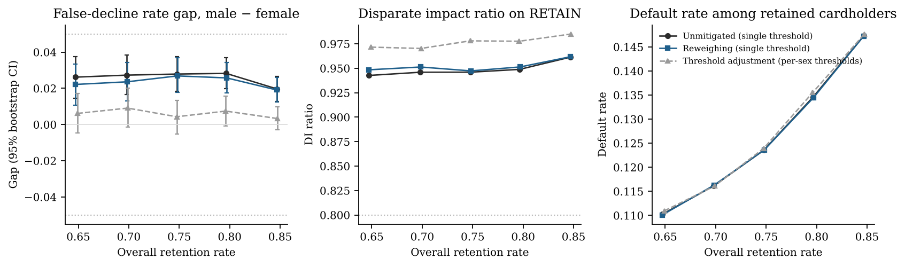
Note. Dotted lines mark the ±.05 benchmark for the gap and the .80 benchmark for the DI ratio.
Table 11
Sensitivity of the Primary Estimates to the Coding Assumptions
Run | AUC [95% CI] | DI ratio | FDR gap [95% CI] | Default rate, retained
Primary: unaware XGBoost | .784 [.778, .791] | .946 | .028 [.018, .038] | .124
A: PAY codes −2 and 0 collapsed (unaware) | .784 [.778, .791] | .945 | .027 [.018, .037] | .124
Primary: aware XGBoost | .786 [.779, .792] | .931 | .038 [.028, .048] | .124
B: undocumented EDUCATION and MARRIAGE merged into other (aware) | .786 [.780, .792] | .929 | .039 [.030, .049] | .123
Note. Sensitivity runs reuse the tuned hyperparameters of the primary run for each fold.

Reproducibility Across Machines
The pipeline was run end to end on two hosts with the same seed: a cloud container (Python 3.13, xgboost 3.4.1, scikit-learn 1.9.1, two cores) and a Linux workspace on an Apple Silicon Mac Studio (Python 3.10, xgboost 3.2.0, scikit-learn 1.6.1, four cores). Checksum, fold assignment, logistic regression AUCs, and every RQ2 statistic matched to four decimals. XGBoost quantities differed by at most .0005 in AUC and .003 in a fairness gap, because the two xgboost versions score the inner-CV candidates slightly differently and the random search selected different hyperparameters in some folds. No decision in the hypothesis register changed between the two runs. Appendix A names the repository file, reproducibility_cross_machine.csv, that holds the full comparison.

Analysis and Discussion

Technical Interpretation
RQ1 confirms the accuracy case at the size the literature predicted. Its three-point AUC gain over logistic regression is within the one to three points Lessmann et al. (2015) reported, it is identical for random forest and XGBoost, and it is stable across folds. Once the class-weighted probabilities are recalibrated the gain carries no calibration cost, and by Brier score the recalibrated ensembles are better calibrated than logistic regression. Demographic fields add .0015 AUC. That near-zero contribution is the first sign that the audit question concerns proxies, because the attributes themselves add nothing the model needs.
RQ2 establishes that the base rates differ, which by Kleinberg et al. (2017) and Chouldechova (2017) rules out a model that is both calibrated within each sex and equal in its error rates across sexes. This study governs to equal opportunity, read as the false-decline rate, and reports calibration separately. Half the raw sex difference in default disappears once credit limit is controlled, and that matters for the mechanism. The issuer's own earlier limit-setting decisions are part of what the model learns, alongside the cardholders' behaviour. The age-band association, though significant, is negligible in effect size, and the U shape means a linear age term would not capture it.
RQ3 answers the question lenders usually answer with a policy statement. The unaware model does treat creditworthy men and women differently, by 2.8 points in the false-decline rate, and the difference is statistically unambiguous, reproducible across folds, and within the ±0.05 benchmark by equivalence test. The two readings sit together without strain, because a gap can be real and acceptable at once. The equivalence test at ±0.02 shows exactly where the benchmark would stop accepting it. Pairing the unaware model with the aware one gives fairness through unawareness its number. Excluding sex narrowed the gap by one point and left 2.8 points. That agrees with Mehrabi et al. (2021) and with the SHAP result that repayment history and credit limit, both legitimately predictive, carry the group difference. The true-positive gap did not reach significance, so the lender-risk reading of equal opportunity is less affected than the borrower reading. The study made the borrower reading primary for that reason.
RQ4 separates the two mitigations more sharply than the synopsis anticipated. Reweighing's non-inferiority on AUC was trivially satisfied because the method barely changed the unaware model, and the paired test shows it did not change the gap either. On the aware model the same weights halved the gap. The mechanism is simple. Weights indexed by sex can only shift a model that has sex as an input or strong proxies for it, and the unaware model's proxies (limit, utilisation, repayment codes) are left where they were by weights that depend on sex and outcome alone. Threshold adjustment acts directly on the decision. It closed the gap to within ±0.02 at a cost of 0.03 points of bad rate, a cost the paired bootstrap cannot distinguish from zero. Fairlearn's ThresholdOptimizer confirms the direct search. None of this depends on the 75% operating point. The unmitigated gap, the failure of reweighing on the unaware model, and the near-zero cost of threshold adjustment all hold from 65% to 85% retention in the trade-off table.

Business Implications
For the chief risk officer and the validation unit, the first implication is that the fairness attestation can be a number. At the lender's chosen cut-off the audit yields a retention rate by group, a disparate impact ratio with an interval, and a default rate among retained customers. It also yields the false-decline gap with an interval and an equivalence verdict against a stated tolerance. Each row of Table 10 is a configuration a committee can sign, with the cost of each alternative visible beside it. A process attestation (protected attributes excluded) becomes an outcome attestation (gap of 2.8 points, within a 5-point tolerance, outside a 2-point tolerance). The RBI FREE-AI recommendations on disclosure of AI-driven credit assessments would, if adopted, require a regulated entity to produce exactly that (Reserve Bank of India, 2025).
For the head of retail credit, the second implication is that the operating cut-off is a fairness lever as well as a credit lever. In the trade-off table the gap narrows as retention rises, from 2.8 points at 75% to 2.0 points at 85%, at a cost of 2.4 points of bad rate among retained customers. A lender that wants to narrow the gap without group-specific thresholds has that option, and the table prices it. For the compliance function, the third implication concerns the choice of mitigation. Per-sex thresholds are the effective fix in this portfolio, but they require the protected attribute at decision time and amount to disparate treatment in several jurisdictions. Reweighing, the single-threshold option that avoids that problem, does not work on a model that cannot see the attribute. For an Indian lender the legally safer method is the one that does not work here, and the question belongs to legal review before it belongs to the model team. For the mid-sized NBFC buying scores from a vendor, the fourth implication is that the audit needs only scores, outcomes, and the protected attribute joined at evaluation time. It works as an independent check on a vendor model with no access to the model's internals.
A fifth implication is one the study did not set out to find. The false-decline gap by age band, 6.8 points between cardholders aged 30 to 39 and those 50 and over, is more than twice the sex gap and outside the benchmark the sex audit met. A validation unit that audits only the attribute the policy names would have certified this model and missed the larger disparity. What follows is a recommendation that the audit be run on every attribute the lender treats as protected, and on age whether or not it is formally protected, before a benchmark verdict is recorded.

Synthesis Against the Hypotheses
Table 12 consolidates the decisions. H1₀ was rejected: gradient boosting outperforms logistic regression by .029 AUC. H2₀ and H2b₀ were rejected: default rates differ by sex by 3.4 points and by age band with a negligible effect size, and the sex difference halves under adjustment for credit limit. H3₀ was rejected: the false-decline rate differs by sex by 2.8 points at 75% retention, within the ±0.05 benchmark by equivalence test and outside ±0.02, with the disparate impact benchmark met. H4₀ was rejected for reweighing on both models: the method is non-inferior on AUC, and it is effective only on the aware model. Threshold adjustment closed the gap to within ±0.02 at a decision-level cost not distinguishable from zero. Taken together, the findings support the position stated in the introduction. In this portfolio the fairness of the deployed model is decided by the threshold and by what the model is allowed to see. A policy statement that sex was excluded decides nothing.
Table 12
Summary of Hypothesis Decisions
RQ | Hypothesis | Key statistic | Effect [95% CI] | Decision
RQ1 | H1₀: AUC_{GB} = AUC_{LR} | DeLong z = 15.66, p < .001 | ΔAUC = .029 [.026, .033] | Rejected; XGBoost superior
RQ2 | H2₀: p_{male} = p_{female} | z = 6.92, p < .001 | 3.39 points [2.42, 4.36]; adjusted OR 1.12 [1.06, 1.18] | Rejected; difference material at 0.03
RQ2 | H2b₀: DEFAULT independent of AGE_BAND | χ²(3) = 44.11, p < .001 | Cramér's V = .038 [.027, .050] | Rejected; negligible effect
RQ3 | H3₀: FDR_{male} = FDR_{female} | z = 5.68, p < .001; TOST(.05) p < .001; TOST(.02) p = .94 | 2.79 points [1.82, 3.77]; DI = .946 [.934, .958] | Rejected; within ±.05, outside ±.02; DI benchmark met
RQ3 | Unawareness effect = 0 | paired bootstrap p < .001 | 1.03 points [0.66, 1.40] | Rejected; aware model has the larger gap
RQ4 | H4₀: AUC_{RW} ≤ AUC_{base} − .01 (unaware) | z = 54.1, p < .001 | ΔAUC = −.0001, lower bound −.0004; Δgap −0.10 [−0.34, 0.14] | Rejected (non-inferior); gap unchanged
RQ4 | H4₀ (aware model) | z = 35.0, p < .001 | ΔAUC = −.0004; Δgap −1.84 [−2.11, −1.56] | Rejected (non-inferior); gap halved
RQ4 | Threshold adjustment: Δgap = 0; Δbad rate = 0 | paired bootstrap p < .001; p = .36 | Δgap −2.36 [−2.65, −2.07]; Δbad +0.03 [−0.04, 0.11] | Gap closed within ±.02; cost not distinguishable from zero
Note. Differences in gaps and bad rates are in percentage points. OR = odds ratio. TOST = two one-sided tests at the stated margin.

Implementation

Practical Deployment as a Validation Artefact
The deliverable is an audit, not a scoring model. A lender runs it as a step in model validation, after a candidate model has produced held-out scores and before the cut-off is signed. Its inputs are three columns joined at evaluation time: the held-out score, the observed outcome, and the protected attribute. Its outputs are the fairness table (Table 7), the trade-off table (Table 10), and the hypothesis register (Appendix D), which together form the decision record. A credit policy committee selects a row of the trade-off table, and the row, its date, and the signatory are recorded in the model inventory. The committee's tolerance, here DI ≥ .80 and |gap| ≤ .05 as research benchmarks, is set in advance and treated as a hard gate. Once set, it is never traded against bad rate, and the cost of meeting it is recorded as the price of the policy, a line the committee owns and the modelling team does not. For a lender that buys scores from a vendor, the same three columns suffice, so the audit runs without access to the vendor's model.

Algorithmic Steps
The pipeline in Figure 1 runs as a sequence of scripts under a Makefile, each writing its outputs to a results folder from which every table and figure in this report was generated. Stage 1 fetches the data file, verifies its checksum, applies the recoding in Table 2, and builds the engineered variables. Stage 2 assigns the five outer folds and the fit and calibration partitions, keyed on the identifier and stratified by sex and outcome. It saves the assignment to disk, so every later stage uses identical splits. Stage 3 trains the three model families on each fit partition with inner-CV tuning, fits isotonic recalibration on the calibration partition, and scores both the calibration partition and the held-out fold, for the unaware and aware feature sets. Stage 4 sets the retention cut-off, the per-sex thresholds by direct search, and the reweighing weights, all on the calibration partition only, then retrains the reweighed model on the fit partition. Stage 5 scores the held-out folds under every configuration, pools them, and computes the performance measures, fairness measures, bootstrap intervals, and formal tests. Stage 6 assembles the trade-off table, the hypothesis register, and the figures. A validation analyst applies the audit to a new portfolio by pointing the download step at the lender's own extract with the same column names, or by supplying the three evaluation columns directly to stages 4 to 6.

Human and Machine Requirements for Reproducibility
The code is Python 3.10 or later with pandas, scikit-learn, XGBoost, Fairlearn, SHAP, statsmodels, and matplotlib, pinned in a requirements file, with a second file of compatible versions for Python 3.10. Every random process uses the seed 640 and the fold assignment is written to disk. A rerun reproduces the same held-out predictions on the same library versions, and on different versions it agreed to within .003 in the cross-machine comparison. A full run takes about seven minutes on two cores and under four on four cores. The 1,000-draw bootstraps are exact binomial draws and take seconds. Memory use is under 2 GB. Appendix A gives the repository layout and run instructions. On the human side, the requirement is a validation analyst who can run a Makefile and read a confusion matrix. The interpretive requirement is a credit policy committee that sets the tolerance in advance and a legal function that rules on whether group-specific thresholds are permissible in the lender's jurisdiction. The pipeline reports the cost of each option. It does not choose between them.

Limitations and Next Steps
The first limitation is the data. The file describes one Taiwanese card issuer in 2005, over-represents women (60%) and university graduates (82% with a degree), and records one issuer's collection outcome in one month. A model that learns it inherits any unevenness in how that issuer pursued late payers. It holds no income, no bureau score, and no regional field, and the attributes an Indian lender would audit first, such as religion, caste, or state, are absent. What transfers to Indian retail lending is the audit method and the decision table. Nothing here is a finding about Indian borrowers. Replication on a second portfolio that carries a sex field and a default outcome is the next step. Two public candidates pass that filter: the Home Credit Default Risk data (307,511 applications with a gender field) and the Bondora peer-to-peer lending data (about 180,000 loans with gender, age, and country). Three patterns would need to reproduce there: unawareness narrows the gap without removing it, reweighing works only when the model sees the attribute, and threshold adjustment closes the gap at negligible bad-rate cost. If they did, a single-portfolio result would become a general one.
The second limitation is the setting. Because the data observe customers who already held credit, every decision in this study is a retention simulation and nothing can be said about approval. A lender's real approval decision operates on applicants the file does not contain, and reject inference, which was out of scope, would be needed to extend the audit to that population. The 75% retention cut-off is a stated scenario and no issuer's observed policy. A trade-off table softens that choice but cannot remove it.
The third limitation is the fairness criteria. This study governs to equal opportunity and disparate impact and reports equalized odds. It does not test calibration within groups or any individual-fairness criterion, and by Kleinberg et al. (2017) a model that satisfies the criteria used here will not satisfy within-group calibration when base rates differ. Both benchmarks, .80 and ±.05, are research conventions borrowed from employment-selection practice and have no standing in Indian credit regulation, and the equivalence test at ±.02 shows how much the verdict depends on the tolerance chosen. The age-band finding shows that an audit confined to one attribute can certify a model that fails on another. A multi-attribute audit with intersectional cells is the next step there. The sample supports sex by age band, but finer intersections run out of defaulters per cell.
The fourth limitation is the mitigation set. Two methods were tested, one pre-processing and one post-processing. In-processing methods such as constrained optimisation or adversarial debiasing were out of scope. They might close the gap under a single threshold, and a single threshold is the configuration the legal constraint favours. What the reweighing result covers is Kamiran–Calders weights indexed by sex and outcome only, and it and does not rule out reweighing schemes indexed by proxies. The threshold search used one parameterisation and the Fairlearn cross-check one constraint. Both agreed, but neither explores randomised thresholds, which Hardt et al. (2016) showed can be needed for exact equalized odds. The SHAP decomposition was computed on one fold. It identifies candidate carriers of the gap, and I make no causal claim from it.
The fifth limitation is statistical. The Hosmer–Lemeshow test rejected at N = 30,000 for a deviation of 1.3 points in one decile. At that sample size the test detects deviations no committee would act on, so the reliability plot is the better evidence. A 12-candidate random search for XGBoost was chosen for a two-core budget, and a wider search raised the inner-CV AUC by less than .002 in a spot check and would not change the contrasts. Minimum detectable effects at N = 30,000 were .005 AUC and 1.4 points of default rate. Smaller differences than those reported cannot be excluded, and none were claimed. In order of value, the next steps are the second-portfolio replication, the multi-attribute audit with age as a named attribute, and a single-threshold in-processing method tested on the same folds with the same paired inference.

References
Barocas, S., Hardt, M., & Narayanan, A. (2019). Fairness and machine learning: Limitations and opportunities. fairmlbook.org. https://fairmlbook.org
Bartlett, R., Morse, A., Stanton, R., & Wallace, N. (2022). Consumer-lending discrimination in the FinTech era. Journal of Financial Economics, 143(1), 30–56. https://doi.org/10.1016/j.jfineco.2021.05.047
Berg, T., Burg, V., Gombović, A., & Puri, M. (2020). On the rise of FinTechs: Credit scoring using digital footprints. The Review of Financial Studies, 33(7), 2845–2897. https://doi.org/10.1093/rfs/hhz099
Bird, S., Dudík, M., Edgar, R., Horn, B., Lutz, R., Milan, V., Sameki, M., Wallach, H., & Walker, K. (2020). Fairlearn: A toolkit for assessing and improving fairness in AI (Technical Report MSR-TR-2020-32). Microsoft. https://www.microsoft.com/en-us/research/publication/fairlearn-a-toolkit-for-assessing-and-improving-fairness-in-ai/
Breiman, L. (2001). Random forests. Machine Learning, 45(1), 5–32. https://doi.org/10.1023/A:1010933404324
Chen, T., & Guestrin, C. (2016). XGBoost: A scalable tree boosting system. In Proceedings of the 22nd ACM SIGKDD International Conference on Knowledge Discovery and Data Mining (pp. 785–794). ACM. https://doi.org/10.1145/2939672.2939785
Chouldechova, A. (2017). Fair prediction with disparate impact: A study of bias in recidivism prediction instruments. Big Data, 5(2), 153–163. https://doi.org/10.1089/big.2016.0047
Cohen, J. (1988). Statistical power analysis for the behavioral sciences (2nd ed.). Lawrence Erlbaum Associates.
Corbett-Davies, S., & Goel, S. (2018). The measure and mismeasure of fairness: A critical review of fair machine learning (arXiv:1808.00023). arXiv. https://doi.org/10.48550/arXiv.1808.00023
DeLong, E. R., DeLong, D. M., & Clarke-Pearson, D. L. (1988). Comparing the areas under two or more correlated receiver operating characteristic curves: A nonparametric approach. Biometrics, 44(3), 837–845. https://doi.org/10.2307/2531595
Dwork, C., Hardt, M., Pitassi, T., Reingold, O., & Zemel, R. (2012). Fairness through awareness. In Proceedings of the 3rd Innovations in Theoretical Computer Science Conference (pp. 214–226). ACM. https://doi.org/10.1145/2090236.2090255
European Parliament & Council of the European Union. (2024). Regulation (EU) 2024/1689 of the European Parliament and of the Council of 13 June 2024 laying down harmonised rules on artificial intelligence (Artificial Intelligence Act). Official Journal of the European Union, L, 2024/1689. https://eur-lex.europa.eu/eli/reg/2024/1689/oj
Feldman, M., Friedler, S. A., Moeller, J., Scheidegger, C., & Venkatasubramanian, S. (2015). Certifying and removing disparate impact. In Proceedings of the 21st ACM SIGKDD International Conference on Knowledge Discovery and Data Mining (pp. 259–268). ACM. https://doi.org/10.1145/2783258.2783311
Fleiss, J. L., Levin, B., & Paik, M. C. (2003). Statistical methods for rates and proportions (3rd ed.). John Wiley & Sons. https://doi.org/10.1002/0471445428
Friedman, J. H. (2001). Greedy function approximation: A gradient boosting machine. The Annals of Statistics, 29(5), 1189–1232. https://doi.org/10.1214/aos/1013203451
Fuster, A., Goldsmith-Pinkham, P., Ramadorai, T., & Walther, A. (2022). Predictably unequal? The effects of machine learning on credit markets. The Journal of Finance, 77(1), 5–47. https://doi.org/10.1111/jofi.13090
Hand, D. J., & Henley, W. E. (1997). Statistical classification methods in consumer credit scoring: A review. Journal of the Royal Statistical Society: Series A (Statistics in Society), 160(3), 523–541. https://doi.org/10.1111/j.1467-985X.1997.00078.x
Hanley, J. A., & McNeil, B. J. (1982). The meaning and use of the area under a receiver operating characteristic (ROC) curve. Radiology, 143(1), 29–36. https://doi.org/10.1148/radiology.143.1.7063747
Hardt, M., Price, E., & Srebro, N. (2016). Equality of opportunity in supervised learning. In D. D. Lee, M. Sugiyama, U. V. Luxburg, I. Guyon, & R. Garnett (Eds.), Advances in Neural Information Processing Systems 29 (pp. 3315–3323). Curran Associates.
Holm, S. (1979). A simple sequentially rejective multiple test procedure. Scandinavian Journal of Statistics, 6(2), 65–70.
Hosmer, D. W., Lemeshow, S., & Sturdivant, R. X. (2013). Applied logistic regression (3rd ed.). John Wiley & Sons. https://doi.org/10.1002/9781118548387
Kamiran, F., & Calders, T. (2012). Data preprocessing techniques for classification without discrimination. Knowledge and Information Systems, 33(1), 1–33. https://doi.org/10.1007/s10115-011-0463-8
Khandani, A. E., Kim, A. J., & Lo, A. W. (2010). Consumer credit-risk models via machine-learning algorithms. Journal of Banking & Finance, 34(11), 2767–2787. https://doi.org/10.1016/j.jbankfin.2010.06.001
Kleinberg, J., Mullainathan, S., & Raghavan, M. (2017). Inherent trade-offs in the fair determination of risk scores. In C. H. Papadimitriou (Ed.), 8th Innovations in Theoretical Computer Science Conference (ITCS 2017) (LIPIcs Vol. 67, pp. 43:1–43:23). Schloss Dagstuhl. https://doi.org/10.4230/LIPIcs.ITCS.2017.43
Kozodoi, N., Jacob, J., & Lessmann, S. (2022). Fairness in credit scoring: Assessment, implementation and profit implications. European Journal of Operational Research, 297(3), 1083–1094. https://doi.org/10.1016/j.ejor.2021.06.023
Lessmann, S., Baesens, B., Seow, H.-V., & Thomas, L. C. (2015). Benchmarking state-of-the-art classification algorithms for credit scoring: An update of research. European Journal of Operational Research, 247(1), 124–136. https://doi.org/10.1016/j.ejor.2015.05.030
Lundberg, S. M., & Lee, S.-I. (2017). A unified approach to interpreting model predictions. In I. Guyon, U. V. Luxburg, S. Bengio, H. Wallach, R. Fergus, S. Vishwanathan, & R. Garnett (Eds.), Advances in Neural Information Processing Systems 30 (pp. 4765–4774). Curran Associates.
Mehrabi, N., Morstatter, F., Saxena, N., Lerman, K., & Galstyan, A. (2021). A survey on bias and fairness in machine learning. ACM Computing Surveys, 54(6), Article 115. https://doi.org/10.1145/3457607
Nadeau, C., & Bengio, Y. (2003). Inference for the generalization error. Machine Learning, 52(3), 239–281. https://doi.org/10.1023/A:1024068626366
Reserve Bank of India. (2025). FREE-AI Committee report: Framework for Responsible and Ethical Enablement of Artificial Intelligence. https://www.rbi.org.in/scripts/FS_Publications.aspx?id=1306
Rudin, C. (2019). Stop explaining black box machine learning models for high stakes decisions and use interpretable models instead. Nature Machine Intelligence, 1(5), 206–215. https://doi.org/10.1038/s42256-019-0048-x
Schuirmann, D. J. (1987). A comparison of the two one-sided tests procedure and the power approach for assessing the equivalence of average bioavailability. Journal of Pharmacokinetics and Biopharmaceutics, 15(6), 657–680. https://doi.org/10.1007/BF01068419
Sun, X., & Xu, W. (2014). Fast implementation of DeLong's algorithm for comparing the areas under correlated receiver operating characteristic curves. IEEE Signal Processing Letters, 21(11), 1389–1393. https://doi.org/10.1109/LSP.2014.2337313
Uniform Guidelines on Employee Selection Procedures, 29 C.F.R. § 1607 (1978). https://www.ecfr.gov/current/title-29/subtitle-B/chapter-XIV/part-1607
Verma, S., & Rubin, J. (2018). Fairness definitions explained. In Proceedings of the International Workshop on Software Fairness (FairWare '18) (pp. 1–7). ACM. https://doi.org/10.1145/3194770.3194776
Yeh, I.-C. (2009). Default of credit card clients [Data set]. UCI Machine Learning Repository. https://doi.org/10.24432/C55S3H
Yeh, I.-C., & Lien, C.-H. (2009). The comparisons of data mining techniques for the predictive accuracy of probability of default of credit card clients. Expert Systems with Applications, 36(2), 2473–2480. https://doi.org/10.1016/j.eswa.2007.12.020

Appendix A

Repository Layout and Run Instructions
The repository at https://github.com/mriyer-walsh/qm640-credit-fairness holds the code, data dictionary, results, and this report. Clone it, create a Python 3.11 environment, install the pinned dependencies with pip install -r requirements.txt (or requirements-py310.txt on Python 3.10), and run make all. The targets run in order: data (download with checksum, recode, folds), rq2 (exploratory analysis and RQ2), train (fit, calibrate, score), rq1, rq3, rq4, sensitivity, extensions (ThresholdOptimizer cross-check, reweighing on the aware model, age-band audit), register (the hypothesis-test register), and sample-size (the synopsis Table 1). On a host with short per-command limits, PART=unaware:0,1 python3 src/train.py trains a subset of folds and PART=merge assembles the outputs.
qm640-credit-fairness/
|-- README.md results summary and run instructions
|-- requirements.txt pinned dependencies (Python 3.11+)
|-- requirements-py310.txt compatible versions for Python 3.10
|-- Makefile make all | data | train | rq1 .. rq4
|-- data/
| |-- data_dictionary.csv source of Table 2
| |-- raw/ fetched by download.py, not committed
| |-- processed/ clients_clean.parquet, folds, scores
|-- src/
| |-- common.py constants, DeLong, KS, Brier
| |-- download.py fetch, verify SHA-256, structural checks
| |-- prepare.py recoding, engineered variables, folds
| |-- train.py three models, inner-CV tuning, calibration
| |-- policy.py cut-offs, per-sex thresholds, reweighing
| |-- evaluate.py audit, bootstrap, non-inferiority
| |-- sample_size.py reproduces the synopsis Table 1
|-- analysis/ 01_eda .. 08_statistical_depth (scripts)
|-- notebooks/ the same eight steps as notebooks
|-- results/
| |-- tables/ 40 CSV files, one per analysis
| |-- figures/ 8 PNG figures
| |-- reproducibility_cross_machine.csv
|-- reports/ synopsis.pdf, final_report.pdf

Appendix B

Sample-Size Plan From the Synopsis
The synopsis sized each research question before data were analysed. Table B1 reproduces the plan, and src/sample_size.py regenerates it. The final minimum was the maximum across questions, 14,587, set by the AUC precision target in RQ1, and the full file of 30,000 was used. The most conservative sensitivity case, RQ4 at a paired correlation of .50, required 23,475, also covered. Observed paired correlation was .85.
Table B1
Sample Size Requirement by Research Question (From the Synopsis)
Research question | Method | Key parameters | Minimum N
RQ1 model performance | Confidence interval for AUC (Hanley & McNeil, 1982), plus paired DeLong power | A = .78, prevalence .2212, half-width .01; paired Δ = .02, r = .70, power .80 | 14,587 (precision); 4,470 (paired)
RQ2 outcome disparity | Two-proportion z test, unequal allocation (Fleiss et al., 2003) | α = .05, power .80, p1 = .24, p2 = .21, k = 1.524 | 6,329
RQ3 fairness at cut-off | Two-proportion z test on the false-decline rate within non-defaulters, inflated by non-default share | α = .05, power .80, FDR .19 vs .14, k = 1.592, male non-defaulter share .3005 | 2,314
RQ4 mitigation | One-sided non-inferiority of correlated AUCs (DeLong et al., 1988) | α = .05 one-sided, power .80, margin .01, r = .70 (sensitivity .50 to .85) | 14,086 (23,475 at r = .50)
Note. Parameters as stated in the synopsis; the observed default prevalence and sex split were used throughout.

Appendix C

Selected XGBoost Hyperparameters by Fold
Table C1 lists the hyperparameters selected by the 12-candidate randomised search under inner three-fold cross-validation on each fold's fit partition, with the inner-CV AUC of the selected candidate. The search space was: trees in {200, 300, 400, 600}, learning rate in {.02, .03, .05, .10}, maximum depth in {3, 4, 5, 6}, row subsample in {.7, .8, .9, 1.0}, column subsample in {.6, .8, 1.0}, minimum child weight in {1, 5, 10, 20}, and L2 penalty in {1, 3, 10}. Positive-class weight was set to the ratio of negatives to positives in the fit partition.
Table C1
XGBoost Hyperparameters Selected per Fold
Feature set | Fold | Inner-CV AUC | Trees | Learning rate | Depth | Subsample | Column sample | Min child weight | L2
Unaware | 0 | .783 | 300 | .03 | 3 | .8 | .8 | 1 | 10
Unaware | 1 | .783 | 600 | .02 | 4 | .9 | .8 | 1 | 10
Unaware | 2 | .783 | 200 | .03 | 3 | .7 | .8 | 5 | 3
Unaware | 3 | .787 | 200 | .02 | 5 | 1.0 | .6 | 1 | 10
Unaware | 4 | .784 | 300 | .02 | 4 | .9 | 1.0 | 10 | 1
Aware | 0 | .784 | 300 | .03 | 3 | .8 | .8 | 1 | 10
Aware | 1 | .785 | 600 | .02 | 4 | .9 | .8 | 1 | 10
Aware | 2 | .784 | 200 | .02 | 5 | .7 | .8 | 5 | 3
Aware | 3 | .788 | 200 | .02 | 5 | 1.0 | .6 | 1 | 10
Aware | 4 | .785 | 300 | .02 | 4 | .9 | 1.0 | 10 | 1
Note. Values from the cloud-container run; the Mac Studio run selected different candidates in some folds with AUC differences under .001.

Appendix D

Hypothesis-Test Register
Table D1 lists every formal test in the study with its statistic, p value, effect size, 95% interval, and decision at α = .05. The repository file hypothesis_test_register.csv adds the assumption check and the minimum detectable effect for each row.
Table D1
Formal Hypothesis Tests for RQ1 to RQ4
RQ | Hypothesis | Test | Statistic | p | Effect [95% CI] | Decision
RQ1 | H1₀: AUC_{GB} = AUC_{LR} vs H1₁: AUC_{GB} > AUC_{LR} (pre-specified, one-sided) | DeLong paired AUC test | z = 15.659 | < .001 | 0.0294 [0.0257, 0.033] | Reject H1₀
RQ1 | Secondary: AUC equal for XGBoost vs logistic (two-sided, Holm-adjusted) | DeLong paired AUC test | z = 15.659 | < .001 | 0.0294 [0.0257, 0.033] | Reject
RQ1 | Secondary: AUC equal for Random forest vs logistic (two-sided, Holm-adjusted) | DeLong paired AUC test | z = 14.379 | < .001 | 0.029 [0.025, 0.0329] | Reject
RQ1 | Secondary: AUC equal for XGBoost vs random forest (two-sided, Holm-adjusted) | DeLong paired AUC test | z = 0.5 | .617 | 0.0004 [-0.0012, 0.002] | Retain
RQ1 | Fold-level: mean AUC difference GB - LR = 0 (one-sided) | Nadeau-Bengio corrected paired t-test across 5 folds | t = 9.849, df = 4.0 | < .001 | 0.0294 [0.0211, 0.0376] | Reject
RQ1 | Calibration: observed = expected default rate across deciles (isotonic-calibrated XGBoost) | Hosmer-Lemeshow chi-square | chi2 = 19.02, df = 8.0 | .015 | 0.1346 | Reject (decile deviation)
RQ2 | H2₀: p_{male} = p_{female} vs H2₁: p_{male} != p_{female} | Two-proportion z test (pooled SE), Newcombe CI | z = 6.921 | < .001 | 3.39 pts [2.42, 4.36] | Reject H2₀
RQ2 | Equivalence: |p_{male} - p_{female}| < 0.03 (TOST, margin 0.03) | Two one-sided z tests | z (upper) = 0.79 | .785 | 3.39 pts [2.42, 4.36] | Retain (not equivalent within 0.03)
RQ2 | H2b₀: DEFAULT independent of AGE_BAND | Chi-square test of independence (2 x 4) | chi2 = 44.11, df = 3.0 | < .001 | 0.0383 [0.0274, 0.0501] | Reject H2b₀
RQ2 | Adjusted: male coefficient = 0 given AGE and log LIMIT_BAL | Wald z test in logistic regression | z = 3.883 | < .001 | 1.119 [1.057, 1.184] | Reject
RQ2 | Adjusted (full): male coefficient = 0 given AGE, log LIMIT_BAL, EDUCATION, MARRIAGE | Wald z test in logistic regression | z = 4.394 | < .001 | 1.136 [1.073, 1.203] | Reject
RQ3 | H3₀: FDR_{male} = FDR_{female} at 75% retention (unaware XGBoost) | Two-proportion z test (pooled SE), Newcombe CI | z = 5.682 | < .001 | 2.79 pts [1.82, 3.77] | Reject H3₀
RQ3 | Benchmark: |FDR_{male} - FDR_{female}| < 0.05 (TOST, margin 0.05) | Two one-sided z tests | z (upper) = -4.44 | < .001 | 2.79 pts [1.82, 3.77] | Reject (gap within 0.05)
RQ3 | Stricter benchmark: |gap| < 0.02 (TOST, margin 0.02) | Two one-sided z tests | z (upper) = 1.582 | .943 | 2.79 pts [1.82, 3.77] | Retain (not within 0.02)
RQ3 | Benchmark: DI ratio >= 0.80 on RETAIN | Stratified bootstrap (1,000) percentile interval | DI = 0.946 |  | 0.946 [0.934, 0.9576] | Benchmark met (lower bound > .80)
RQ3 | H3₀ (chi-square form): FLAG independent of SEX among non-defaulters | Chi-square 2 x 2 without continuity correction | chi2 = 32.29, df = 1.0 | < .001 | 0.0372 | Reject
RQ3 | Secondary: TPR_{male} = TPR_{female} among defaulters | Two-proportion z test, Newcombe CI | z = 1.936 | .053 | 2.37 pts [-0.03, 4.75] | Retain
RQ3 | Unawareness effect: FDR gap (aware) - FDR gap (unaware) = 0 | Paired stratified bootstrap (1,000), percentile interval | difference of gaps = 0.0103 | < .001 | 1.03 pts [0.66, 1.40] | Reject
RQ3 | Consistency: FDR gap across the five folds | Descriptive: mean and SD of fold-level gaps | mean gap = 0.0279, df = 4.0 |  | 0.0096 [0.0197, 0.0433] | All five folds positive
RQ3 | Age band: FDR equal for 30-39 vs >=50 (largest of six pairs, Holm-adjusted) | Two-proportion z test, Newcombe CI | z = -7.634 | < .001 | -6.80 pts [-8.76, -4.92] | Reject
RQ4 | H4₀: AUC_{RW} <= AUC_{base} - 0.01 vs H4₁: AUC_{RW} > AUC_{base} - 0.01 (unaware model) | One-sided non-inferiority, DeLong paired variance | z = 54.06 | < .001 | -0.00012 (lower bound -0.00042) | Reject H4₀ (non-inferior)
RQ4 | Extension: AUC_{RW} <= AUC_{base} - 0.01 (aware model) | One-sided non-inferiority, DeLong paired variance | z = 35.04 | < .001 | -0.00039 (lower bound -0.00084) | Reject (non-inferior)
RQ4 | Reweighing (unaware) vs unmitigated: change in FDR gap = 0 | Paired stratified bootstrap (1,000) | difference = -0.001 | .430 | -0.10 pts [-0.34, 0.14] | Retain
RQ4 | Reweighing (unaware) vs unmitigated: change in default rate among retained = 0 | Paired stratified bootstrap (1,000) | difference = 1e-05 | .958 | 0.00 pts [-0.07, 0.07] | Retain
RQ4 | Threshold adjustment vs unmitigated: change in FDR gap = 0 | Paired stratified bootstrap (1,000) | difference = -0.0236 | < .001 | -2.36 pts [-2.65, -2.07] | Reject
RQ4 | Threshold adjustment vs unmitigated: change in default rate among retained = 0 | Paired stratified bootstrap (1,000) | difference = 0.00033 | .358 | 0.03 pts [-0.04, 0.11] | Retain
RQ4 | Reweighing (aware) vs aware unmitigated: change in FDR gap = 0 | Paired stratified bootstrap (1,000) | difference = -0.0184 | < .001 | -1.84 pts [-2.11, -1.56] | Reject
RQ4 | Reweighing (aware) vs aware unmitigated: change in default rate among retained = 0 | Paired stratified bootstrap (1,000) | difference = 5e-05 | .964 | 0.01 pts [-0.07, 0.08] | Retain
RQ4 | Threshold adjustment: residual |FDR gap| < 0.02 (TOST, margin 0.02) | Two one-sided z tests | z (upper) = -3.186 | < .001 | 0.43 pts [-0.53, 1.40] | Reject (gap within 0.02)
RQ4 | Threshold adjustment changes the overall flag rate (marginal homogeneity) | McNemar chi-square with continuity correction | chi2 = 0.28, df = 1.0 | .597 | 357 [184, 173] | Retain (flag rate unchanged)
Note. p values below .001 are shown as < .001. Effects are AUC differences, proportion differences in percentage points, odds ratios, or ratios as named in the hypothesis. Paired bootstrap p values are two-sided percentile p values.

