R Notebook

Textbook[<http://www-bcf.usc.edu/~gareth/ISL/data.html>]

### Basic Commands

#### Defining Variables

x <- 5  
x

## [1] 5

y = 9  
y

## [1] 9

#### Vector

Create a Vector of Numbers

x = c (1,3,2,5)  
x

## [1] 1 3 2 5

Addition of two Vectors

x = c (1,3,2,5)  
y = c (2,4,3,6)  
x + y

## [1] 3 7 5 11

#### Using Functions

x = c(1,3,2,5)  
length(x)

## [1] 4

Using the Help for functions bei ?functionname

?length()

#### Sequence

x = seq(1,10)  
x

## [1] 1 2 3 4 5 6 7 8 9 10

x = 2:11  
x

## [1] 2 3 4 5 6 7 8 9 10 11

x = seq ( - pi , pi , length =10)  
x

## [1] -3.1415927 -2.4434610 -1.7453293 -1.0471976 -0.3490659 0.3490659  
## [7] 1.0471976 1.7453293 2.4434610 3.1415927

#### Matrix

##### Create a Matrix

x = matrix(data=c(1,2,3,4),nrow=2,ncol=2)  
x

## [,1] [,2]  
## [1,] 1 3  
## [2,] 2 4

Short version

x = matrix(c(1,2,3,4),2,2)

Change filling order to row fill

matrix(c(1,2,3,4),2,2,byrow=TRUE)

## [,1] [,2]  
## [1,] 1 2  
## [2,] 3 4

##### Select element from matrix

x[2,2]

## [1] 4

##### Subsection from matrix

x = matrix (1:16 ,4 ,4)  
x

## [,1] [,2] [,3] [,4]  
## [1,] 1 5 9 13  
## [2,] 2 6 10 14  
## [3,] 3 7 11 15  
## [4,] 4 8 12 16

x [c(1,3),c(2,4)]

## [,1] [,2]  
## [1,] 5 13  
## [2,] 7 15

x [1:3,2:4]

## [,1] [,2] [,3]  
## [1,] 5 9 13  
## [2,] 6 10 14  
## [3,] 7 11 15

x [1:2,]

## [,1] [,2] [,3] [,4]  
## [1,] 1 5 9 13  
## [2,] 2 6 10 14

x [-c(1,3),]

## [,1] [,2] [,3] [,4]  
## [1,] 2 6 10 14  
## [2,] 4 8 12 16

##### Dimensions

dim(x)

## [1] 4 4

#### Objects

List all of the saved objects(data and functions)

ls()

## [1] "x" "y"

Remove objects

rm(y)  
ls()

## [1] "x"

Remove all objects

rm(list=ls())  
ls()

## character(0)

#### Random Numbers

Generate random normal distributed variables with mean of 0 and a standard deviation of 1

x = rnorm(10)  
x

## [1] -0.3447971 -0.6202722 -1.0492965 -0.6451181 2.0652989 -2.2914928  
## [7] -0.6233043 -0.2812226 0.9687006 -1.7479259

y = rnorm(10,mean=10,sd=0.1)  
y

## [1] 10.098488 10.115656 9.902823 9.993945 10.123089 9.817141 9.932852  
## [8] 9.817107 10.011095 9.928731

Set seed for the RNG

set.seed(232)  
rnorm(10)

## [1] 1.75298569 -1.25529692 0.40855173 0.24528662 0.01703264  
## [6] 0.51582884 0.47480988 -1.17967062 0.17695023 -1.07310557

#### Correlation

Compute the correlation of numbersets

x = rnorm (50)  
y = x + rnorm (50 , mean =50 , sd =.1)  
cor ( x , y )

## [1] 0.994691

#### Mean

x = rnorm(100,mean=10,sd=0.1)  
mean(x)

## [1] 9.996454

#### Variance

x = rnorm(100,mean=10,sd=0.1)  
var(x)

## [1] 0.01015385

#### Standard deviation

x = rnorm(100,mean=10,sd=0.1)  
sqrt(var(x))

## [1] 0.09669588

### Graphics

#### Scatter plot

x = rnorm (100)  
y = rnorm (100)  
plot (x ,y , xlab =" this is the x - axis " , ylab =" this is the y-axis", main =" Plot of X vs Y")

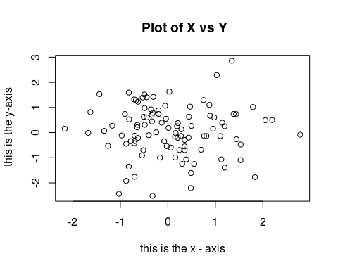

#### Contour plot

x = seq (1 ,10)  
y = x  
f = outer (x ,y , function (x , y ) cos ( y ) /(1+ x ^2) )  
fa =( f - t ( f ) ) /2  
contour (x ,y , fa , nlevels =45)

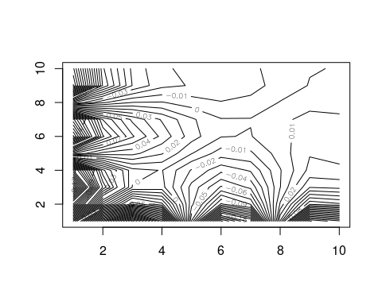 ####Heat map

x = seq (1 ,10)  
y = x  
f = outer (x ,y , function (x , y ) cos ( y ) /(1+ x ^2) )  
fa =( f - t ( f ) ) /2  
image (x ,y , fa)

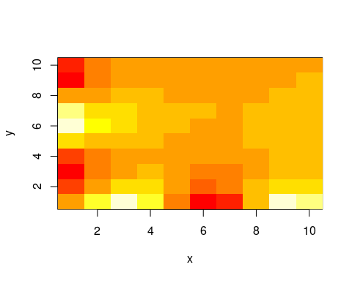 ####Three-dimensional plot

x = seq (1 ,10)  
y = x  
f = outer (x ,y , function (x , y ) cos ( y ) /(1+ x ^2) )  
fa =( f - t ( f ) ) /2  
persp (x ,y , fa , theta =30 , phi =40)

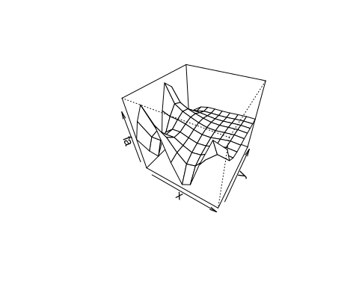

#### Save Plot

Save plot to an output file. There are functions for different file types(pdf(), jpeg())

pdf("Figure.pdf")  
plot(x,y,col="green")  
dev.off()

## png   
## 2

### Data import/export

Auto=read.table("Auto.data")  
fix(Auto)