*********DRAFT*********
Adapting the ICOBOARD ZIPCPU
to the CATBOARD
06/03/18
*********DRAFT*********

The following information is from https://github.com/ZipCPU/zipcpu/blob/master/doc/spec.pdf

Introduction
The goal of the ZipCPU was to be a very simple CPU. You might think of it as a poor manâ
alternative to the OpenRISC architecture. You might also think of it as an Open Source microcontroller. For this reason, all instructions have been designed to be as simple as possible, and the base instructions are all designed to be executed in one instruction cycle per instruction, barring pipeline stalls.1 Indeed, even the bus has been simplified to a constant 32-bit width, with no option for more or less. This has resulted in the choice to drop push and pop instructions, pre-increment and post-decrement addressing modes, the integrated memory management unit (MMU), and more
For those who like buzz words, the ZipCPU is:
A 32-bit CPU: All registers are 32-bits, addresses are 32-bits, instructions are 32-bits wide,
etc.
A RISC CPU. There is no microcode for executing instructions. All instructions are designed
to be completed in one clock cycle.
A Load/Store architecture. (Only load and store instructions can access memory.)
Wishbone compliant. All peripherals are accessed just like memory across this bus.
A Von-Neumann architecture. The instructions and data share a common bus.
A pipelined architecture, having stages for Prefetch, Decode, Read-Operand, a combined
stage containing the ALU, Memory, Divide, and Floating Point units, and then the final
Write-back stage. See Fig. 1.1 for a diagram of this structure.
Completely open source, licensed under the GPL.3

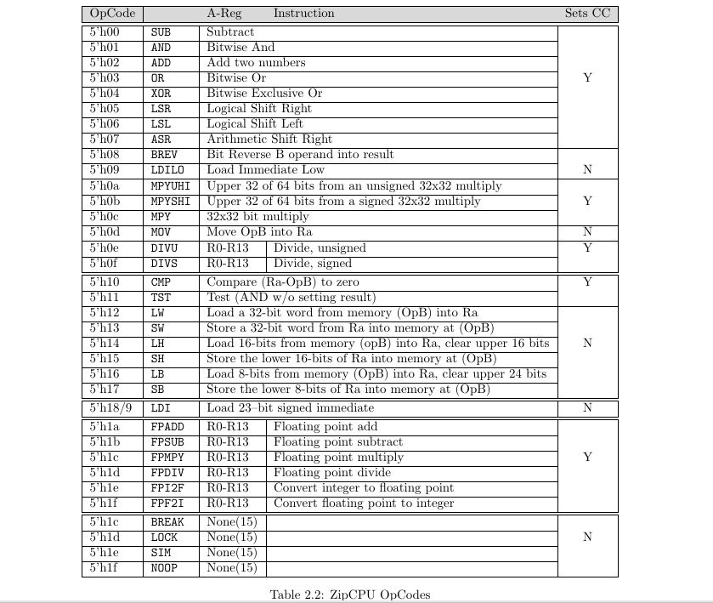

Initial testing
06/03/18

cd catzip/rtl/catzip

sudo config_cat catzip.bin

cd catzip/sw/host

./arm-netpport
Listening on port 8363
Listening on port 8364

cd catzip/sw/host

./arm-wbregs version
00001010 ( VERSION) : [....] 2017081

./arm-wbregs 0x2000 0x01
00002000 ( RAM)-> 00000001
pi@pi3-5:~/catzip/sw/host $ ./arm-wbregs ram
00002000 ( RAM) : [....] 00000001
pi@pi3-5:~/catzip/sw/host $ ./arm-wbregs 0x2000 0x02
00002000 ( RAM)-> 00000002
pi@pi3-5:~/catzip/sw/host $ ./arm-wbregs ram
00002000 ( RAM) : [....] 00000002

./arm-wbregs pic
00001004 ( PIC) : [....] 00000003

./arm-wbregs ufifo
00000804 ( UFIFO) : [@?@.] 403f4000
ICOBOARD RPi
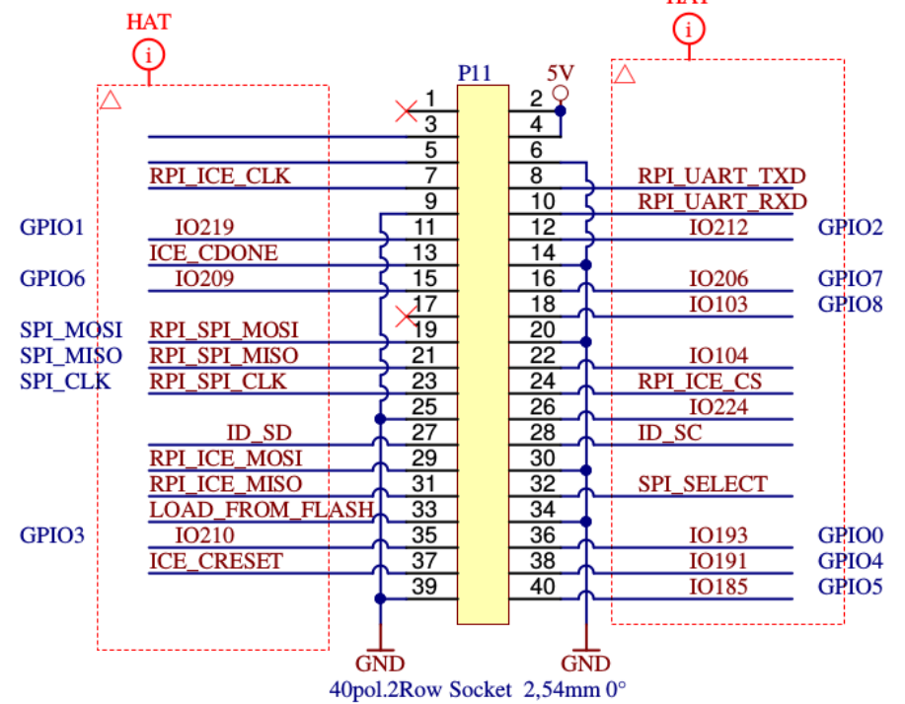

RPI_SPI_CLK H11 Pin 23 Pi icoboard

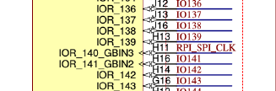

rpi_cs D4 IOT_224 Pin 26 Pi icoboard

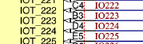

CATBOARD RPi

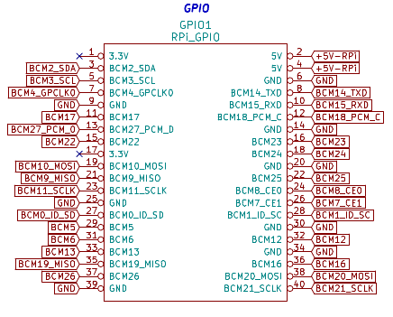
CATBOARD connection to FPGA pins PMOD 2 & PMOD 3 push button switches, dip switch, and leds.

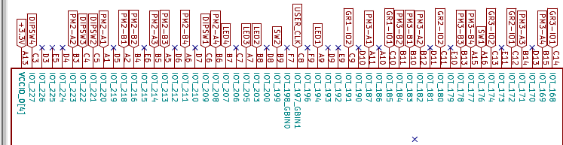

CATBOARD sw1 & sw2

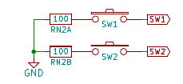

CATBOARD leds

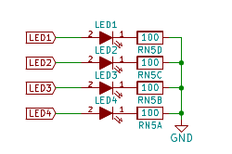

BCM11_SCLK Pin 23 CATBOARD
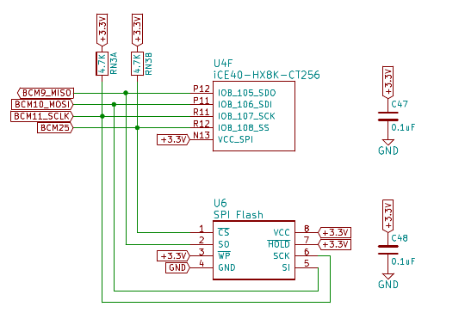
BCM7_CE1 Pin 26 CATBOARD
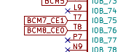

CATBOARD

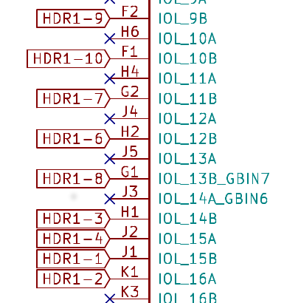

2.) The 2nd issue is the PMOD connections to FPGA are different.
3.) Third, I do not have a Diglient PMOD 4 push button switch module.
4.) The 4th issue is the PHASE LOCK LOOP difference.
Post on #yosys
Pin C8 is my USER_CLK comes from a 100MHz osc. It is connected to IOT_197_GBIN1 on HX8K. When I try using it for as an input to PLL I get the fatal error: bad constraint on `i_clk': no PLL at pin C8.
Can only certain pins be used as inputs to PLL?
daveshah
develonepi3: use the SB_PLL40_CORE instead of SB_PLL40_PAD variant (and REFERENCECLK in instead of PACKAGEPIN)
set_io clk_100mhz C8 #R9

set_io pmod1_1 A11 #D8
set_io pmod1_2 B12 #B9
set_io pmod1_3 B14 #B10
set_io pmod1_4 B15 #B11
# 654321 catboard # 654321 icoboard
# xxxxxx PMOD3 A # xxxxxx PMOD1 A
# xxxxxx PMOD3 B # xxxxxx PMOD1 B
# 654321 # 654321
#
set_io pmod1_7 B10 #B8
set_io pmod1_8 B11 #A9
set_io pmod1_9 B13 #A10
set_io pmod1_10 A15 #A11

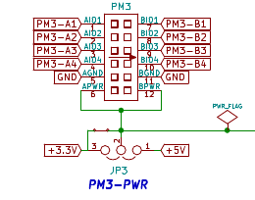

CATBOARD connection to FPGA pins PMOD 2 & PMOD 3 push button switches, dip switch, and leds.

In top.v

module top(clk_100mhz, pmod1_1, pmod1_2, pmod1_3, pmod1_4, pmod1_7, pmod1_8,
pmod1_9, pmod1_10, pmod2_7, pmod2_8, pmod2_9, pmod2_10, rpi_sck, rpi_cs,
rpi_mosi);

input rpi_sck, rpi_cs, rpi_mosi;
rpi_sck
rpi_cs
rpi_mosi

spi_ram_slave spi_ram_slave(clk, rpi_sck, rpi_cs, rpi_mosi,
ram_addr, ram_data, ram_wr);
module spi_ram_slave(clk, sck, cs, mosi, ram_addr, ram_data, ram_wr);
PMOD pin out on icoboard
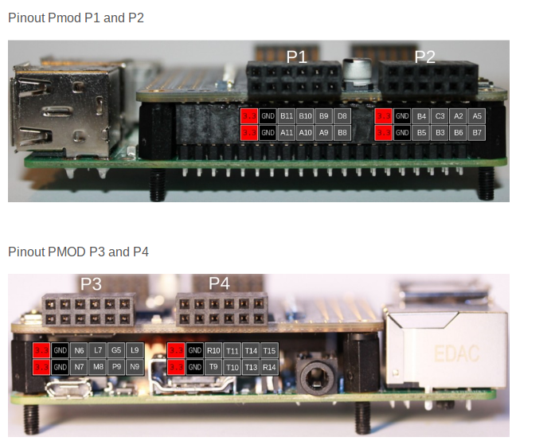

“lrwxrwxrwx 1 root staff 34 May 18 20:10 /usr/local/bin/config_cat -> /home/pi/catboard_yosys/config_cat”

#!/bin/bash

# A script to configure Lattice iCE40 FPGA by SPI from Raspberry Pi
#
# Copyright (C) 2015 Jan Marjanovic <jan@marjanovic.pro>
#
# This program is free software: you can redistribute it and/or modify
# it under the terms of the GNU General Public License as published by
# the Free Software Foundation, either version 3 of the License, or
# (at your option) any later version.
#
# This program is distributed in the hope that it will be useful,
# but WITHOUT ANY WARRANTY; without even the implied warranty of
# MERCHANTABILITY or FITNESS FOR A PARTICULAR PURPOSE. See the
# GNU General Public License for more details.
#
# You should have received a copy of the GNU General Public License
# along with this program. If not, see <http://www.gnu.org/licenses/>.

echo ""
if [ $# -ne 1 ]; then
echo "Usage: $0 FPGA-bin-file "
exit 1
fi

if [ $EUID -ne 0 ]; then
echo "This script must be run as root" 1>&2
exit 1
fi

if [ ! -d /sys/class/gpio/gpio25 ]; then
echo "GPIO 25 not exported, trying to export..."
echo 25 > /sys/class/gpio/export
if [ ! -d /sys/class/gpio/gpio25 ]; then
echo "ERROR: directory /sys/class/gpio/gpio25 does not exist"
exit 1
fi
else
echo "OK: GPIO 25 exported"
fi

if [ ! -d /sys/class/gpio/gpio17 ]; then
echo "GPIO 17 not exported, trying to export..."
echo 17 > /sys/class/gpio/export
if [ ! -d /sys/class/gpio/gpio17 ]; then
echo "ERROR: directory /sys/class/gpio/gpio17 does not exist"
exit 1
fi
else
echo "OK: GPIO 17 exported"
fi

if [ ! -d /sys/class/gpio/gpio22 ]; then
echo "GPIO 22 not exported, trying to export..."
echo 22 > /sys/class/gpio/export
if [ ! -d /sys/class/gpio/gpio22 ]; then
echo "ERROR: directory /sys/class/gpio/gpio22 does not exist"
exit 1
fi
else
echo "OK: GPIO 22 exported"
fi

echo ""
if [ -e /dev/spidev0.0 ]; then
echo "OK: SPI driver loaded"
else
echo "spidev does not exist"

lsmod | grep spi_bcm2708 >& /dev/null

if [ $? -ne 0 ]; then
echo "SPI driver not loaded, try to load it..."
modprobe spi_bcm2708

if [ $? -eq 0 ]; then
echo "OK: SPI driver loaded"
else
echo "Could not load SPI driver"
exit 1
fi
fi
fi

echo ""
echo "Setting GPIO directions"
echo out > /sys/class/gpio/gpio25/direction
cat /sys/class/gpio/gpio25/direction
echo out > /sys/class/gpio/gpio22/direction
cat /sys/class/gpio/gpio22/direction
echo in > /sys/class/gpio/gpio17/direction
cat /sys/class/gpio/gpio17/direction

echo "Setting output to low"
echo 0 > /sys/class/gpio/gpio25/value
cat /sys/class/gpio/gpio25/value

#echo ""
#echo "Please reset the iCE40 FPGA board"
#echo "Press any key..."
#read

echo "Reseting FPGA"
echo 0 > /sys/class/gpio/gpio22/value
cat /sys/class/gpio/gpio22/value
echo 1 > /sys/class/gpio/gpio22/value
cat /sys/class/gpio/gpio22/value

echo "Checking DONE pin"
cat /sys/class/gpio/gpio17/value

echo "Continuing with configuration procedure"
dd if=$1 of=/dev/spidev0.0

echo -e "\x0\x0\x0\x0\x0\x0\x0" > /dev/spidev0.0

echo "Setting output to high"
echo 1 > /sys/class/gpio/gpio25/value
cat /sys/class/gpio/gpio25/value

echo "Checking DONE pin"
cat /sys/class/gpio/gpio17/value

“cd otl-icoboard-pmodoledrgb-demo/stream-tool/”

“ffmpeg -f v4l2 -i /dev/video0 -s 96x64 -f rawvideo -pix_fmt rgb565 - | ./stream-tool”

