********Draft*******
VGA Testing Design for Go Board adapting for Catboard
06/29/18
********Draft*******

This information found at https://www.nandland.com/goboard/vga-introduction-test-patterns.html

https://www.edaplayground.com/x/37up
Files:
Sync_To_Count.v
testbench.v
Test_Pattern_Gen.v
VGA_Sync_Porch.v
VGA_Sync_Pulses.v

The command to create the simulation “iverilog -o vga testbench.v”

The comand to create the vcd file “vvp vga”
VCD info: dumpfile dump.vcd opened for output.

The command to display vcd file “gtkwave dump.vcd”

The o_Hsync is hi for 280 nsecs. and goes lo during counts 8 & 9 o_Col_Count 80 nsecs.

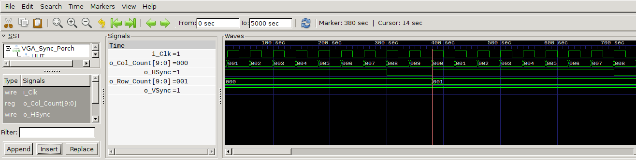
The o_VSync is hi for 1440 nsecs. and goes lo during counts 4 & 5. o_Row_Count 720 nsecs.

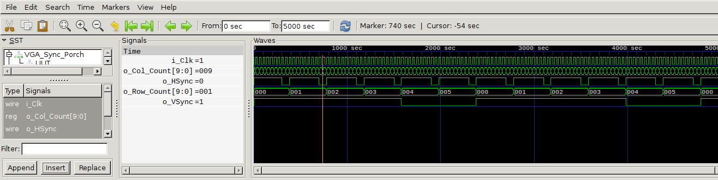

Learn how VGA works, display test patterns to your VGA monitor
VGA Connector Image
VGA stands for Video Graphics Array and is a very common display interface.
VGA was first introduced in 1987 and it is still widely supported today.
Nearly 30 years for VGA's prominence, very impressive! This project will
get you acquainted with VGA and show you how the Go Board is able to drive
your desktop monitor directly.

What is VGA? How Does it Work?
Today VGA is slowly being replaced by other displays such as DVI, HDMI, and DisplayPort to name a few. The reason that the Go Board uses VGA as opposed to something like HDMI is that VGA is easier to deal with. The HDMI specification is very detailed, so interfacing directly from an FPGA to an HDMI display is more of a challenge than a VGA display. It's best to learn the concepts about displays first using VGA.

The main difference between VGA and modern display interfaces is analog vs. digital. Analog means that the color driven to the pixel is determined by a voltage level. Digital means that the color driven to the pixel is determined by a binary code.

In addition to the analog voltage level, there's some control signals, usually referred to as syncs that tell the monitor when to drive each pixel. These are Horizontal Sync and Vertical Sync. Let's look at a single image frame.

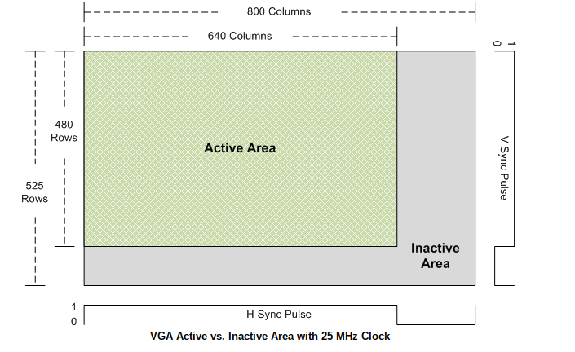
Look at the block diagram above. Now things are starting to get really interesting! We have a lot of modules that are all working together. The projects are building on each other to become more complicated and exercise more functionality on the FPGA. The code to drive the VGA display is linked in the EDA Playground environment below. The testbench only exercises the Sync Pulse Generator and the Test Pattern Generator. I included the necessary code for the VGA Front and Back Porch modifications in the EDA Playground for you. Once you have a handle on the VGA code, take a look at the top level module below to see how everything gets wired up. The results of the programmed Go Board are shown in the GIF below. I also included a short description of each of the new VGA modules in the block diagram.

Sync Pulse Generator:
The purpose of this module is to generate the sync pulses for the active and the inactive area using a 25 MHz clock. You should have some input parameters (in Verilog) or generics (in VHDL) that set the active and total number of rows and columns. This way, if the frame size changes, only the input values need to be updated. This module should simply generate free-running HSync and VSync that downstream modules can use to know where they are in the frame.

Test Pattern Generator:
The test pattern generator should be looking at where you are in your image based on the HSync and VSync inputs from the Sync Generator. Based on your location, you can keep a Column Counter and Row Counter. When you reach certain parts of the image, you can drive the pixel values differently, generating different colors. The actual test pattern that gets selected should be driven by some input to the module.

VGA Sync Porch:
This module modifies the sync pulses to add in the front and back porches required to properly drive the VGA display. The output of this module should the actual VGA signals that go right to the VGA pins.

Sync to Count:
Although this module is not shown in the block diagram above, I did add it to the EDA Playground environment. The purpose of this module is to simply output the Column and Row Index of the current pixel that we are on. This is useful information to know both in the Test Pattern Generator and in the VGA Sync Porch modules, so I chose to write the module once and instantiate it in two places. Reuse FTW

Project Description
Create a project that outputs test patterns to the VGA port on the Go Board. The test patterns should be selectable by the computer keyboard. Use the UART and Binary-To-7-Segment modules from the previous project

