*************DRAFT*************
UART No Flow Ctrl
06/27/18
*************DRAFT*************

UART simulation: Universal Asychronous Receiver Transmitter. Using Iverilog the following simulation of helloword with no flow control.

iverilog -o uart tb_txuart.v txuart.v creates uart which is executed with the vvp command

vvp uart This creates the Value Change Dump VCD file dump.vcd.

VCD info: dumpfile dump.vcd opened for output.
gtkwave dump.vcd
GTKWave Analyzer v3.3.79 (w)1999-2017 BSI

[0] start time.
[6624000] end time.

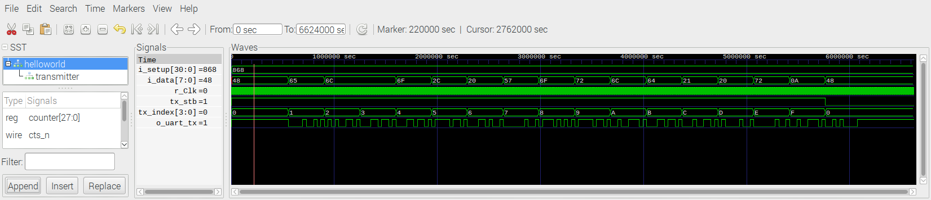

minicom

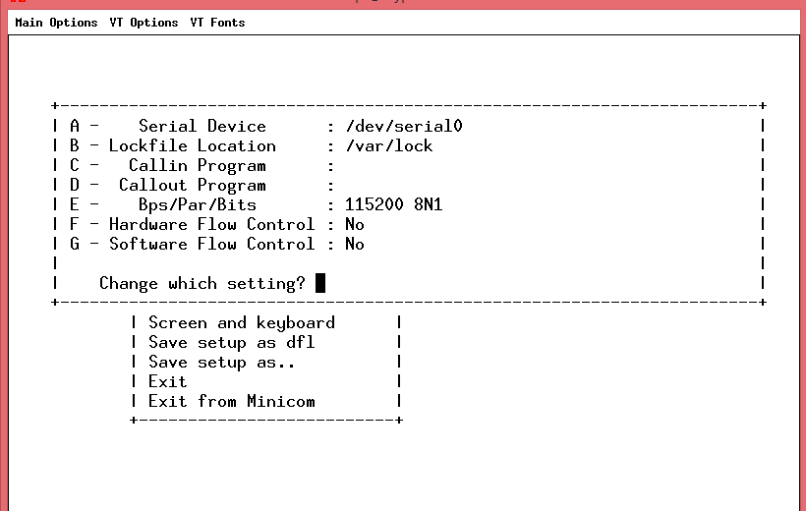

Note: A change to file /boot/cmdline.txt is required when using the RPi on board UART. This is only require with RaspBian.

diff /boot/cmdline.txt /boot/cmdline.txt.orig
1c1
< dwc_otg.lpm_enable=0 root=PARTUUID=0015d3fb-02 rootfstype=ext4 elevator=deadline fsck.repair=yes rootwait quiet splash plymouth.ignore-serial-consoles
---
> dwc_otg.lpm_enable=0 console=serial0,115200 console=tty1 root=PARTUUID=0015d3fb-02 rootfstype=ext4 elevator=deadline fsck.repair=yes rootwait quiet splash plymouth.ignore-serial-consoles

ls -la /dev/serial0
lrwxrwxrwx 1 root root 5 Jun 26 15:45 /dev/serial0 -> ttyS0

Serial Device : /dev/serial0
Bps/Par/Bits : 115200 8N1
Hardware Flow Control : No

/home/pi/Ultibo_Projects/progcat
sudo config_cat speechfifo.bin

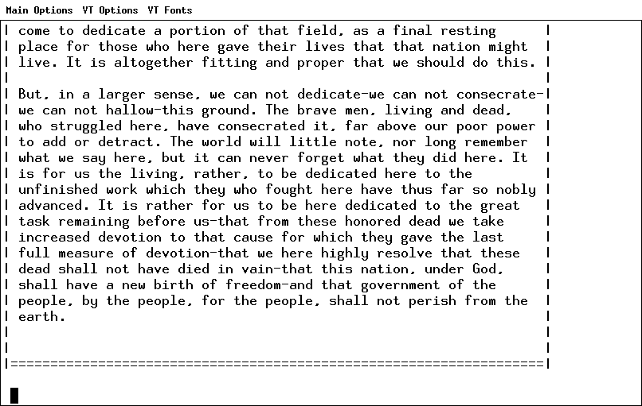

helloworld.bin
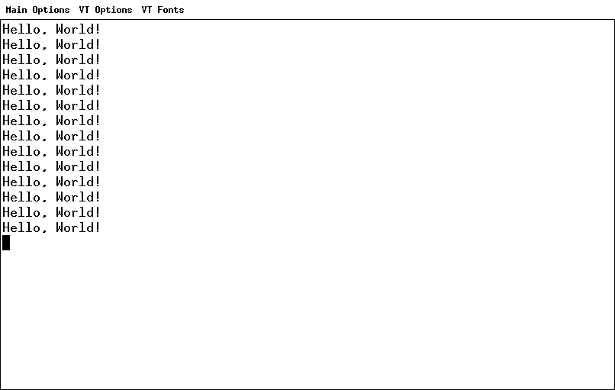

Ultibo programming FPGA
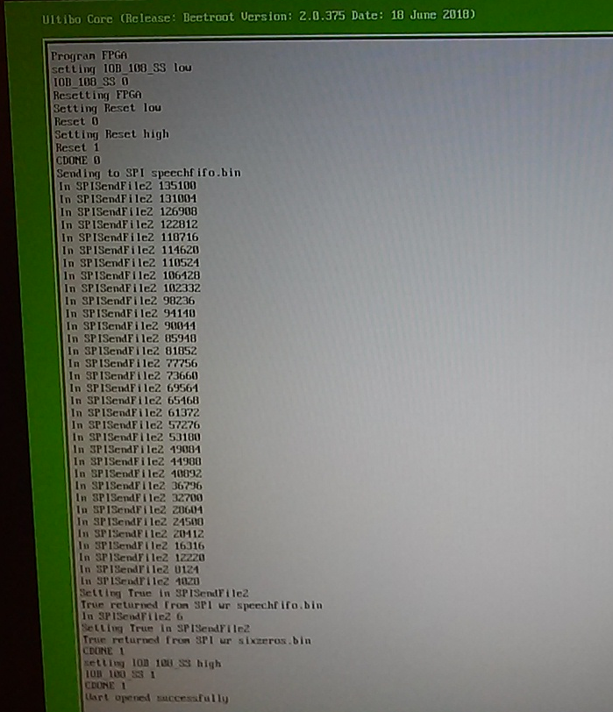

Ultibo

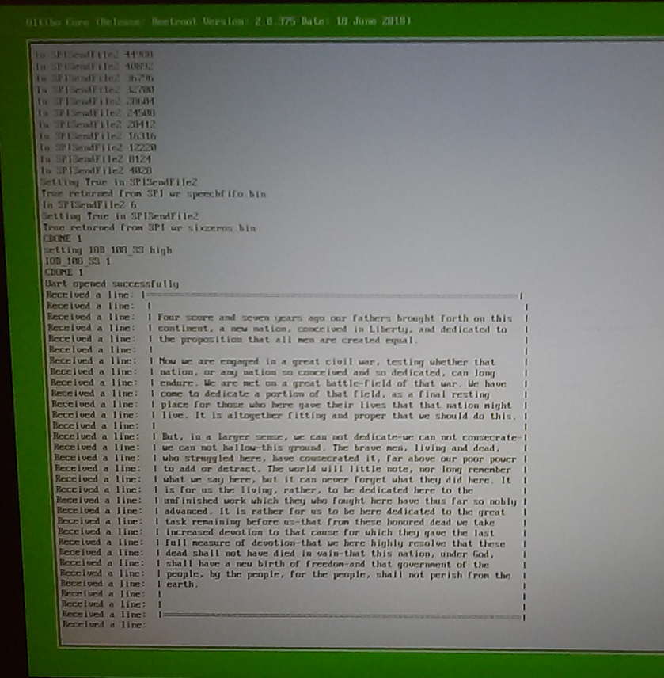

/home/pi/catzip/rtl/uart/noflowcntl/pi
helloworld.v includes txuart.v
make helloworld
sudo config_cat helloworld.bin
helloworld.pcf
# pin definitions

set_io i_clk C8
#set_io i_uart_rx B5
#set_io o_uart_tx B3
set_io o_uart_tx T14

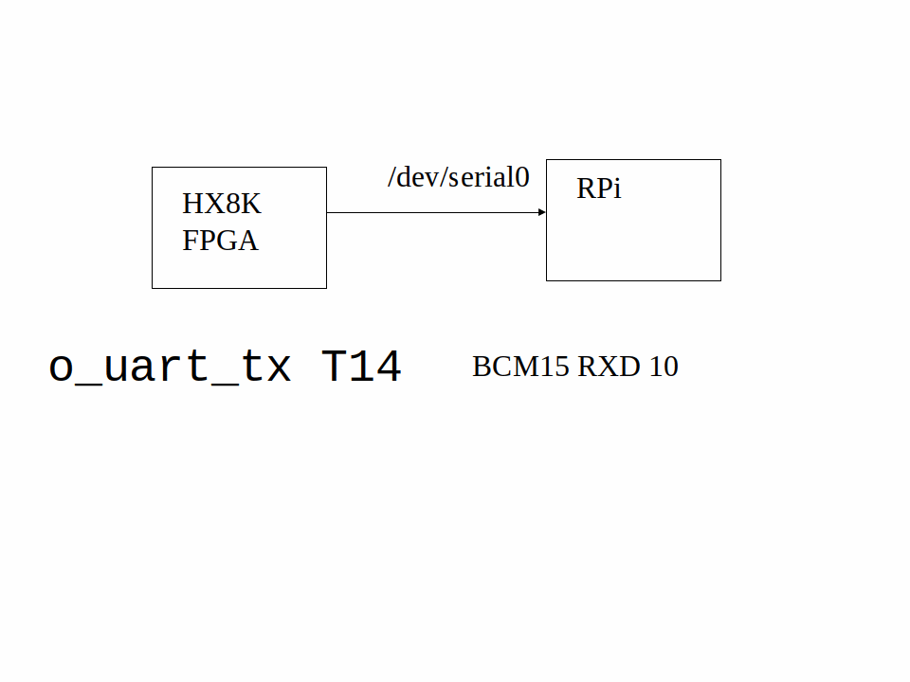

/home/pi/catzip/rtl/uart/noflowcntl/
helloworld.v includes txuart.v
make helloworld
sudo config_cat helloworld.bin
helloworld.pcf
# pin definitions

set_io i_clk C8
#set_io i_uart_rx B5
set_io o_uart_tx B3

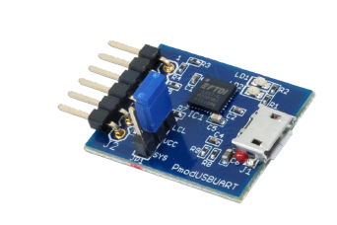
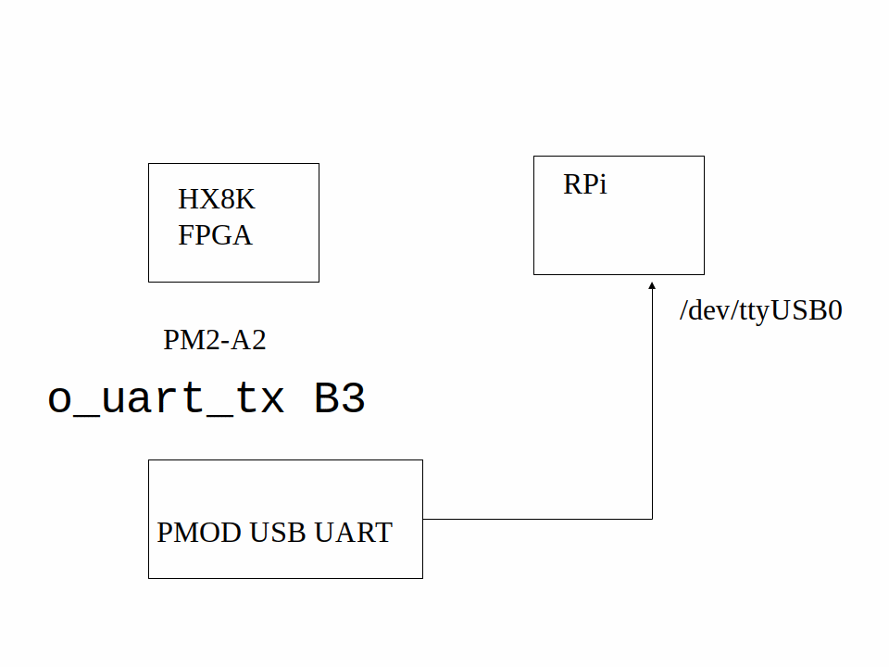

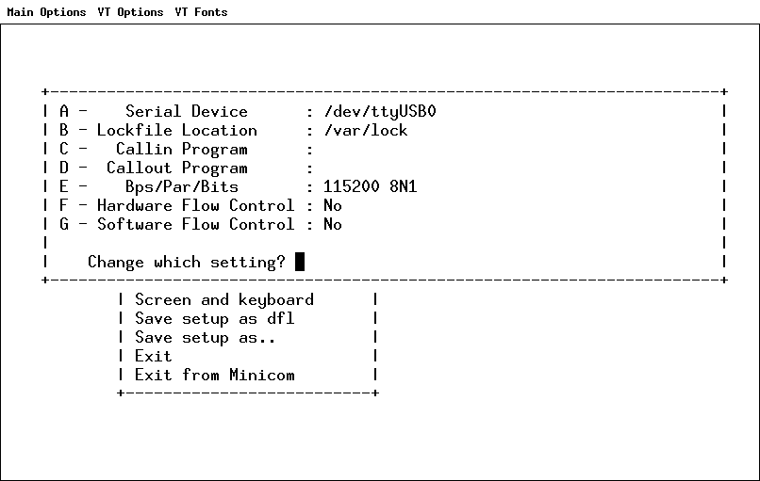

Serial Device : /dev/ttyUSB0
Bps/Par/Bits : 115200 8N1
Hardware Flow Control : No

