Testing Verilog on the CATBOARD
on RPi Zero with CATBOARD
06/08/18

A Pizero with CATBOARD FPGA. The CATBOARD provides 2 PMOD connector and a 20 pin with 3.3 v & Grd and 18 I/Os.

ICOBARD RPI

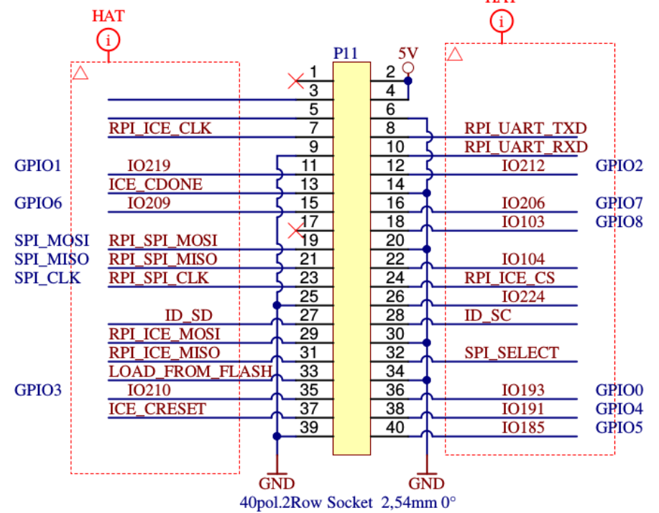

CATBOARD RPI

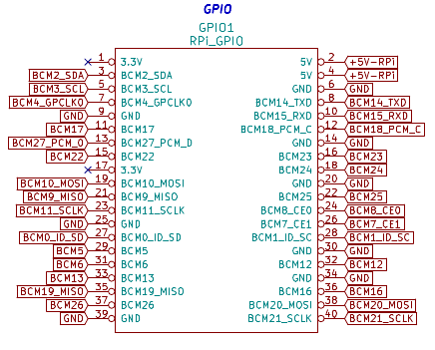

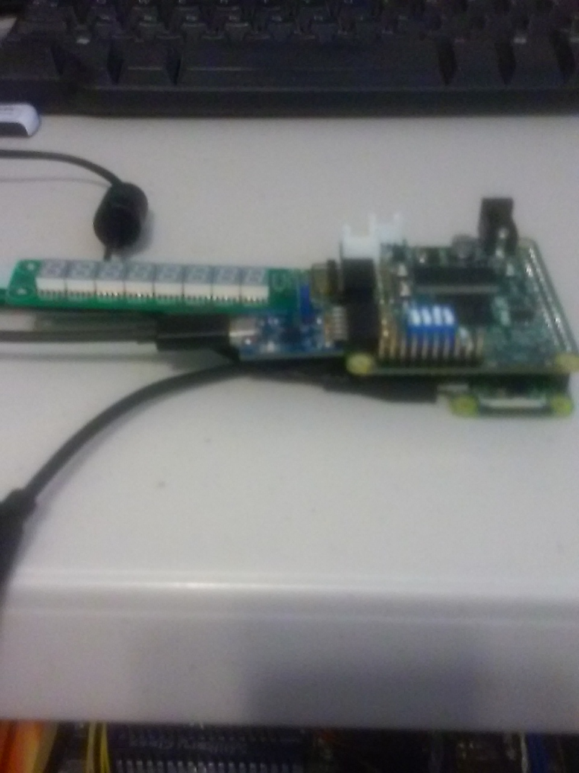

Using a Pizero to program the FPGA.
Most of Verilog was written by Dan Gisselquist, Ph.D. from Gisselquist Technology, LLC. He is working with the ICOBARD which is a HX8K Lattice FPGA like the CATBOARD. The Verilog and C++ software is found at

URL: https://github.com/develone/catzip.git

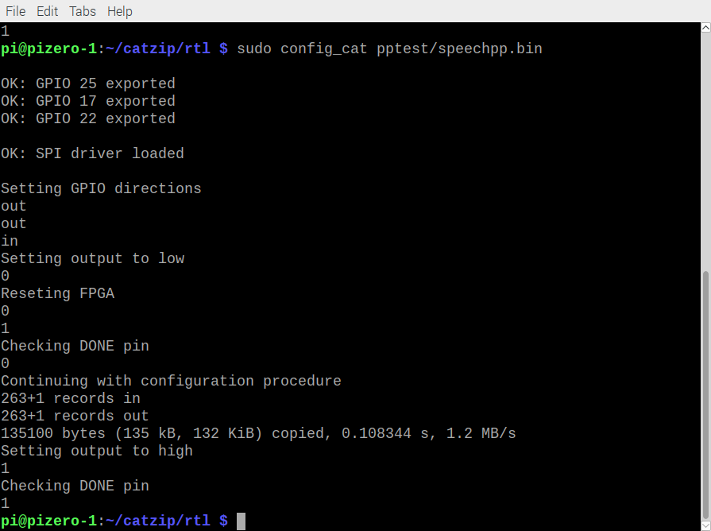
In the catzip/rtl/pptest make creates hellopp.bin, linepp.bin, and speechpp.bin using yosys, arachne-pnr and icepack.

In the speechpp.pcf set_io i_clk R9. Pin R9 on the icoboard ICE_CLK is connected to IOB_81_GBIN5 on the right side of the image below.

Trying to chg set_io i_clk R9 # 100 MHz clock
To C8 USER_CLK was causing the following error
fatal error: bad constraint on 'i_clk': no PLL at pin C8

Post on #yosys
Pin C8 is my USER_CLK comes from a 100MHz osc. It is connected to IOT_197_GBIN1 on HX8K. When I try using it for as an input to PLL I get the fatal error: bad constraint on `i_clk': no PLL at pin C8.
Can only certain pins be used as inputs to PLL?
daveshah
develonepi3: use the SB_PLL40_CORE instead of SB_PLL40_PAD variant (and REFERENCECLK in instead of PACKAGEPIN)
on the left side of the image below.

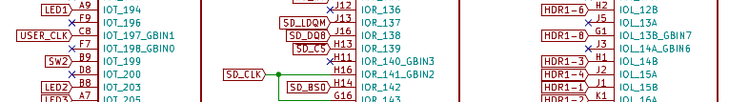

The verison of speechpp.bin uses a PPL to reduce the 100MHz Oscilator down to 66MHz.
wire clk_66mhz, pll_locked;
SB_PLL40_CORE #(
.FEEDBACK_PATH("SIMPLE"),
.DELAY_ADJUSTMENT_MODE_FEEDBACK("FIXED"),
.DELAY_ADJUSTMENT_MODE_RELATIVE("FIXED"),
.PLLOUT_SELECT("GENCLK"),
.FDA_FEEDBACK(4'b1111),
.FDA_RELATIVE(4'b1111),
.DIVR(4'd8), // Divide by (DIVR+1)
.DIVQ(3'd4), // Divide by 2^(DIVQ)
.DIVF(7'd94), // Multiply by (DIVF+1)
.FILTER_RANGE(3'b001)
) plli (
.REFERENCECLK (i_clk ),
.PLLOUTCORE (clk_66mhz ),
.LOCK (pll_locked ),
.BYPASS (1'b0 ),
.RESETB (1'b1 )
);
assign s_clk = clk_66mhz;

The ICOBOARD used SB_PLL40_PAD since a different GBIN was used,

Running “arm-netpport” on pizero-1 which receives the data from the FPGA in parallel using 11 gpio pins
Maps pins on FPGA to Pins on Rpi. These pins were different on the ICOBOARD.

set_io i_clk C8

set_io o_ledg[0] A9
set_io o_ledg[1] B8
set_io o_ledr B7

set_io i_pp_dir R3
set_io i_pp_clk T8

set_io io_pp_data[0] R4
set_io io_pp_data[1] T3
set_io io_pp_data[2] T13
set_io io_pp_data[3] T6
set_io io_pp_data[4] T5
set_io io_pp_data[5] P9
set_io io_pp_data[6] T9
set_io io_pp_data[7] T11

set_io o_pp_clkfb T7
The code for netpport.cpp uses witingPi.

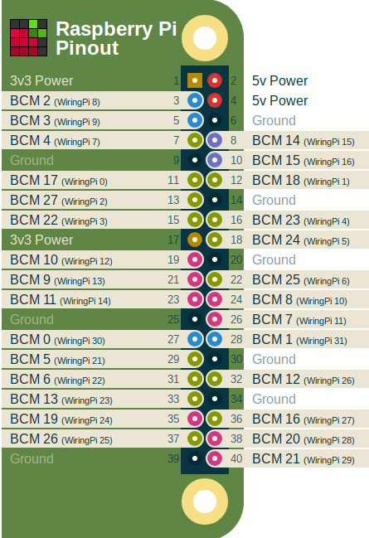

To create the executeable

To create arm-netpport & arm-wbregs ~/catzip/sw/host or ~/icozip/sw/host and type make.

# define RASPI_DIR 28 //BCM20 PIN 38, GPIO.28 IOB_59 R3
# define RASPI_CLK 10 //BCM8 PIN 24, GPIO.10, IOB_75 T8

# define RASPI_D0 27 //BCM16 PIN 36, GPIO.27, IOB_63 R4
# define RASPI_D1 24 //BCM19 PIN 35, GPIO.24, IOB_61 T3
# define RASPI_D2 0 //BCM17 PIN 11, GPIO.0 ,IOB_94 T13

# define RASPI_D3 21 //BCM5 PIN 29,GPIO.21 ,IOB_73 T6

# define RASPI_D4 22 //BCM6 PIN 31,GPIO.22 ,IOB_69 T5
# define RASPI_D5 4 //BCM23 PIN 16,GPIO.4, IOB_83 P9

# define RASPI_D6 5 //BCM24 PIN 18, GPIO.5, IOB_79 T9
# define RASPI_D7 1 //BCM18 pin 12, GPIO.1, IOB_89 T11
# define RASPI_D8 11 //BCM7 PIN 26, GPIO.11, IOB_75 T7

#define READ_FROM_ICO 0
#define WRITE_TO_ICO 1

The file “speech.hex” is read by the FPGA and sent to the pizero.

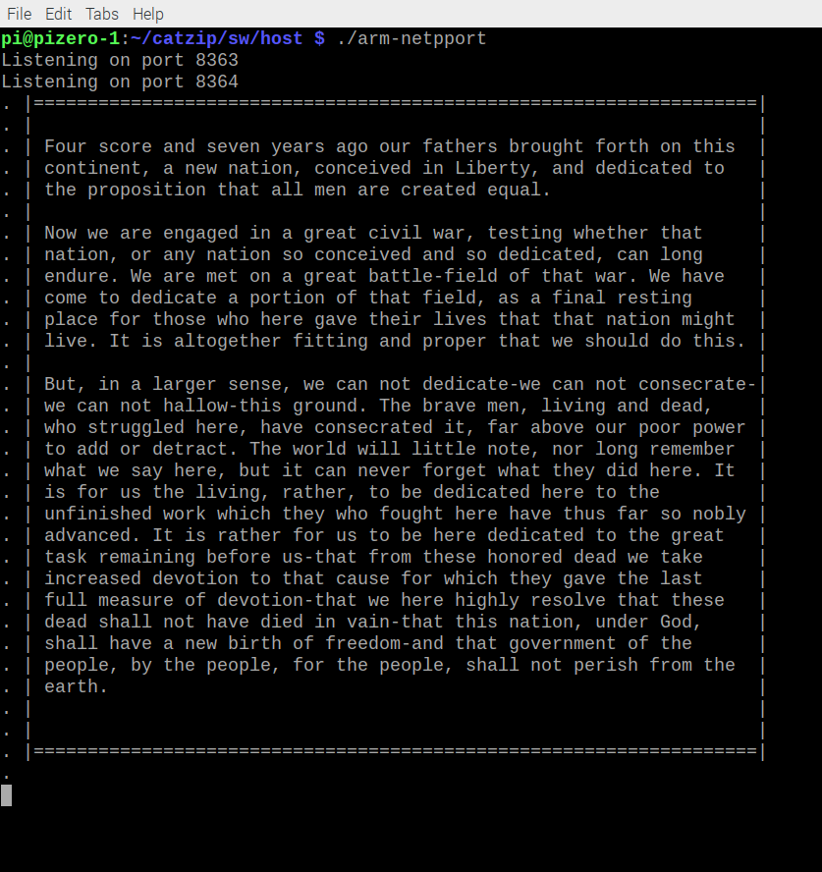

In addition, a remote host, using telnet can receive the data being sent from the FPGA. The command “telnet pizero-1 8364
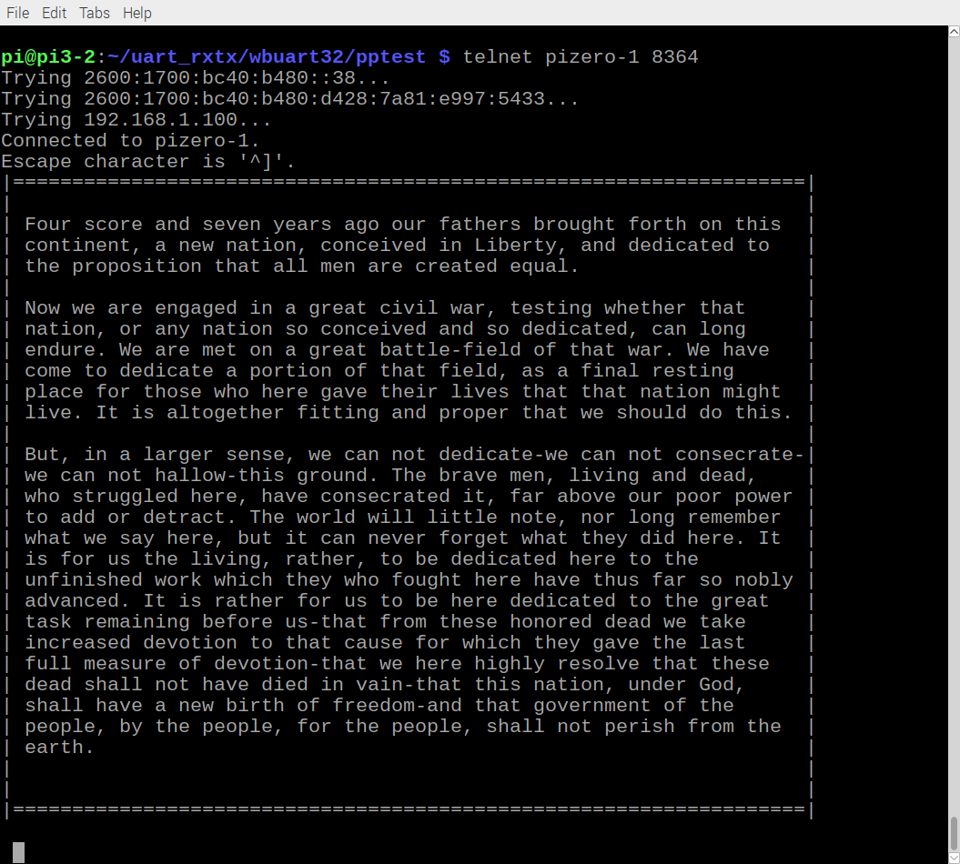

Steps to run on Bare Metal

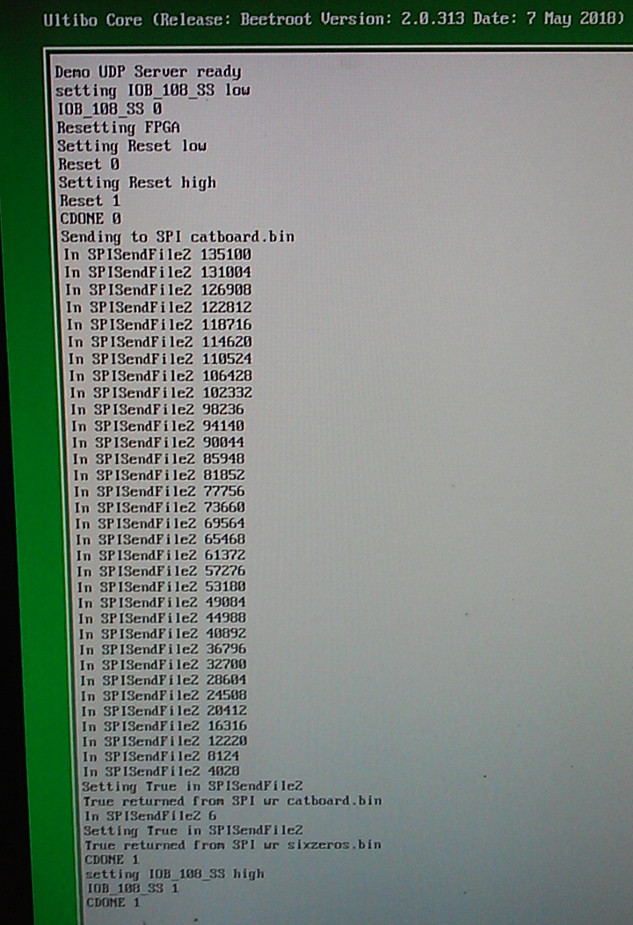
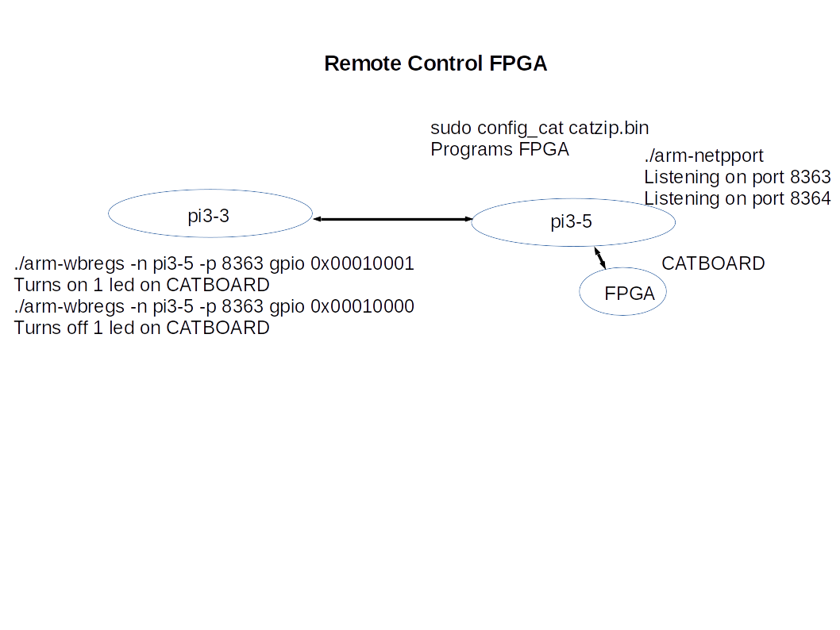

06/06/18
The initial socket code was found at

“https://forum.lazarus.freepascal.org/index.php?topic=21024.0”

“cd Ultibo_Projects/socket_tests/raspbian”

“export PATH=/home/pi/ultibo/core/fpc/bin:$PATH”

“fpc -B -Tlinux -Parm @/home/pi/ultibo/core/fpc/bin/fpc.cfg -O2 server.pas”

pi@pi3-2:~/Ultibo_Projects/socket_tests/raspbian $ ./server
Listener has been created
Socket successfully initialized
Bind on 5050
We have 1 client threads!
Accepted connection from 192.168.1.214:47914

pi@pi3-3:~/Ultibo_Projects/socket_tests/raspbian $ telnet pi3-2 5050
Trying 2600:1700:bc40:b480::49...
Trying 2600:1700:bc40:b480:4077:e4cb:6d18:81df...
Trying 192.168.1.181...
Connected to pi3-2.
Escape character is '^]'.
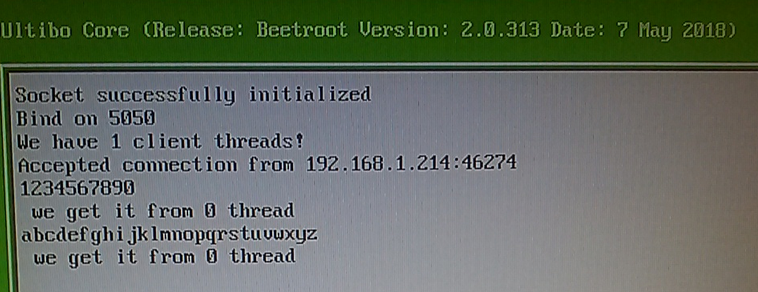

./arm-wbregs -n 192.168.1.185 -p 5050 version
A1011R Read from Addr A1011R

./arm-wbregs -n 192.168.1.185 -p 5050 gpio 0x00010001
A1009W10001 This means write to Addr 1009 data 10001

ufpga
function initfpgagpio(): Boolean;
function SPISendFile2(const Filename: String; BlockSize: LongWord;Window:TWindowHandle): Boolean;

function ProgFpga(const Filename: String; ProgWindow:TWindowHandle):Boolean;
function ReadFpga(ProgWindow:TWindowHandle):integer;

wishbone

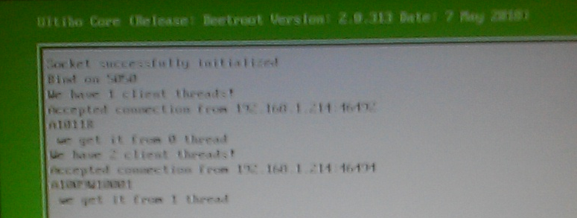
Now can program do the following:
program the fpga
read the parallel port of the fpga
connect remote to socket 5050
receive data over the socket.

