*************DRAFT*************
UART No Flow Ctrl
06/26/18
*************DRAFT*************

minicom

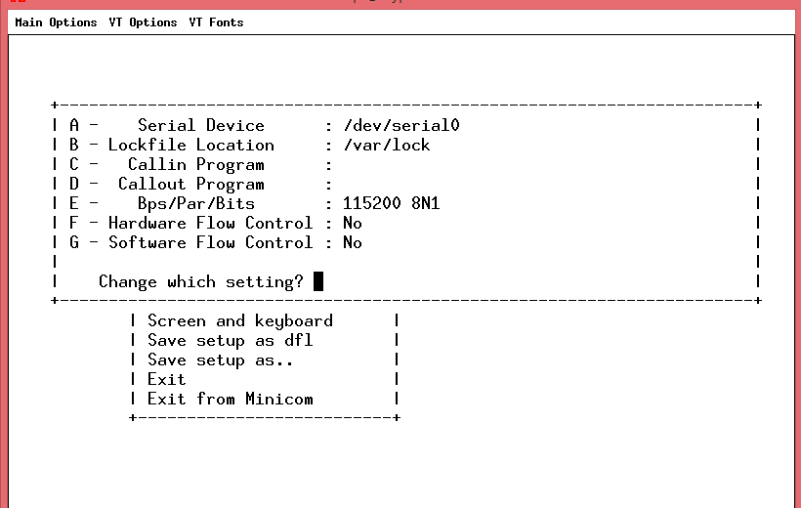

diff /boot/cmdline.txt /boot/cmdline.txt.orig
1c1
< dwc_otg.lpm_enable=0 root=PARTUUID=0015d3fb-02 rootfstype=ext4 elevator=deadline fsck.repair=yes rootwait quiet splash plymouth.ignore-serial-consoles
---
> dwc_otg.lpm_enable=0 console=serial0,115200 console=tty1 root=PARTUUID=0015d3fb-02 rootfstype=ext4 elevator=deadline fsck.repair=yes rootwait quiet splash plymouth.ignore-serial-consoles

ls -la /dev/serial0
lrwxrwxrwx 1 root root 5 Jun 26 15:45 /dev/serial0 -> ttyS0

Serial Device : /dev/serial0
Bps/Par/Bits : 115200 8N1
Hardware Flow Control : No

/home/pi/Ultibo_Projects/progcat
sudo config_cat speechfifo.bin

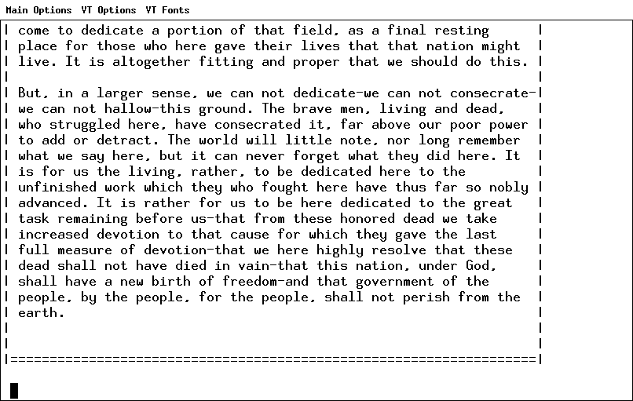

Ultibo programming FPGA
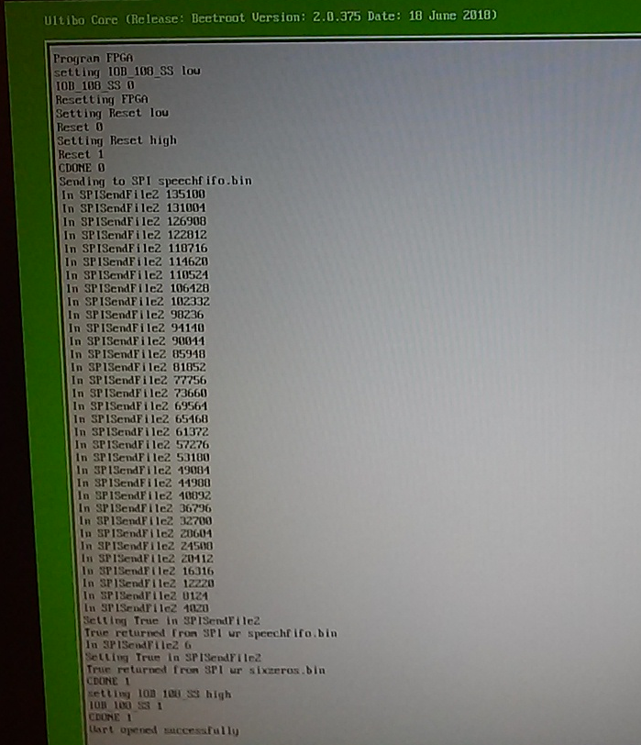

Ultibo

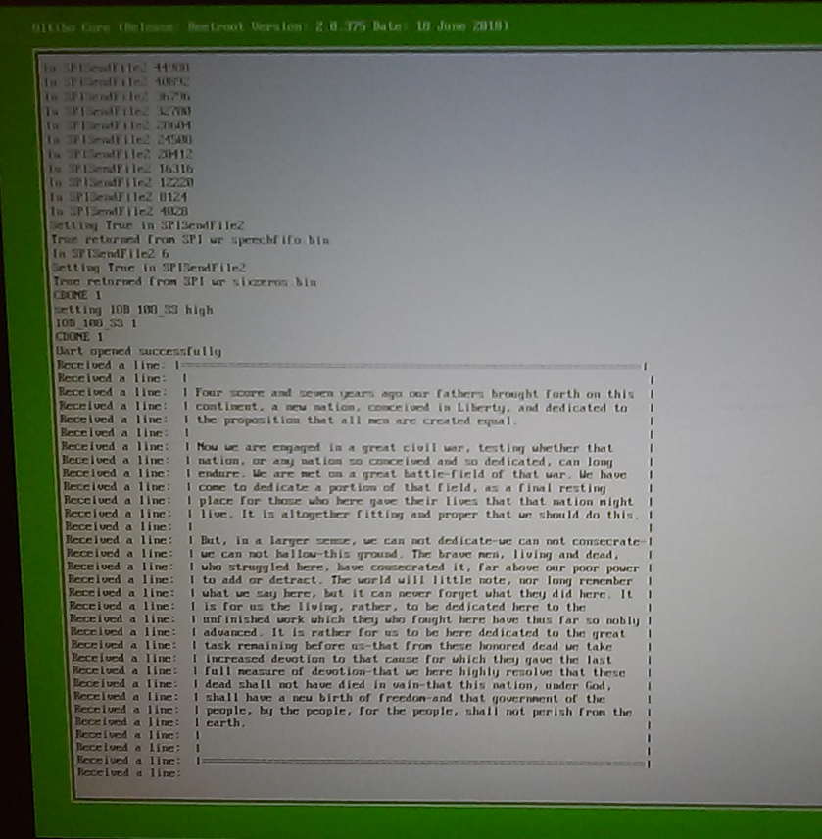

/home/pi/catzip/rtl/uart/noflowcntl/pi
helloworld.v includes txuart.v
sudo config_cat helloworld.bin
helloworld.pcf
# pin definitions

set_io i_clk C8
#set_io i_uart_rx B5
#set_io o_uart_tx B3
set_io o_uart_tx T14
