*******************Draft*******************
Testing Upgrades to icestorm, yosys, zipcpu and nextpnr
mypi3-20 pi400-2
09/29/21
*******************Draft*******************

Tested verilog & C++
commit 5df54b35ca8724fe0cf3149f1543cfa2dd66acd7 (HEAD -> catzip)
Author: Edward Vidal Jr <develone@sbcglobal.net>
Date: Wed Sep 29 06:23:55 2021 -0600

missing from last commit

yosys -V
Yosys 0.9+4081 (git sha1 83a21814, gcc 8.3.0-6+rpi1 -fPIC -Os)

nextpnr-ice40 -V
nextpnr-ice40 -- Next Generation Place and Route (Version 67bd349e)

verilator -V
Verilator 4.100 2020-09-07 rev v4.100-10-g39eea781

zipcpu

commit 0046fdc254222ed7b8c9e4ae08c0fe98c2b959f7 (HEAD -> master, upstream/master)
Author: ZipCPU <dgisselq@ieee.org>
Date: Wed Sep 1 17:25:39 2021 -0400

Moved GCC patch from zipcore to master

Includes fix for genzipops

autofpga
devel@mypi3-20:~/autofpga $ git log
commit 5b57538081d60a04cd32aeba2436816062cb0141 (HEAD -> master, upstream/master, upstream/dev)
Author: ZipCPU <dgisselq@ieee.org>
Date: Fri Aug 14 07:55:55 2020 -0400

Fixes MacOS build err--std::string vs char * in gbl_msg.err()

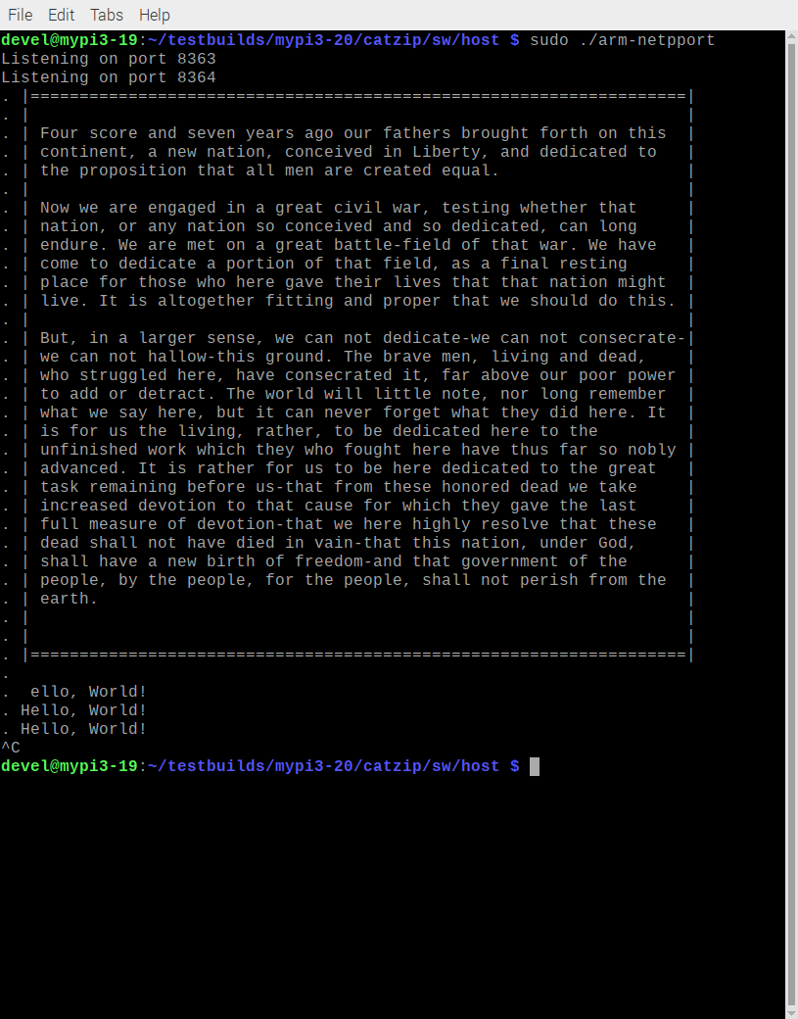

cputest

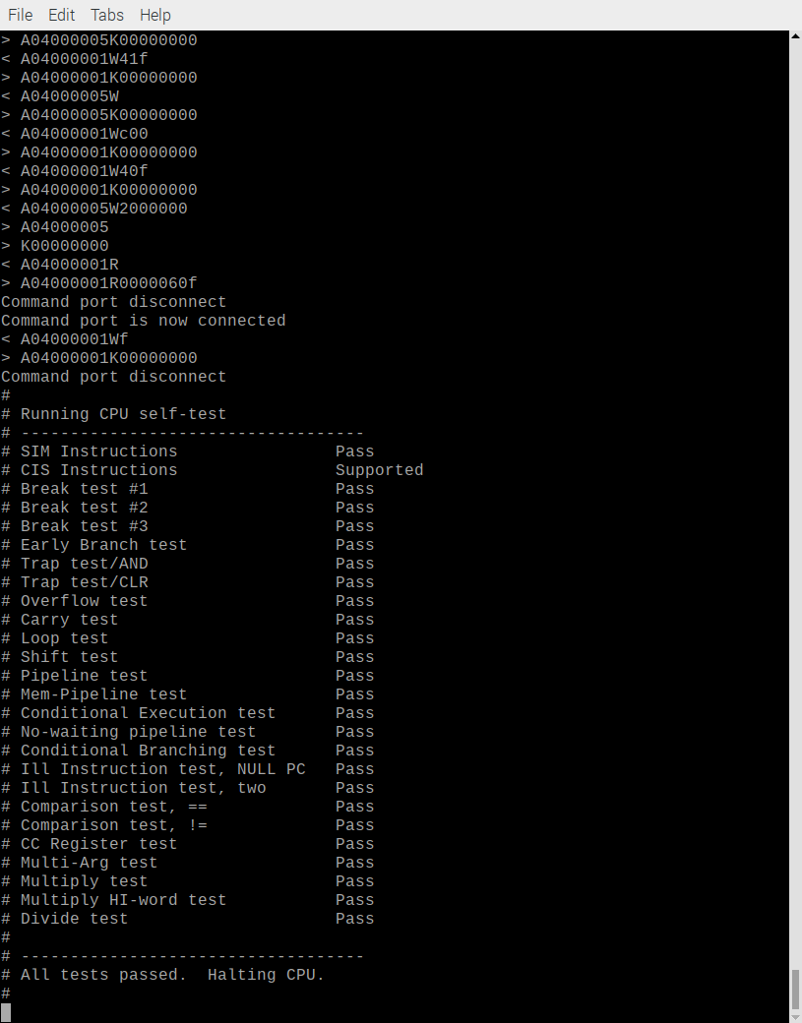

hello

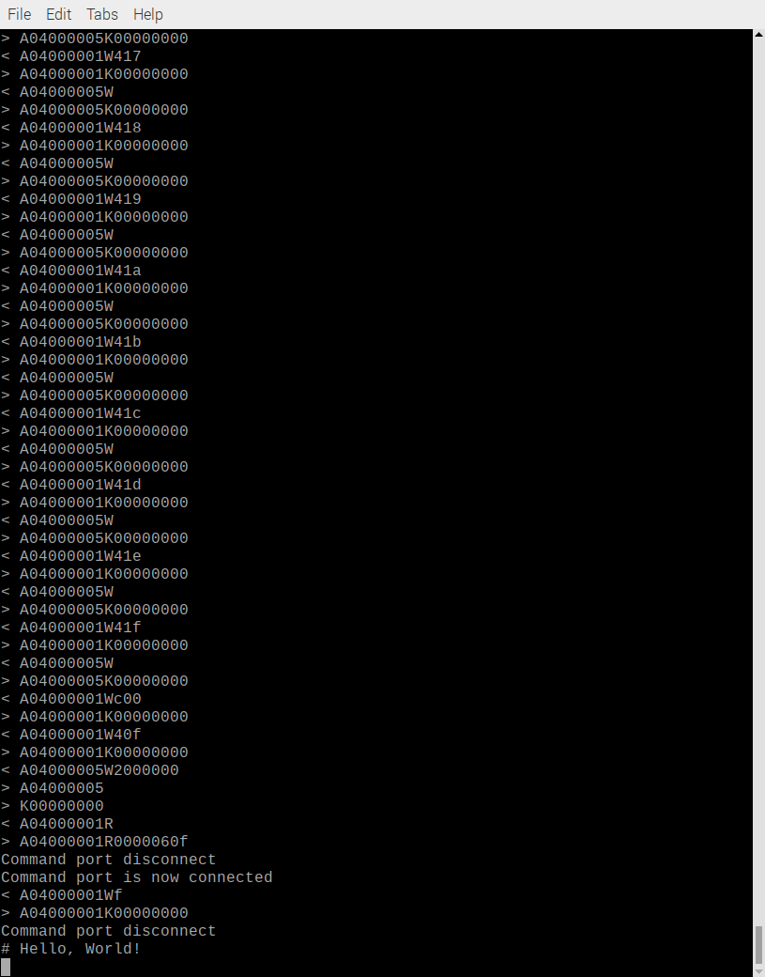
now using b.bin which was extracted from blu.pgm with wrpgm.m
This does not need to use split.
./runjpeg.sh
01401000 ( )-> 00000002
01401004 ( )-> 00000001
01401008 ( )-> 00000001
0140100c ( )-> 00000000
01401010 ( )-> 00000001
01401018 ( )-> 00000001
Halting the CPU
Memory regions:
Block RAM: 01400000 - 01402000
SDRAM : 02000000 - 03000000
Loading: ../board/jpeg
Section 0: 02000000 - 0204fe6c
Writing to MEM: 02000000-0204fe6c
Clearing the CPUs registers
Setting PC to 02000000
The CPU should be fully loaded, you may now
start it (from reset/reboot) with:
> wbregs cpu 0x0f

CPU Status is: 0000060f
04000000 ( CPU)-> 0000000f

# w=256 h=256
# 1401000 2
# flag 2 0x204fde8
# 1401004 1
# 140100c 200fde8

./arm-wrsdram b.bin or ./arm-wrsdram g.bin or ./arm-wrsdram r.bin
The size of the buffer is 0x010000 or 65536 words

READ-COMPLETE

./arm-wbregs 0x01401008 0
01401008 ( )-> 00000000

# ptrs.alt 0x20544c8 0x200fde8
# 131072

./arm-wbregs 0x01401010 0
01401010 ( )-> 00000000

./arm-wbregs 0x01401008 0
01401008 ( )-> 00000000

./arm-wbregs 0x01401010 0
01401010 ( )-> 00000000

# 0x200fde8 0x7e
# 0x200fdec 0x7d
# 0x200fdf0 0x7b
# 0x200fdf4 0x76
#
# 0x202fde8 0x6a
# 0x202fdec 0x6a
# 0x202fdf0 0x68
# 0x202fdf4 0x64
#
# 0x204fdd8 0x48
# 0x204fddc 0x4a
# 0x204fde0 0x4e
# 0x204fde4 0x50
# 256 0x200fde8 0x20544c8 0x 1401004
# 256

./arm-rdsdram dwt.bin

Write-COMPLETE
The size of the buffer is 0x010000 or 65536 words

