********************************Draft********************************
Working Software & Hardware
05/08/21
********************************Draft********************************

https://github.com/develone/catzip.git
git branch -a
* master

commit 9891c9e3e4cb578584b8006ce58337862bb0def6 (HEAD -> master, origin/master, origin/HEAD)
Author: Edward Vidal Jr <develone@sbcglobal.net>
Date: Wed Feb 12 16:28:22 2020 -0700

work around to build speechpp.bin, hellopp.bin, and linepp.bin

/arm-wbregs version
00800010 ( VERSION) : [....] 20200617

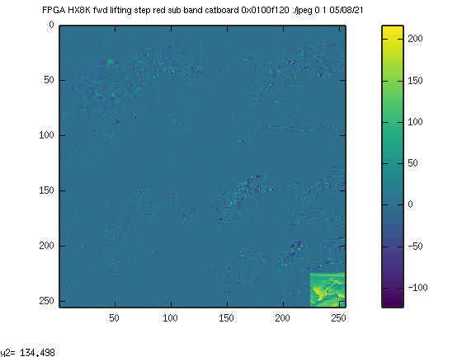
Loading the C program in FPGA

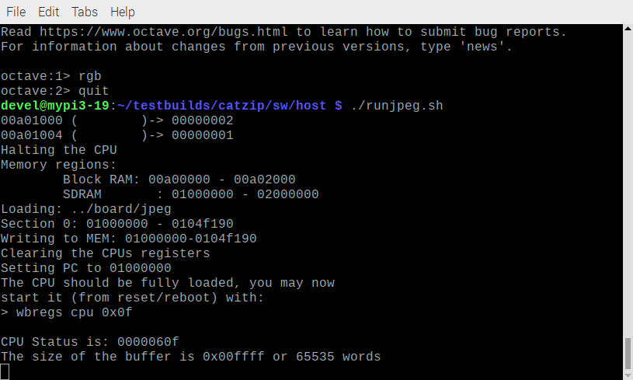
Running the C program in fpga.

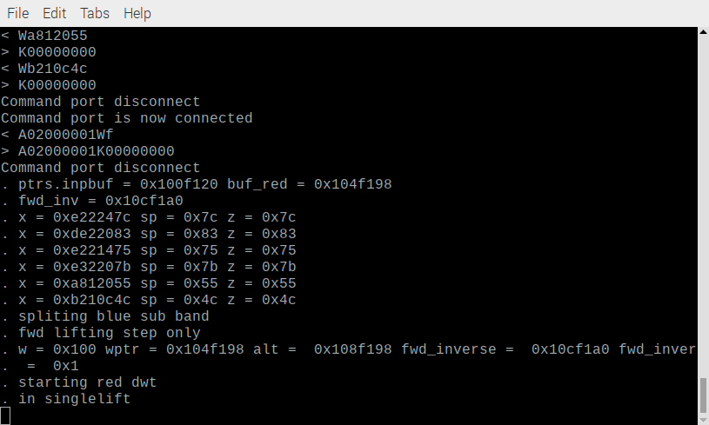
Reading data from fpga to be displayed with Octave

