./pc-main_tb ../../sw/board/helloListening on port 8363
Listening on port 8364
> T

BOMB : CPU BREAK RECEIVED
ZIPM--DUMP: Supervisor mode

sR0 : 020001dc sR1 : 0000e484 sR2 : 02000050 sR3 : 00000000
sR4 : 00000000 sR5 : 00000000 sR6 : 00000000 sR7 : 00000000
sR8 : 00000000 sR9 : 00000000 sR10: 00000000 sR11: 00000000
sR12: 00000000 sSP : 02ffffec sCC : 00000001 sPC : 02000374

uR0 : 00000000 uR1 : 00000000 uR2 : 00000000 uR3 : 00000000
uR4 : 00000000 uR5 : 00000000 uR6 : 00000000 uR7 : 00000000
uR8 : 00000000 uR9 : 00000000 uR10: 00000000 uR11: 00000000
uR12: 00000000 uSP : 00000000 uCC : 00000020 uPC : 02000048

Will exit: DONE!!

Testing cputest as it would be run in hardware which uses main_tb with zipload & wbregs.

./pc-main_tb
Listening on port 8363
Listening on port 8364
> T
< [CLOSED]
Hello, World

& eewess s

5525hh h6656

BOMB : CPU BREAK RECEIVED
ZIPM--DUMP: Supervisor mode

sR0 : 02000254 sR1 : 0000000d sR2 : 00000000 sR3 : 00c00000
sR4 : 0000000a sR5 : 0200f300 sR6 : 00000000 sR7 : 00000000
sR8 : 00000000 sR9 : 00000000 sR10: 00000000 sR11: 00000000
sR12: 00000000 sSP : 02ffffec sCC : 00000000 sPC : 02000254

uR0 : 00000000 uR1 : 00000000 uR2 : 00000000 uR3 : 00000000
uR4 : 00000000 uR5 : 00000000 uR6 : 00000000 uR7 : 00000000
uR8 : 00000000 uR9 : 00000000 uR10: 00000000 uR11: 00000000
uR12: 00000000 uSP : 00000000 uCC : 00000020 uPC : 02000048
./pc-zipload -v ../board/hello
Halting the CPU
Memory regions:
Block RAM: 01400000 - 01402000
SDRAM : 02000000 - 03000000
Loading: ../board/hello
Section 0: 02000000 - 0200f788
Writing to MEM: 02000000-0200f788
Clearing the CPUs registers
Setting PC to 02000000
The CPU should be fully loaded, you may now
start it (from reset/reboot) with:
> wbregs cpu 0

CPU Status is: 00000600

./pc-wbregs cpu 0x0f
04000080 ( CPU)-> 0000000f

Full

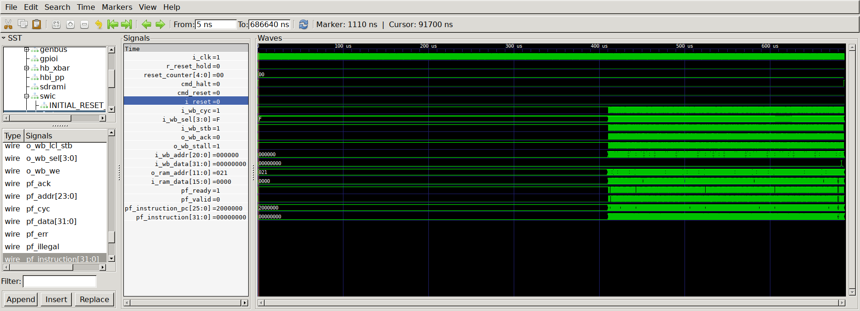

Reset

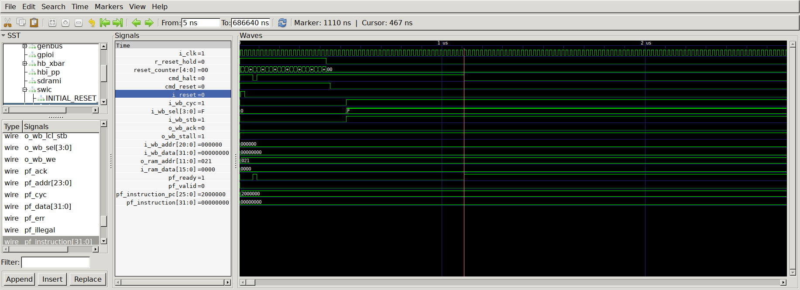

zip-objdump -d hello

02000000 <_boot_address>:
2000000: 6a 00 00 c0 LDI 0x03000000,SP // 3000000 <_top_of_stack>
2000004: 6a 40 00 00
2000008: 7b 47 c0 0f MOV $60+PC,uPC
200000c: 03 43 c0 02 LJSR @0x02000058 // 2000058 <_bootloader>
2000010: 7c 87 c0 00
2000014: 02 00 00 58

6a 00 00 c0 & 6a 40 00 00

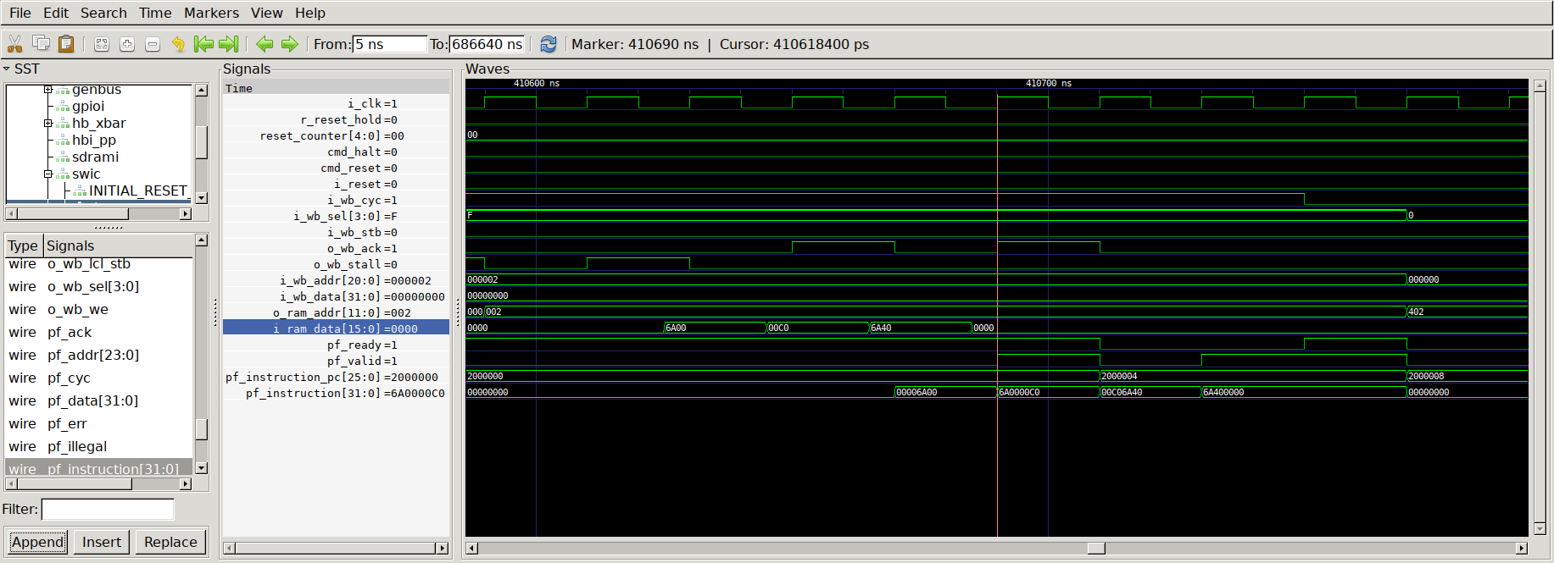

7b 47 c0 0f & 03 43 c0 02

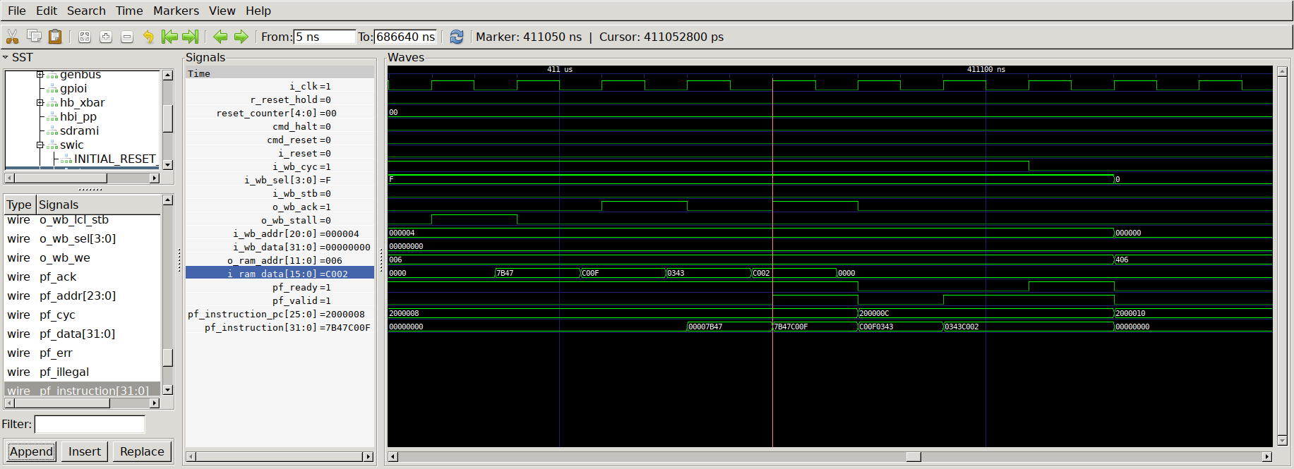

7c 87 c0 00 & 02 00 00 58

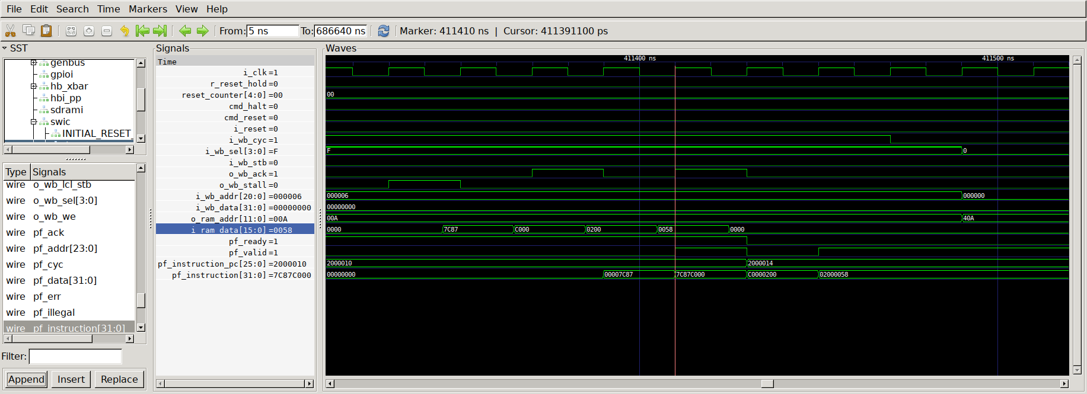

Halt

