Xxx
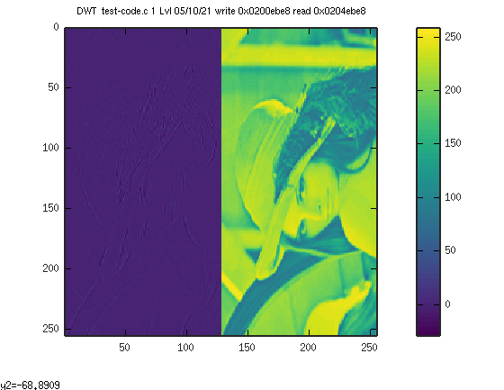
xxx

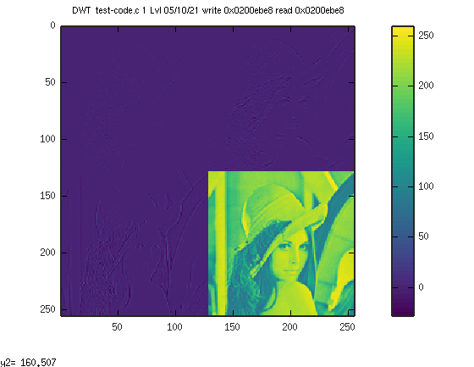

**************************Draft**************************
Lifting step using Verilator simulation
with test-code.c instead of jpeg.c
This is needed since the printf is not working correctly in simulation
These steps are not working on the iCE 40 HX8K FPGA with Rpi3B+.

05/10/21
**************************Draft**************************

Create the jpep zipcpu C program. The command to compile and create the dissambly “cp test-code.c jpeg.c; make;zip-objdump -d jpeg > jpeg-disasm.txt” in the “~/testbuilds/icozip-catzip-br/icozip/sw/board” folder.

The file “jpeg-disasm.txt” is used to find where the struct ptrs is in memory. Towards the end of file “0200ec14 <ptrs>:” is found.

Starting the simulator. With the following command ./arm-main_tb in the ~/testbuilds/icozip-catzip-br/icozip/sim/verilated folder.

Set 3 values in bkram with the following command.
“../host/arm-wbregs 0x01401000 2; ../host/arm-wbregs 0x01401008 2; ../host/arm-wbregs 0x01401004 1” in the “~/testbuilds/icozip-catzip-br/icozip/sw/board” folder.

01401000 ( )-> 00000002
01401008 ( )-> 00000002
01401004 ( )-> 00000001

The value at location “0x01401008” is used to prevent the program from performing the lifting step before the data in “r.bin” is written to sdram with the command “./arm-wrsdram r.bin” in “~/testbuilds/icozip-catzip-br/icozip/sw/host” folder.

Load the program jpeg into the simulator with the following command.
“./arm-zipload -v ../board/jpeg;./arm-wbregs cpu 0x0f;./test-code.sh” in “~/testbuilds/icozip-catzip-br/icozip/sw/host” folder. The script “test-code.sh” is used in conjuntion with “0200ec14 <ptrs>:” is used to display values from the struct ptrs.

#!/bin/bash

echo "inpbuf"
./arm-wbregs 0x0200ec14
COUNTER=10
ADDRESS=0x0200ec14
until [ $COUNTER -lt 1 ]; do
echo COUNTER $COUNTER
let COUNTER-=1
let ADDRESS+=4
./arm-wbregs $ADDRESS
done
The first 2 values are the w & h of the image. The 3rd value is the
while(ptrs.status==2) {
ptrs.status = ptrs.ptr_blkram_status[0];
}
to prevent the program from performing the lifting step before the data in “r.bin” is written to sdram with the command “./arm-wrsdram r.bin” in “~/testbuilds/icozip-catzip-br/icozip/sw/host” folder. The 4th value is the result of the ptrs.buf_red = ( int *)malloc(sizeof( int)* ptrs.w*ptrs.h*2);. While the 5th value is where the lifting step results are found. These pointers are used in “wrsdram.cpp” and “rdsdram.cpp”.
inpbuf
0200ec14 ( ) : [....] 00000100
COUNTER 10
0200ec18 ( ) : [....] 00000100
COUNTER 9
0200ec1c ( ) : [....] 00000002
COUNTER 8
0200ec20 ( ) : [....] 0200eca0
COUNTER 7
0200ec24 ( ) : [....] 0204eca0
COUNTER 6
0200ec28 ( ) : [....] 00000001
COUNTER 5
0200ec2c ( ) : [.@..] 01401000
COUNTER 4
0200ec30 ( ) : [.@..] 01401004
COUNTER 3
0200ec34 ( ) : [.@..] 01401008
COUNTER 2
0200ec38 ( ) : [....] 00000002
COUNTER 1
0200ec3c ( ) : [....] 00000000

Once the data has been loaded in sdram the signal to start the lifting step is provided with command “../host/arm-wbregs 0x01401008 1” in the folder “~/testbuilds/icozip-catzip-br/icozip/sw/board”.

Xxx

The first level of an image e 256x256 is the 128x128.
The 2 level of an image 256x256 is the 64x64.

