*********************Default*********************
Catboard-Pipelinec
PMOD-Ethernet
03/05/25
*********************Default*********************

The current image which does work in the form matrix multiply.

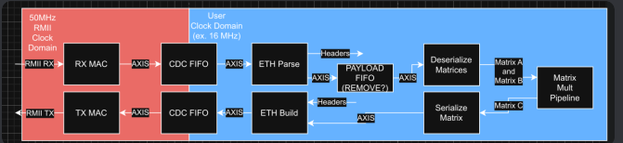

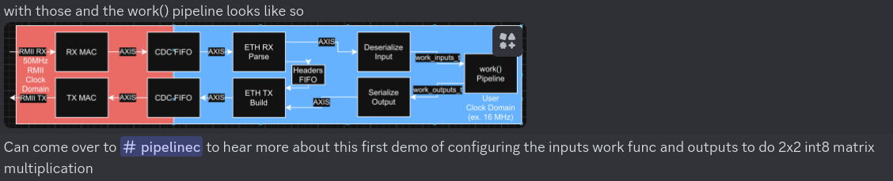

Tested 02/28/25 in PipelineC repo.

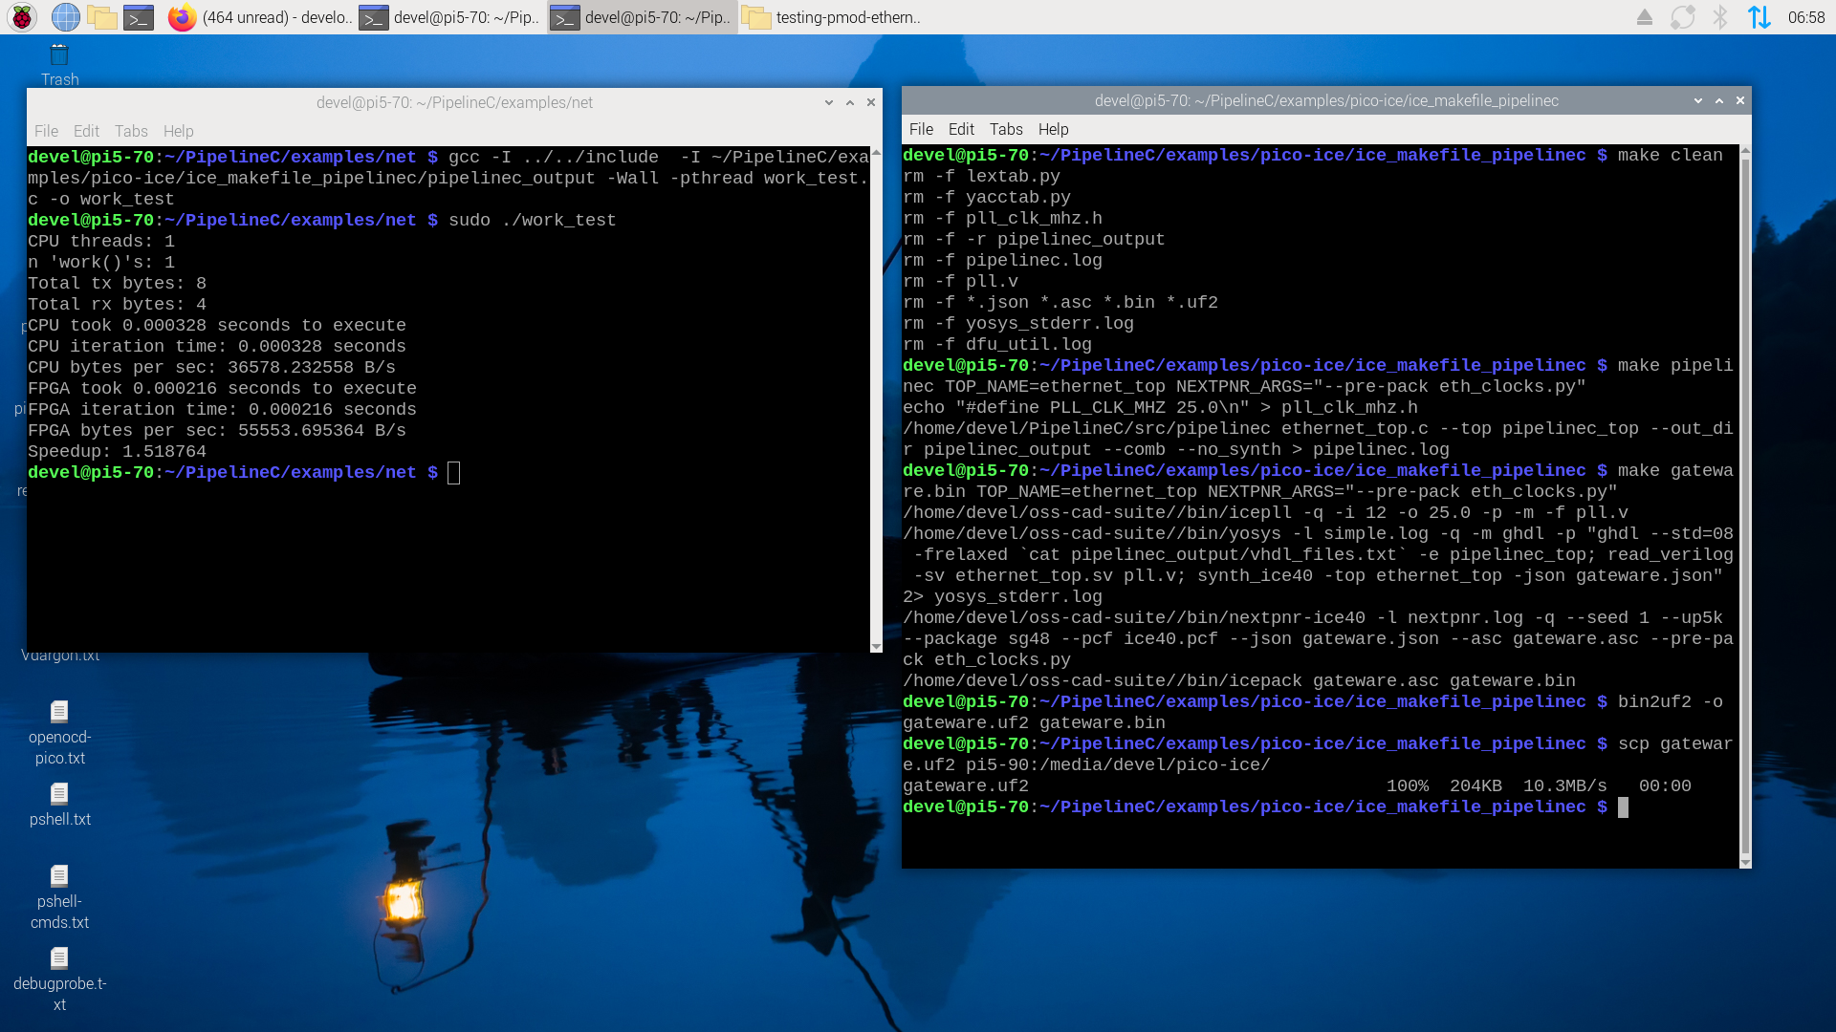

This image was loopback tested on 02/17/25
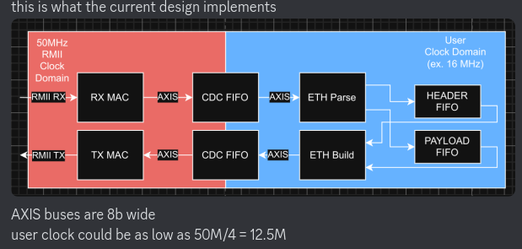

pico-ice 12MHz Catboard 100MHz
pmod-ether 25MHz

/**
* PLL configuration
*
* This Verilog header file was generated automatically
* using the icepll tool from the IceStorm project.
* It is intended for use with FPGA primitives SB_PLL40_CORE,
* SB_PLL40_PAD, SB_PLL40_2_PAD, SB_PLL40_2F_CORE or SB_PLL40_2F_PAD.
* Use at your own risk.
*
* Given input frequency: 100.000 MHz
* Requested output frequency: 25.000 MHz
* Achieved output frequency: 25.000 MHz
*/

.FEEDBACK_PATH("SIMPLE"),
.DIVR(4'b0000), // DIVR = 0
.DIVF(7'b0000111), // DIVF = 7
.DIVQ(3'b101), // DIVQ = 5
.FILTER_RANGE(3'b101) // FILTER_RANGE = 5

pico-ice to catboard
# PMOD0A
set_io -nowarn ICE_45 B15 #PM3-A4 345
set_io -nowarn ICE_47 B14 #PM3-A3 47
set_io -nowarn ICE_2 B12 #PM3-A2 2
set_io -nowarn ICE_4 A11 #PM3-A1 4

# PMOD0B
set_io -nowarn ICE_44 A15 #PM3-B4 44
set_io -nowarn ICE_46 B13 #PM3-B3 46
set_io -nowarn ICE_48 B11 #PM3-B2 48
set_io -nowarn ICE_3 B10 #PM3-B1 3

# PMOD1A
set_io -nowarn ICE_31 B6 #PM2-A4 31
set_io -nowarn ICE_34 A5 #PM2-A3 34
set_io -nowarn ICE_38 B3 #PM2-A2 38
set_io -nowarn ICE_43 A1 #PM2-A1 43

# PMOD1B
set_io -nowarn ICE_28 A6 #PM2-B4 28
set_io -nowarn ICE_32 A5 #PM2-B3 32
set_io -nowarn ICE_36 B4 #PM2-B2 36
set_io -nowarn ICE_42 A2 #PM2-B1 42

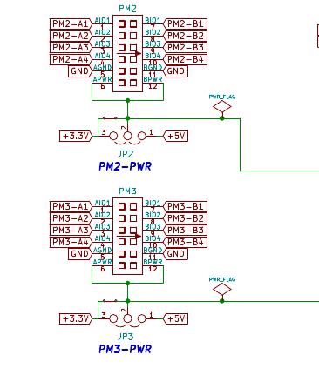
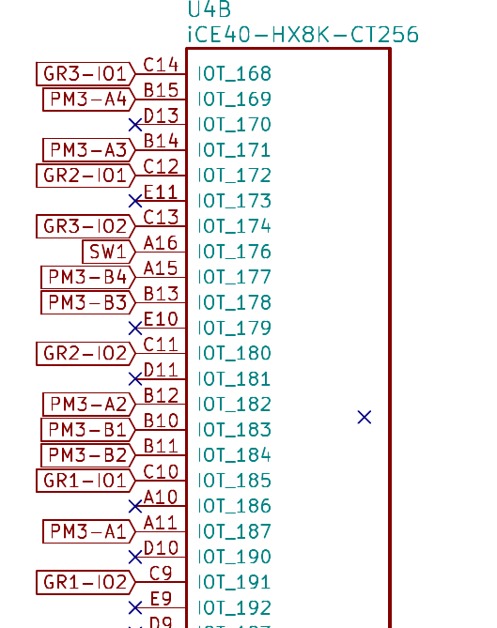

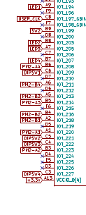

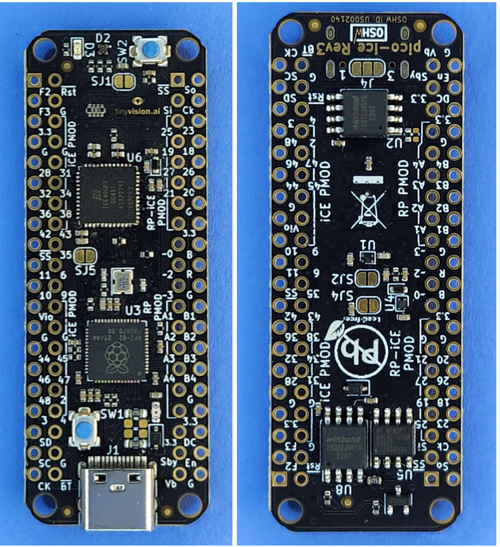
devel@pi5-70:~/Catboard-Pipelinec/pmod-ethernet/ice_makefile_pipelinec $ make clean
rm -f lextab.py
rm -f yacctab.py
rm -f pll_clk_mhz.h
rm -f -r pipelinec_output
rm -f pipelinec.log
rm -f pll.v
rm -f *.json *.asc *.bin *.uf2
rm -f yosys_stderr.log
rm -f dfu_util.log
devel@pi5-70:~/Catboard-Pipelinec/pmod-ethernet/ice_makefile_pipelinec $ make pipelinec TOP_NAME=ethernet_top
echo "#define PLL_CLK_MHZ 25.0\n" > pll_clk_mhz.h
/home/devel/PipelineC/src/pipelinec ethernet_top.c --top pipelinec_top --out_dir pipelinec_output --comb --no_synth > pipelinec.log
devel@pi5-70:~/Catboard-Pipelinec/pmod-ethernet/ice_makefile_pipelinec $ make gateware.bin TOP_NAME=ethernet_top
/home/devel/oss-cad-suite//bin/icepll -q -i 100 -o 25.0 -p -m -f pll.v
/home/devel/oss-cad-suite//bin/yosys -l simple.log -q -m ghdl -p "ghdl --std=08 -frelaxed `cat pipelinec_output/vhdl_files.txt` -e pipelinec_top; read_verilog -sv ethernet_top.sv pll.v; synth_ice40 -top ethernet_top -json gateware.json" 2> yosys_stderr.log
/home/devel/oss-cad-suite//bin/nextpnr-ice40 -l nextpnr.log -q --randomize-seed --hx8k --package ct256 --pcf ice40.pcf --json gateware.json --asc gateware.asc --freq 25.0
ERROR: PLL 'pll_inst.uut' PACKAGEPIN SB_IO 'clk_12p0$sb_io' is not connected to any PLL BEL
ERROR: Packing design failed.
0 warnings, 2 errors
make: *** [Makefile:40: gateware.bin] Error 255

