*****************************Default*****************************
Catboard-Pipelinec vga-pong
&
vga-pll
03/05/25
*****************************Default*****************************

This chekout of PipelineC repo was noted in the pico-ice repo on 02/17/25 and documented https://raw.githubusercontent.com/develone/pico-ice/refs/heads/test-dev-100424/myDocs/Pipelinec-rebuild-tests/built-files.txt

devel@pi5-70:~/PipelineC $ git checkout 6161
Note: switching to '6161'.

You are in 'detached HEAD' state. You can look around, make experimental
changes and commit them, and you can discard any commits you make in this
state without impacting any branches by switching back to a branch.

If you want to create a new branch to retain commits you create, you may
do so (now or later) by using -c with the switch command. Example:

git switch -c <new-branch-name>

Or undo this operation with:

git switch -

Turn off this advice by setting config variable advice.detachedHead to false

HEAD is now at 6161654 Merge branch 'JulianKemmerer:master' into test-dev

git clone https://github.com/develone/Catboard-Pipelinec.git
cd Catboard-Pipelinec/vga-pong/examples/pico-ice/
devel@pi5-70:~/Catboard-Pipelinec/vga-pong/examples/pico-ice/ice_makefile_pipelinec

$ make clean
rm -f lextab.py
rm -f yacctab.py
rm -f pll_clk_mhz.h
rm -f -r pipelinec_output
rm -f pipelinec.log
rm -f pll.v
rm -f *.json *.asc *.bin *.uf2
rm -f yosys_stderr.log
rm -f dfu_util.log
devel@pi5-70:~/Catboard-Pipelinec/vga-pong/examples/pico-ice/ice_makefile_pipelinec $

make pipelinec
echo "#define PLL_CLK_MHZ 25.0\n" > pll_clk_mhz.h
/home/devel/PipelineC/src/pipelinec pong_top.c --top pipelinec_top --out_dir pipelinec_output --comb --no_synth > pipelinec.log
devel@pi5-70:~/Catboard-Pipelinec/vga-pong/examples/pico-ice/ice_makefile_pipelinec $

make gateware.bin
/home/devel/oss-cad-suite//bin/icepll -q -i 100 -o 25.0 -m -f pll.v
/home/devel/oss-cad-suite//bin/yosys -l simple.log -q -m ghdl -p "ghdl --std=08 -frelaxed `cat pipelinec_output/vhdl_files.txt` -e pipelinec_top; read_verilog -sv top.sv pll.v; synth_ice40 -top top -json gateware.json" 2> yosys_stderr.log
/home/devel/oss-cad-suite//bin/nextpnr-ice40 -l nextpnr.log -q --randomize-seed --hx8k --package ct256 --pcf ice40.pcf --json gateware.json --asc gateware.asc --freq 25.0
/home/devel/oss-cad-suite//bin/icepack gateware.asc gateware.bin
devel@pi5-70:~/Catboard-Pipelinec/vga-pong/examples/pico-ice/ice_makefile_pipelinec $

rsync -avl --delete /home/devel/Catboard-Pipelinec pi4-28:~/

devel@pi4-28:~/Catboard-Pipelinec/vga-pong/examples/pico-ice/ice_makefile_pipelinec $ sudo ../../../../utils/config_cat gateware.bin

GPIO 25 not exported, trying to export...
GPIO 17 not exported, trying to export...
GPIO 22 not exported, trying to export...

OK: SPI driver loaded

Setting GPIO directions
out
out
in
Setting output to low
0
Reseting FPGA
0
1
Checking DONE pin
0
Continuing with configuration procedure
263+1 records in
263+1 records out
135100 bytes (135 kB, 132 KiB) copied, 0.0282328 s, 4.8 MB/s
Setting output to high
1
Checking DONE pin
1

devel@pi5-70:~/Catboard-Pipelinec/vga-pll/ice_makefile_pipelinec $ make clean
rm -f lextab.py
rm -f yacctab.py
rm -f pll_clk_mhz.h
rm -f -r pipelinec_output
rm -f pipelinec.log
rm -f pll.v
rm -f *.json *.asc *.bin *.uf2
rm -f yosys_stderr.log
rm -f dfu_util.log
devel@pi5-70:~/Catboard-Pipelinec/vga-pll/ice_makefile_pipelinec $ make pipelinec
echo "#define PLL_CLK_MHZ 25.0\n" > pll_clk_mhz.h
/home/devel/PipelineC/src/pipelinec top.c --top pipelinec_top --out_dir pipelinec_output --comb --no_synth > pipelinec.log
devel@pi5-70:~/Catboard-Pipelinec/vga-pll/ice_makefile_pipelinec $ make gateware.bin
/home/devel/oss-cad-suite//bin/icepll -q -i 100 -o 25.0 -m -f pll.v
/home/devel/oss-cad-suite//bin/yosys -l simple.log -q -m ghdl -p "ghdl --std=08 -frelaxed `cat pipelinec_output/vhdl_files.txt` -e pipelinec_top; read_verilog -sv top.sv pll.v; synth_ice40 -top top -json gateware.json" 2> yosys_stderr.log
/home/devel/oss-cad-suite//bin/nextpnr-ice40 -l nextpnr.log -q --randomize-seed --hx8k --package ct256 --pcf ice40.pcf --json gateware.json --asc gateware.asc --freq 25.0
/home/devel/oss-cad-suite//bin/icepack gateware.asc gateware.bin
devel@pi5-70:~/Catboard-Pipelinec/vga-pll/ice_makefile_pipelinec $ rsync -avl --delete /home/devel/Catboard-Pipelinec pi4-28:~/
devel@pi4-28:~/Catboard-Pipelinec/vga-pll/ice_makefile_pipelinec $ sudo ../../utils/config_cat gateware.bin

OK: GPIO 25 exported
OK: GPIO 17 exported
OK: GPIO 22 exported

OK: SPI driver loaded

Setting GPIO directions
out
out
in
Setting output to low
0
Reseting FPGA
0
1
Checking DONE pin
0
Continuing with configuration procedure
263+1 records in
263+1 records out
135100 bytes (135 kB, 132 KiB) copied, 0.0278676 s, 4.8 MB/s
Setting output to high
1
Checking DONE pin
1

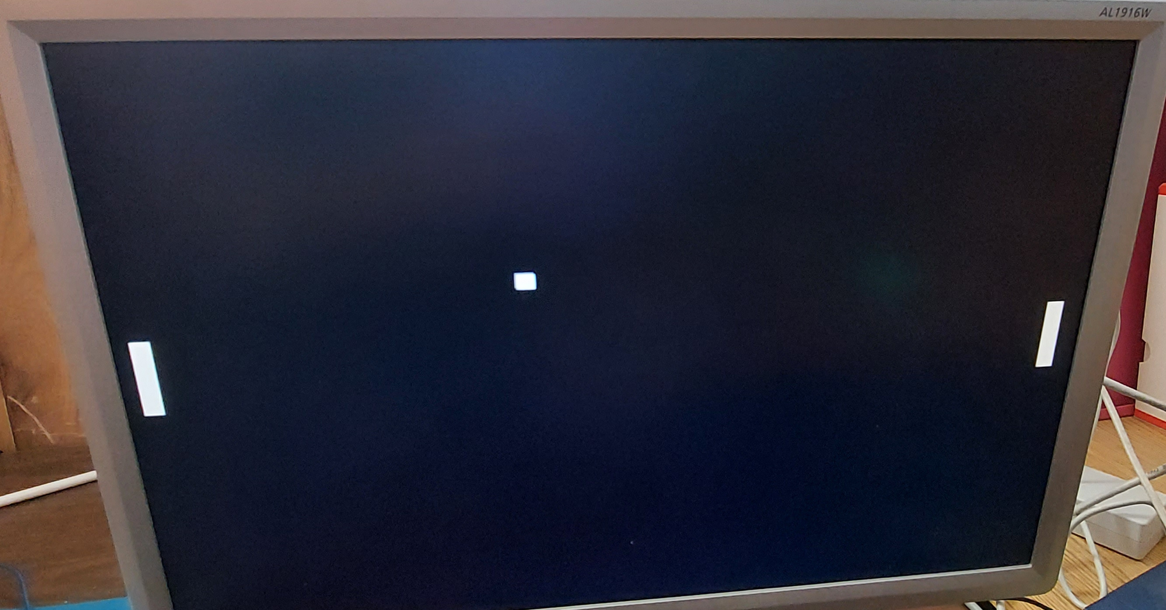
devel@pi4-28:~ $ minicom myusb0

Welcome to minicom 2.8

OPTIONS: I18n
Port /dev/ttyUSB0, 13:29:20

Press CTRL-A Z for help on special keys

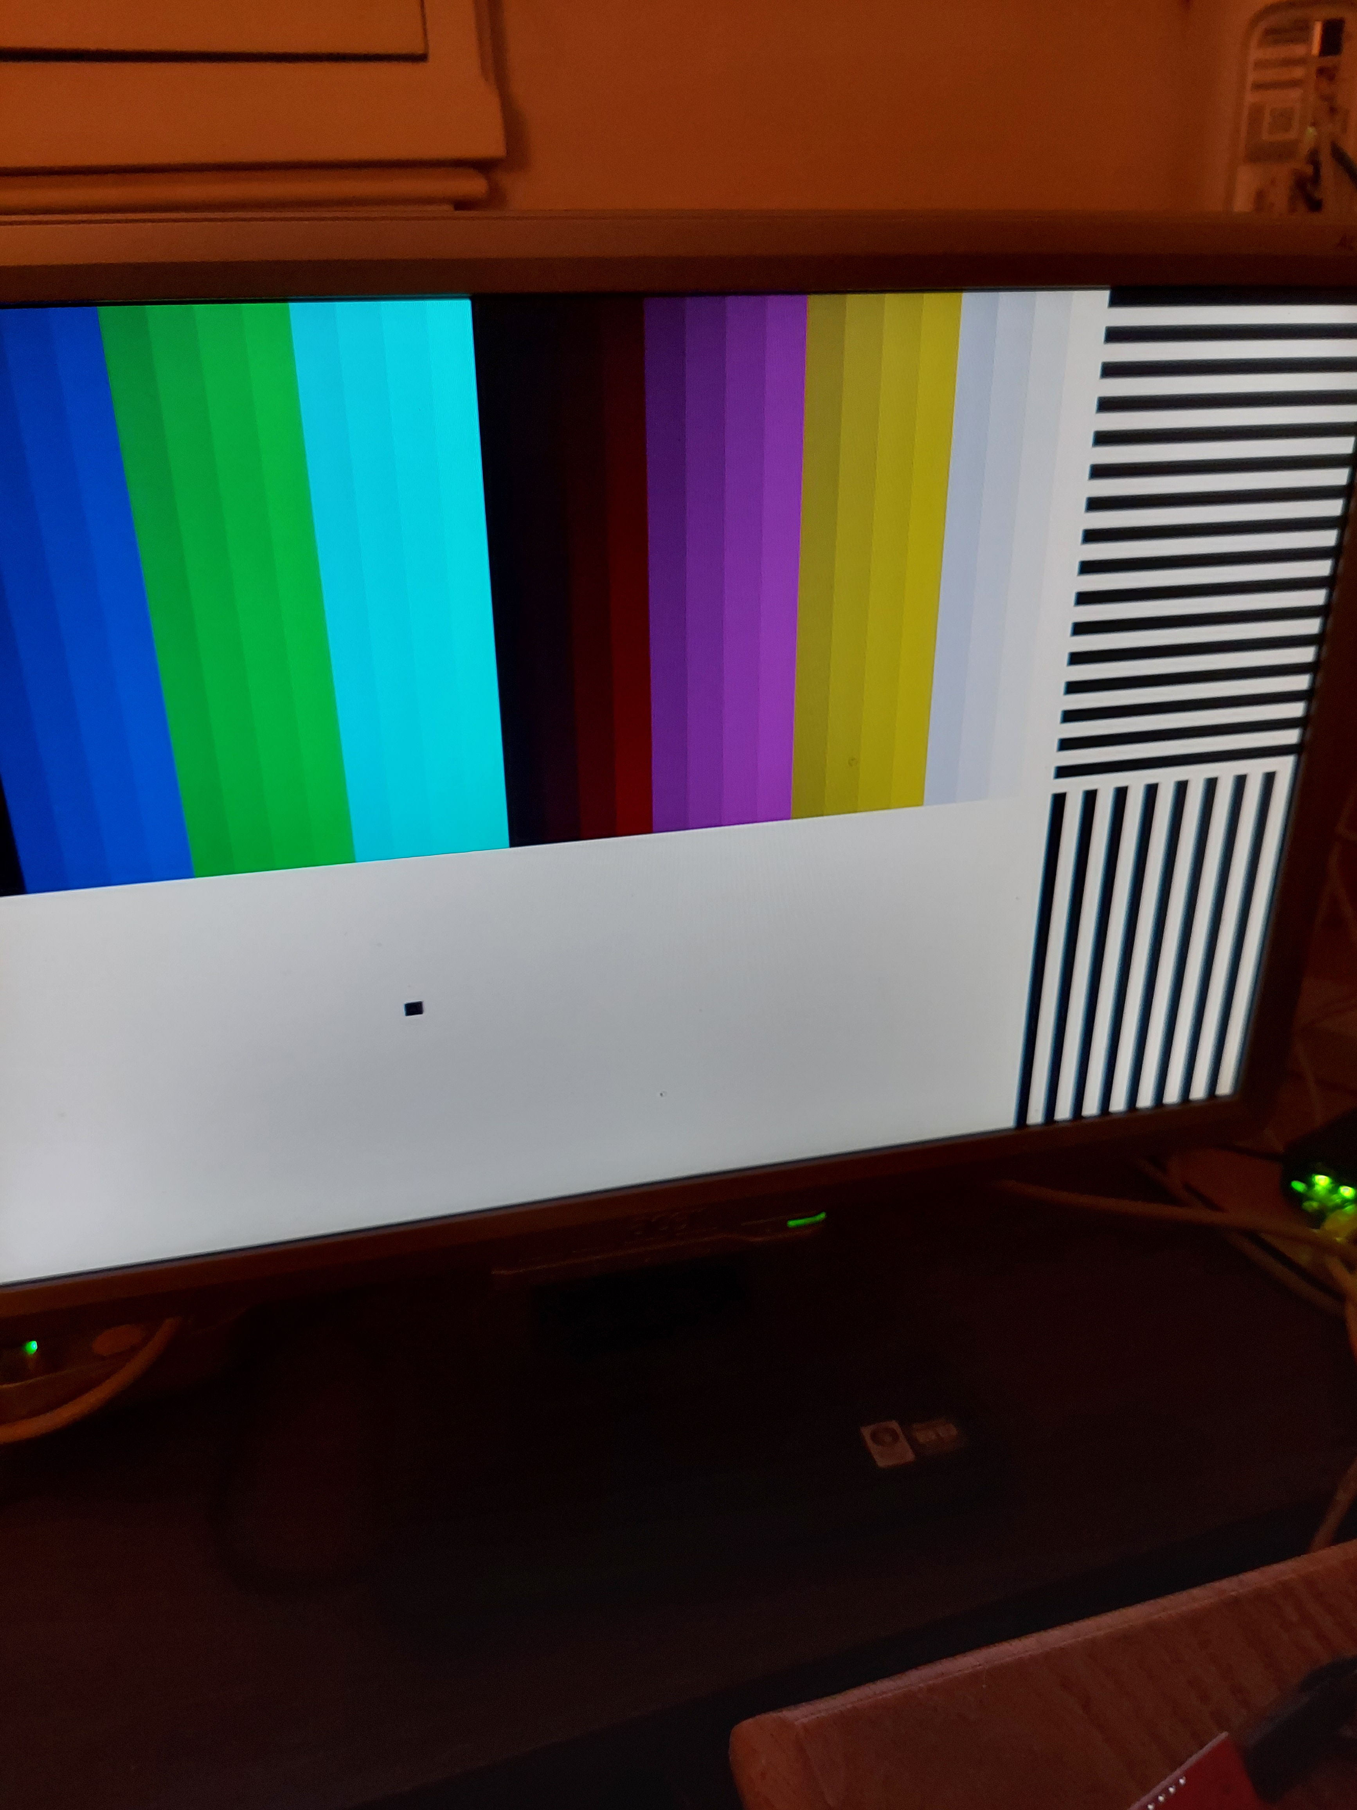

The pmods needed for vga-pong are reversed on the catboard pmod2 pmo3. This was noted when the pmod-ethernet was tested.

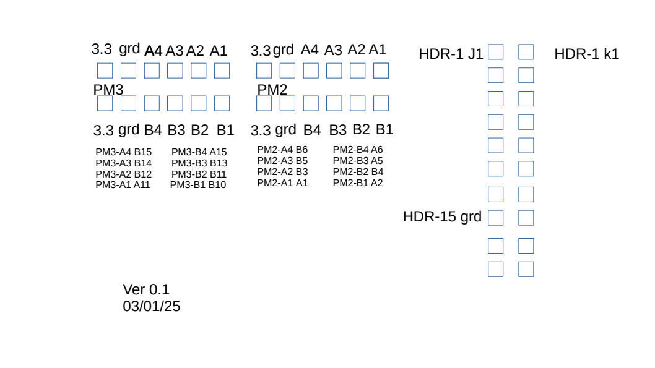

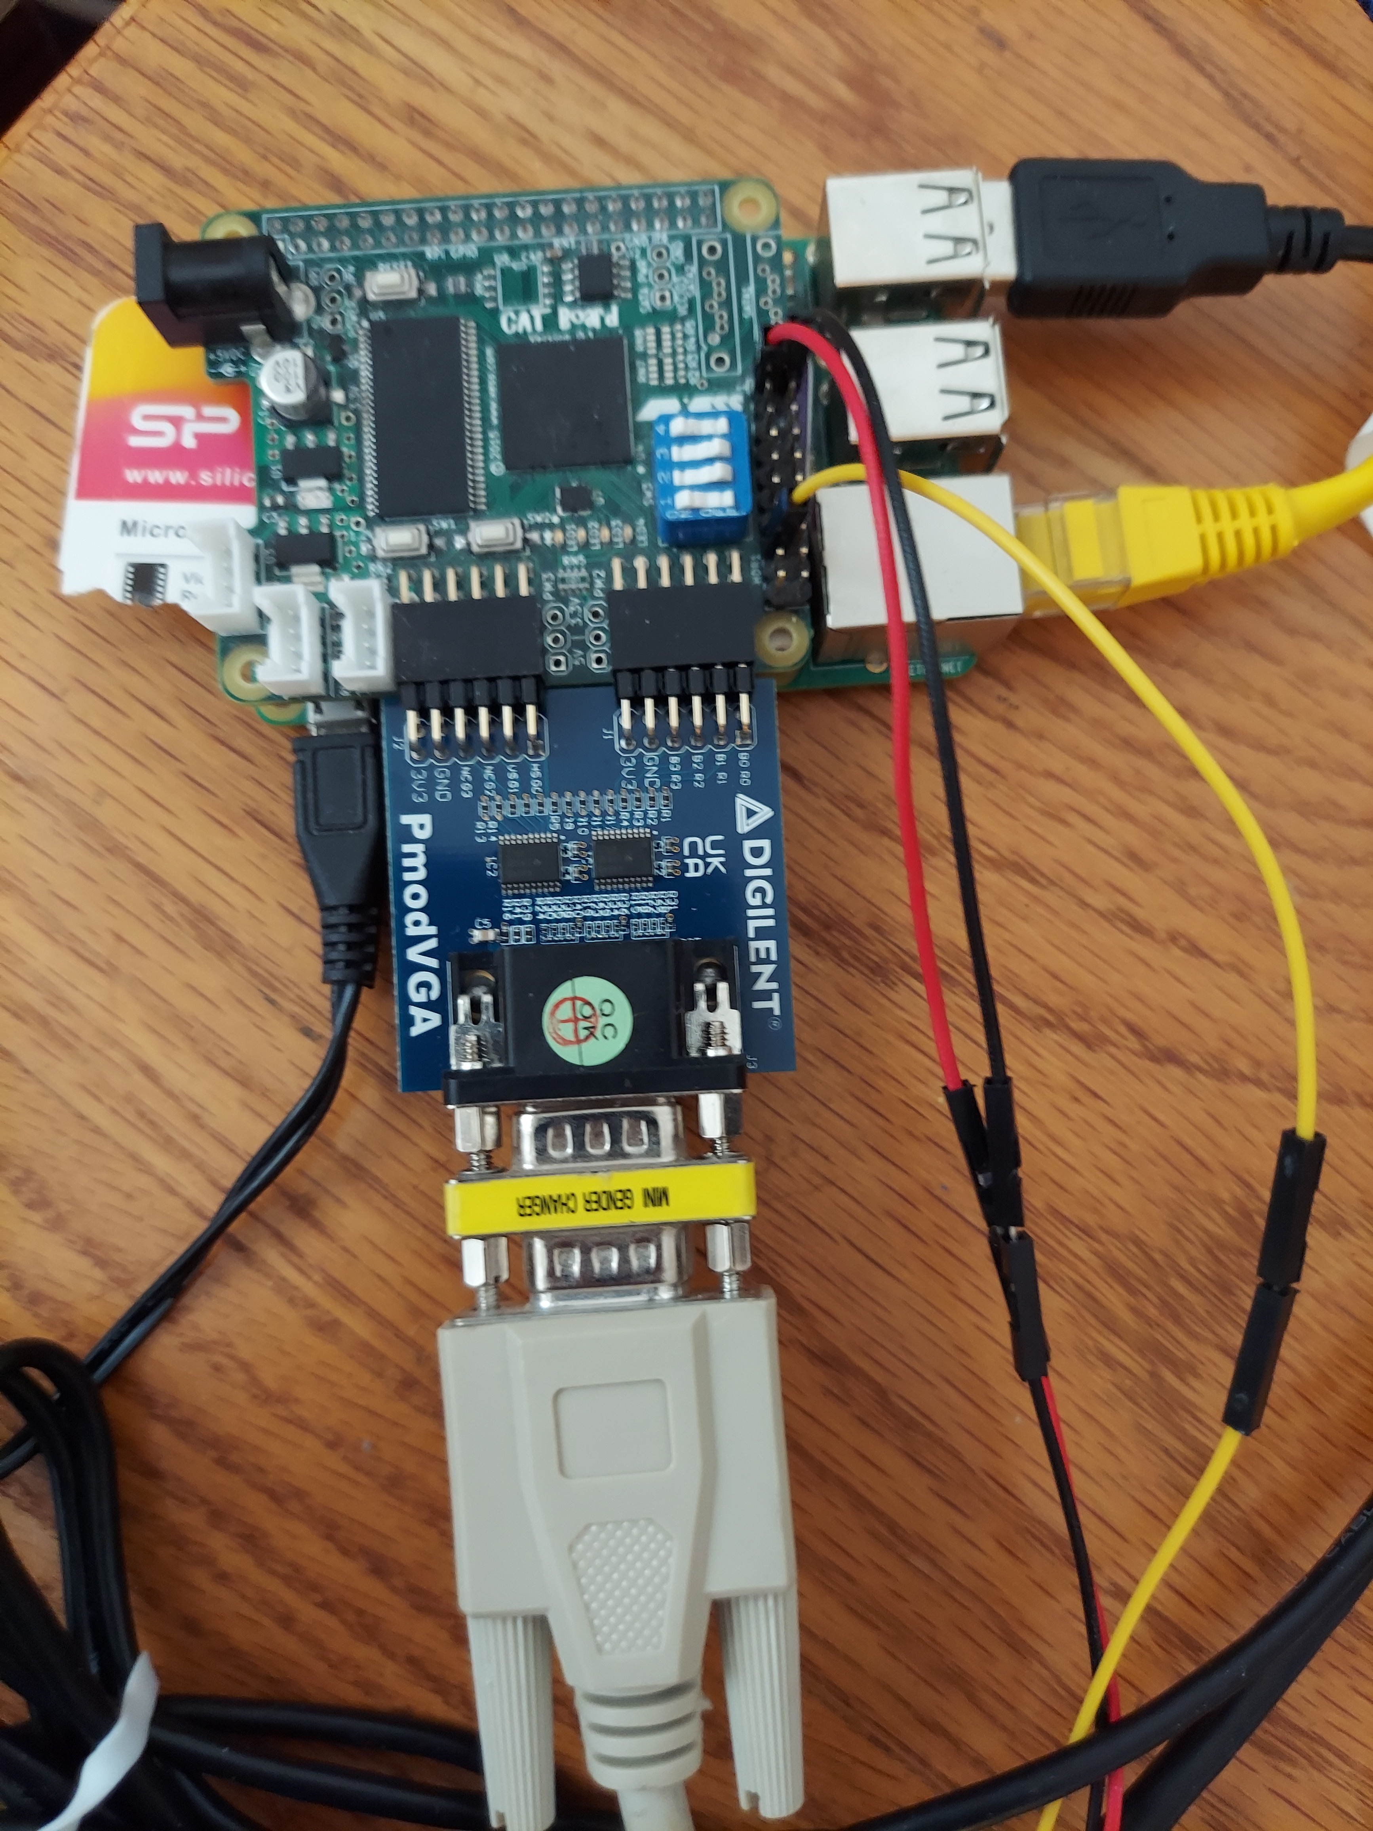

Catboard with PmodVGA
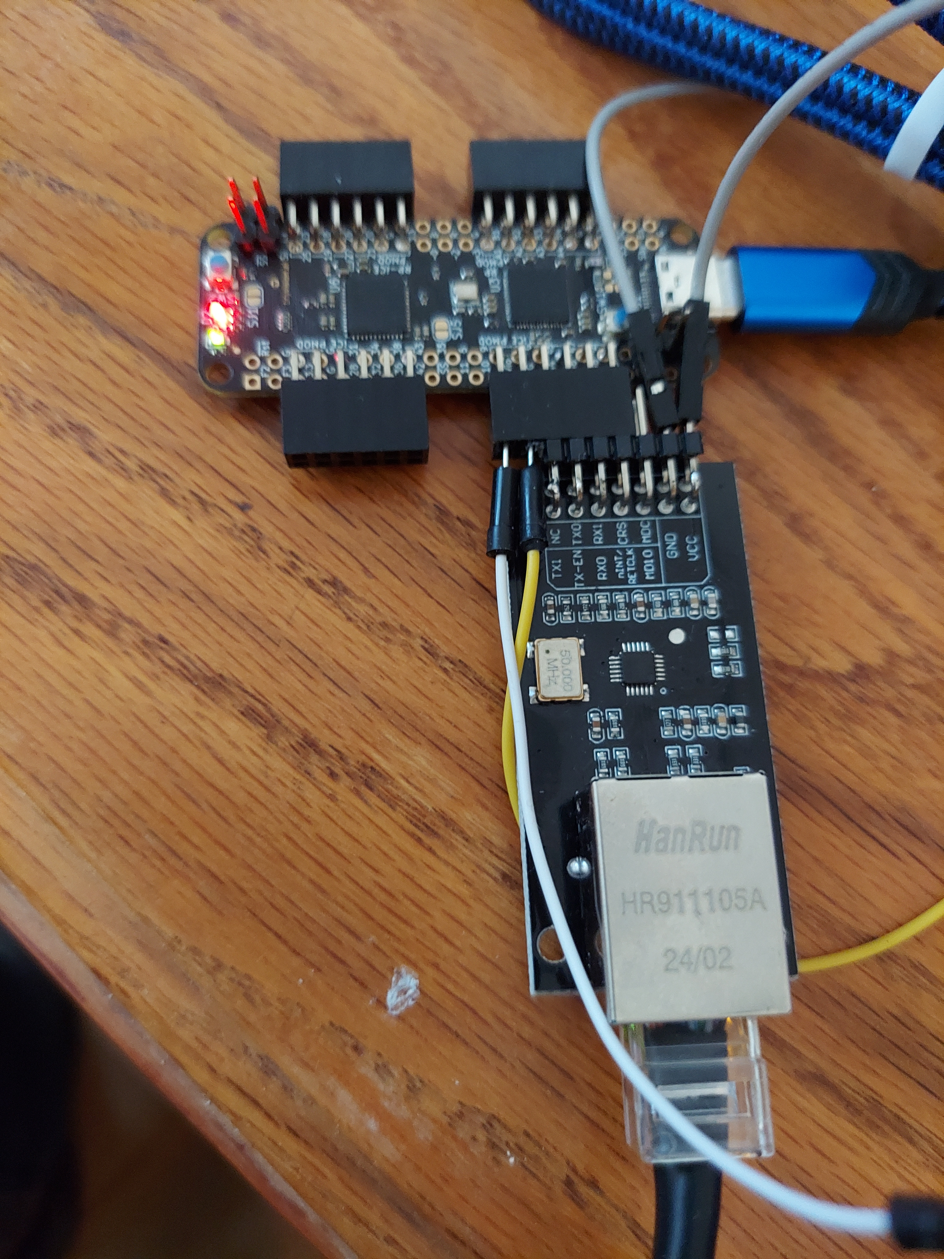
pico-ice wuth omod-ethernet
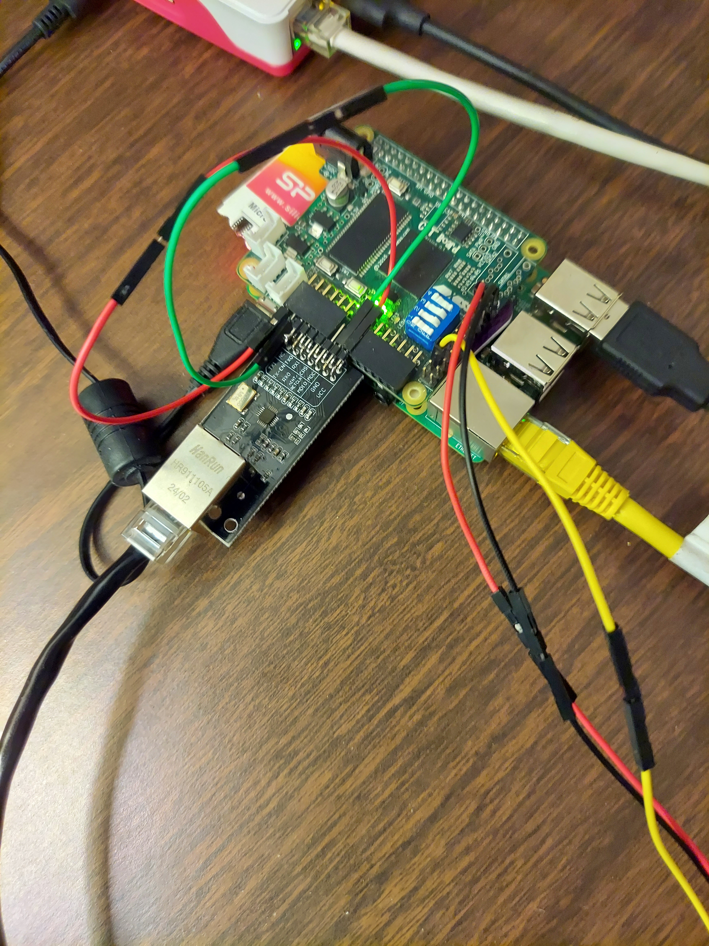
The following was from the Catboard-Pipelinec/doc/vga-pong/nextpnr.log
Info: Device utilisation:
Info: ICESTORM_LC: 999/ 7680 13%
Info: ICESTORM_RAM: 0/ 32 0%
Info: SB_IO: 20/ 256 7%
Info: SB_GB: 7/ 8 87%
Info: ICESTORM_PLL: 1/ 2 50%
Info: SB_WARMBOOT: 0/ 1 0%

