************************Default************************
03/17/25
************************Default************************

tftp 192.168.1.212 5069

devel@pi5-90:~/master-repos/Catboard-Pipelinec/jpeg_block $ tftp 192.168.1.212 5069
tftp> binary
tftp> put lena_rgb_32.bmp
tftp>

devel@pi5-90:~/master-repos/Catboard-Pipelinec/jpeg_block $ tftp 192.168.1.212 5069
tftp> binary
tftp> put lena_rgb_64.bmp
tftp> quit

devel@pi5-90:~/master-repos/Catboard-Pipelinec/jpeg_block $ tftp 192.168.1.212 5069
tftp> binary
tftp> put 64com
tftp> put 64decom
tftp> quit

telnet 192.168.1.212 5023

C:\>del MyBitmap.bmp

C:\>copy lena_rgb_64.bmp MyBitmap.bmp
C:\lena_rgb_64.bmp
1 file(s) copied

C:\>del testesfile

C:\>copy 64com testfile
C:\64com
1 file(s) copied

C:\>restart
Restarting in 1000 milliseconds

The image below is QEMU working on 64x64 image.

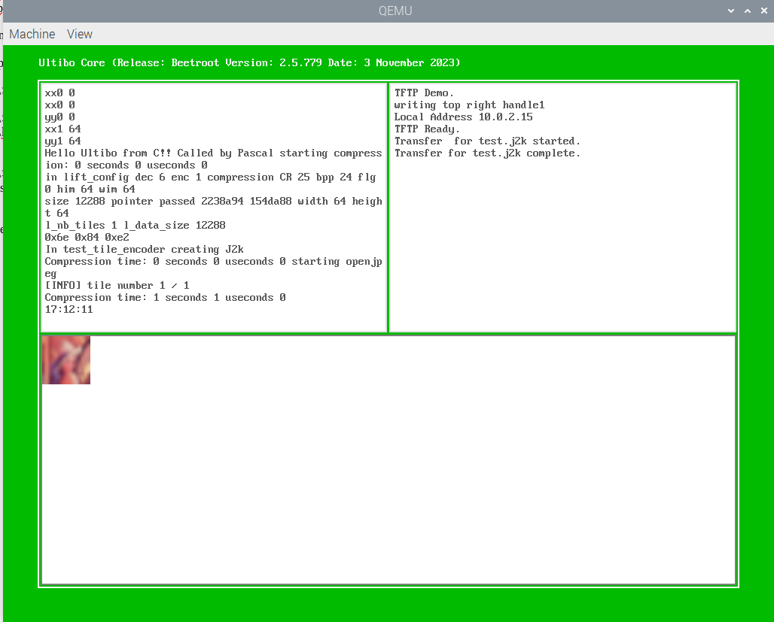

devel@pi5-90:~/master-repos/Catboard-Pipelinec/jpeg_block $ tftp 192.168.1.212 5069
tftp> binary
tftp> get test.j2k
tftp> quit

devel@pi5-90:~/t_ultibo/build/bin $ ./opj_decompress -i qemu64.j2k -o qemu64.bmp
[INFO] Start to read j2k main header (0).
[INFO] Main header has been correctly decoded.
[INFO] No decoded area parameters, set the decoded area to the whole image
[INFO] Header of tile 1 / 1 has been read.
[INFO] Generated Outfile qemu64.bmp
decode time: 0 ms

xx

xx

C:\>del testfile

C:\>copy 64decom testfile
C:\64decom
1 file(s) copied

C:\>restart
Restarting in 1000 milliseconds

QEMU decompression

xx
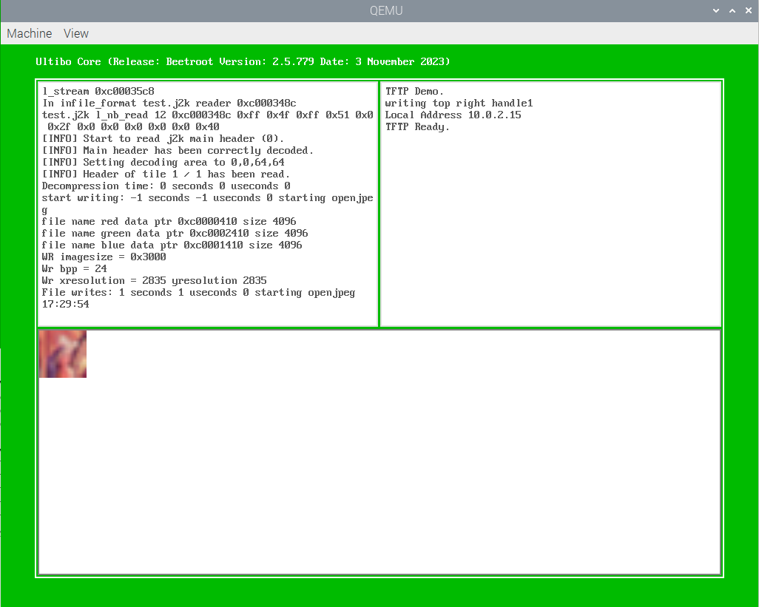
xx

devel@pi5-90:~/master-repos/Catboard-Pipelinec/jpeg_block $ tftp 192.168.1.212 5069
tftp> binary
tftp> get test_wr.bmp
tftp> quit

xx

xx

