*********************Draft*********************
RPi4 with 2GB & Rpi3B+with 1GB
07/23/19
Testing
*********************Draft*********************

Currently the only package that appears to not work correctly is octave which is used to diplay the images used in the fpga work. This appears to be problem with the buster changes for the Rpi4.
GNU Octave - Bugs: PMbug #56570, unable to plot with OpenGL on... [Savannah]

The buster release installs 1693 pkgs. The 2019-06-20-raspbian-buster-full.zip was used for the initial install with a sha256sum 7c0dec54e9ad694d6f306f495f793d1a5021020e7c46a6df02b6c84478473e17 2019-06-20-raspbian-buster-full.zip. The current pkgs count is 2197 which is the software required to support FPGA development.
07/07/19
on mypi3-8 downloaded the zip file
7c0dec54e9ad694d6f306f495f793d1a5021020e7c46a6df02b6c84478473e17
sha256sum Downloads/2019-06-20-raspbian-buster-full.zip
7c0dec54e9ad694d6f306f495f793d1a5021020e7c46a6df02b6c84478473e17 Downloads/2019-06-20-raspbian-buster-full.zip
root@mypi3-8:/home/pi/Downloads# gzip -dc 2019-06-20-raspbian-buster-full.zip | dd bs=4M status='progress' of=/dev/sda
5286559744 bytes (5.3 GB, 4.9 GiB) copied, 295 s, 17.9 MB/s
gzip: 2019-06-20-raspbian-buster-full.zip: invalid compressed data--length error

0+146238 records in
0+146238 records out
5289017344 bytes (5.3 GB, 4.9 GiB) copied, 302.261 s, 17.5 MB/s

initial pkgs 1693
sudo apt-get update
./extra_pkgs.sh 2196 pkgs070719.txt
root@mypi3-11:/etc# diff dphys-swapfile.orig dphys-swapfile
16c16
< CONF_SWAPSIZE=100
---
> CONF_SWAPSIZE=1000
needed to be rebuilt with gcc version 8.3.0 (Raspbian 8.3.0-6+rpi1)
autofpga arachne-pnr icestorm verilator zipcpu yosys nextpnr
uname -a
Linux mypi3-11 4.19.50-v7+ #896 SMP Thu Jun 20 16:11:44 BST 2019 armv7l GNU/Linux
root@mypi3-11:/usr/local/bin# ln -sf /home/devel/catboard_yosys/reset_cat reset_cat
root@mypi3-11:/usr/local/bin# ln -sf /home/devel/catboard_yosys/config_cat config_cat
root@mypi3-11:/usr/local/bin# ln -sf /home/devel/autofpga/sw/autofpga autofpga
The buster repository chg'ed from testing to stable
pi@mypi3-11:~ $ sudo apt-get update
Hit:1 http://archive.raspberrypi.org/debian buster InRelease
Get:2 http://raspbian.raspberrypi.org/raspbian buster InRelease [15.0 kB]
Reading package lists... Done
E: Repository 'http://raspbian.raspberrypi.org/raspbian buster InRelease' changed its 'Suite' value from 'testing' to 'stable'
N: This must be accepted explicitly before updates for this repository can be applied. See apt-secure(8) manpage for details.
I was getting and error sudo apt-get update on mypi3-12
On mypi3-12 needed to apt-get update --allow-releaseinfo-change
transfer from mypi3-11 to mypi3-12
sudo rsync -avl --delete catboard_yosys ~/ ;sudo rsync -avl --delete verilator ~/
sudo rsync -avl --delete zipcpu ~/
sudo rsync -avl --delete verilator ~
rsync -avl --delete icestorm ~/
rsync -avl --delete arachne-pnr ~/
rsync -avl --delete testbuilds/nextpnr /home/pi/testbuilds

arachne-pnr
autofpga
icestorm
yosys
zipcpu
verilator
The user pi was replaced with user devel to improve security.

https://www.raspberrypi.org/documentation/configuration/security.md
sudo adduser devel
Adding user `devel' ...
Adding new group `devel' (1001) ...
Adding new user `devel' (1001) with group `devel' ...
Creating home directory `/home/devel' ...
Copying files from `/etc/skel' ...
New password:
Retype new password:
passwd: password updated successfully
Changing the user information for devel
Enter the new value, or press ENTER for the default
Full Name []: Ed Vidal Jr.
Room Number []:
Work Phone []:
Home Phone []:
Other []:
Is the information correct? [Y/n] Y
sudo adduser devel sudo
Adding user `devel' to group `sudo' ...
Adding user devel to group sudo
Done.
grep devel /etc/group
sudo:x:27:pi,devel
devel:x:1001:

# This file MUST be edited with the 'visudo' command as root.

Move the pi user file to user devel and change the owner to devel

root@mypi3-13:/home/pi# mv ultiboinstaller.sh /home/devel/

root@mypi3-13:/home/pi# chown devel:devel /home/devel/ultiboinstaller.sh

root@mypi3-13:/home/pi# mv autofpga/ /home/devel/

root@mypi3-13:/home/pi# chown -R devel:devel /home/devel/autofpga/

root@mypi3-13:/home/pi# mv arachne-pnr/ /home/devel/

root@mypi3-13:/home/pi# chown -R devel:devel /home/devel/arachne-pnr/

root@mypi3-13:/home/pi# mv icestorm/ /home/devel/

root@mypi3-13:/home/pi# chown -R devel:devel /home/devel/icestorm/

root@mypi3-13:/home/pi# mv yosys/ /home/devel/

root@mypi3-13:/home/pi# chown -R devel:devel /home/devel/yosys/

root@mypi3-13:/home/pi# mv verilator/ /home/devel/

root@mypi3-13:/home/pi# chown -R devel:devel /home/devel/verilator

root@mypi3-13:/home/pi# mv zipcpu/ /home/devel/

root@mypi3-13:/home/pi# chown -R devel:devel /home/devel/zipcpu/

root@mypi3-13:/home/pi# mv testbuilds/ /home/devel/

root@mypi3-13:/home/pi# chown -R devel:devel /home/devel/testbuilds/

root@mypi3-13:/home/pi# mv catboard_yosys/ /home/devel/

root@mypi3-13:/home/pi# chown -R devel:devel /home/devel/catboard_yosys/

root@mypi3-13:/usr/local/bin# ln -sf /home/devel/catboard_yosys/reset_cat reset_cat

root@mypi3-13:/usr/local/bin# ln -sf /home/devel/catboard_yosys/config_cat config_cat

root@mypi3-13:/usr/local/bin# ln -sf /home/devel/autofpga/sw/autofpga autofpga

testbuilds/catzip/
The script extra_pkgs.sh was used to install the additonal 499 pkgs.This pkgs are needed for FPGA softwware to build and install correctly.
#!/bin/bash
sudo apt-get update
sudo apt-get install octave vlc kicad hexchat \
ecryptfs-utils gawk gimp gtkwave iverilog clang \
samba samba-common-bin smbclient cifs-utils \
libftdi-dev libmpc-dev libmpfr-dev verilator bc mercurial \
libbison-dev libgmp-dev libelf-dev ncurses-dev ctags \
default-jdk libreadline-dev xdot graphviz minicom xpdf lrzsz \
libusb-1.0.0 exuberant-ctags gparted ffmpeg qt5-default \
mesa-utils libboost-all-dev freeglut3 freeglut3-dev \
python3-dev libgtk2.0-dev libcairo2-dev libpango1.0-dev \
libgdk-pixbuf2.0-dev libatk1.0-dev libghc-x11-dev binutils-arm-none-eabi \
gcc-arm-none-eabi diffuse gitk tcl-dev telnet tftp hexedit cmake flex bison \
gtkmm-3.0 gperf build-essential qt5-default
extra_pkgs.sh (END)

The script to install Lazarus & FPC “ultiboinstaller.sh” on the Rpi4 work very well and appears to run slightly faster than on Rpi3B+. See devel@mypi3-13:~/Ultibo_Projects/jpeg2000/doc $ ls lazarus_jpeg2000.odt or devel@mypi3-13:~/Ultibo_Projects/jpeg2000/doc $ ls lazarus_jpeg2000.pdf
pgs 11-13 where the Lazarus GUI is used to build the jpeg2000 project.https://github.com/develone/Ultibo_Projects/blob/master/jpeg2000/doc/lazarus_jpeg2000.pdf

Raspberry Pi 4 specs
- SoC: Broadcom BCM2711B0 quad-core A72 (ARMv8-A) 64-bit @ 1.5GHz
- GPU: Broadcom VideoCore VI
- Networking: 2.4 GHz and 5 GHz 802.11b/g/n/ac wireless LAN
- RAM: 1GB, 2GB, or 4GB LPDDR4 SDRAM
- Bluetooth: Bluetooth 5.0, Bluetooth Low Energy (BLE)
- GPIO: 40-pin GPIO header, populated
- Storage: microSD
- Ports: 2 × micro-HDMI 2.0, 3.5 mm analogue audio-video jack, 2 × USB 2.0, 2 × USB 3.0, Gigabit Ethernet, Camera Serial Interface (CSI), Display Serial Interface (DSI)
- Dimensions: 88 mm × 58 mm × 19.5 mm, 46 g

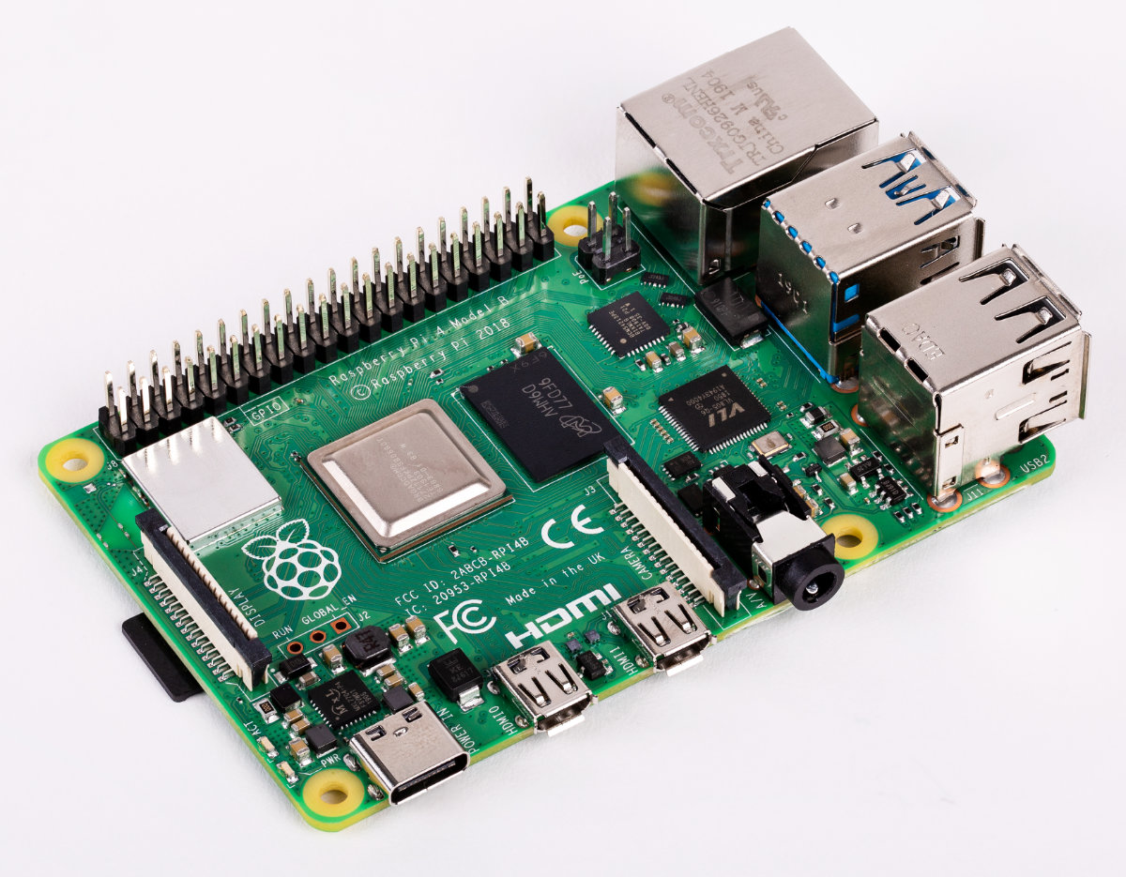
Raspberry pi 3B+

The Raspberry Pi model 3 B+ Specs
- SOC: Broadcom BCM2837B0, Cortex-A53 (ARMv8) 64-bit SoC
- CPU: 1.4GHz 64-bit quad-core ARM Cortex-A53 CPU
- RAM: 1GB LPDDR2 SDRAM
- WIFI: Dual-band 802.11ac wireless LAN (2.4GHz and 5GHz ) and Bluetooth 4.2
- Ethernet: Gigabit Ethernet over USB 2.0 (max 300 Mbps). Power-over-Ethernet support (with separate PoE HAT). Improved PXE network and USB mass-storage booting.
- Thermal management: Yes
- Video: Yes – VideoCore IV 3D. Full-size HDMI
- Audio: Yes
- USB 2.0: 4 ports
- GPIO: 40-pin
- Power: 5V/2.5A DC power input
- Operating system support: Linux and Unix

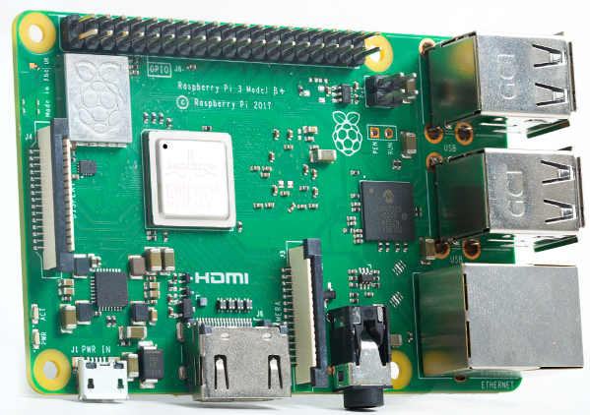

Adding a fan.Tesing a fan blowing up from Raspberry Pi 4.
sudo vcgencmd measure_temp
temp=52.0'C
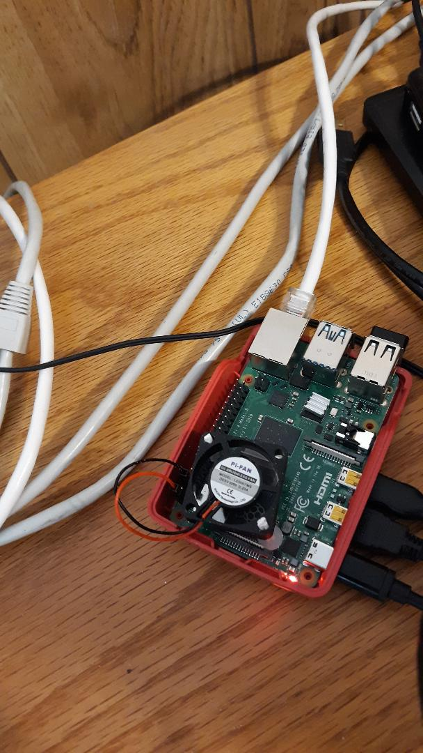

Dual monitors
From Raspberry/Preference/Screen Configuration

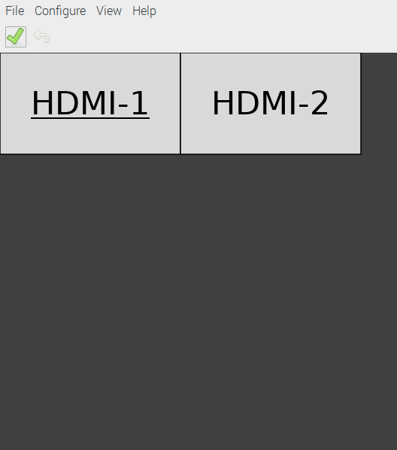

Loggin

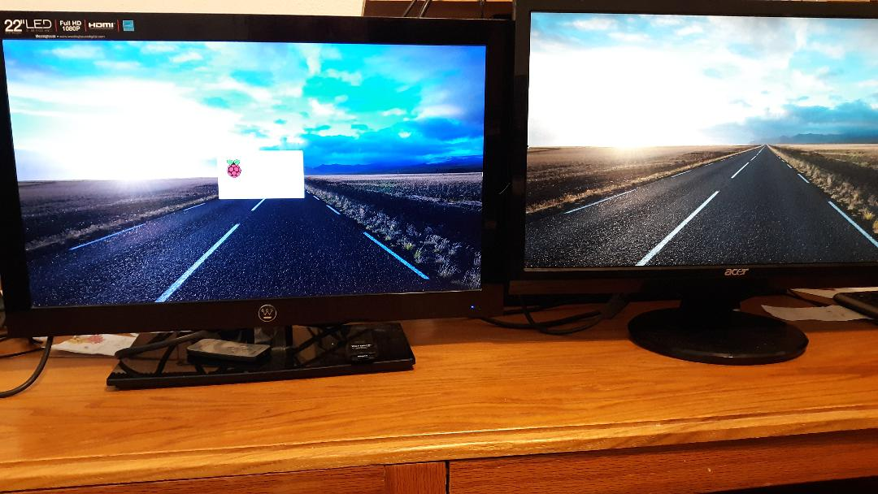
DeskTop

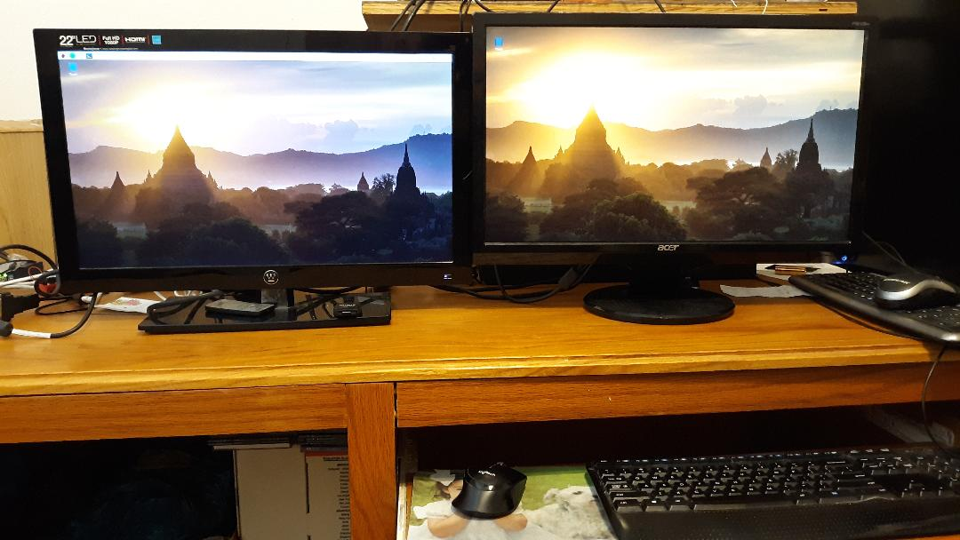

The catboard software provides a simulation of the FPGA
devel@mypi3-13:~/testbuilds/catzip/sim/verilated $ ./arm-main_tb -d
Listening on port 8363
Listening on port 8364
Opening Bus-master with
Debug Access port = 8363
Serial Console = 8364
VCD File = trace.vcd
> T
CMD: Only sent 0 bytes of 3!
Accepted CMD connection
POLL = 1
RCVD: 12 bytes
< A00200001W8
> A00200001K00000000
POLL = 1
RCVD: 0 bytes
< [CLOSED]
Accepted CMD connection
POLL = 1
RCVD: 11 bytes
< A00200001R
> A00200001R12400008
POLL = 1
RCVD: 11 bytes
< A00200001R
> A00200001R12400008
POLL = 1
RCVD: 0 bytes
< [CLOSED]
Accepted CMD connection
POLL = 1
RCVD: 19 bytes
< A01000005W55aaaa55
> A01000005
> K00000000
POLL = 1
RCVD: 0 bytes
< [CLOSED]
Accepted CMD connection
POLL = 1
RCVD: 11 bytes
< A00200001R
> A00200001R72400008
POLL = 1
RCVD: 11 bytes
< A00200005R
> A00200005R01e10000
POLL = 1
RCVD: 11 bytes
< A00200005R
> A00200005R01e10000
POLL = 1
RCVD: 11 bytes
< A00200005R
> A00200005R01e10000
POLL = 1
RCVD: 11 bytes
< A00200005R
> A00200005R39e10000
POLL = 1
RCVD: 11 bytes
< A00200005R
> A00200005R6ce10000
POLL = 1
RCVD: 11 bytes
< A00200005R
> A00200005R6c6055aa
POLL = 1
RCVD: 11 bytes
< A00200005R
> A00200005R6ce055aa
POLL = 1
RCVD: 11 bytes
< A00200005R
> A00200005R688255aa
POLL = 1
RCVD: 11 bytes
< A00200005R
> A00200005R6ee2aa55
POLL = 1
RCVD: 11 bytes
< A00200005R
> A00200005R68e255aa
POLL = 1
RCVD: 11 bytes
< A00200005R
> A00200005R68e255aa
POLL = 1
RCVD: 11 bytes
< A00200005R
> A00200005R68e255aa
POLL = 1
RCVD: 11 bytes
< A00200005R
> A00200005R68e255aa
POLL = 1
RCVD: 11 bytes
< A00200005R
> A00200005R48e255aa
POLL = 1
RCVD: 11 bytes
< A00200005R
> A00200005R40220000
POLL = 1
RCVD: 11 bytes
< A00200005R
> A00200005R01e255aa
POLL = 1
RCVD: 0 bytes
< [CLOSED]
Accepted CMD connection
POLL = 1
RCVD: 11 bytes
< A01000005R
> A01000005R55aaaa55
POLL = 1
RCVD: 0 bytes
< [CLOSED]
^C

write

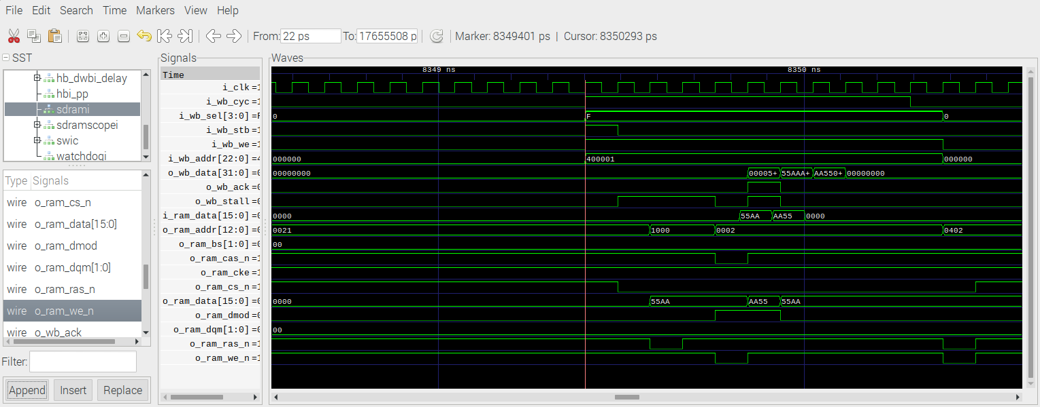
read

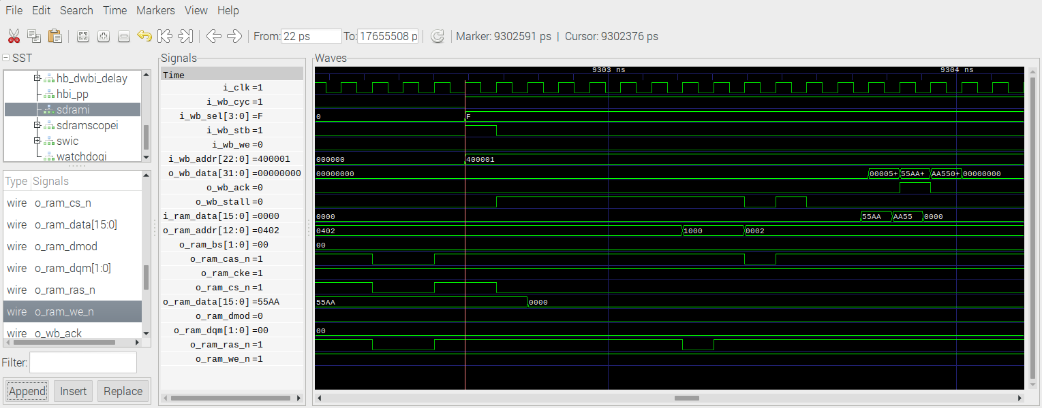

Simulation shell when executed without -d option does not create a VCD file.

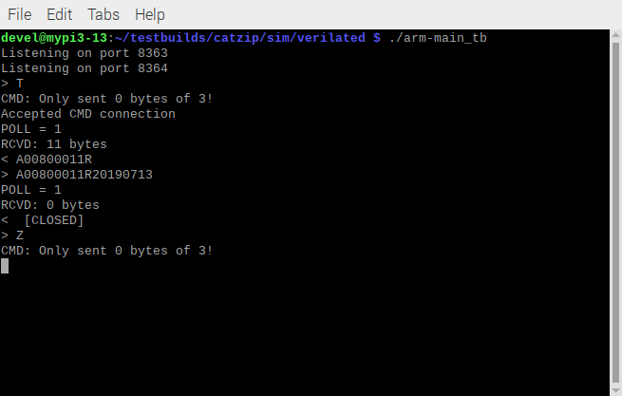
Rpi4 querry of the FPGA or simulator.
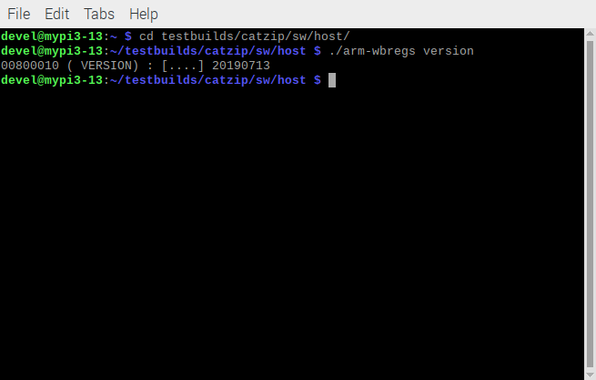

Load the program in the FPGA

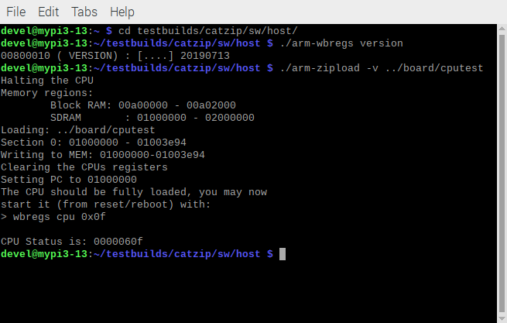

With ./arm-wbregs cpu 0x0f

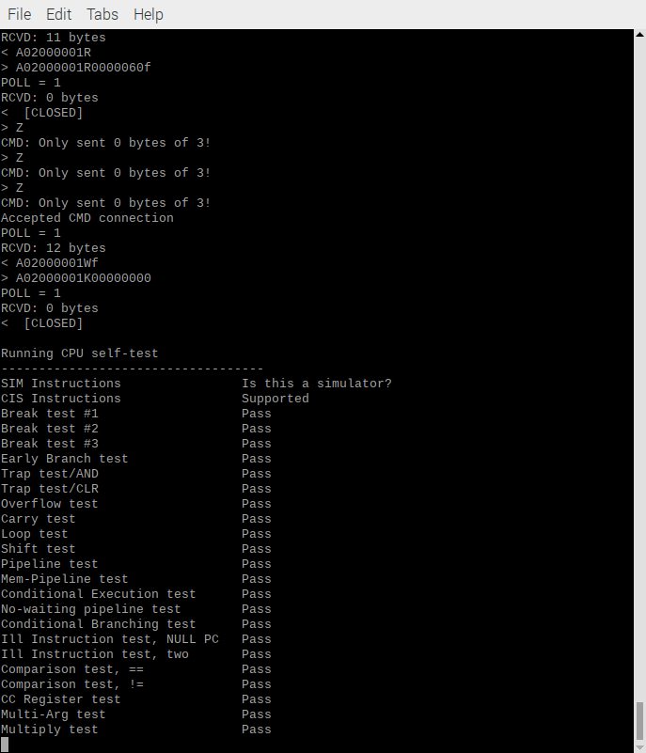

devel@mypi3-13:~/testbuilds/catzip/sw/host $ ./arm-zipload -v ../board/hello
Halting the CPU
Memory regions:
Block RAM: 00a00000 - 00a02000
SDRAM : 01000000 - 02000000
Loading: ../board/hello
Section 0: 01000000 - 010048ec
Writing to MEM: 01000000-010048ec
Clearing the CPUs registers
Setting PC to 01000000
The CPU should be fully loaded, you may now
start it (from reset/reboot) with:
> wbregs cpu 0x0f

CPU Status is: 0000060f

With ./arm-wbregs cpu 0x0f

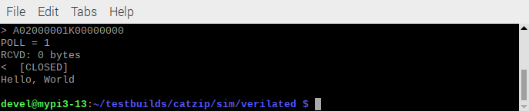

Simulation cputest

Simulation Hello

Thread SVD

