Octave GNU Octave. Scientific Programming Language. Powerful mathematics-oriented syntax with built-in 2D/3D plotting and visualization tools; Free software, runs on GNU/Linux,

x2 - 8x + 12 for x -25 to 25 top plot
x2 - 8x + 12 factor (x-2) & x-6) for x -25 to 25 middle plot
x3 - 8x + 12 for x -25 to 25 bottom plot

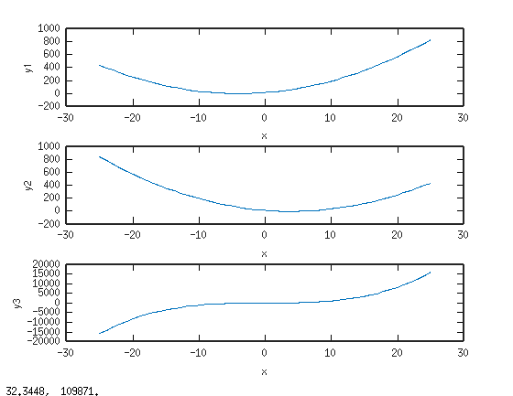

Octave runs on Rpi3

