simulation of MyTopLevel.v with verilator

create sim_main.cpp ~/iverilog-examples/ex-05-hello/helloworld_tb.cpp
chg #include "Vhelloworld.h" to #include "VMyTopLevel.h"
rm #include "uartsim.h"
chg TESTB<Vhelloworld> *tb
= new TESTB<Vhelloworld>;
TESTB<VMyTopLevel> *tb
= new TESTB<VMyTopLevel>;
chg tb->opentrace("helloworld.vcd"); to tb->opentrace("MyTopLevel.vcd");

create testb.h ~/iverilog-examples/ex-05-hello/testb.h

chg i_clk to clk

verilator -Wall --trace -cc MyTopLevel.v --exe --build sim_main.cpp

creates obj_dir with VMyTopLevel

cd obj_dir

./VMyTopLevel creates MyTopLevel.vcd

gtkwave MyTopLevel.vcd

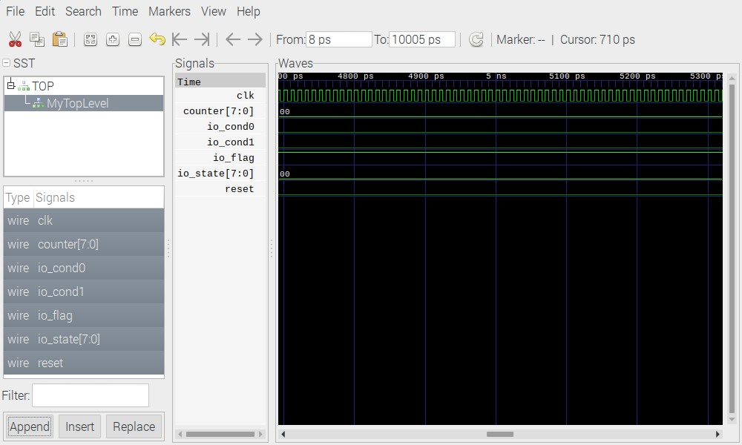
tb->opentrace("MyTopLevel.vcd");
-
+ tb->m_core->reset = 0;
for(unsigned clocks=0;
clocks < 1000;
clocks++) {
-
+ if (clocks==10) tb->m_core->reset = 1;
tb→tick();

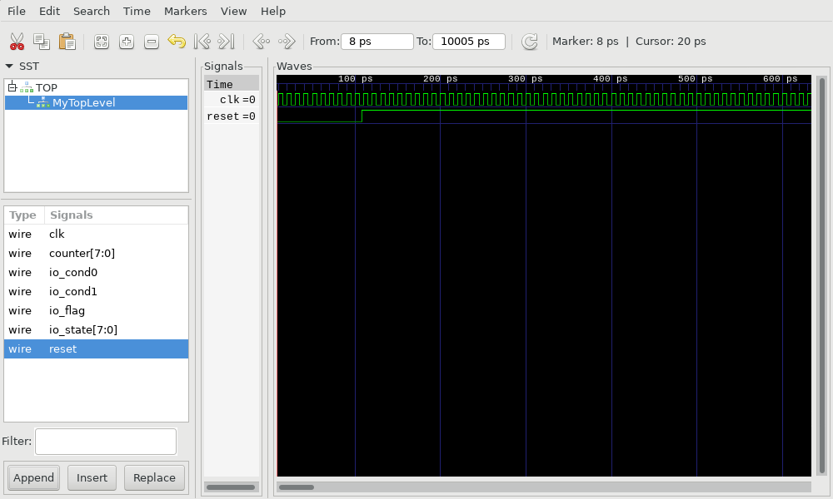
Adding other signals

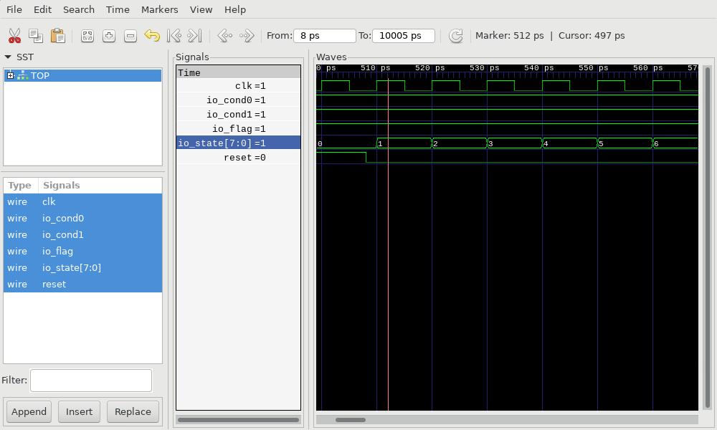
pg2 other signls

