***************DRAFT***************
Counter Test SpinalHDL
Verilator Simulation
02/28/21
***************DRAFT***************

~/SpinalTemplateSbt/src/main/scala/mylib/Counter.scala
package mylib

import spinal.core._

class Counter(width : Int) extends Component{
val io = new Bundle{
val clear = in Bool
val value = out UInt(width bits)
}
val register = Reg(UInt(width bits)) init(0)
register := register + 1
when(io.clear){
register := 0
}
io.value := register
}

object CounterVerilog {
// Let's go
def main(args: Array[String]) {
SpinalVerilog(new Counter(6))
}
}

~/SpinalTemplateSbt/

sbt run

[5] mylib.CounterVerilog

~/SpinalTemplateSbt/

// Generator : SpinalHDL v1.4.3 git head : adf552d8f500e7419fff395b7049228e4bc5de26
// Component : Counter
// Git hash : 95d6bcd599277f65c1cb6acfe7a971d8d9b90c2f

module Counter (
input io_clear,
output [5:0] io_value,
input clk,
input reset
);
reg [5:0] register_1;

assign io_value = register_1;
always @ (posedge clk or posedge reset) begin
if (reset) begin
register_1 <= 6'h0;
end else begin
register_1 <= (register_1 + 6'h01);
if(io_clear)begin
register_1 <= 6'h0;
end
end
end

endmodule

////////////////////////////////////////////////////////////////////////////////
//
// Filename: helloworld_tb.cpp
//
// Project: Verilog Tutorial Example file
//
// Purpose: To demonstrate a Verilog main() program that calls a local
// serial port co-simulator.
//
// Creator: Dan Gisselquist, Ph.D.
// Gisselquist Technology, LLC
//
////////////////////////////////////////////////////////////////////////////////
//
// Written and distributed by Gisselquist Technology, LLC
//
// This program is hereby granted to the public domain.
//
// This program is distributed in the hope that it will be useful, but WITHOUT
// ANY WARRANTY; without even the implied warranty of MERCHANTIBILITY or
// FITNESS FOR A PARTICULAR PURPOSE.
//
////////////////////////////////////////////////////////////////////////////////
//
//
#include <verilatedos.h>
#include <stdio.h>
#include <fcntl.h>
#include <unistd.h>
#include <string.h>
#include <time.h>
#include <sys/types.h>
#include <signal.h>
#include "verilated.h"
#include "VCounter.h"
#include "testb.h"

int main(int argc, char **argv) {
Verilated::commandArgs(argc, argv);
TESTB<VCounter> *tb
= new TESTB<VCounter>;

Verilated::traceEverOn(true); // Verilator must compute traced signals
VL_PRINTF("Enabling waves...\n");

tb->opentrace("Counter.vcd");

for(unsigned clocks=0;clocks < 10000;clocks++) {

if (clocks==30) tb->m_core->io_clear=1;
if (clocks==31) tb->m_core->io_clear=0;

tb->tick();

}

printf("\n\nSimulation complete\n");
}

~/SpinalTemplateSbt/test_Counter

verilator -Wall --trace -cc Counter.v --exe --build sim_main.cpp

~/SpinalTemplateSbt/test_Counter/obj_dir
./VCounter

Enabling waves...

Simulation complete

gtkwave Counter.vcd
if (clocks==30) tb->m_core->io_clear=1;
if (clocks==31) tb->m_core->io_clear=0;

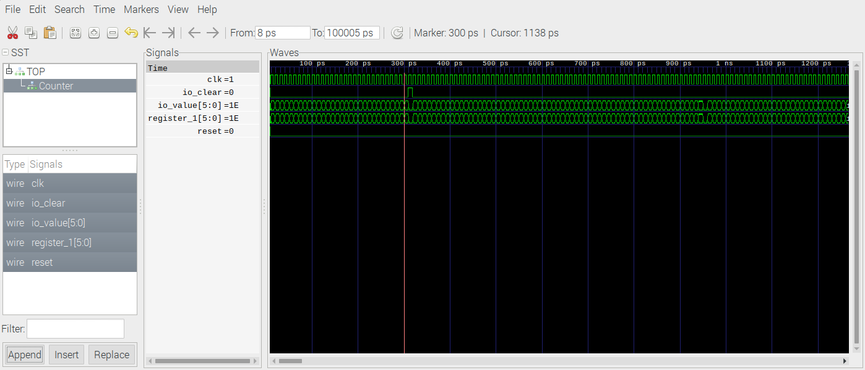

When no io.clear is valid the io.value counts to 0x3F 6 bits.

