*****************Draft*****************
Crypto-Socket
Using AraratSnyapse Library
05/27/20
*****************Draft*****************

A connection from RaspBian to Ultibo System "telnet 192.168.1.245 5050".

The initial values were below.
MyKey: AnsiString = '1234567890123456'; {Must be 16, 24 or 32 bytes}
MyIV: AnsiString = 'My Secret IV';
MyAAD: AnsiString = 'My Extra Secret AAD';
MyData: AnsiString = 'The quick brown fox jumps over the lazy dog.The quick brown fox jumps over the lazy dog.';

when the string below is sent to the Ultibo System

412345678901234567890123456789012:My Secret IV:My Extra Secret AAD:The quick brown The quick brown The quick brown The quick brown The quick brown The quick brown
The delimiter is :
MyKey 12345678901234567890123456789012
MyIV My Secret IV
MyAAD My Extra Secret AAD
MyData The quick brown The quick brown The quick brown The quick brown The quick brown The quick brown

The results are writen to file test0527.txt

tftp 192.168.1.245
tftp> binary
tftp> get test0527.txt
Received 366 bytes in 0.0 seconds
tftp> quit

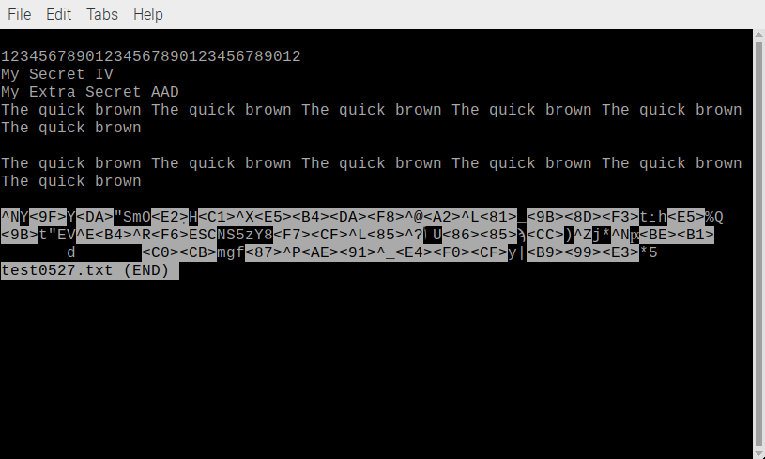
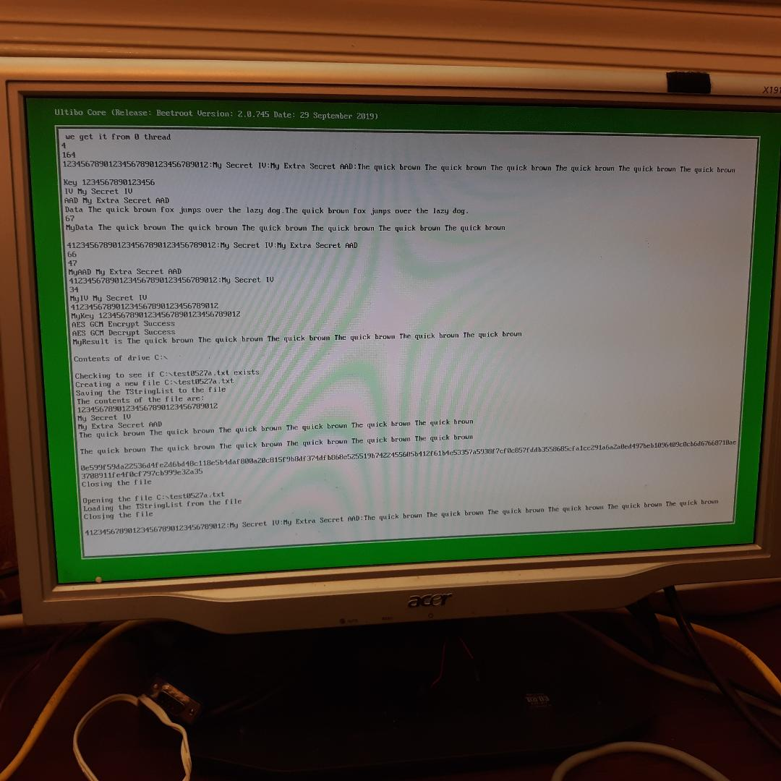
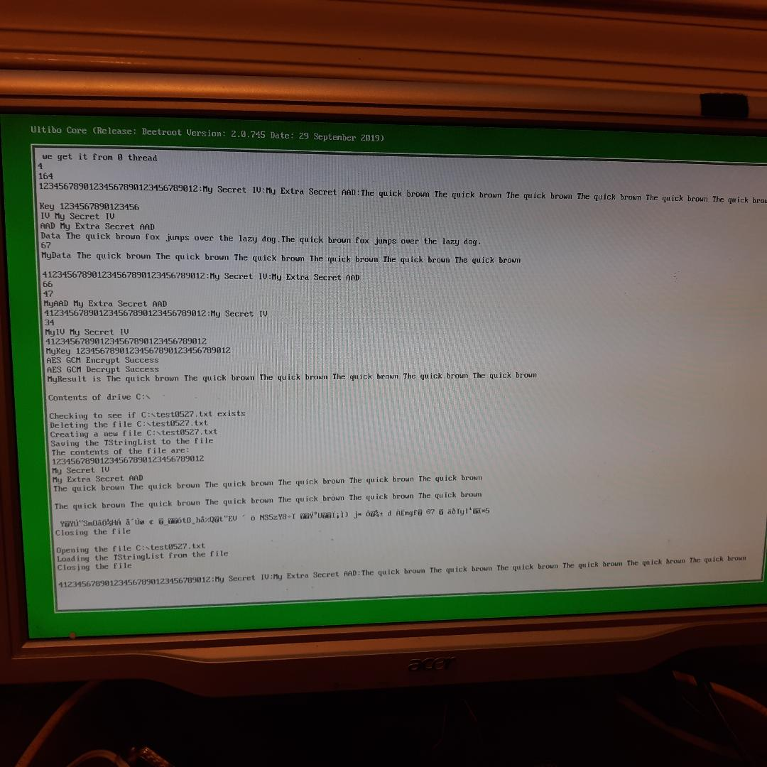

Background: Started with 2 projects test_crypto.lpi & Srv.lpi from github devlone
Ultibo_Projects.

Commad line using FPC

Step 1
. ~/fpc.sh

Step 2
cd Ultibo_Projects/Crypto-Socket/Rpi3/ or cd Ultibo_Projects/Crypto-Socket/RPi2/

Step 3
compile

fpc -vi -B -Tultibo -Parm -CpARMV7A -WpRPI3B -Fu../../../AraratSynapse @/home/devel/ultibo/core/fpc/bin/RPI3.CFG -O2 Srv.lpr

or

fpc -vi -B -Tultibo -Parm -CpARMV7A -WpRPI2B -Fu../../../AraratSynapse @/home/devel/ultibo/core/fpc/bin/RPI2.CFG -O2 Srv.lpr
Transfer kernel7.img

To transfer kernel7.img
tftp 192.168.1.69 < cmdstftp
tftp> tftp> Sent 2701996 bytes in 5.3 seconds

Compiling with Lazaraus.

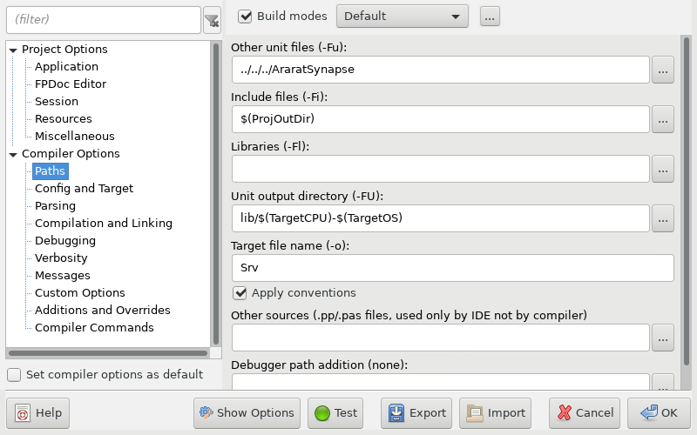

Depress Run/Compile

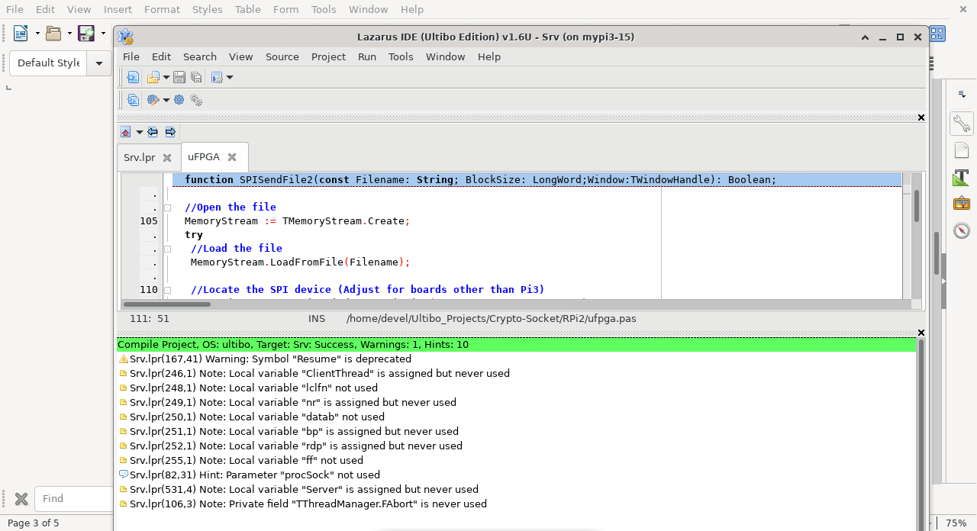

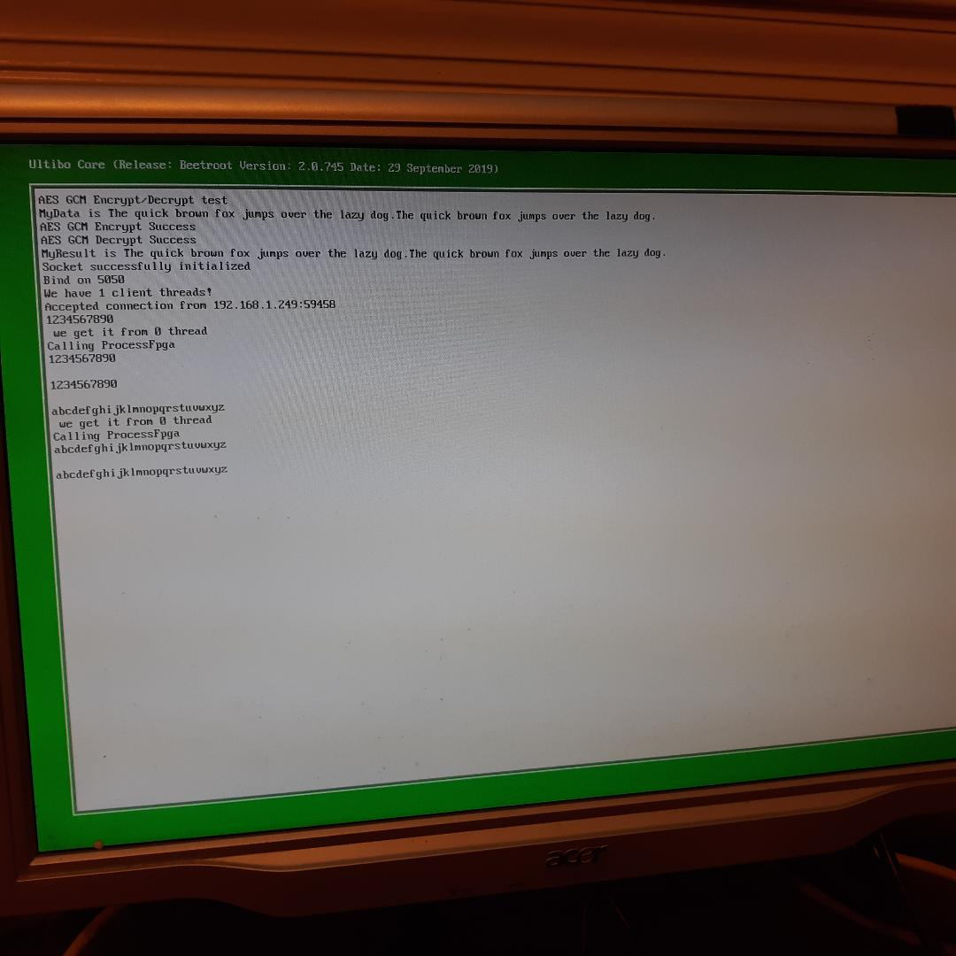
Telnet

