************************Default************************
Test Ric’s WIFI for Ultibo
11/28/21
************************Default************************

Initial tests
kernel7.img still not getting WIFI https://github.com/develone/Ultibo_Projects/tree/master/RIC-WIFI/tests/RPi3/0403-0201/022720
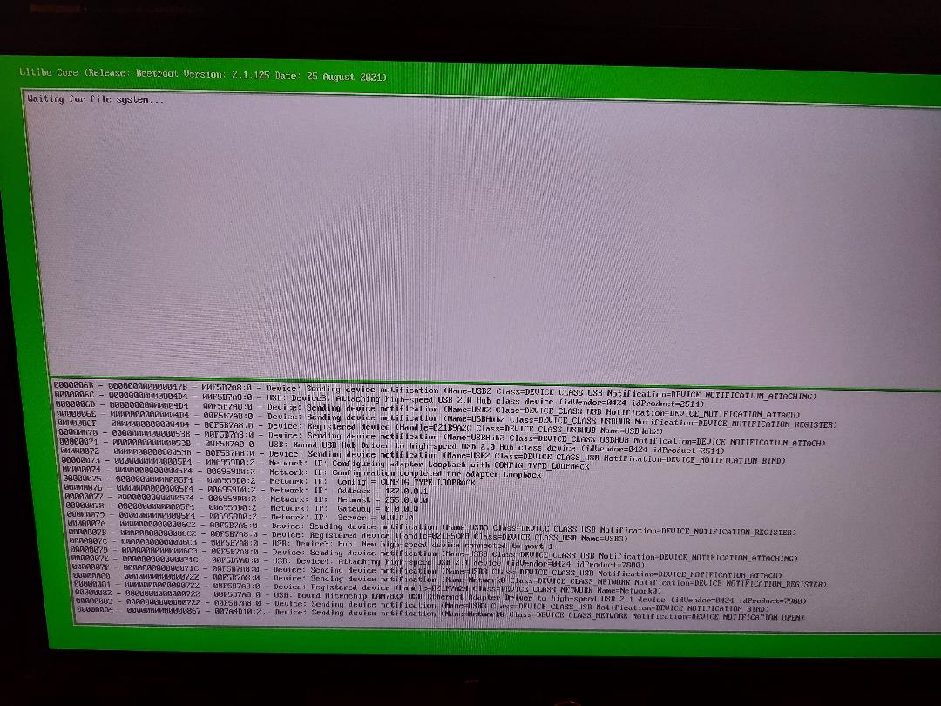

kernel7l.img now supports tftp https://github.com/develone/Ultibo_Projects/tree/master/RIC-WIFI/tests/RPi3/0403-0201/112221

Using Ultibo member Paul’s uTFTP.pas.

config.txt
cmdline.txt

firmware
brcmfmac43430-sdio.bin brcmfmac43455-sdio.clm_blob
brcmfmac43430-sdio.txt brcmfmac43455-sdio.txt
brcmfmac43436-sdio.bin brcmfmac43456-sdio.bin
brcmfmac43436-sdio.clm_blob brcmfmac43456-sdio.clm_blob
brcmfmac43436-sdio.txt brcmfmac43456-sdio.txt
brcmfmac43436s-sdio.bin LICENCE.broadcom_bcm43xx
brcmfmac43436s-sdio.txt Makefile
brcmfmac43455-sdio.bin

The folder firmware was copied from ultibowifi 3b1b3d8.

ls firmwar_for_ultibo/022720/
bootcode.bin fixup.dat fixup_x.dat start.elf start_x.elf

