******************DRAFT******************
Single Value Decomposition SVD using threads
RaspBian & Ultibo bare metal
07/03/19
******************DRAFT******************

https://github.com/develone/master_slave.git
master.c (main raspbian) & ultibo_th_svd.c (test_svd ultibo ) is a procedure
called by the Pascal svd_FS_Rpi2.lpr.
The Ultibo version provides a remote shell using telnet, tftp, and webstatus webpage.
Creates thread that reads and image and performs the Single Value Decomposition
SVD. The singular values and the reconstructed image are written in files
that can be read by octave to display the results.
The master or ultibo_th_svd use two structures (FILEs & th_var)
found in master_slave.h
to pass infomation to the thread.

The image is read into a 2 Dim array

pi@mypi3-1:~/master_slave/examples $ ./build_svd.sh
Compiling master_svd
pi@mypi3-1:~/master_slave/examples $ ./master
In main red.bin Sred.bin rcred.bin 0 0
In main grn.bin Sgrn.bin rcgrn.bin 0 0
In main blu.bin Sblu.bin rcblu.bin 0 0
name: Allen
age: 20
0x0

1st thread processing th_id[0] 0x76d67470
In mysvd input_file: red.bin
In mysvd first_output: Sred.bin
In mysvd second_output: rcred.bin
In mysvd status: 0
In mysvd num_bytes_rd: 0

In mysvd status input file read: 1 num_bytes_rd 65535
grn.bin th0.len1 = 65535
len = 263168 th0.len2 = 263168 th0.len3 = 263168 th0.len4 = 263168
setting up ptrs with malloc
pa 0x7637e408 ppa 0x7637e008
pv = 0x76526408 ppv = 0x76526008
pvt = 0x762fc408 ppvt = 0x762fc008
pds = 0x7633d408 ppds = 0x7633d008
puds = 0x763bf408 ppuds = 0x763bf008
pudsvt = 0x7627a408 ppudsvt = 0x7627a008
U row = 256 col = 256
Singular Values
V row = 256 col = 256
V' row = 256 col = 256
Call mul u * s
UDS row = 256 col = 256
Call mul u * ds * vt
USDVT row = 256 col = 256
ps converted from float to int 0x76440478
# of data written 0x10000

2nd thread processing th_id[1] 0x76d67470
In mysvd input_file: grn.bin
In mysvd first_output: Sgrn.bin
In mysvd second_output: rcgrn.bin
In mysvd status: 0
In mysvd num_bytes_rd: 0

In mysvd status input file read: 1 num_bytes_rd 65535
grn.bin th1.len1 = 65535
len = 263168 th1.len2 = 263168 th1.len3 = 263168 th1.len4 = 263168
len = 263168 th1.len2 = 263168 th1.len3 = 263168 th1.len4 = 263168
setting up ptrs with malloc
pa 0x76240820 ppa 0x76240420
pv = 0x76480880 ppv = 0x76480480
pvt = 0x76000418 ppvt = 0x76000018
pds = 0x76280c28 ppds = 0x76280828
puds = 0x76200418 ppuds = 0x76200018
pudsvt = 0x76080c28 ppudsvt = 0x76080828
U row = 256 col = 256
Singular Values
V row = 256 col = 256
V' row = 256 col = 256
Call mul u * s
UDS row = 256 col = 256
Call mul u * ds * vt
USDVT row = 256 col = 256
ps converted from float to int 0x762c0c30
# of data written 0x10000

3rd thread processing th_id[2] 0x76d67470
In mysvd input_file: blu.bin
In mysvd first_output: Sblu.bin
In mysvd second_output: rcblu.bin
In mysvd status: 0
In mysvd num_bytes_rd: 0

In mysvd status input file read: 1 num_bytes_rd 65535
grn.bin th2.len1 = 65535
len = 263168 th2.len2 = 263168 th2.len3 = 263168 th2.len4 = 263168
len = 263168 th1.len2 = 263168 th1.len3 = 263168 th1.len4 = 263168
setting up ptrs with malloc
pa 0x76040820 ppa 0x76040420
pv = 0x76480880 ppv = 0x76480480
pvt = 0x76100418 ppvt = 0x76100018
pds = 0x76080c28 ppds = 0x76080828
puds = 0x76000418 ppuds = 0x76000018
pudsvt = 0x76180c28 ppudsvt = 0x76180828
U row = 256 col = 256
Singular Values
V row = 256 col = 256
V' row = 256 col = 256
Call mul u * s
UDS row = 256 col = 256
Call mul u * ds * vt
USDVT row = 256 col = 256
ps converted from float to int 0x760c0c30
# of data written 0x10000
all threads joined
In main status 4 num_bytes_rd 65535
In main status 4 num_bytes_rd 65535
In main status 4 num_bytes_rd 65535

First 5 of 256 values from svd of red image 4.6490e+04 5.5967e+03 4.3327e+03 3.5266e+03 2.8699e+03

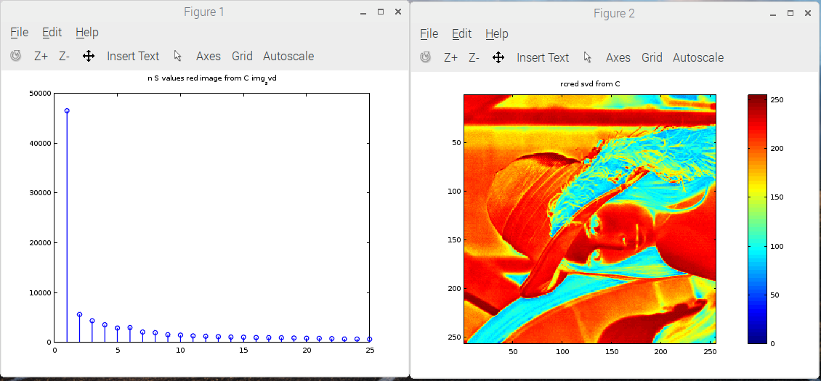
First 5 of 256 values from svd of grn image 2.6137e+04 5.8601e+03 4.6489e+03 3.6501e+03 3.2528e+03

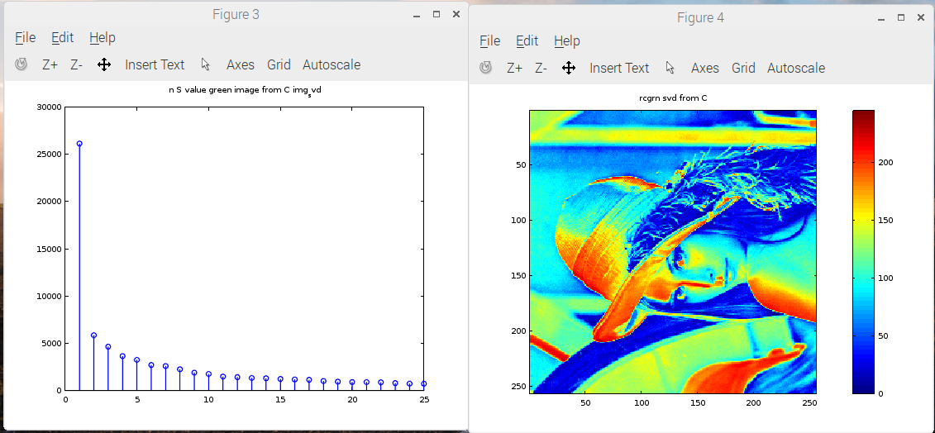

First 5 of 256 values from svd of blu image 2.7159e+04 3.5082e+03 3.2195e+03 2.1732e+03 2.0808e+03

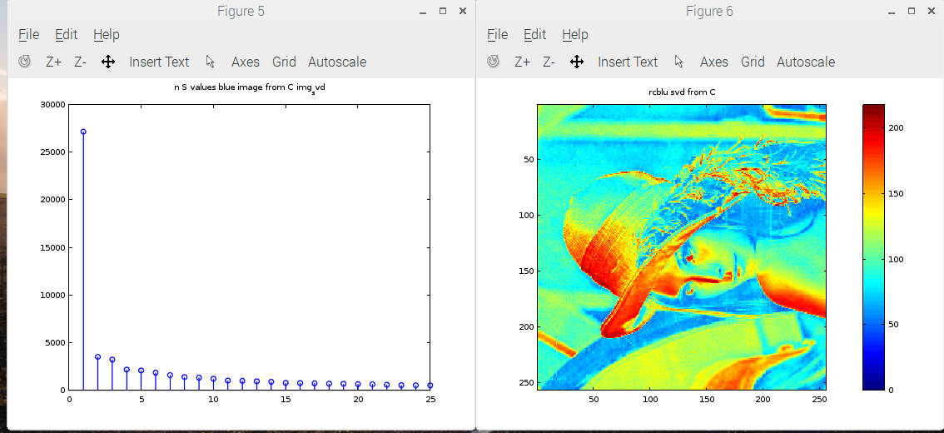

export PATH=/home/pi/ultibo/core/fpc/bin:$PATH

pi@mypi3-1:~/master_slave/examples $ ./buildlib.sh
Compiling example ultibo_th_svd
pi@mypi3-1:~/master_slave/examples $ fpc -vi -B -Tultibo -Parm -CpARMV7A -WpRPI2B @/home/pi/ultibo/core/fpc/bin/RPI2.CFG -O4 svd_FS_RPi2.lpr
Free Pascal Compiler version 3.1.1 [2019/05/15] for arm
Copyright (c) 1993-2015 by Florian Klaempfl and others
Target OS: Ultibo
Compiling svd_FS_RPi2.lpr
Compiling uTFTP.pas
Assembling utftp
svd_FS_RPi2.lpr(40,2) Note: Local variable "MyPLoggingDevice" not used
svd_FS_RPi2.lpr(42,2) Note: Local variable "Handle1" not used
svd_FS_RPi2.lpr(43,2) Note: Local variable "Handle3" not used
svd_FS_RPi2.lpr(45,2) Note: Local variable "Window" not used
Assembling svd_fs_rpi2
Linking svd_FS_RPi2
687 lines compiled, 5.5 sec, 2831536 bytes code, 91356 bytes data
4 note(s) issued

pi@mypi3-1:~/master_slave/examples $ tftp 192.168.1.202 < cmdstftp
tftp> tftp> Sent 2897352 bytes in 33.5 seconds

Home page

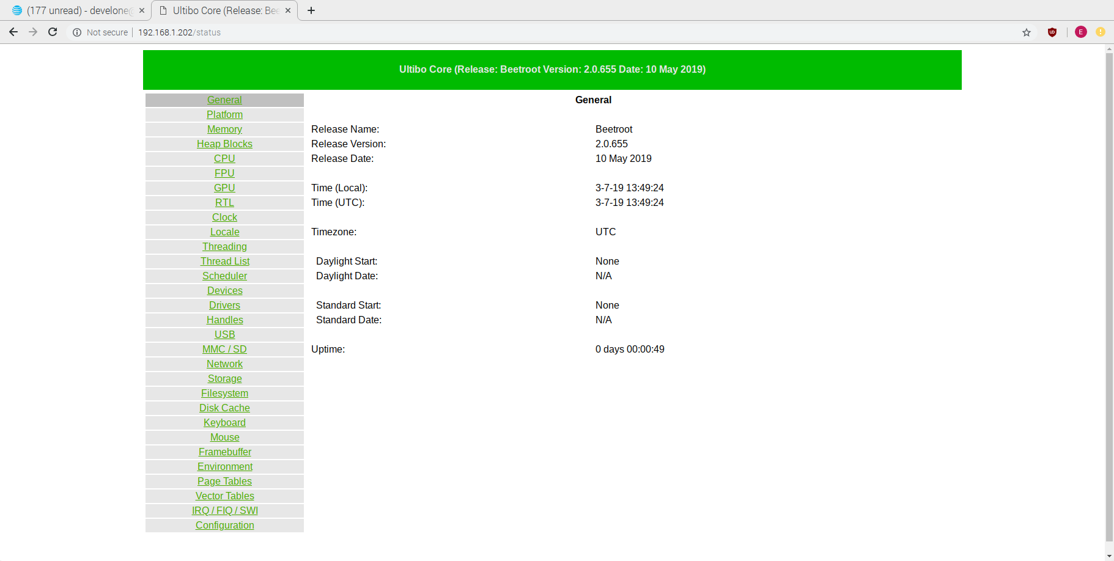
Platform

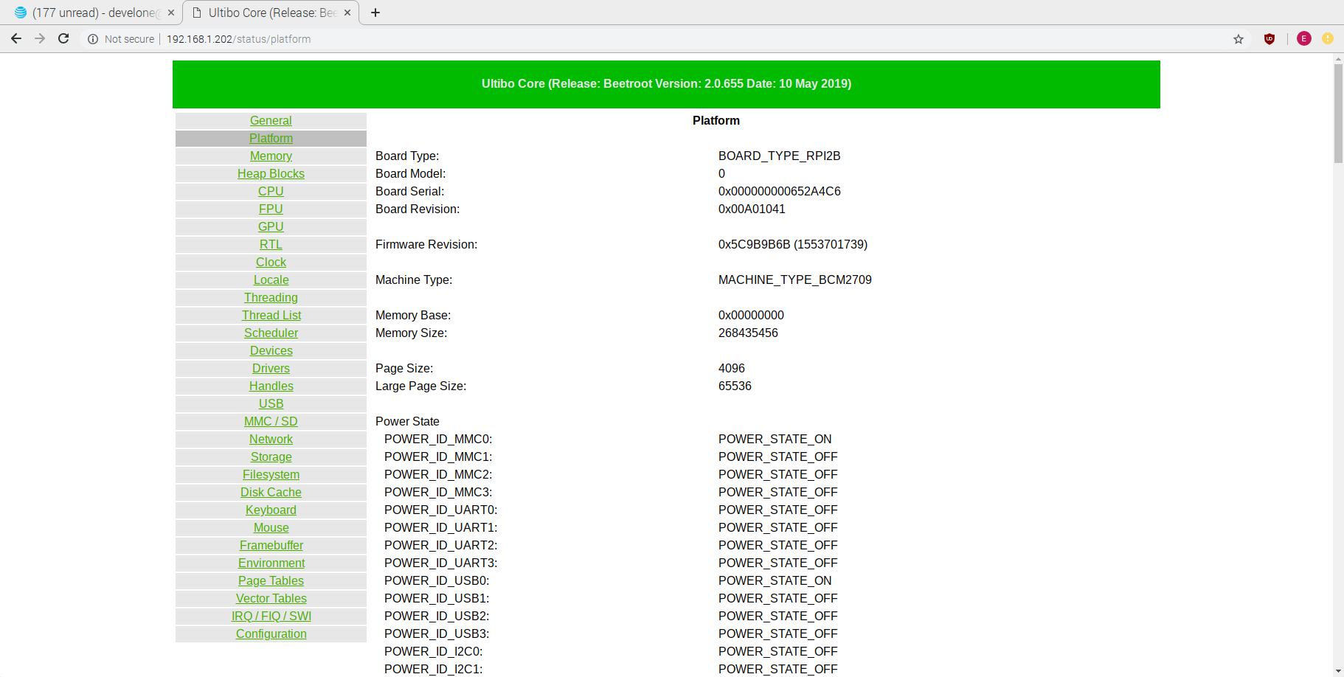
Thread List
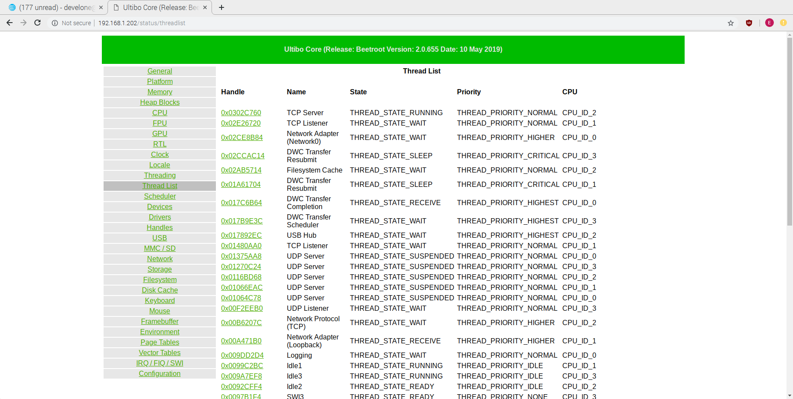
Remote Shell

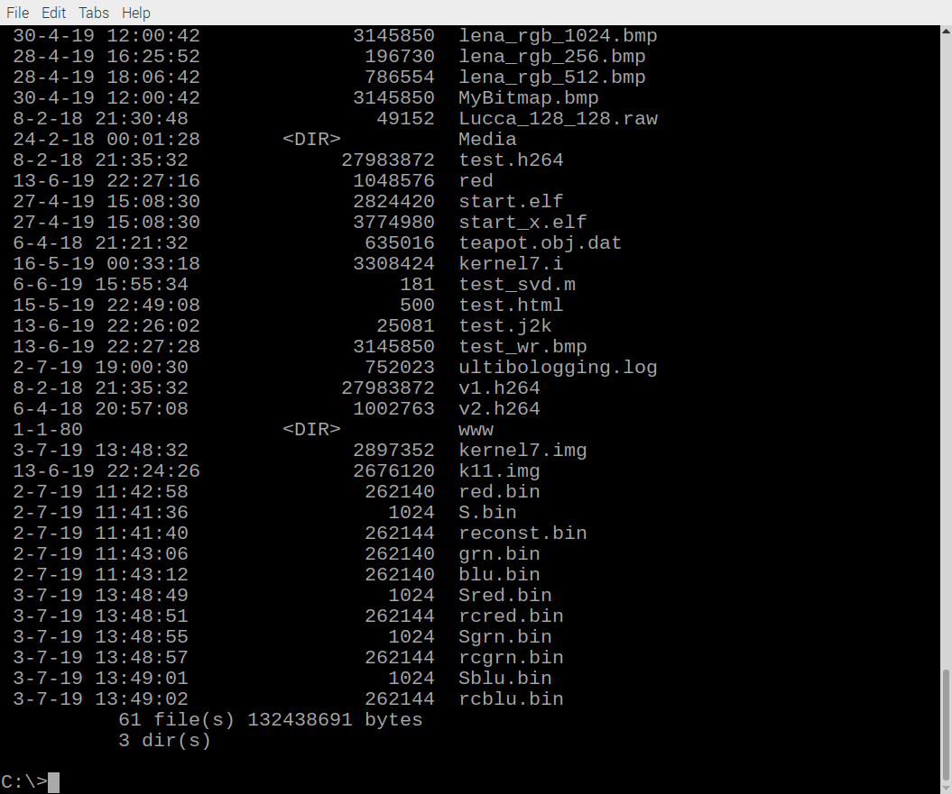
pi@mypi3-1:~/master_slave/examples $ tftp 192.168.1.202
tftp> binary
tftp> get Sred.bin
Error code 5: 52531
Received 1024 bytes in 5.0 seconds
tftp> get Sgrn.bin
Error code 5: 37941
Received 1024 bytes in 5.0 seconds
tftp> get Sblu.bin
Error code 5: 47595
Received 1024 bytes in 5.0 seconds
tftp> get rcred.bin
Error code 5: 40661
Received 262144 bytes in 6.0 seconds
tftp> get rcgrn.bin
Error code 5: 51602
Received 262144 bytes in 6.4 seconds
tftp> get rcblu.bin
Error code 5: 54316
Received 262144 bytes in 6.0 seconds
tftp> quit

Reboot

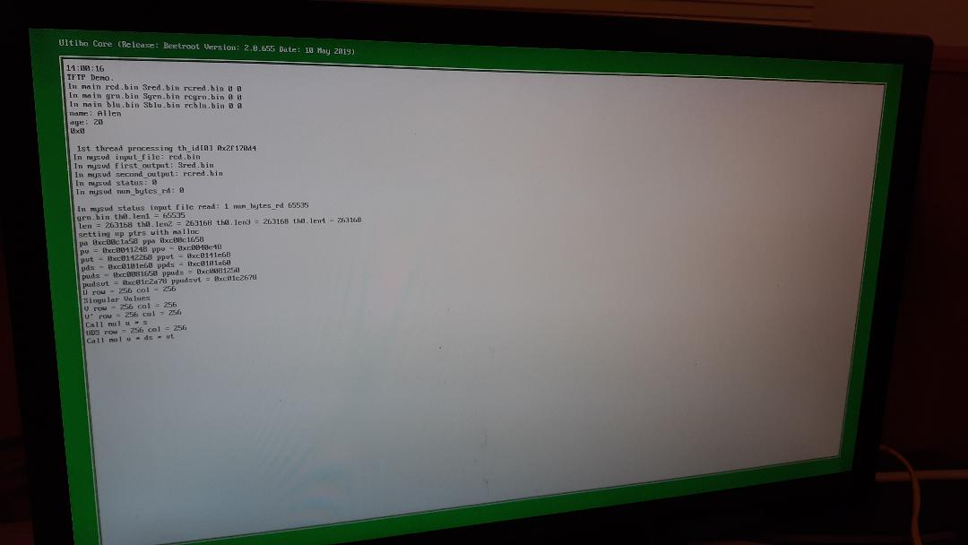

Transfer of Files.

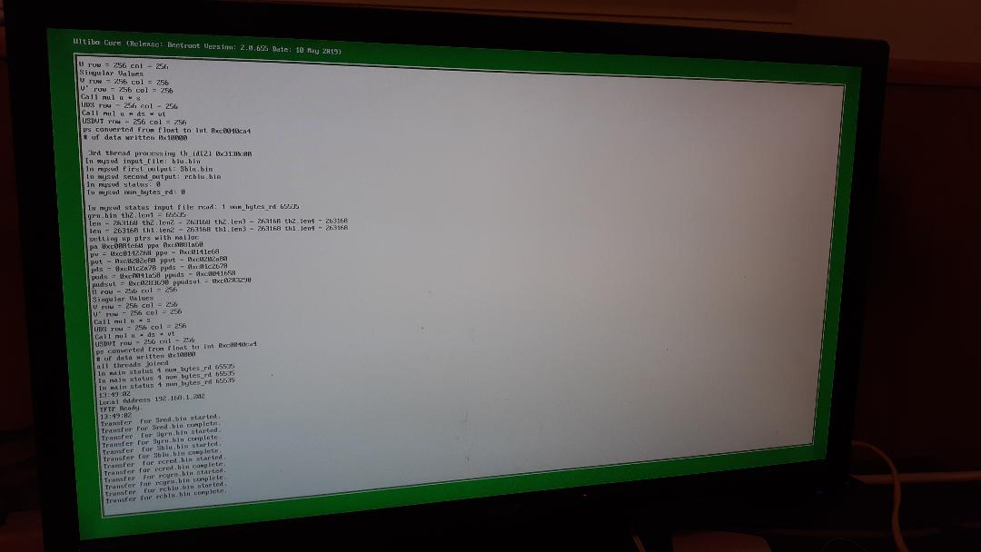

First 5 of 256 values from svd of red image 4.6490e+04 5.5965e+03 4.3319e+03 3.5266e+03 2.8700e+03

First 5 of 256 values from svd of grn image 2.6137e+04 5.8596e+03 4.6487e+03 3.6502e+03 3.2528e+03

First 5 of 256 values from svd of blu image 2.7159e+04 3.5077e+03 3.2194e+03 2.1732e+03 2.0808e+03

