********DRAFT********

SLIP for Ultibo
03/20/20

********DRAFT********

Started with the project devel@mypi3-15:~/Examples/Synapse/SerialEcho/RPi2

The kernel was built and tested on a RPi3B+ running ultibo and RPi4 4G running RaspBain with a PMODUSBUART.

devel@mypi3-15:~/Ultibo_Projects/slip-ppp/snapase/RPi2

Needed to update my AraratSynapse at github 03/20/20.

git clone https://github.com/develone/AraratSynapse.git
This branch is 3 commits behind ultibohub:ultibo.

git log

commit eda069bfd8001700def7e707016e0a696d74dce3 (HEAD -> ultibo, origin/ultibo, origin/HEAD)
Author: Ultibo <admin@ultibo.org>
Date: Sat Sep 30 11:23:02 2017 +1000

Update README

git clone https://github.com/ultibohub/AraratSynapse.git

git log

commit d6c76d9b2c1b1e77151985861355c723ff49550a (HEAD -> ultibo, origin/ultibo, origin/HEAD)
Author: Ultibo <admin@ultibo.org>
Date: Fri Jun 15 13:07:18 2018 +1000

Fix for socket send and receive timeout values plus other minor fixes

git remote add upstream https://github.com/ultibohub/AraratSynapse.git

git fetch upstream

git merge upstream/ultibo

git push origin ultibo

git log

commit d6c76d9b2c1b1e77151985861355c723ff49550a (HEAD -> ultibo, upstream/ultibo, origin/ultibo, origin/HEAD)
Author: Ultibo <admin@ultibo.org>
Date: Fri Jun 15 13:07:18 2018 +1000

Fix for socket send and receive timeout values plus other minor fixes

Started with the project devel@mypi3-15:~/Examples/Synapse/SerialEcho/RPi2

devel@mypi3-15:~/Ultibo_Projects/slip-ppp/snapase/RPi2

Needed to add the “/home/devel/AraratSynapse” to Other unit files (-FU):

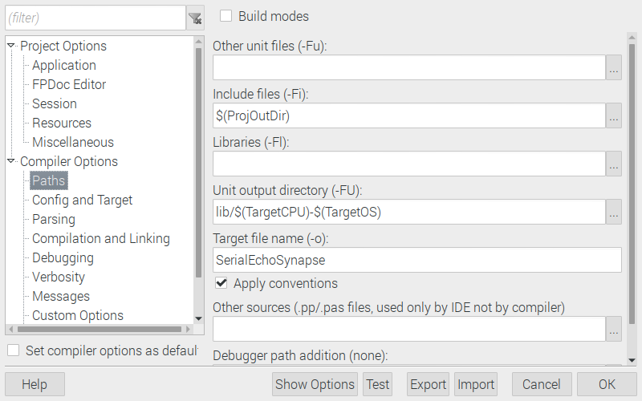
Add

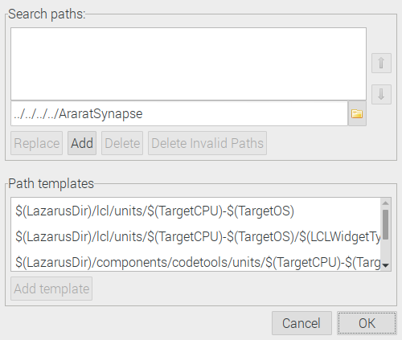

Depress OK

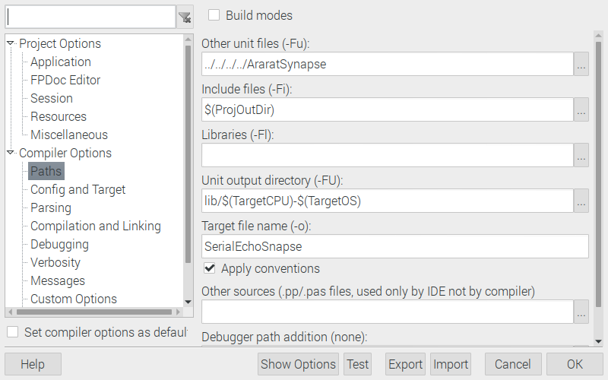

-Tultibo -Parm -CpARMV7A -WpRPI2B @/home/devel/ultibo/core/fpc/bin/RPI2.CFG -MObjFPC -Scghi -CX -O2 -XX -l -vewnhibq -Filib/arm-ultibo -Fu../../../../AraratSynapse -Fu. -FUlib/arm-ultibo

devel@mypi3-15:~/Ultibo_Projects/slip-ppp/snapase/RPi2 $ ls lib/arm-ultibo/
SerialEchoSnapse.compiled synafpc.o synaser.o synautil.o
SerialEchoSnapse.o synafpc.ppu synaser.ppu synautil.ppu

-rwxr-xr-x 1 devel devel 2407512 Mar 19 11:46 kernel7.img

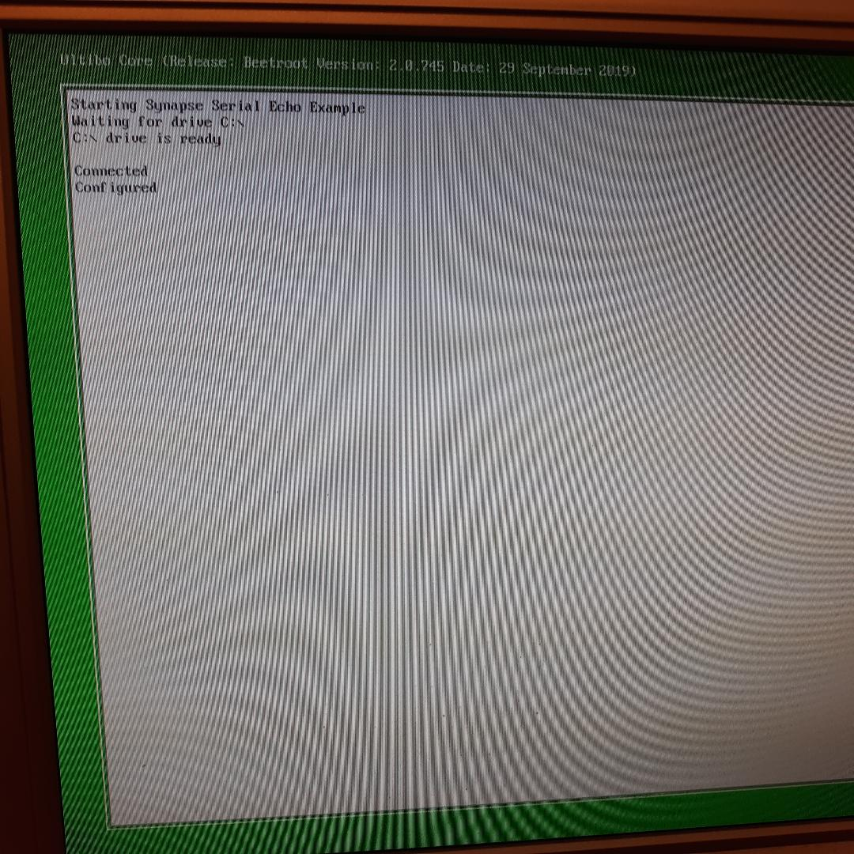

Echo

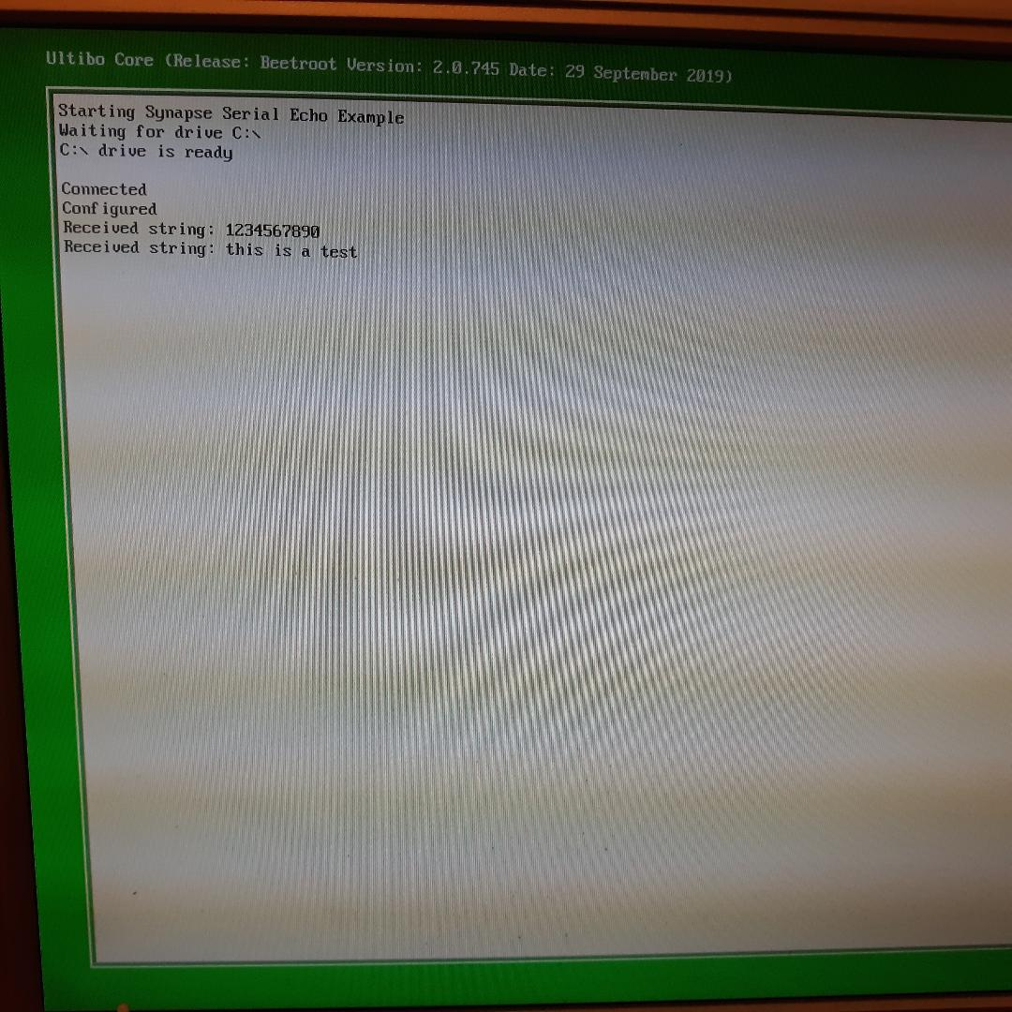

sudo minicom -s

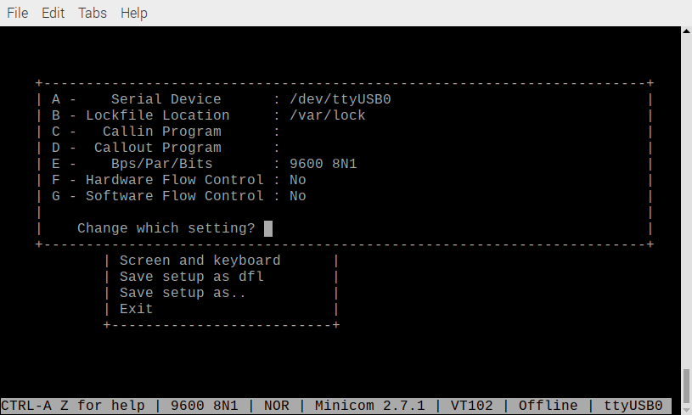
Testing OK

