****************Draft****************
FFT Octave
08/28/20
****************Draft****************

Starting with an example in Matlab at “https://www.mathworks.com/help/matlab/ref/fft.html”

The signal below is combination of 3 frequencies. The 3 frequencies are
50, 120, and 200 Hz.

Figure 1
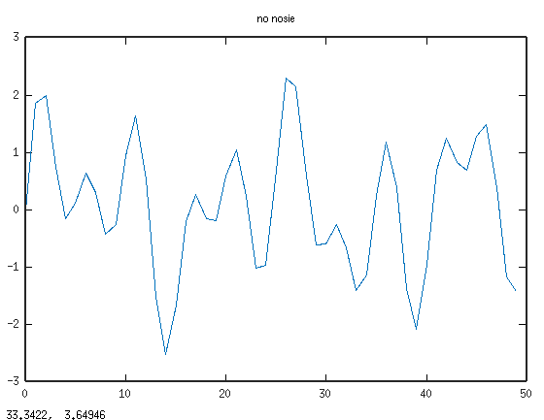

Taking the FFT demonstrates what frequencies make up the signal above.

Figure 2
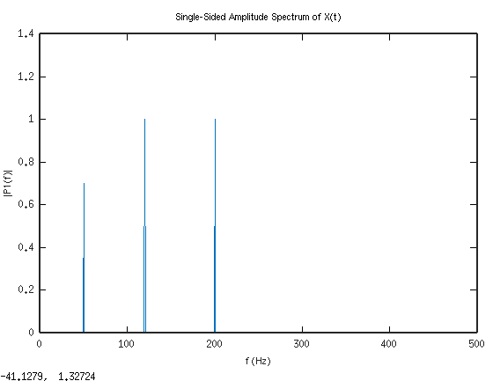
The signal below is combination of 3 frequencies witgh random noise. The 3 frequencies are
50, 120, and 200 Hz.

Figure 3
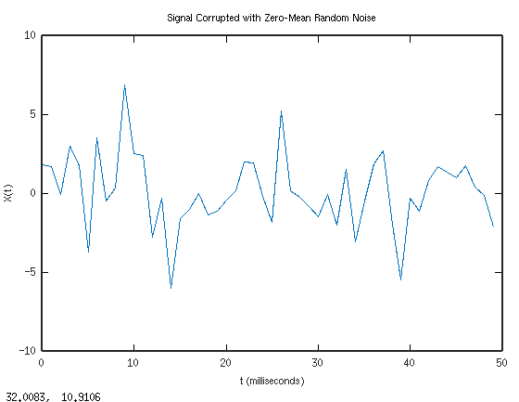

Taking the FFT demonstrates what frequencies make up the signal above.

Figure 4
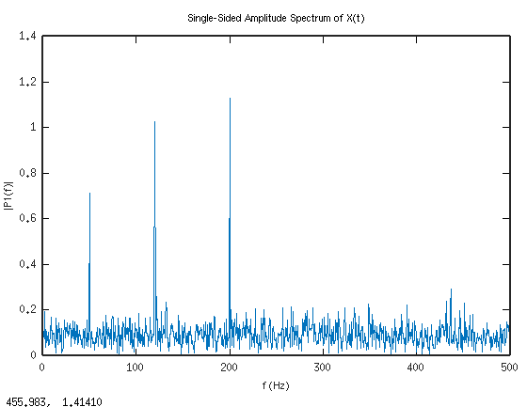
https://www.youtube.com/watch?v=z7X6jgFnB6Y&feature=youtu.be

fft.png

FFT basic concepts
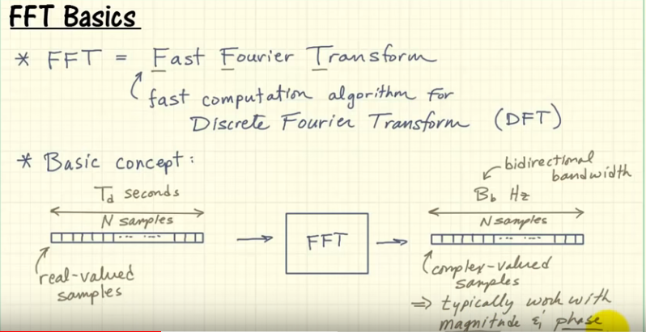

fft1.png

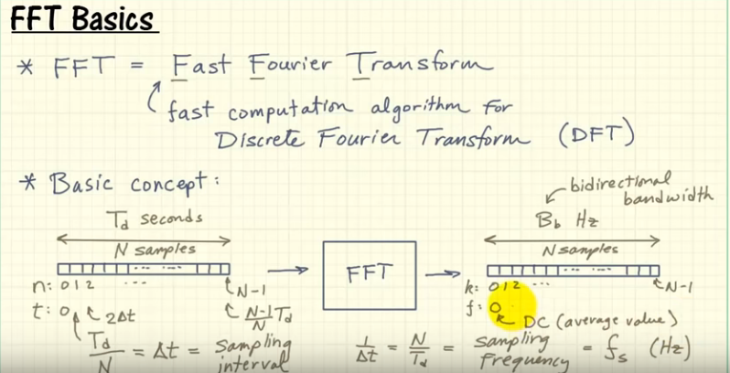

fft2.png

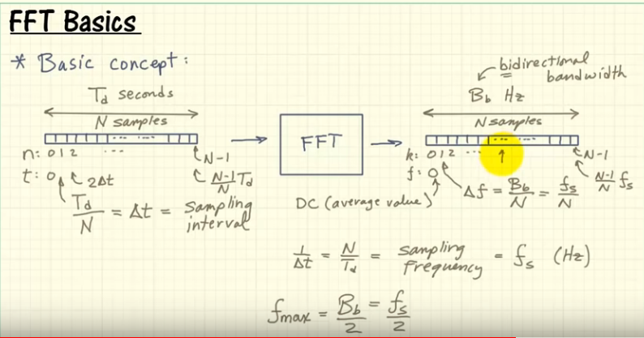

fft3.png

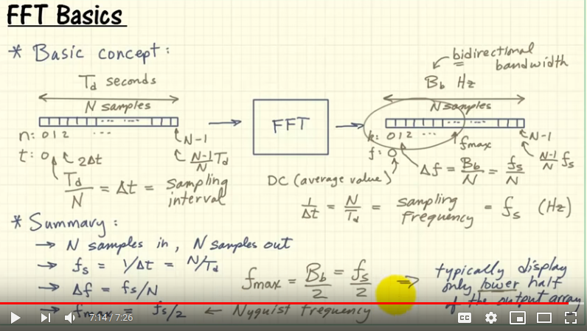

Octave code that produce the plots above.

clear
close all

Fs = 1000; % Sampling frequency
T = 1/Fs; % Sampling period
L = 1500; % Length of signal
t = (0:L-1)*T; % Time vectorc

%S = 0.7*sin(2*pi*50*t) + sin(2*pi*120*t);
S = 0.7*sin(2*pi*50*t) + sin(2*pi*120*t) + sin(2*pi*200*t);

X = S + 2*randn(size(t));

figure

plot(1000*t(1:50),X(1:50))
title('Signal Corrupted with Zero-Mean Random Noise')
xlabel('t (milliseconds)')
ylabel('X(t)')

Y = fft(X);

P2 = abs(Y/L);
P1 = P2(1:L/2+1);
P1(2:end-1) = 2*P1(2:end-1);

figure
f = Fs*(0:(L/2))/L;
plot(f,P1)
title('Single-Sided Amplitude Spectrum of X(t)')
xlabel('f (Hz)')
ylabel('|P1(f)|')

red.pgm 50th row sampled at 1KHz

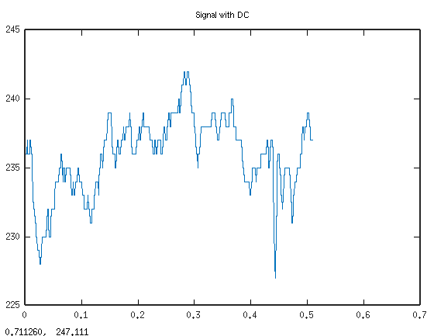
red.pgm 50th row sampled at 1KHz with DC removed.
xbar = 235.90

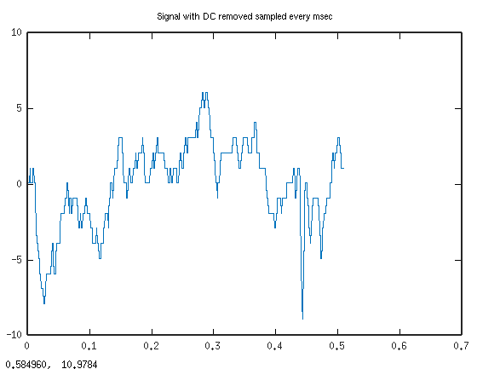

FFT red.pgm 50th row.

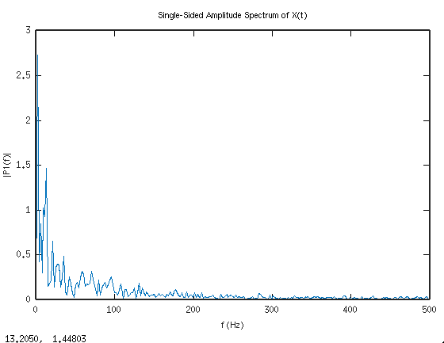
clear
close all
%https://www.mathworks.com/matlabcentral/answers/1828-remove-dc-component-from-eeg-signals
Fs = 1000; % Sampling frequency
T = 1/Fs; % Sampling period
L = 512; % Length of signal
t = (0:L-1)*T; % Time vector

A = imread('red.pgm');
figure
x = A(1:512,50);
xbar = mean(x)

plot(t,x)

title("Signal with DC")

f = fft(x);
f(1) = 0;
x_ac = real(ifft(f));
[x_ac, x - mean(x)];

figure
plot(t,x_ac)
title("Signal with DC removed sampled every msec")

Ys = fft(x_ac);

P2 = abs(Ys/L);
P1 = P2(1:L/2+1);
P1(2:end-1) = 2*P1(2:end-1);

figure
f = Fs*(0:(L/2))/L;
plot(f,P1)
title('Single-Sided Amplitude Spectrum of X(t)')
xlabel('f (Hz)')
ylabel('|P1(f)|')

Located an example of real fft using kissftt https://github.com/heavyii/kissfft-example
Extracted the 2048 samples of real data from kissfft-example and read it into octave.
100 FFTs using kiss-fft
time ./real-fft
hz = 1044.921875
hz = 1044.921875
hz = 1044.921875
hz = 1044.921875
hz = 1044.921875
.
.
.
hz = 1044.921875
hz = 1044.921875
hz = 1044.921875
hz = 1044.921875

real 0m0.026s
user 0m0.008s
sys 0m0.018s

Octave finds the hz at 1089.26 which is 4.24 % higher than kiss-fft.

*****************Draft*****************
Testing kissfft using kissfft-example
08/27/20
*****************Draft*****************

forked the kissfft-example

git clone https://github.com/heavyii/kissfft-example.git

git clone https://github.com/develone/kissfft-example.git

cd kissfft-example/

make
kiss_fftr.c: In function ‘kiss_fftr_alloc’:
kiss_fftr.c:53:18: warning: cast increases required alignment of target type [-Wcast-align]
st->tmpbuf = (kiss_fft_cpx *) (((char *) st->substate) + subsize);

cp ../kissfft/kiss_fft.c .

cp ../kissfft/*.h .

cp ../kissfft/*.hh .

make

sudo pip install matplotlib

sudo apt-get install python-gi-cairo

./real-fft dump-raw-3.txt test-output.txt

image1
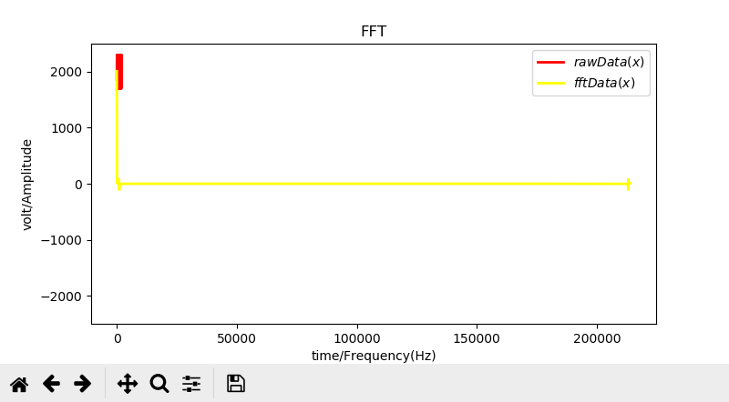
image2
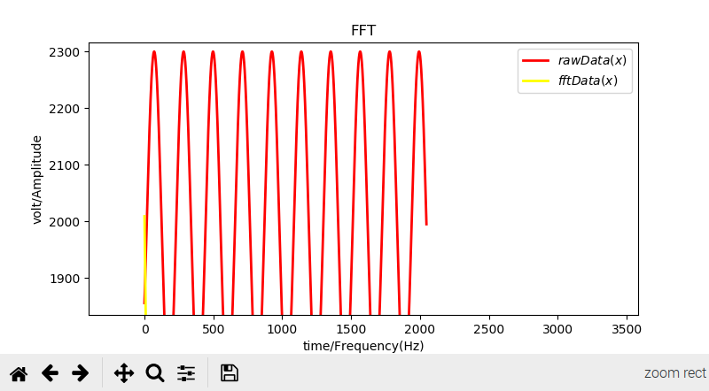
image3
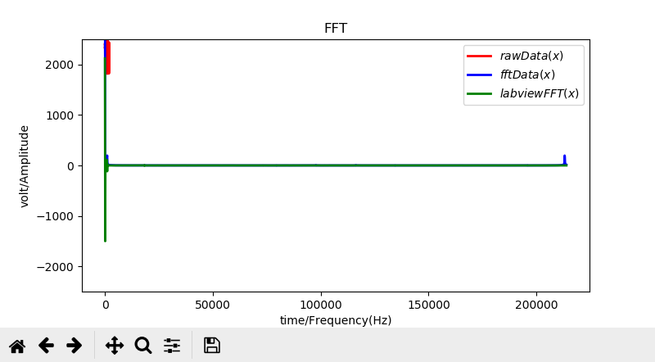
image4
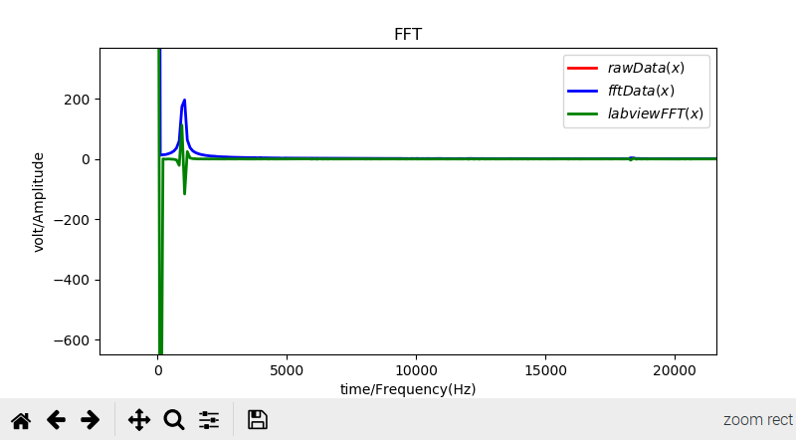
image5
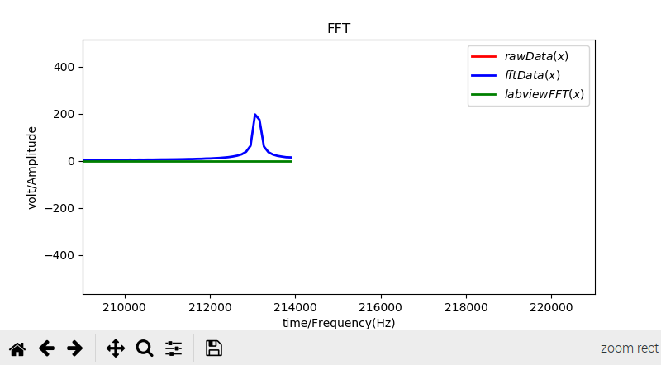
image6

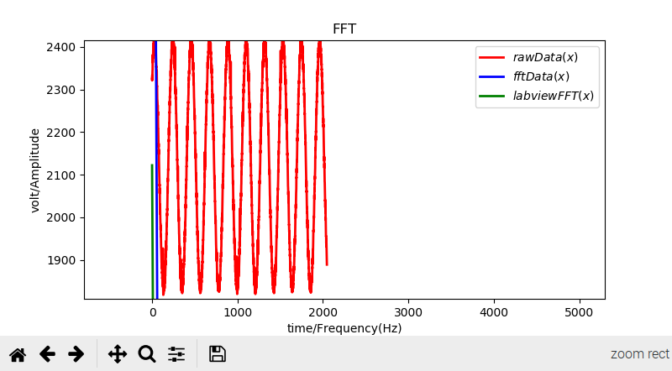

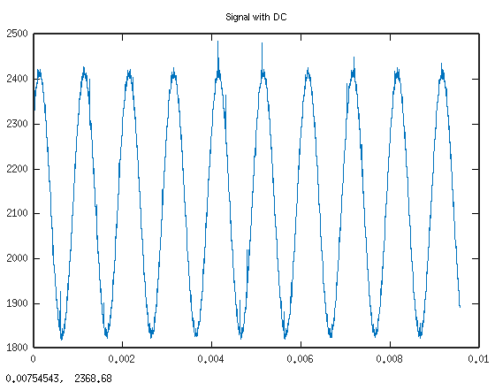

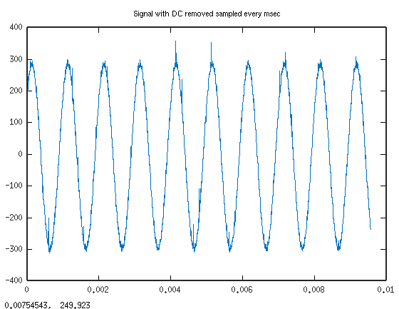
Removed the DC from extracted data.

Compute the FFT.

