***********Draft***********
crypto notes 05/05/20
Starting with TFTP_Template
Testing Electronic Codebook (ECB) & AES Cipher Block Chaining (CBC)

***********Draft***********

Started with the file from “TFTP_Template.lpr” to creare “test_crypto.lpr” & “test_crypto.lpi”
In addition this needs uTFTP.pas, upker7.sh, and cmdstftp.

Compile the project with “Run/Compile” or “Run/Clean up and Build”.

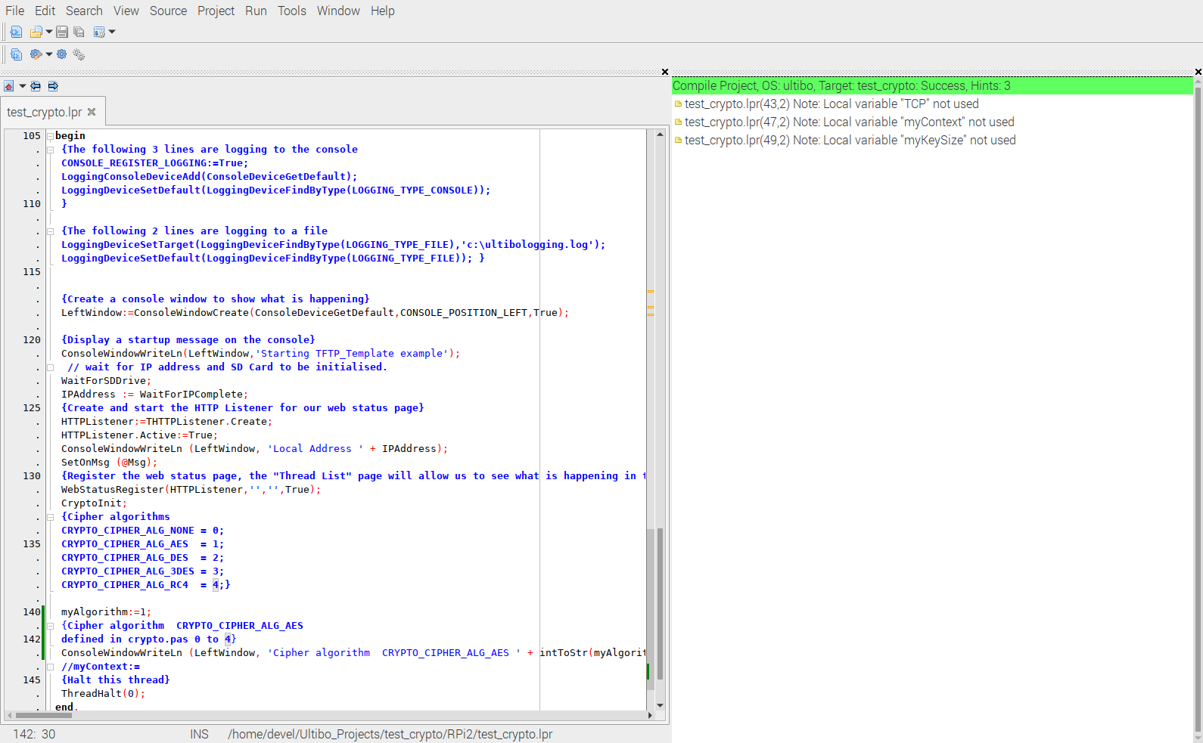
Once the Green bar is displayed it can be transfer to the Ultibo System.

AESEncryptBlock (128bit)
Electronic Codebook (ECB)

AESEncryptBlock (192bit)
Electronic Codebook (ECB)

AESEncryptBlock (256bit)
Electronic Codebook (ECB)

AESDecryptBlock (128bit)
Electronic Codebook (ECB)

AESDecryptBlock (192bit)
Electronic Codebook (ECB)

AESDecryptBlock (256bit)
Electronic Codebook (ECB)

After adding APICrypto.pas

In test_crypto.lpt in
var
AESECBKey:PByte;
AESECBData:PByte;
AESECBAESKey:TAESKey;

AESCBCKey:PByte;
AESCBCData:PByte;
AESCBCVector:PByte;

Cipher:PCipherContext;

key:String;
Data:String;
Actual:String;
PData:PString;
Datalen:LongWord;

InKey:LongWord;
InKeyStr:String;
InDataStr:String;
EncryptDecrypt:LongWord;

With the addition of function below matches APICrypto.pas

tstencryption(InKeyStr,InDataStr:String;InKey,EncryptDecrypt:LongWord):String;
var
AESECBKey:PByte;
AESECBData:PByte;
AESECBAESKey:TAESKey;
begin

AESECBData:=AllocMem(AES_BLOCK_SIZE);
if(InKey=0) then
begin
AESECBKey:=AllocMem(AES_KEY_SIZE128);
StringToBytes(InKeyStr,PByte(AESECBKey),AES_KEY_SIZE128);
StringToBytes(InDataStr,PByte(AESECBData),AES_BLOCK_SIZE);
AESKeySetup(AESECBKey,AES_KEY_SIZE128,@AESECBAESKey);
end;
if(InKey=1) then
begin
AESECBKey:=AllocMem(AES_KEY_SIZE192);
StringToBytes(InKeyStr,PByte(AESECBKey),AES_KEY_SIZE192);
StringToBytes(InDataStr,PByte(AESECBData),AES_BLOCK_SIZE);
AESKeySetup(AESECBKey,AES_KEY_SIZE192,@AESECBAESKey);
end;
if(InKey=2) then
begin
AESECBKey:=AllocMem(AES_KEY_SIZE256);
StringToBytes(InKeyStr,PByte(AESECBKey),AES_KEY_SIZE256);
StringToBytes(InDataStr,PByte(AESECBData),AES_BLOCK_SIZE);
AESKeySetup(AESECBKey,AES_KEY_SIZE256,@AESECBAESKey);
end;

//AESECBData:=AllocMem(AES_BLOCK_SIZE);

if(EncryptDecrypt=1) then
begin
AESEncryptBlock(AESECBData,AESECBData,@AESECBAESKey);
end;

if(EncryptDecrypt=0) then
begin
AESDecryptBlock(AESECBData,AESECBData,@AESECBAESKey);
end;

./upker.sh

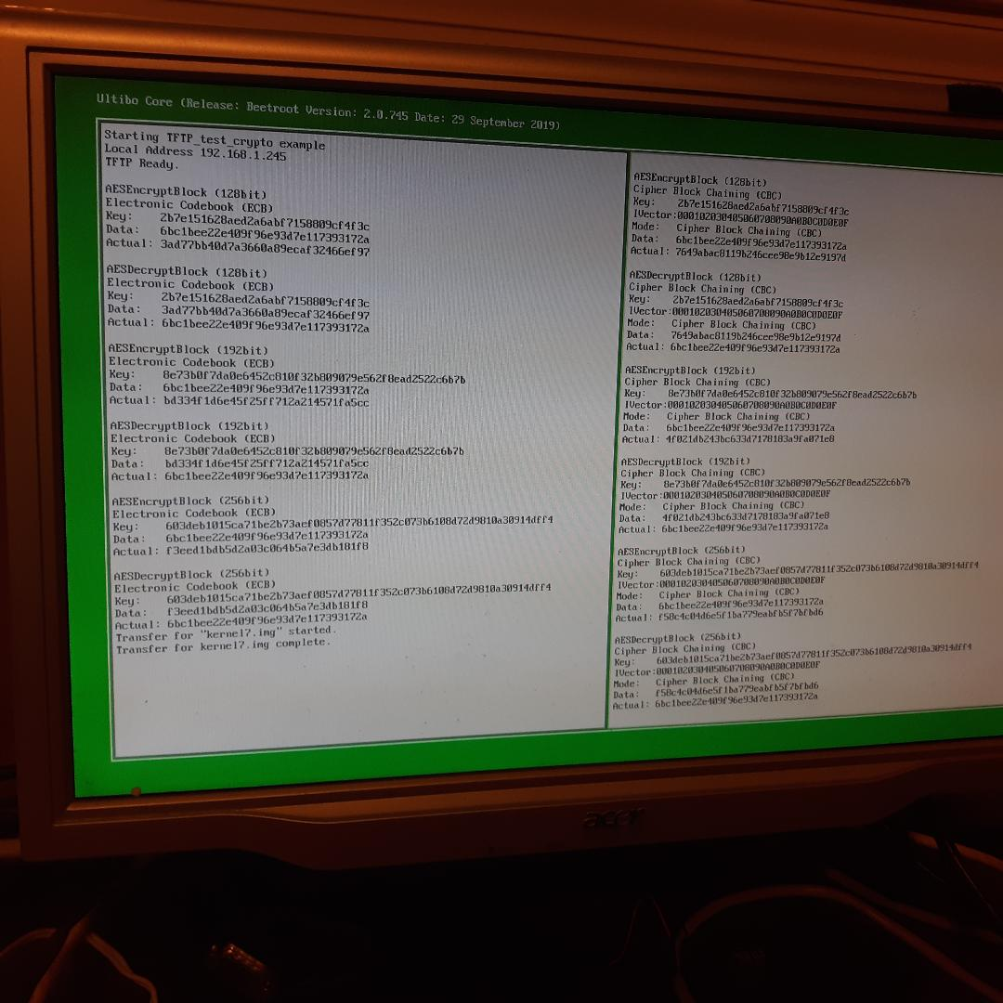

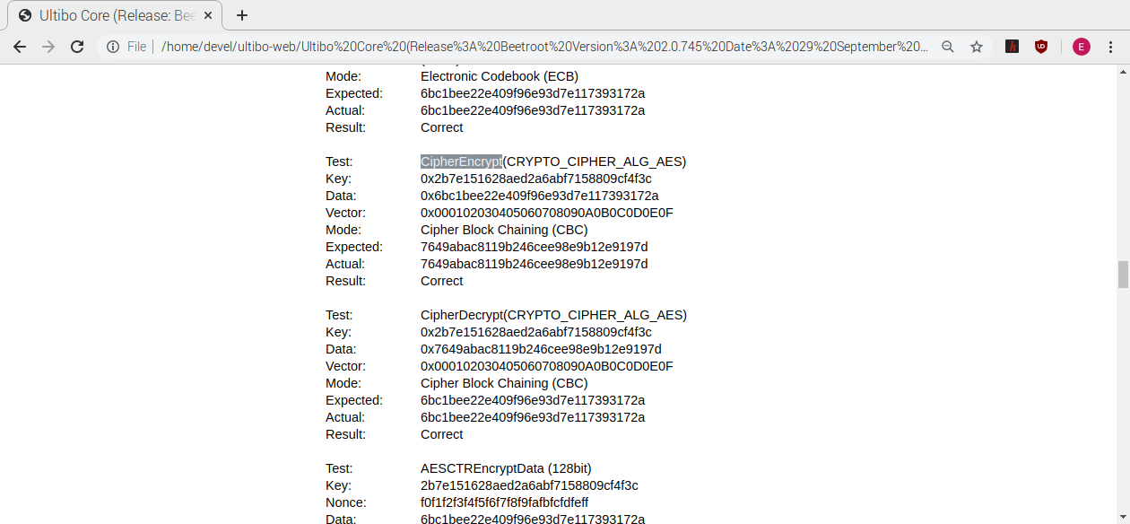

Now the results match the results on http://192.168.1.245/status/cryptoapi/

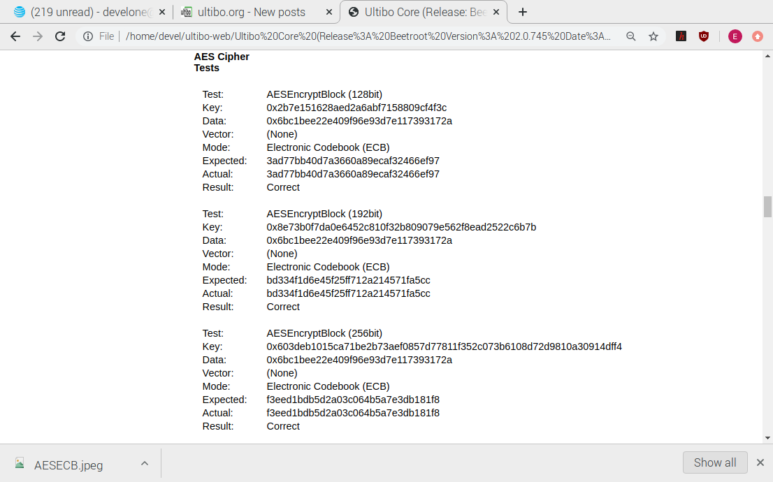
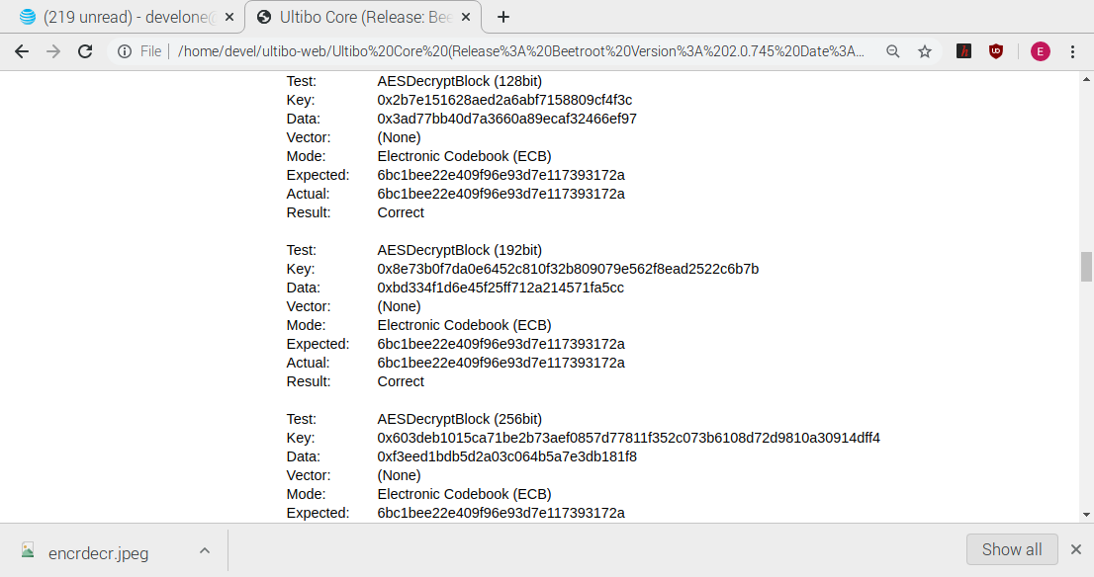
Decryption APICrypto.pas

shell1

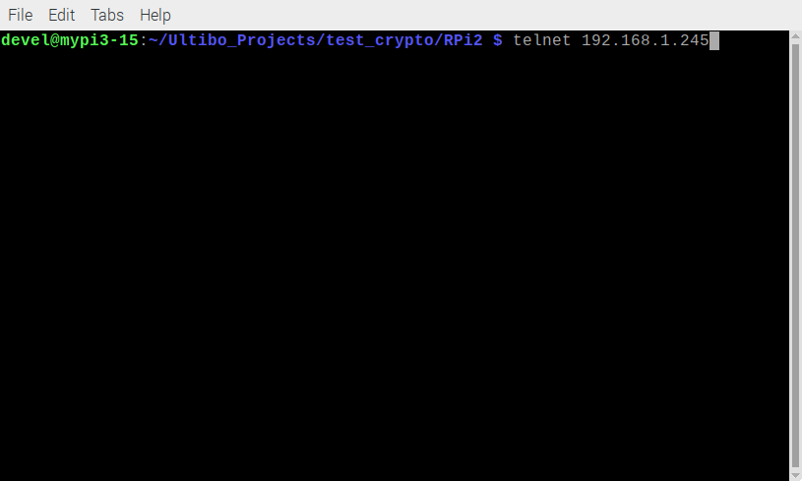
shell2

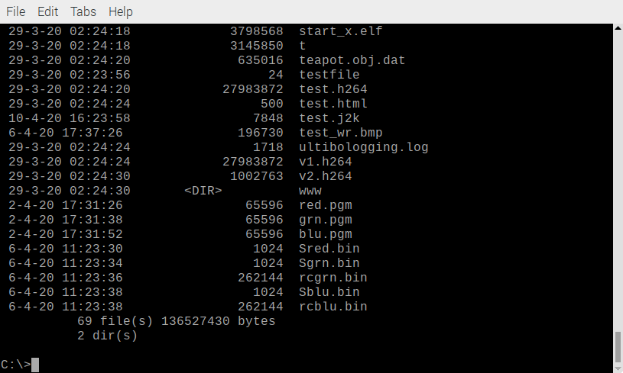
Webstatus

