*****************DRAFT*****************
Ultibo Bare Metal
openjpeg source files now included in Ultibo_Projects
07/07/19
*****************DRAFT*****************

Note: Currently Ultibo does not support WiFi.
Requires: Latest Ultibo run time RTL.

ULTIBO_RELEASE_DATE = '18 May 2019';
ULTIBO_RELEASE_NAME = 'Beetroot';
ULTIBO_RELEASE_VERSION = '2.0.667';
ULTIBO_RELEASE_VERSION_MAJOR = 2;
ULTIBO_RELEASE_VERSION_MINOR = 0;
ULTIBO_RELEASE_VERSION_REVISION = 667;
Linux firmware used by Ultibo to start kernel7.img Rpi2B, Rpi3B. Rpi kernel.img.

Ultibo with GPS receiver.

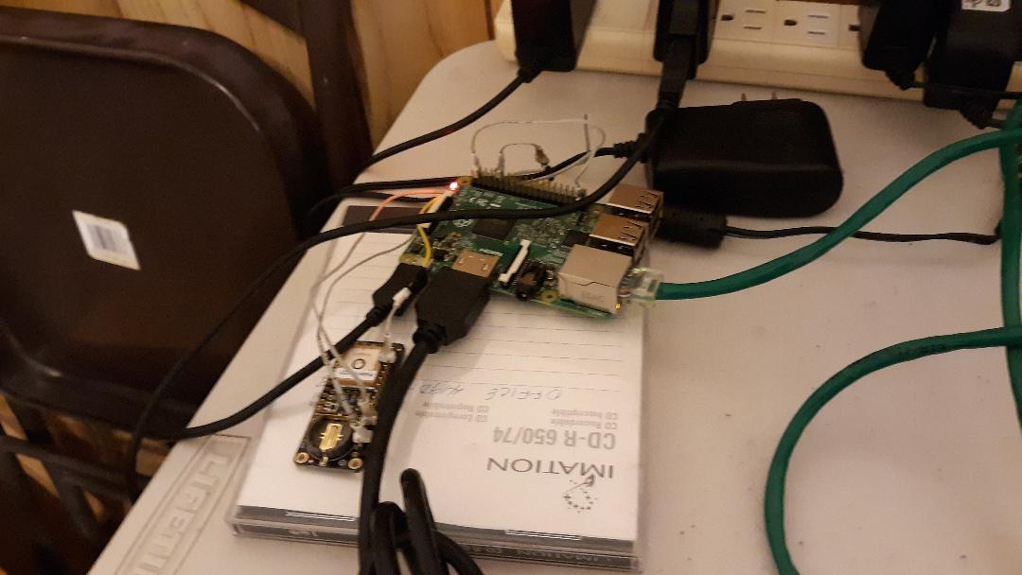
My configuration includes a HDMI switch hub and .

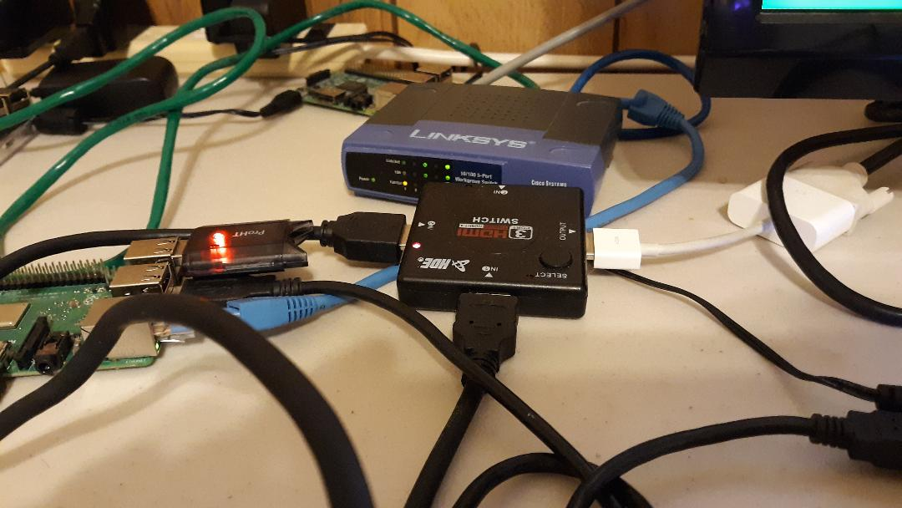
Lazarus RPI3B.

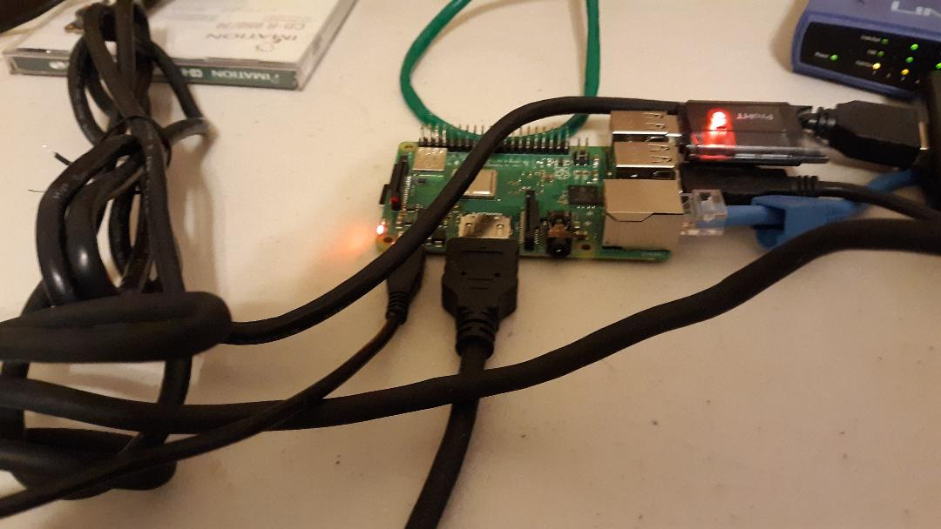
The following files need to be on micro sd
These files are found in repository https://github.com/develone/firmwar_for_ultibo

bootcode.bin
fixup.dat
fixup_x.dat
start.elf
start_x.elf
kernel7.img
config.txt
lena_rgb_1024.bmp in MyBitmap.bmp The file to be compressed.

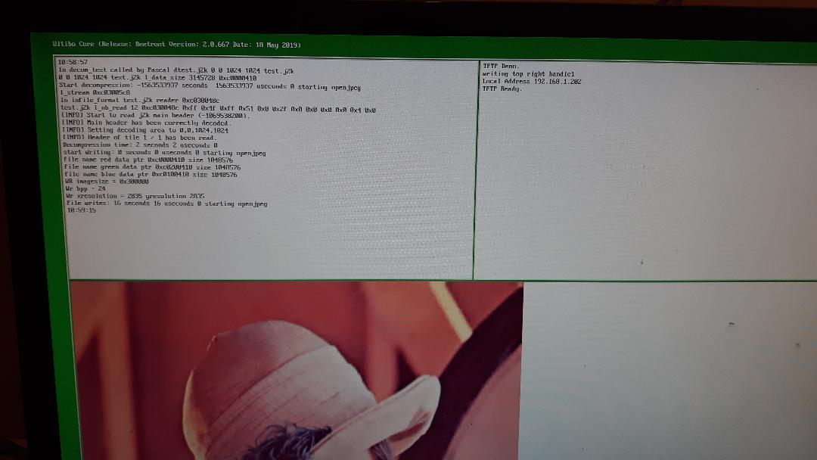
From a Rpi3B telnet 192.168.1.202 at the prompt type C:\> dir

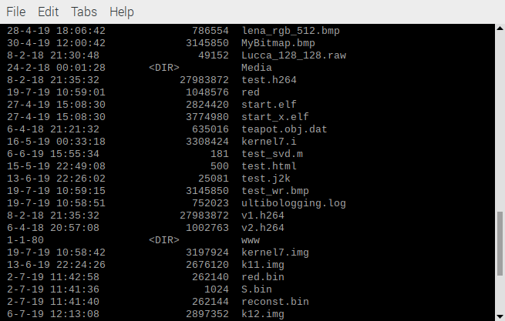
C:\logout

Transfer test.j2k from Ultibo system to RaspBian.

devel@mypi3-11:~ $ tftp 192.168.1.202
tftp> binary
tftp> get test.j2k
Received 25081 bytes in 0.2 seconds
tftp> quit

Note: openjpeg needs to be install from
devel@mypi3-8:~ $ git clone https://github.com/develone/openjpeg.git t_ultibo
Cloning into 't_ultibo'...
remote: Enumerating objects: 26333, done.
remote: Total 26333 (delta 0), reused 0 (delta 0), pack-reused 26333
Receiving objects: 100% (26333/26333), 86.86 MiB | 2.27 MiB/s, done.
Resolving deltas: 100% (19090/19090), done.
devel@mypi3-8:~ $ cd t_ultibo/
devel@mypi3-8:~/t_ultibo $ git checkout -b ultibo
Switched to a new branch 'ultibo'
devel@mypi3-8:~/t_ultibo $ git branch -a

master
* ultibo
remotes/origin/HEAD -> origin/master
remotes/origin/UCL
remotes/origin/avendor
remotes/origin/codingstyle
remotes/origin/coverity_scan
remotes/origin/fix-bypass-restart
remotes/origin/gh-pages
remotes/origin/j2kviewer
remotes/origin/master
remotes/origin/openjp3d
remotes/origin/openjpeg-1.5
remotes/origin/openjpeg-2.0
remotes/origin/openjpeg-2.1
remotes/origin/openjpeg3d
remotes/origin/openjpeg3d@745
remotes/origin/openjpeg3d@749
remotes/origin/opj-v1-branch
remotes/origin/ultibo
remotes/origin/v2

devel@mypi3-8:~/t_ultibo $ mkdir build
devel@mypi3-8:~/t_ultibo $ cd build
devel@mypi3-8:~/t_ultibo/build $ cmake ../
-- The C compiler identification is GNU 8.3.0
-- The CXX compiler identification is GNU 8.3.0
-- Check for working C compiler: /usr/bin/cc
-- Check for working C compiler: /usr/bin/cc -- works
-- Detecting C compiler ABI info
-- Detecting C compiler ABI info - done
-- Detecting C compile features
-- Detecting C compile features - done
-- Check for working CXX compiler: /usr/bin/c++
-- Check for working CXX compiler: /usr/bin/c++ -- works
-- Detecting CXX compiler ABI info
-- Detecting CXX compiler ABI info - done
-- Detecting CXX compile features
-- Detecting CXX compile features - done
-- Check if the system is big endian
-- Searching 16 bit integer
-- Looking for sys/types.h
-- Looking for sys/types.h - found
-- Looking for stdint.h
-- Looking for stdint.h - found
-- Looking for stddef.h
-- Looking for stddef.h - found
-- Check size of unsigned short
-- Check size of unsigned short - done
-- Using unsigned short
-- Check if the system is big endian - little endian
-- Looking for string.h
-- Looking for string.h - found
-- Looking for memory.h
-- Looking for memory.h - found
-- Looking for stdlib.h
-- Looking for stdlib.h - found
-- Looking for stdio.h
-- Looking for stdio.h - found
-- Looking for math.h
-- Looking for math.h - found
-- Looking for float.h
-- Looking for float.h - found
-- Looking for time.h
-- Looking for time.h - found
-- Looking for stdarg.h
-- Looking for stdarg.h - found
-- Looking for ctype.h
-- Looking for ctype.h - found
-- Looking for assert.h
-- Looking for assert.h - found
-- Looking for stdint.h
-- Looking for stdint.h - found
-- Looking for inttypes.h
-- Looking for inttypes.h - found
-- Looking for strings.h
-- Looking for strings.h - found
-- Looking for sys/stat.h
-- Looking for sys/stat.h - found
-- Looking for unistd.h
-- Looking for unistd.h - found
-- Checking for 64-bit off_t
-- Checking for 64-bit off_t - present with _FILE_OFFSET_BITS=64
-- Checking for fseeko/ftello
-- Checking for fseeko/ftello - present
-- Large File support - found
-- Looking for include file malloc.h
-- Looking for include file malloc.h - found
-- Looking for _aligned_malloc
-- Looking for _aligned_malloc - not found
-- Looking for posix_memalign
-- Looking for posix_memalign - found
-- Looking for memalign
-- Looking for memalign - found
-- Found ZLIB: /usr/lib/arm-linux-gnueabihf/libz.so (found version "1.2.11")
-- Your system seems to have a Z lib available, we will use it to generate PNG lib
-- Found PNG: /usr/lib/arm-linux-gnueabihf/libpng.so (found version "1.6.36")
-- Your system seems to have a PNG lib available, we will use it
-- Could NOT find TIFF (missing: TIFF_LIBRARY TIFF_INCLUDE_DIR)
-- TIFF lib not found, activate BUILD_THIRDPARTY if you want build it
-- Could NOT find LCMS2 (missing: LCMS2_LIBRARY LCMS2_INCLUDE_DIR)
-- Could NOT find LCMS (missing: LCMS_LIBRARY LCMS_INCLUDE_DIR)
-- LCMS2 or LCMS lib not found, activate BUILD_THIRDPARTY if you want build it
-- Configuring done
-- Generating done
-- Build files have been written to: /home/devel/t_ultibo/build
devel@mypi3-8:~/t_ultibo/build $ make
devel@mypi3-8:~/t_ultibo/build $ ls bin
libopenjp2.a libopenjp2.so.2.2.0 opj_compress opj_dump
libopenjp2.so libopenjp2.so.7 opj_decompress

devel@mypi3-11:~ $ ~/t_ultibo/build/bin/opj_dump -i test.j2k > tt.txt

[INFO] Start to read j2k main header (1996034884).
[INFO] Main header has been correctly decoded.
Image info {
x0=0, y0=0
x1=1024, y1=1024
numcomps=3
component 0 {
dx=1, dy=1
prec=8
sgnd=0
}
component 1 {
dx=1, dy=1
prec=8
sgnd=0
}
component 2 {
dx=1, dy=1
prec=8
sgnd=0
}
}
Codestream info from main header: {
tx0=0, ty0=0
tdx=1024, tdy=1024
tw=1, th=1
default tile {
csty=0
prg=0
numlayers=1
mct=0
comp 0 {
csty=0
numresolutions=6
cblkw=2^6
cblkh=2^6
cblksty=0
qmfbid=1
preccintsize (w,h)=(15,15) (15,15) (15,15) (15,15) (15,15) (15,15)
qntsty=0
numgbits=2
stepsizes (m,e)=(0,8) (0,9) (0,9) (0,10) (0,9) (0,9) (0,10) (0,9) (0,9) (0,10) (0,9) (0,9) (0,10) (0,9) (0,9) (0,10)
roishift=0
}
comp 1 {
csty=0
numresolutions=6
cblkw=2^6
cblkh=2^6
cblksty=0
qmfbid=1
preccintsize (w,h)=(15,15) (15,15) (15,15) (15,15) (15,15) (15,15)
qntsty=0
numgbits=2
stepsizes (m,e)=(0,8) (0,9) (0,9) (0,10) (0,9) (0,9) (0,10) (0,9) (0,9) (0,10) (0,9) (0,9) (0,10) (0,9) (0,9) (0,10)
roishift=0
}
comp 2 {
csty=0
numresolutions=6
cblkw=2^6
cblkh=2^6
cblksty=0
qmfbid=1
preccintsize (w,h)=(15,15) (15,15) (15,15) (15,15) (15,15) (15,15)
qntsty=0
numgbits=2
stepsizes (m,e)=(0,8) (0,9) (0,9) (0,10) (0,9) (0,9) (0,10) (0,9) (0,9) (0,10) (0,9) (0,9) (0,10) (0,9) (0,9) (0,10)
roishift=0
}
}
}
Codestream index from main header: {
Main header start position=0
Main header end position=125
Marker list: {
type=0xff4f, pos=0, len=2
type=0xff51, pos=2, len=49
type=0xff52, pos=51, len=14
type=0xff5c, pos=65, len=21
type=0xff64, pos=86, len=39
}
}

devel@mypi3-11:~ $ ~/t_ultibo/build/bin/opj_decompress -i test.j2k -o test.bmp

[INFO] Start to read j2k main header (1995494212).
[INFO] Main header has been correctly decoded.
[INFO] No decoded area parameters, set the decoded area to the whole image
[INFO] Header of tile 1 / 1 has been read.
[INFO] Generated Outfile test.bmp
decode time: 1749 ms

devel@mypi3-11:~ $ gimp test.bmp

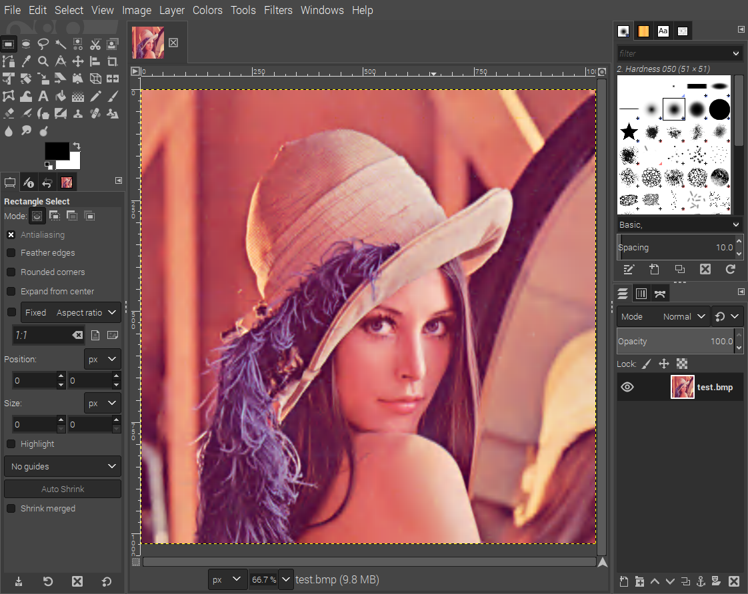
The above gimp image is the file -rw-r--r-- 1 devel devel 3145850 Jul 19 04:48 /home/devel/sd_img/lena_rgb_1024.bmp. The file was compressed by Ultibo jpeg2000 kernel7.img
with compression ration 125:1 to file test.j2k -rw-r--r-- 1 devel devel 25081 Jul 19 05:35 test.j2k

Execute the program that installs Lazarus & Free Pascal Compiler.
"./ultiboinstaller.sh"
Fetch the repository from github with the command
"git clone https://github.com/develone/Ultibo_Projects.git"
Start Lazarus with "ultibo/core/lazarus.sh"

Create the “libopenjp.a” which has the objects to perform openjpeg compress & decompression using the DWT.

devel@mypi3-8:~/Ultibo_Projects/jpeg2000/src $ ./compile_ultibo.sh

devel@mydevel@mypi3-8:~/Ultibo_Projects/jpeg2000/src $
"wc libopenjp2_obj.txt"
21 21 161 libopenjp2_obj.txt
The objects created from source are listed below.
"less libopenjp2_obj.txt"
bio.o
cio.o
dwt.o
event.o
function_list.o
image.o
invert.o
j2k.o
jp2.o
mct.o
mqc.o
openjpeg.o
opj_clock.o
opj_malloc.o
pi.o
raw.o
t1.o
t2.o
tcd.o
tgt.o
thread.o
devel@mypi3-8:~/Ultibo_Projects/jpeg2000/src $ ls *.c
bio.c event.c invert.c mct.c opj_clock.c raw.c tcd.c
cio.c function_list.c j2k.c mqc.c opj_malloc.c t1.c tgt.c
dwt.c image.c jp2.c openjpeg.c pi.c
The command “./libuild.sh” in devel@mypi3-8:~/Ultibo_Projects/jpeg2000/RPi2 $ compiles "dwtlift.c"
and adds with the objects in libopenjp2.a creating "libdwtlift.a". This library is called from
Pascal

"./libuild.sh"
If this is to be executed on other RPi2B or Rpi3B, For Rpi zero see minor differences below
devel@mypi3-11:~/Ultibo_Projects/jpeg2000 $ diff RPi/libbuild.sh RPi2/libbuild.sh
9c9
< arm-none-eabi-gcc -L. -llibopenjp2 -O2 -mabi=aapcs -marm -march=armv6 -mfpu=vfp -mfloat-abi=hard -c dwtlift.c
---
> arm-none-eabi-gcc -L. -llibopenjp2 -O3 -mabi=aapcs -marm -march=armv7-a -mfpu=vfpv3-d16 -mfloat-abi=hard -c dwtlift.c
16c16
<
---
>

devel@mypi3-11:~ $ ultibo/core/lazarus.sh

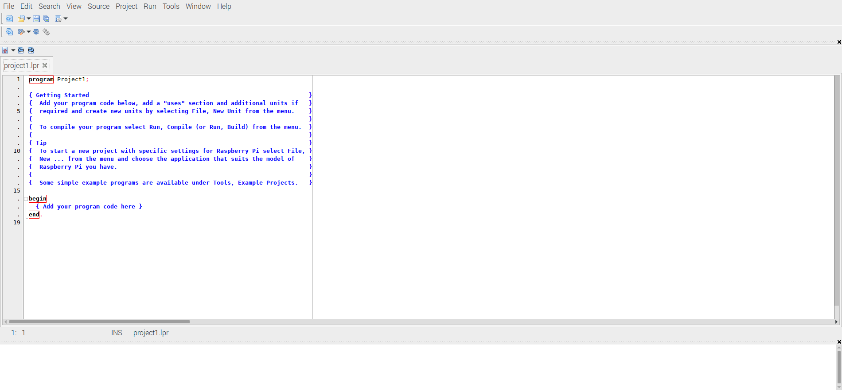

devel@mypi3-11:~ $ cd Ultibo_Projects/jpeg2000/src/
devel@mypi3-11:~/Ultibo_Projects/jpeg2000/src $ ./compile_ultibo.sh
The word count here should be 21
the word count in /home/pi/jpeg-2000-test/bare-metal/openjp
when ./libbuild.sh is executed should be 22
21 21 161 libopenjp2_obj.txt
devel@mypi3-11:~/Ultibo_Projects/jpeg2000/src $ cd ../RPi2
devel@mypi3-11:~/Ultibo_Projects/jpeg2000/RPi2 $ ./libbuild.sh
dwtlift.c: In function 'decompress':
dwtlift.c:658:3: warning: implicit declaration of function 'octave_write_byte'; did you mean 'opj_write_tile'? [-Wimplicit-function-declaration]
octave_write_byte(r_decompress_fn,r_decompress,da_x1*da_y1);
^~~~~~~~~~~~~~~~~
opj_write_tile

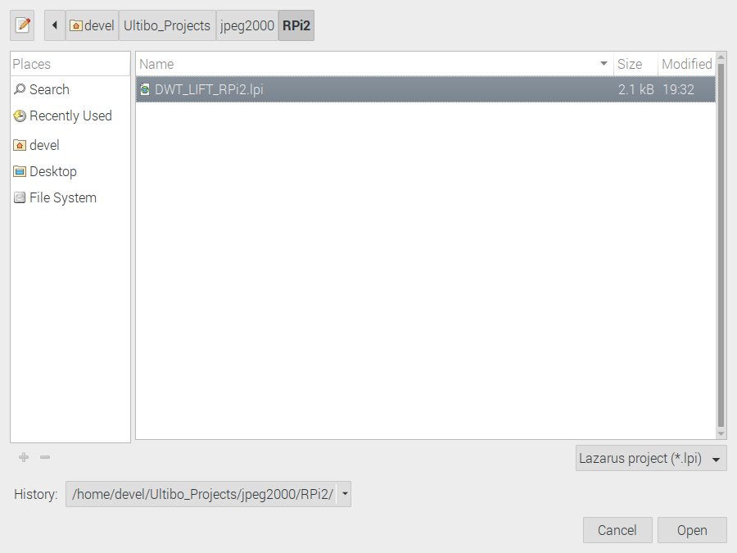
Depress Open

Run/Clean up and build or Run/Compile
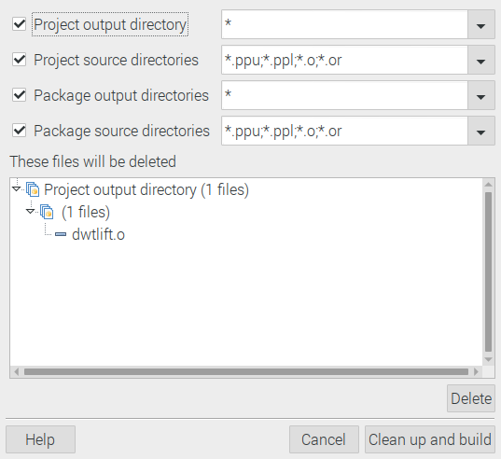

Depress Clean up and Build

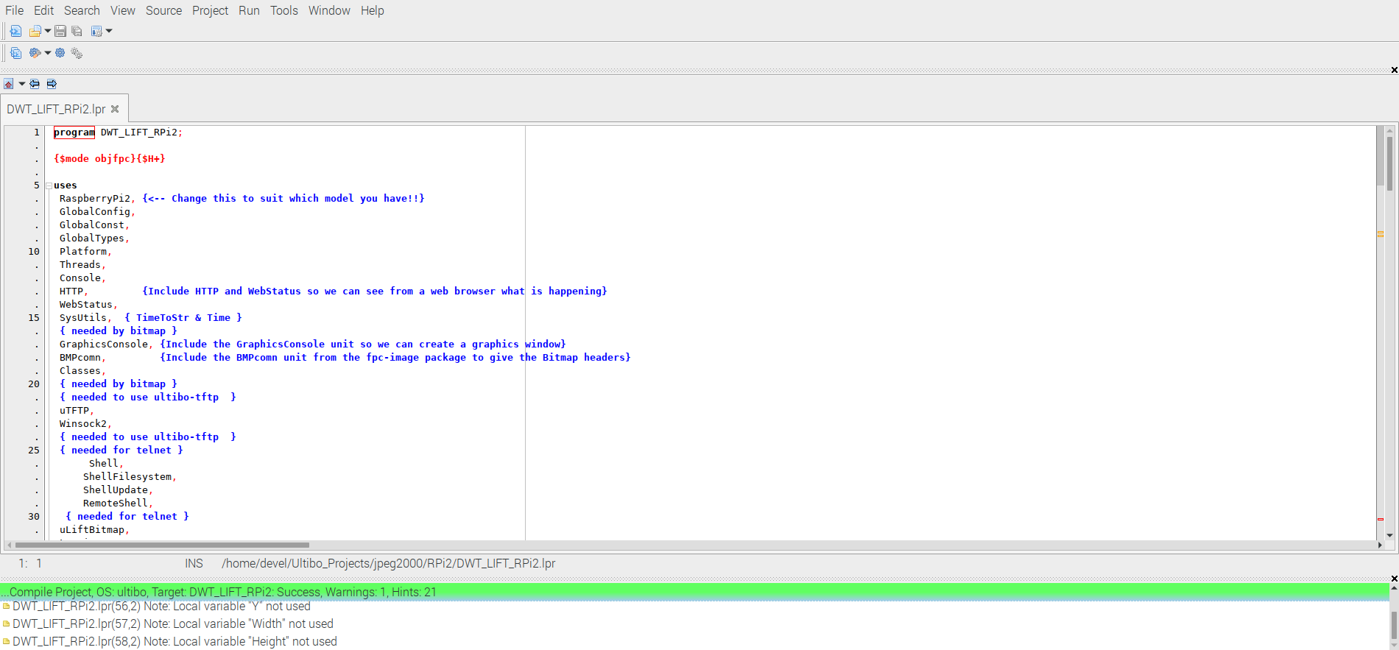
When the bar turns green indicated the everything compiled without errors.

