Upgraded Lazarus IDE Ultibo-Edition

{Version constants}
ULTIBO_RELEASE_DATE = '5 January 2022';
ULTIBO_RELEASE_NAME = 'Beetroot';
ULTIBO_RELEASE_VERSION = '2.1.279';
ULTIBO_RELEASE_VERSION_MAJOR = 2;
ULTIBO_RELEASE_VERSION_MINOR = 1;
ULTIBO_RELEASE_VERSION_REVISION = 279;
My https://github.com/develone/pico-examples/blob/master/ultibo_blink/ultibo_blink.c &

Adding Paul's download from https://ultibo.org/forum/download/file.php?id=630
to my Projects https://github.com/develone/Ultibo_Projects/blob/master/Pauls-pico-receive/RPi3/PicoTest1.lpr from Paul’s PicoTest1.lps. In addition, added Paul’s CmakeLists.txt & main.c to my https://github.com/develone/pico-examples/blob/master/pulsing/main.c
https://github.com/develone/pico-examples/blob/master/pulsing/CMakeLists.txt to my pico-examples. This worked correctly.

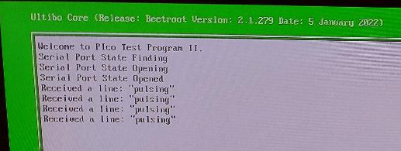

After reviewing Paul’s C code main.c found at https://github.com/develone/pico-examples/blob/master/pulsing/main.c. I questioned how it compiled since it was missing a return 0;

My https://github.com/develone/Ultibo_Projects/blob/master/picoledonoff/RPI3/picoledonoff.lpr (this version will not even try finding pico or gets and IP with pico connected) https://github.com/develone/Ultibo_Projects/blob/master/wifipicoledonoff/RPI3/wifipicoledonoff.lpr do not detect the pico.

res := SerialDeviceOpen (SerialDevice, 115200, SERIAL_DATA_8BIT, SERIAL_STOP_1BIT, SERIAL_PARITY_NONE, SERIAL_FLOW_DSR_DTR, 0, 0);

