***********************Draft***********************

DWT Lifting Step
12/01/20

***********************Draft***********************

Note: This is only needed when compiling from the command line:
Need to set the PATH for fpc.
export PATH=/home/devel/ultibo/core/fpc/bin/:$PATH
echo $PATH

The lifting.c C code is part of test.c.

cd Ultibo_Projects/dwt_lifting_step/RPi2/
./compile.sh

#!/bin/bash
date
rm -f test.o
rm -f libtest.a
rm -f kernel7.img
arm-none-eabi-gcc -O2 -mabi=aapcs -marm -march=armv7-a -mfpu=vfpv3-d16 - mfloat- abi=hard -c test.c
arm-none-eabi-ar rcs libtest.a test.o

fpc -vi -B -Tultibo -Parm -CpARMV7A -WpRPI2B @/home/devel/ultibo/core/fpc/bin/RPI2.CFG -O2 LibCTest_RPi2.lpr
ls -la test.o libtest.a kernel7.img

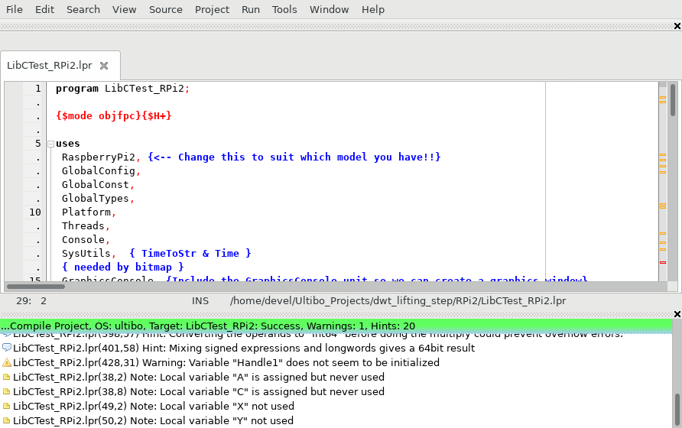
Depress Run/compile to create kernel7.img when the green bar appears.
tftp 192.168.1.247 < cmdstftp
tftp> tftp> Sent 2688432 bytes in 33.1 seconds

