******************Draft******************
Paul’s BTStack with Blue Kitchen Library
Ultibo RPi3B Bare Metal &
Pico_W
04/14/23
******************Draft******************

Background:

Ultibo RPi3 currently has limited Wireless support as WiFi is currently in development
by Ultibo Garry Wood & Ultibo user ric355 “https://github.com/ric355/ultibowifi”.
Need to create a method to compile blue kitchen library. Note: Currently only a libbtstack.a of unknown status is being used.

BlueTooth for the pico_w was released in pico-sdk 1.5
commit f396d05f8252d4670d4ea05c8b7ac938ef0cd381 (HEAD -> master, origin/master, origin/HEAD)
Author: Graham Sanderson <graham.sanderson@raspberrypi.com>
Date: Sat Feb 11 16:54:33 2023 -0600

Actually target correct USB1.5.0 version - same code (#1245)

commit 2ccab115de0d42d31d6611cca19ef0cd0d2ccaa7
Author: graham sanderson <graham.sanderson@raspberrypi.com>
Date: Fri Feb 10 18:23:51 2023 -0600

release SDK 1.5.0

Status:

Downloaded BTStack.zip from https://ultibo.org/forum/viewtopic.php?f=9&t=1736&sid=b5bd87d879e3f33c4e7cb8a93cbb7c6b&start=10

Adding Paul's BTStack to Ultibo_Projects/Pauls-BTStack/RPi3
needed uLog.pas & uTFTP.pas

devel@pi4-60:~/Ultibo_Projects/Pauls-BTStack/RPi3 $ tftp 192.168.1.231 <cmdstftp
tftp> tftp> Sent 2705260 bytes in 17.8 seconds

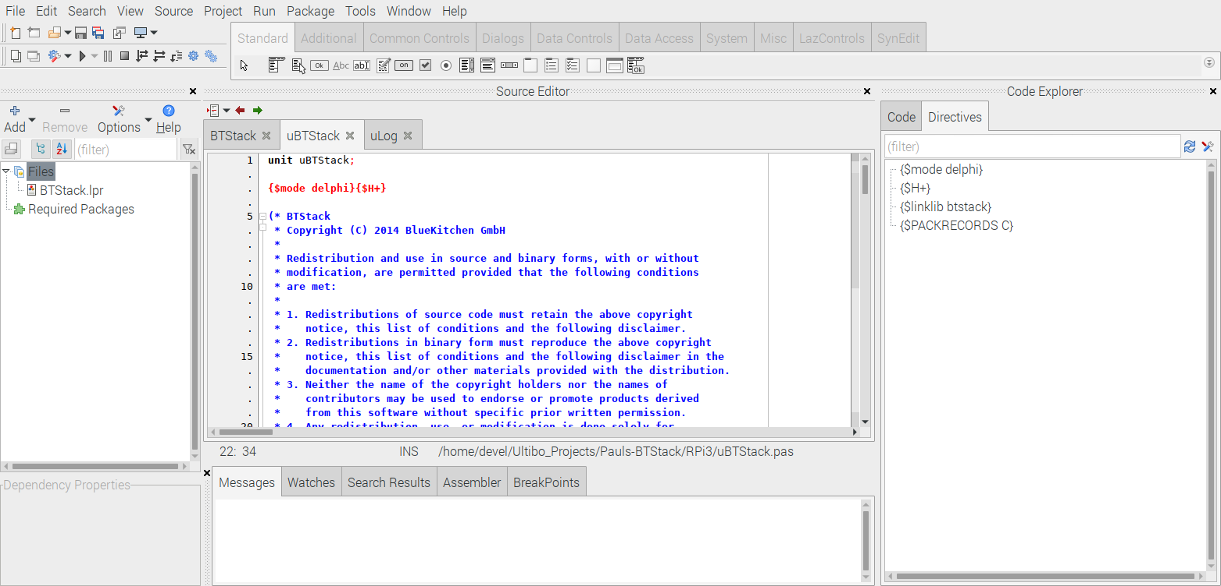

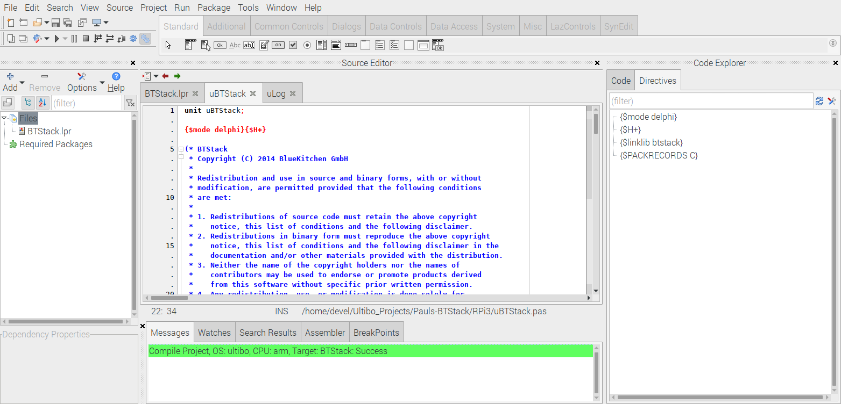
The kernel7.img is ready for transfer to RPi3B

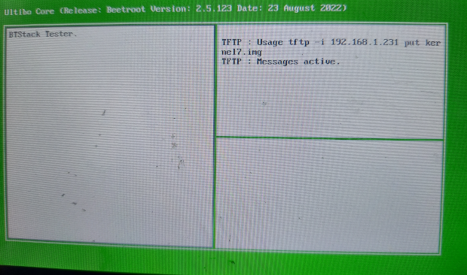
Booting on RPi3B with 7in Display

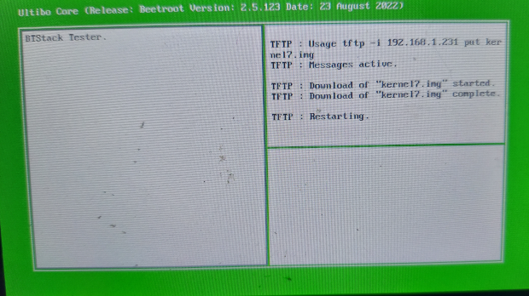
tftp 192.168.1.231 <cmdstftp
tftp> tftp> Sent 2705260 bytes in 17.8 seconds

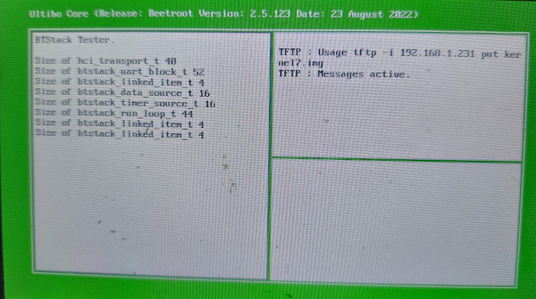
Depressing “1”

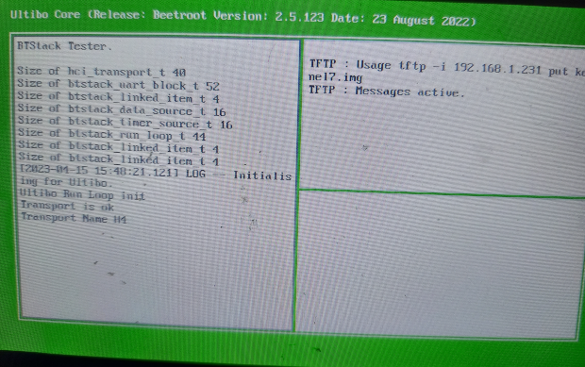
Depressing “2”

