***********************Draft***********************
QEMU Ultibo Bare Metal
SVD
with
Remote Shell and Web Status
07/27/21
***********************Draft***********************

Note:
https://ultibo.org/forum/viewtopic.php?f=13&t=1303&p=11632#p11632

By Ultibo Wed Jul 21, 2021 9:01 pm

I suspect the version of QEMU that you have on the RPI3B+ is later than the one on the RPi4, try doing qemu-system-arm -version on each one.
We recently discovered that the Ultibo SD card driver was not compatible with the latest versions of QEMU, a fix for this is included in the release from today (Ultibo core 2.1.079) so if you update your RTL to the latest either using the RTL Builder or by rerunning the ultiboinstaller script then it should work now.
https://en.m.wikipedia.org/wiki/QEMU. On the pi400-1 I ran
./ultiboinstaller.sh on pi400-1.

QEMU is a hosted virtual machine monitor: it emulates the machine's processor through dynamic binary translation and provides a set of different hardware and device models for the machine, enabling it to run a variety of guest operating systems. It also can be used with Kernel-based Virtual Machine (KVM) to run virtual machines at near-native speed (by taking advantage of hardware extensions such as Intel VT-x). QEMU can also do emulation for user-level processes, allowing applications compiled for one architecture to run on another.[3]

Note : Additional software is needed to run QEMU “sudo apt-get install qemu-system-arm”.
The following programs are added.

/usr/bin/qemu-img /usr/bin/qemu-nbd /usr/bin/qemu-system-aarch64
/usr/bin/qemu-io /usr/bin/qemu-pr-helper /usr/bin/qemu-system-arm

The command line for starting Lazarus IDE (Ultibo Edition) “~/ultibo/core/lazarus.sh”

buildlib.sh

#!/bin/bash
#export PATH=/home/devel/ultibo/core/fpc/bin:$PATH
rm -f *.o
rm -f libsvd.a

arm-none-eabi-gcc -I../include -O3 -mabi=aapcs -marm -march=armv7-a -mfpu=vfpv3-d16 -mfloat-abi=hard -c svd.c -o svd.o
arm-none-eabi-gcc -I../include -O3 -mabi=aapcs -marm -march=armv7-a -mfpu=vfpv3-d16 -mfloat-abi=hard -c disp_mat.c -o disp_mat.o
arm-none-eabi-gcc -I../include -O3 -mabi=aapcs -marm -march=armv7-a -mfpu=vfpv3-d16 -mfloat-abi=hard -c trans_mat.c -o trans_mat.o
arm-none-eabi-gcc -I../include -O3 -mabi=aapcs -marm -march=armv7-a -mfpu=vfpv3-d16 -mfloat-abi=hard -c mul_mat.c -o mul_mat.o
arm-none-eabi-gcc -D_POSIX_THREADS -lpthread -I../include -O3 -mabi=aapcs -marm -march=armv7-a -mfpu=vfpv3-d16 -mfloat-abi=hard -c mythread.c -o mythread.o
arm-none-eabi-gcc -I../include -O3 -mabi=aapcs -marm -march=armv7-a -mfpu=vfpv3-d16 -mfloat-abi=hard -c pnmio.c -o pnmio.o
arm-none-eabi-gcc -I../include -O3 -mabi=aapcs -marm -march=armv7-a -mfpu=vfpv3-d16 -mfloat-abi=hard -c error.c -o error.o

echo "Compiling example ultibo_th_svd "
arm-none-eabi-gcc -DUltibo -D_POSIX_THREADS -lpthread -I../include -O3 -mabi=aapcs -marm -march=armv7-a -mfpu=vfpv3-d16 -mfloat-abi=hard -c master.c -o ultibo_th_svd.o

#gcc test_svd.c svd.o disp_mat.o -lm -o test_svd
arm-none-eabi-ar rcs libsvd.a *.o
arm-none-eabi-ar -t libsvd.a > libsvd_obj.txt
#fpc -vi -B -Tultibo -Parm -CpARMV7A -WpRPI3B @/home/devel/ultibo/core/fpc/bin/RPI3.CFG -O4 svd_FS_RPi3.lpr

./buildlib.sh
Compiling example ultibo_th_svd

less libsvd_obj.txt

disp_mat.o
error.o
mul_mat.o
mythread.o
pnmio.o
svd.o
trans_mat.o
ultibo_th_svd.o

ls -la libsvd.a
-rw-r--r-- 1 devel devel 33010 Jul 27 17:33 libsvd.a

Project/Open Project

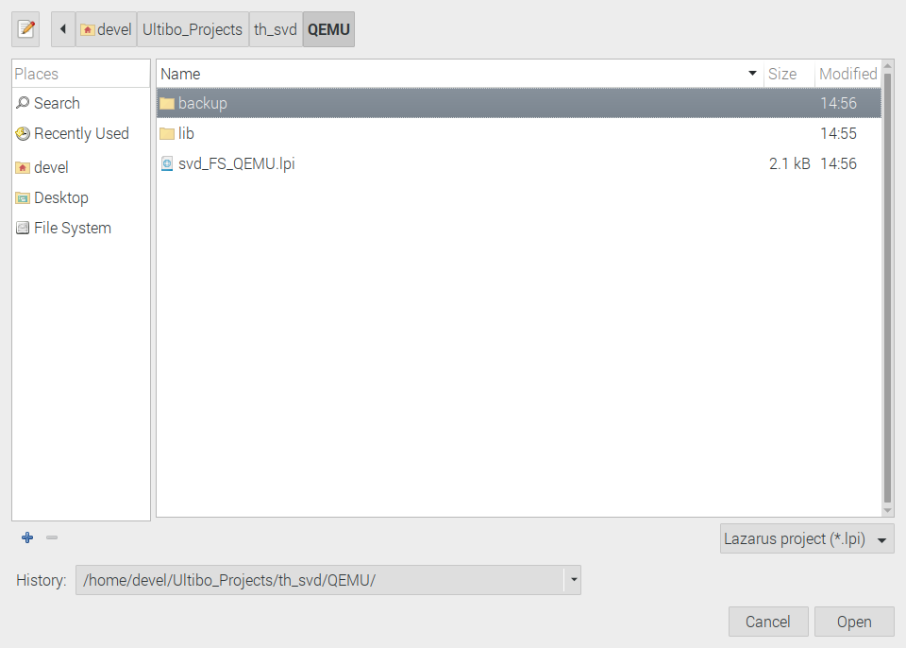

Select svd_FS_QEMU.lpi

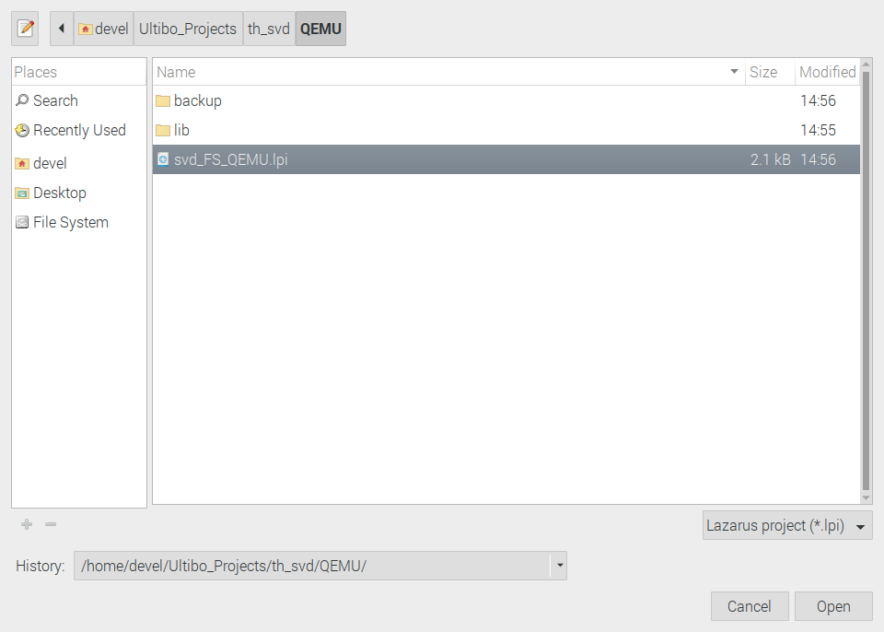

Depress Open

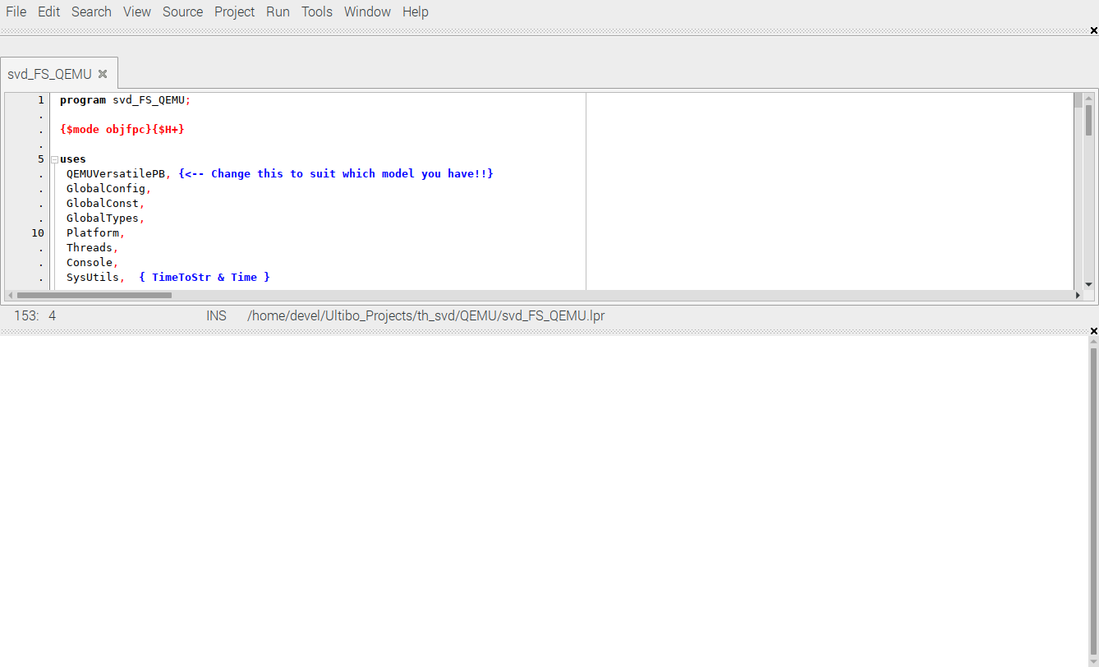

qemu-img create disk.img 25M

Formatting 'disk.img', fmt=raw size=26214400

sudo fdisk disk.img

Welcome to fdisk (util-linux 2.33.1).
Changes will remain in memory only, until you decide to write them.
Be careful before using the write command.

Device does not contain a recognized partition table.
Created a new DOS disklabel with disk identifier 0x165f8cb7.

Command (m for help): n
Partition type
p primary (0 primary, 0 extended, 4 free)
e extended (container for logical partitions)
Select (default p): p
Partition number (1-4, default 1): 1
First sector (2048-51199, default 2048):
Last sector, +/-sectors or +/-size{K,M,G,T,P} (2048-51199, default 51199):

Created a new partition 1 of type 'Linux' and of size 24 MiB.

Command (m for help): t
Selected partition 1
Hex code (type L to list all codes): L

0 Empty 24 NEC DOS 81 Minix / old Lin bf Solaris
1 FAT12 27 Hidden NTFS Win 82 Linux swap / So c1 DRDOS/sec (FAT-
2 XENIX root 39 Plan 9 83 Linux c4 DRDOS/sec (FAT-
3 XENIX usr 3c PartitionMagic 84 OS/2 hidden or c6 DRDOS/sec (FAT-
4 FAT16 <32M 40 Venix 80286 85 Linux extended c7 Syrinx
5 Extended 41 PPC PReP Boot 86 NTFS volume set da Non-FS data
6 FAT16 42 SFS 87 NTFS volume set db CP/M / CTOS / .
7 HPFS/NTFS/exFAT 4d QNX4.x 88 Linux plaintext de Dell Utility
8 AIX 4e QNX4.x 2nd part 8e Linux LVM df BootIt
9 AIX bootable 4f QNX4.x 3rd part 93 Amoeba e1 DOS access
a OS/2 Boot Manag 50 OnTrack DM 94 Amoeba BBT e3 DOS R/O
b W95 FAT32 51 OnTrack DM6 Aux 9f BSD/OS e4 SpeedStor
c W95 FAT32 (LBA) 52 CP/M a0 IBM Thinkpad hi ea Rufus alignment
e W95 FAT16 (LBA) 53 OnTrack DM6 Aux a5 FreeBSD eb BeOS fs
f W95 Ext'd (LBA) 54 OnTrackDM6 a6 OpenBSD ee GPT
10 OPUS 55 EZ-Drive a7 NeXTSTEP ef EFI (FAT-12/16/
11 Hidden FAT12 56 Golden Bow a8 Darwin UFS f0 Linux/PA-RISC b
12 Compaq diagnost 5c Priam Edisk a9 NetBSD f1 SpeedStor
14 Hidden FAT16 <3 61 SpeedStor ab Darwin boot f4 SpeedStor
16 Hidden FAT16 63 GNU HURD or Sys af HFS / HFS+ f2 DOS secondary
17 Hidden HPFS/NTF 64 Novell Netware b7 BSDI fs fb VMware VMFS
18 AST SmartSleep 65 Novell Netware b8 BSDI swap fc VMware VMKCORE
1b Hidden W95 FAT3 70 DiskSecure Mult bb Boot Wizard hid fd Linux raid auto
1c Hidden W95 FAT3 75 PC/IX bc Acronis FAT32 L fe LANstep
1e Hidden W95 FAT1 80 Old Minix be Solaris boot ff BBT
Hex code (type L to list all codes): 4
Changed type of partition 'Linux' to 'FAT16 <32M'.

Command (m for help): p
Disk disk.img: 25 MiB, 26214400 bytes, 51200 sectors
Units: sectors of 1 * 512 = 512 bytes
Sector size (logical/physical): 512 bytes / 512 bytes
I/O size (minimum/optimal): 512 bytes / 512 bytes
Disklabel type: dos
Disk identifier: 0x165f8cb7

Device Boot Start End Sectors Size Id Type
disk.img1 2048 51199 49152 24M 4 FAT16 <32M

Command (m for help): w
The partition table has been altered.
Syncing disks.

mkdosfs disk.img

mkfs.fat 4.1 (2017-01-24)

sudo mount disk.img /mnt/img1

sudo cp -R ~/Ultibo_Projects/Little_Interpreted_Language/img-tests/disk/* /mnt/img1

sudo cp *.pgm /mnt/img1/

ls /mnt/img1
'Another File.txt' blu.pgm grn.pgm red.pgm 'Test File.txt' www

sudo umount /mnt/img1

./startqemu.sh

#!/bin/bash
qemu-system-arm -machine versatilepb -cpu cortex-a8 -kernel kernel.bin \
-net user,hostfwd=tcp::5080-:80,hostfwd=tcp::5023-:23,hostfwd=udp::5069-:69,hostfwd=tcp::6050-:5050 -net nic \
-drive file=disk.img,if=sd,format=raw

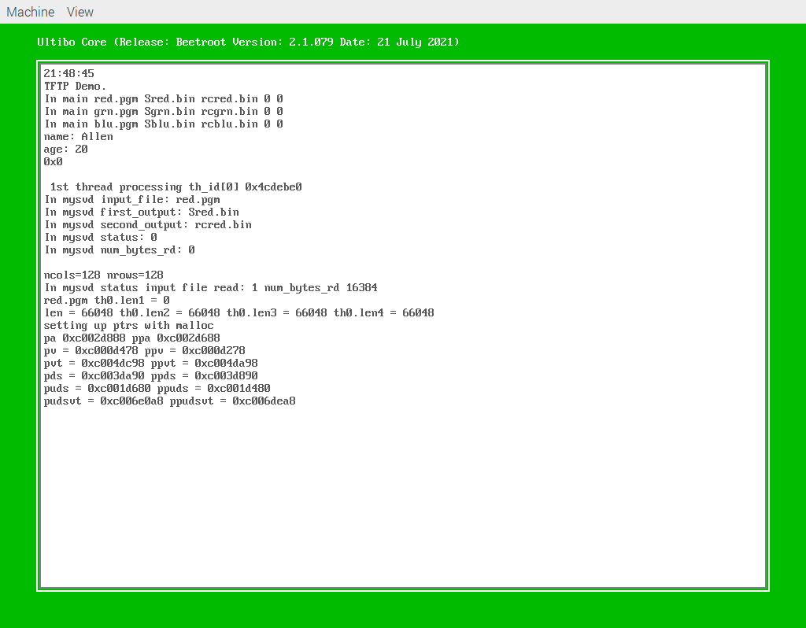
svd

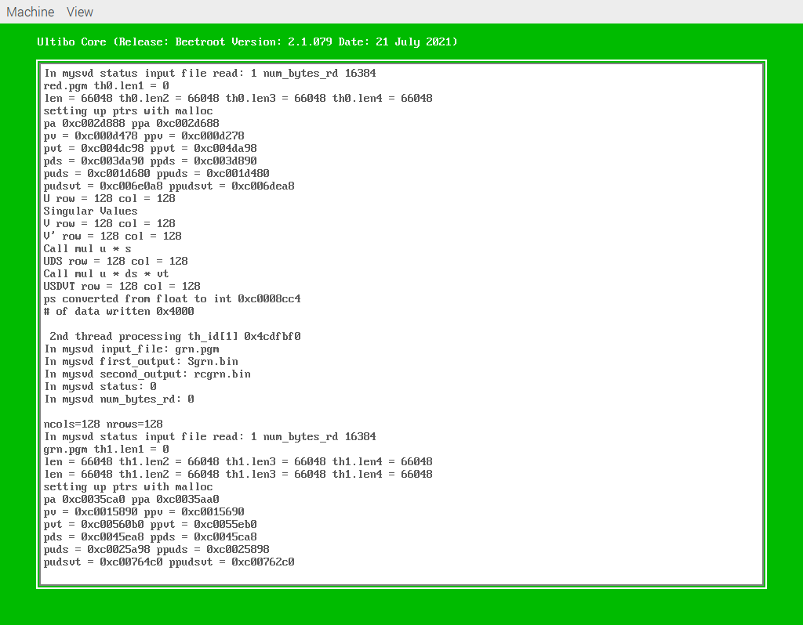
svd1

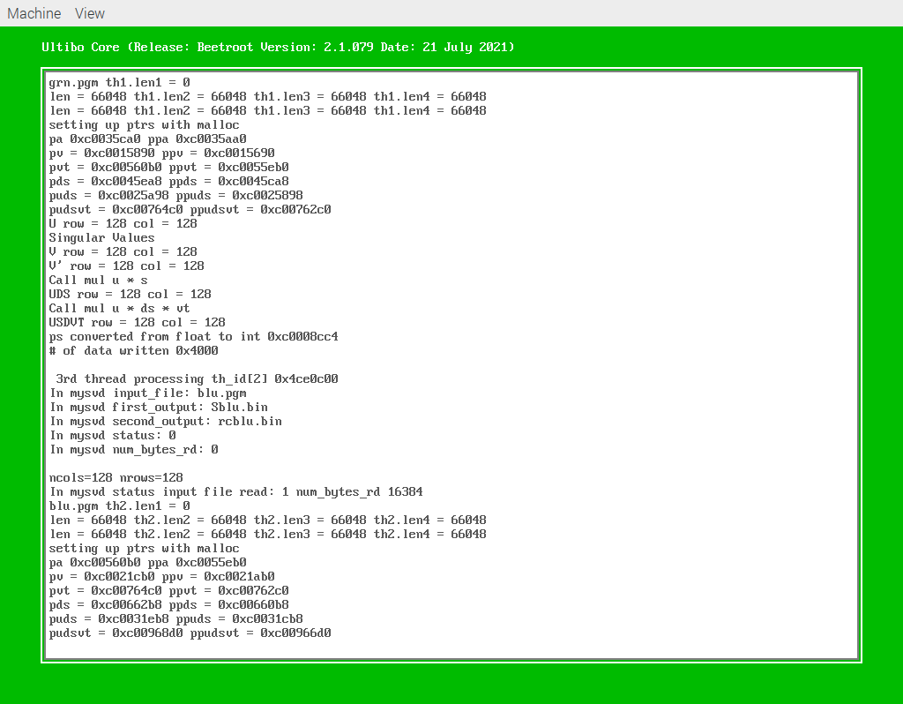
svd2

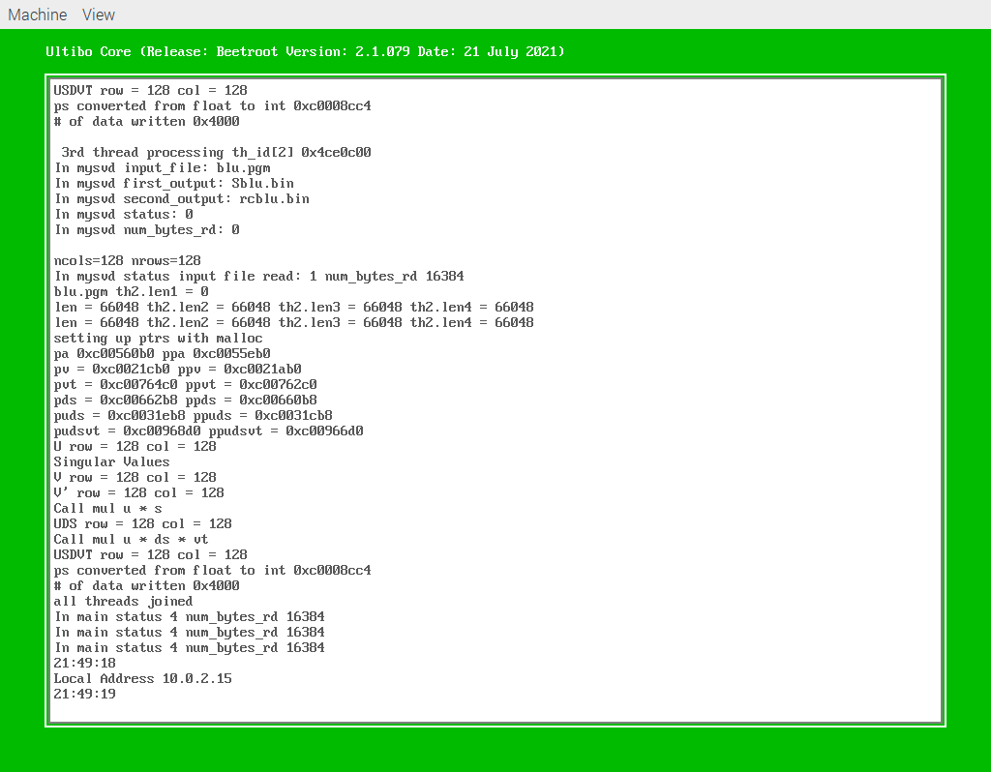
svd3

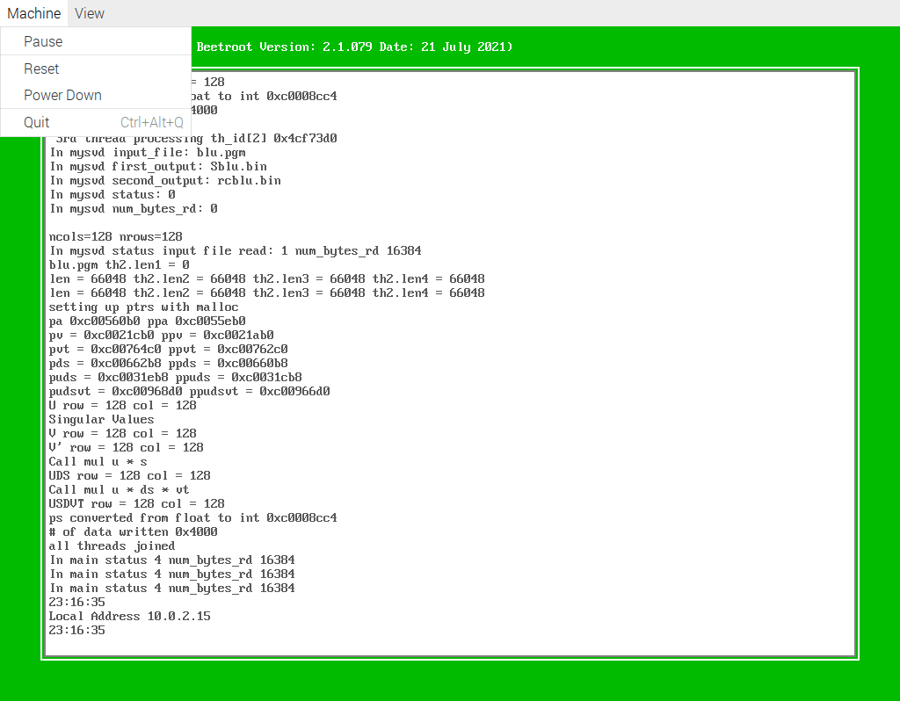
Depress Quit

sudo mount disk.img /mnt/img1

ls -la /mnt/img1
total 278
drwxr-xr-x 3 root root 16384 Dec 31 1969 .
drwxr-xr-x 5 root root 4096 Jul 18 10:10 ..
-rwxr-xr-x 1 root root 53 Jul 27 17:14 'Another File.txt'
-rwxr-xr-x 1 root root 16444 Jul 27 17:14 blu.pgm
-rwxr-xr-x 1 root root 16444 Jul 27 17:14 grn.pgm
-rwxr-xr-x 1 root root 65536 Jul 27 17:16 rcblu.bin
-rwxr-xr-x 1 root root 65536 Jul 27 17:16 rcgrn.bin
-rwxr-xr-x 1 root root 65536 Jul 27 17:16 rcred.bin
-rwxr-xr-x 1 root root 16444 Jul 27 17:14 red.pgm
-rwxr-xr-x 1 root root 512 Jul 27 17:16 Sblu.bin
-rwxr-xr-x 1 root root 512 Jul 27 17:16 Sgrn.bin
-rwxr-xr-x 1 root root 512 Jul 27 17:16 Sred.bin
-rwxr-xr-x 1 root root 31 Jul 27 17:14 'Test File.txt'
drwxr-xr-x 2 root root 2048 Jul 27 17:14 www

sudo cp /mnt/img1/*.bin .

ls -la *.bin
-rwxr-xr-x 1 devel devel 2921536 Jul 27 15:46 kernel.bin
-rwxr-xr-x 1 devel devel 65536 Jul 27 17:19 rcblu.bin
-rwxr-xr-x 1 devel devel 65536 Jul 27 17:19 rcgrn.bin
-rwxr-xr-x 1 devel devel 65536 Jul 27 17:19 rcred.bin
-rwxr-xr-x 1 devel devel 512 Jul 27 17:19 Sblu.bin
-rwxr-xr-x 1 devel devel 512 Jul 27 17:19 Sgrn.bin
-rwxr-xr-x 1 devel devel 512 Jul 27 17:19 Sred.bin

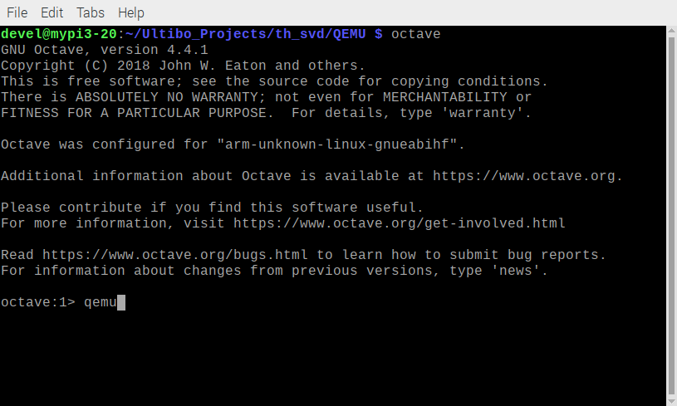
Start octave

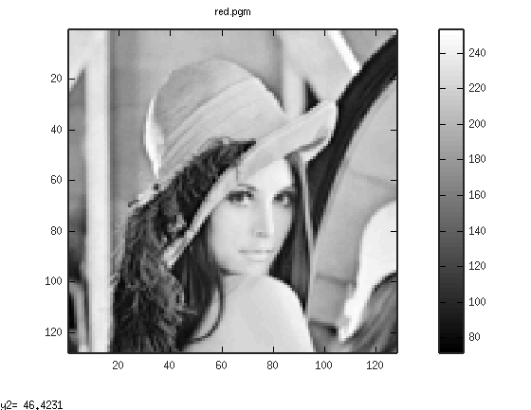
oct1

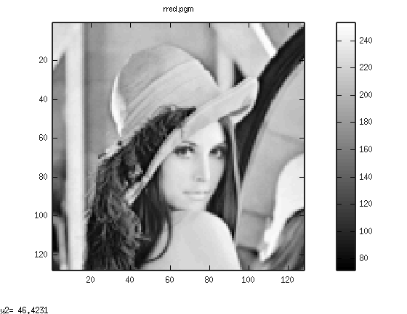
oct2

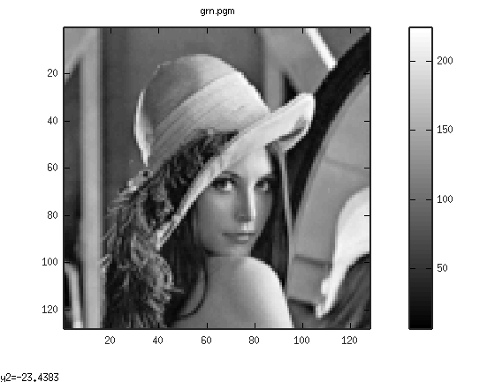
oct3

oct4

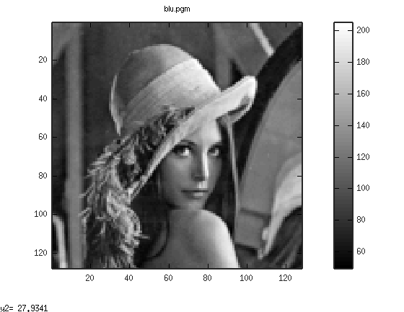

oct5

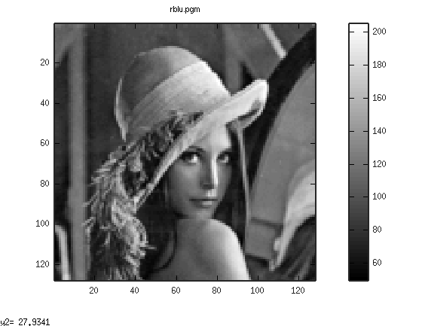
oct6

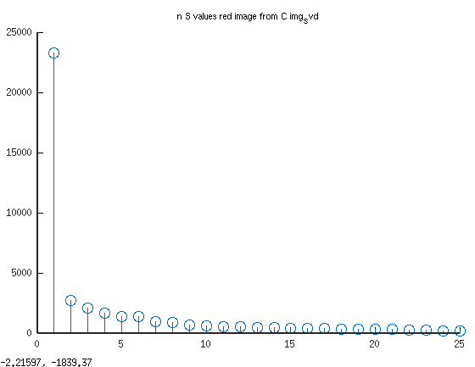
oct7
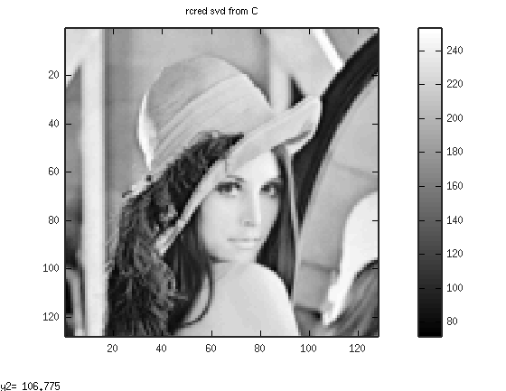
oct8

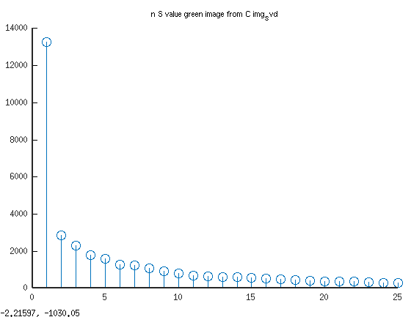
oct9
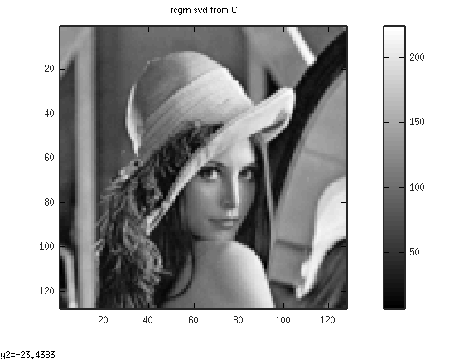
oct10

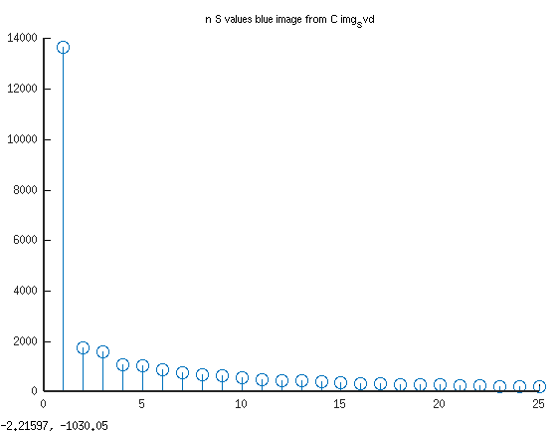
oct11
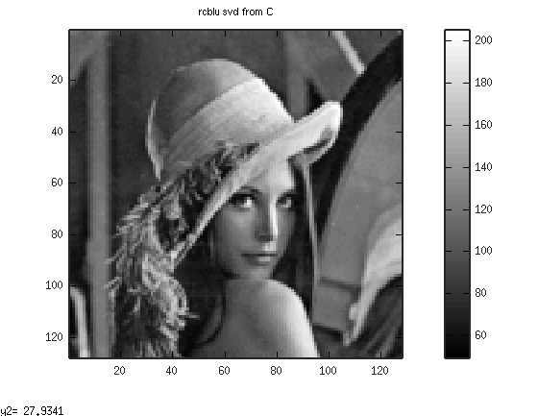
oct12

