***********************Draft***********************
Ultitbo UDPSERVER running a RPi4
Sending a message to RPi4 running Linux on UDP port 514
06/06/21
***********************Draft***********************

Original code was found at https://github.com/ultibohub/Examples/tree/master/Advanced/UDPServer/RPi2

gcc server.c -o server
server.c: In function ‘main’:
server.c:68:5: warning: implicit declaration of function ‘close’; did you mean ‘pclose’? [-Wimplicit-function-declaration]
close(s);
^~~~~
pclose
Lazarus IDE (Ultibo Edition)

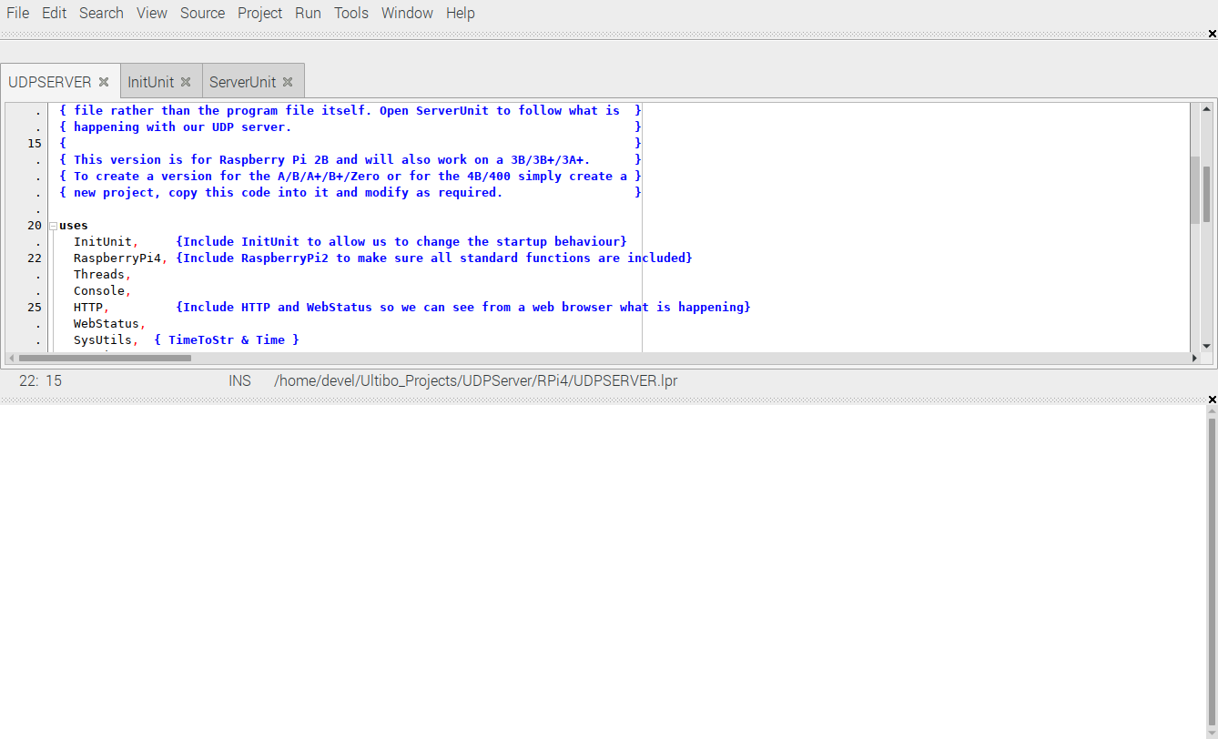
Run/Compile

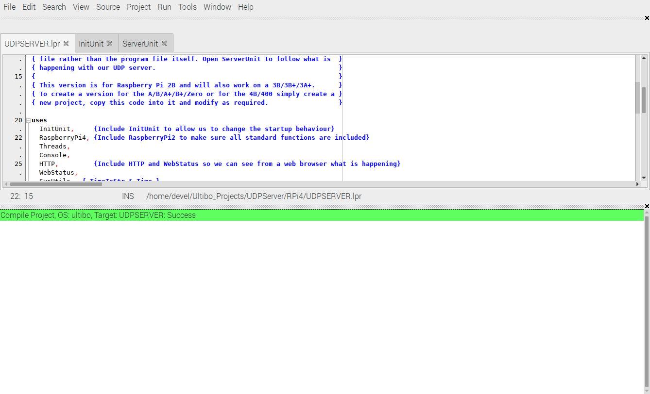
The green bar indicates that the kernel7l.img was succecsfully created.

tftp 192.168.1.143 < cmdstftp
tftp> tftp> Sent 2672408 bytes in 5.3 seconds

sudo ./server
[sudo] password for devel:
Waiting for data…

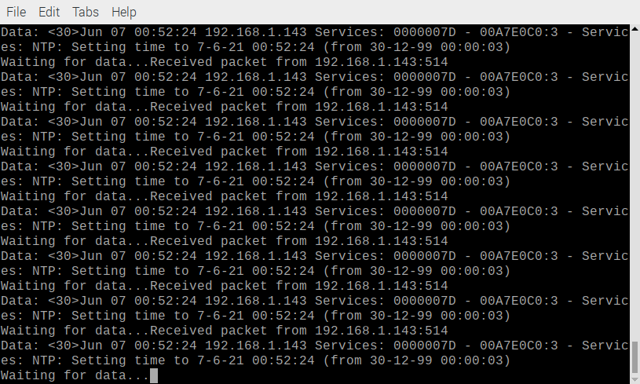

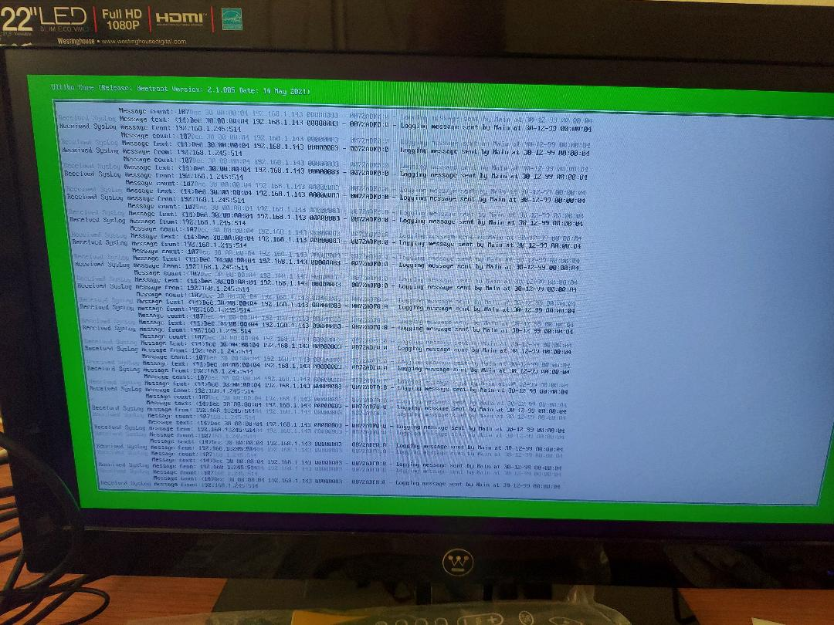
server.c

/*
Simple udp server
*/
#include<stdio.h> //printf
#include<string.h> //memset
#include<stdlib.h> //exit(0);
#include<arpa/inet.h>
#include<sys/socket.h>

#define BUFLEN 1024 //Max length of buffer
#define PORT 514 //The port on which to listen for incoming data

void die(char *s)
{
perror(s);
exit(1);
}

int main(void)
{
struct sockaddr_in si_me, si_other;

int s, i, slen = sizeof(si_other) , recv_len;
char buf[BUFLEN];

//create a UDP socket
if ((s=socket(AF_INET, SOCK_DGRAM, IPPROTO_UDP)) == -1)
{
die("socket");
}

// zero out the structure
memset((char *) &si_me, 0, sizeof(si_me));

si_me.sin_family = AF_INET;
si_me.sin_port = htons(PORT);
si_me.sin_addr.s_addr = htonl(INADDR_ANY);

//bind socket to port
if( bind(s , (struct sockaddr*)&si_me, sizeof(si_me) ) == -1)
{
die("bind");
}

//keep listening for data
while(1)
{
printf("Waiting for data...");
fflush(stdout);

//try to receive some data, this is a blocking call
if ((recv_len = recvfrom(s, buf, BUFLEN, 0, (struct sockaddr *) &si_other, &slen)) == -1)
{
die("recvfrom()");
}

//print details of the client/peer and the data received
printf("Received packet from %s:%d\n", inet_ntoa(si_other.sin_addr), ntohs(si_other.sin_port));
printf("Data: %s\n" , buf);

//now reply the client with the same data
if (sendto(s, buf, recv_len, 0, (struct sockaddr*) &si_other, slen) == -1)
{
die("sendto()");
}
}

close(s);
return 0;
}

